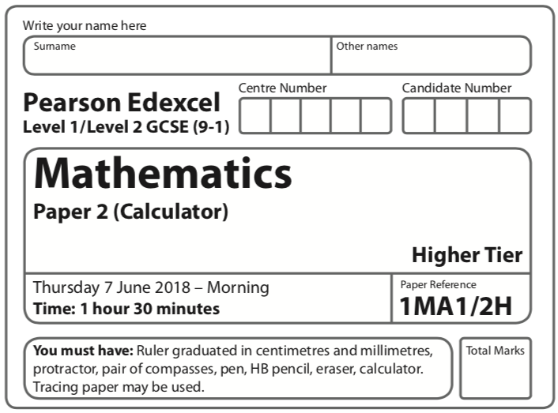

Instructions
- Use black ink or ball-point pen.
  - Fill in the boxes at the top of this page with your name,
centre number and candidate number.
- Answer all questions.
- Answer the questions in the spaces provided
– there may be more space than you need.
- You must show all your working.
- Diagrams are NOT accurately drawn, unless otherwise indicated.
- Calculators may be used.
- If your calculator does not have a π button, take the value of π to be
3.142 unless the question instructs otherwise.
Information
- The total mark for this paper is 80.
- The marks for each question are shown in brackets
– use this as a guide as to how much time to spend on each question.
Advice
- Read each question carefully before you start to answer it.
- Keep an eye on the time.
- Try to answer every question.
- Check your answers if you have time at the end.

Answer ALL questions.
Write your answers in the spaces provided.
You must write down all the stages in your working.

1 (a) Simplify m³ × m⁴

......................................................
(1)
(b) Simplify (5np³)³

......................................................
(2)
(c) Simplify

......................................................
(2)
(Total for Question 1 is 5 marks)
____________________________________________________________________________

2 (a) Find the lowest common multiple (LCM) of 40 and 56

......................................................
(2)

A = 2³ × 3 × 5 B = 2² × 3 × 5²
(b) Write down the highest common factor (HCF) of A and B.

......................................................
(1)
(Total for Question 2 is 3 marks)
____________________________________________________________________________

3 The line L is shown on the grid.

Find an equation for L.

......................................................
(Total for Question 3 is 3 marks)
____________________________________________________________________________

4 Raya buys a van for £8500 plus VAT at 20%
Raya pays a deposit for the van.
She then pays the rest of the cost in 12 equal payments of £531.25 each month.
Find the ratio of the deposit Raya pays to the total of the 12 equal payments.
Give your answer in its simplest form.

......................................................
(Total for Question 4 is 5 marks)
____________________________________________________________________________
5 (a) Complete the table of values for y = x² – x – 6

x | –3 | –2 | –1 | 0 | 1 | 2 | 3
y | 6 |  |  | – 6

(2)
(b) On the grid, draw the graph of y = x² – x – 6 for values of x from –3 to 3
(2)
(c) Use your graph to find estimates of the solutions to the equation x² – x – 6 = –2

.................................................................................
(2)
(Total for Question 5 is 6 marks)
____________________________________________________________________________

6 A force of 70 newtons acts on an area of 20 cm²
The force is increased by 10 newtons.
The area is increased by 10 cm²
Helen says,
“The pressure decreases by less than 20%”
Is Helen correct?
You must show how you get your answer.

(Total for Question 6 is 3 marks)
____________________________________________________________________________
7
Enlarge shape A by scale factor centre (0, 1)

(Total for Question 7 is 2 marks)
____________________________________________________________________________

8 60 people were asked if they prefer to go on holiday in Britain or in Spain or in Italy.
38 of the people were male.
11 of the 32 people who said Britain were female.
8 males said Italy.
12 people said Spain.
One of the females is chosen at random.
What is the probability that this female said Spain?

......................................................
(Total for Question 8 is 4 marks)
____________________________________________________________________________

9 Jean invests £12 000 in an account paying compound interest for 2 years.
In the first year the rate of interest is x%
At the end of the first year the value of Jean’s investment is £12 336
In the second year the rate of interest is %
What is the value of Jean’s investment at the end of 2 years?

£......................................................
(Total for Question 9 is 4 marks)
____________________________________________________________________________

10 The vector a and the vector b are shown on the grid.

(a) On the grid, draw and label vector –2a
(1)
(b) Work out a + 2b as a column vector.

(2)
(Total for Question 10 is 3 marks)
____________________________________________________________________________

11 f and g are functions such that
f(x) = and g(x) = 4x³
(a) Find f(–5)

......................................................
(1)
(b) Find fg(1)

......................................................
(2)
(Total for Question 11 is 3 marks)
____________________________________________________________________________

12

The graphs of y against x represent four different types of proportionality.
Match each type of proportionality in the table to the correct graph.

Type of proportionality | Graph letter
y x
y x²
y
y

(Total for Question 12 is 2 marks)
____________________________________________________________________________

13

A, B, C and D are points on the circumference of a circle, centre O.
FDE is a tangent to the circle.
(a) Show that y – x = 90
You must give a reason for each stage of your working.

(3)

Dylan was asked to give some possible values for x and y.
He said,
“y could be 200 and x could be 110, because 200 – 110 = 90”
(b) Is Dylan correct?
You must give a reason for your answer.

.........................................................................................................................................................

.........................................................................................................................................................
(1)
(Total for Question 13 is 4 marks)
____________________________________________________________________________
14 The distance-time graph shows information about part of a car journey.

Use the graph to estimate the speed of the car at time 5 seconds.

...................................................... m/s
(Total for Question 14 is 3 marks)
____________________________________________________________________________

15 A darts team is going to play a match on Saturday and on Sunday.
The probability that the team will win on Saturday is 0.45
If they win on Saturday, the probability that they will win on Sunday is 0.67
If they do not win on Saturday, the probability that they will win on Sunday is 0.35
(a) Complete the probability tree diagram.

(2)
(b) Find the probability that the team will win exactly one of the two matches.

......................................................
(3)
(Total for Question 15 is 5 marks)
____________________________________________________________________________
16 (a) On the grid, draw the graph of x² + y² = 12.25

(2)
(b) Hence find estimates for the solutions of the simultaneous equations
x² + y² = 12.25
2x + y = 1

............................................................................................................
(3)
(Total for Question 16 is 5 marks)
____________________________________________________________________________

17 The histogram shows information about the times taken by some students to finish a puzzle.

(a) Complete the frequency table for this information.

Time taken (t minutes) | Frequency
0 < t ⩽ 5 | 4
5 < t ⩽ 15
15 < t ⩽ 25
25 < t ⩽ 30
30 < t ⩽ 50
(2)
(b) Find an estimate for the lower quartile of the times taken to finish the puzzle.

................................. minutes
(2)
(Total for Question 17 is 4 marks)
____________________________________________________________________________

18 ABCDEFGH is a cuboid.

AB = 7.3 cm
CH = 8.1 cm
Angle BCA = 48°
Find the size of the angle between AH and the plane ABCD.
Give your answer correct to 1 decimal place.

..................................................... °
(Total for Question 18 is 4 marks)
____________________________________________________________________________
19 Shape S is one quarter of a solid sphere, centre O.

The volume of S is 576 π cm³
Find the surface area of S.
Give your answer correct to 3 significant figures.
You must show your working.

...................................................... cm²
(Total for Question 19 is 5 marks)
____________________________________________________________________________

20 Martin did this question.
Rationalise the denominator of

Here is how he answered the question.
=
=
=
=

Martin’s answer is wrong.
(a) Find Martin’s mistake.

.........................................................................................................................................................

.........................................................................................................................................................
(1)
Sian did this question.
Rationalise the denominator of

Here is how she answered the question.
=
=
=

Sian’s answer is wrong.
(b) Find Sian’s mistake.

.........................................................................................................................................................

.........................................................................................................................................................
(1)
(Total for Question 20 is 2 marks)
____________________________________________________________________________
21 Jackson is trying to find the density, in g/cm³, of a block of wood.
The block of wood is in the shape of a cuboid.
He measures
the length as 13.2 cm, correct to the nearest mm
the width as 16.0 cm, correct to the nearest mm
the height as 21.7 cm, correct to the nearest mm
He measures the mass as 1970 g, correct to the nearest 5 g.
By considering bounds, work out the density of the wood.
Give your answer to a suitable degree of accuracy.
You must show all your working and give a reason for your final answer.

(Total for Question 21 is 5 marks)
____________________________________________________________________________

TOTAL FOR PAPER IS 80 MARKS

