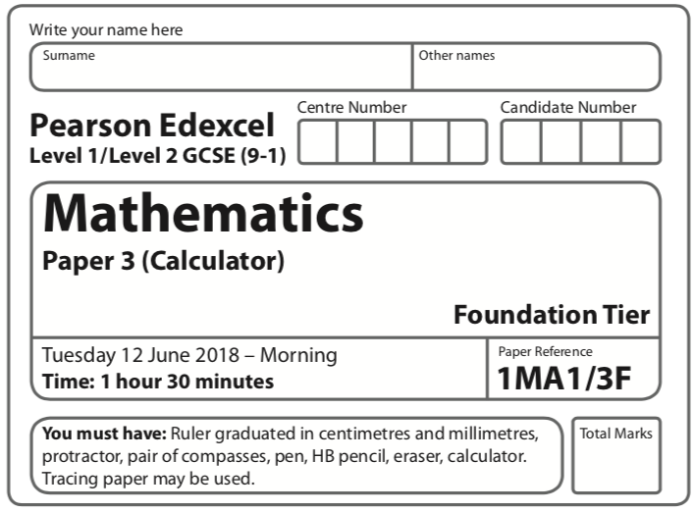

Instructions
- Use black ink or ball-point pen.
  - Fill in the boxes at the top of this page with your name,
centre number and candidate number.
- Answer all questions.
- Answer the questions in the spaces provided
– there may be more space than you need.
- You must show all your working.
- Diagrams are NOT accurately drawn, unless otherwise indicated.
- Calculators may be used.
- If your calculator does not have a π button, take the value of π to be 3.142
unless the question instructs otherwise.
Information
- The total mark for this paper is 80.
- The marks for each question are shown in brackets
– use this as a guide as to how much time to spend on each question.
Advice
- Read each question carefully before you start to answer it.
- Keep an eye on the time.
- Try to answer every question.
- Check your answers if you have time at the end.

Answer ALL questions.

Write your answers in the spaces provided.

You must write down all the stages in your working.

1 Write as a decimal.

.......................................................
(Total for Question 1 is 1 mark)
____________________________________________________________________________

2 Write 0.3 as a percentage.

.......................................................%
(Total for Question 2 is 1 mark)
____________________________________________________________________________

3 Write the number 2538 correct to the nearest hundred.

.........................................
(Total for Question 3 is 1 mark)
____________________________________________________________________________

4 Here are the first 4 terms of a sequence.
2 | 9 | 16 | 23

(a) (i) Write down the next term in the sequence.

.......................................................
(1)
(ii) Explain how you got your answer.

.........................................................................................................................................................
(1)
(b) Work out the 10th term of the sequence.

.......................................................
(1)
(Total for Question 4 is 3 marks)
____________________________________________________________________________
5 Here are four digits.
7 | 3 | 4 | 9

(a) Use three of these digits to write down the largest possible 3-digit number.

.......................................................
(1)
(b) Here are four different digits.
8 | 2 | 1 | 6

Put one of these digits in each box to give the smallest possible answer to the sum.
You must use each digit only once.

(1)
(Total for Question 5 is 2 marks)
____________________________________________________________________________

6 Write down all the factors of 30.

..............................................................................................................
(Total for Question 6 is 2 marks)
____________________________________________________________________________

7 David has twice as many cousins as Becky.
Becky has twice as many cousins as Nishat.
Nishat has 6 cousins.
How many cousins does David have?

.......................................................
(Total for Question 7 is 2 marks)
____________________________________________________________________________

8 (a) Find the value of

.......................................................
(1)
(b) Find the value of (3.54 – 0.96)² – 4.096

.......................................................
(2)
(Total for Question 8 is 3 marks)
____________________________________________________________________________

9 This is part of a bus timetable between Bury and Manchester.
Bury | 08 25 | 08 55 | 09 15 | 09 30 | 09 45 | 10 05
Whitefield | 08 34 | 09 04 | 09 24 | 09 39 | 09 54 | 10 14
Heaton Park | 08 46 | 09 16 | 09 36 | 09 51 | 10 06 | 10 27
Cheetham | 08 56 | 09 26 | 09 46 | 10 01 | 10 16 | 10 37
Manchester | 09 05 | 09 35 | 09 55 | 10 10 | 10 25 | 10 48

(a) How many minutes should the 08 25 bus take to go from Bury to Manchester?

....................................................... minutes
(1)

Daniel goes from Whitefield to Manchester by bus.
Daniel takes 17 minutes to get from his house to the bus stop in Whitefield.
He takes 15 minutes to get from the bus stop in Manchester to work.
Daniel has to get to work by 10 am.
He leaves his house at 8.45 am.
(b) Does Daniel get to work by 10 am?
You must show all your working.

(3)
(Total for Question 9 is 4 marks)
____________________________________________________________________________
10 Bronwin works in a restaurant.
The table gives her rates of pay.

Day | Rate of pay
Monday to Friday | £8.40 per hour
Weekend | £11.20 per hour

Bronwin worked for a total of 20 hours last week.
She worked 8 of these 20 hours at the weekend.
Show that Bronwin was paid less than £200 last week.

(Total for Question 10 is 3 marks)
____________________________________________________________________________

11 Last year the cost of a season ticket for a football club was £560.
This year the cost of a season ticket for the club has been increased to £600.
Write down the increase in the cost of a season ticket as a fraction of last year’s cost.

.......................................................
(Total for Question 11 is 2 marks)
____________________________________________________________________________

12 The diagram shows a scale drawing of a tennis court.

The scale of the drawing is 1 : 200
Work out the perimeter of the real tennis court.
Give your answer in metres.

....................................................... metres
(Total for Question 12 is 5 marks)
____________________________________________________________________________

13 Here are six straight line graphs.

Match each equation in the table to the correct graph.
Write the letter of the graph in the table.

Equation | Graph
y = 2
y = x
x + y = 2

(Total for Question 13 is 2 marks)
____________________________________________________________________________

14 Here are the marks 20 students got in a French test.
76 | 82 | 84 | 69 | 80 | 64 | 70 | 81 | 75 | 91
87 | 67 | 80 | 70 | 94 | 76 | 81 | 69 | 71 | 77

(a) Show this information in a stem and leaf diagram.

(3)

One of these students is going to be chosen at random.
The pass mark in the French test is 71.
Omar writes,
The probability that this student failed the French test is
Omar is wrong.
(b) Explain why.
.........................................................................................................................................................
.........................................................................................................................................................
(2)
(Total for Question 14 is 5 marks)
____________________________________________________________________________

15 Jenny is asked to find the value of 12 – 2 × 4
Here is her working.
12 – 2 × 4 = 10 × 4 = 40
Jenny’s answer is wrong.
(a) Explain what Jenny has done wrong.
.........................................................................................................................................................

.........................................................................................................................................................
(1)

Rehan is asked to find the range of the numbers 3 1 8 7 5
Here is his working.
Range = 5 – 3 = 2
This is wrong.
(b) Explain why.
.........................................................................................................................................................
.........................................................................................................................................................
(1)
(Total for Question 15 is 2 marks)
____________________________________________________________________________

16 Alan, Bispah and Chan share a sum of money.
Alan gets of the money.
Bispah gets of the money.
Chan gets the rest of the money.
Alan gets £2.50
(a) Work out how much money Bispah gets.

£.......................................................
(2)
(b) Find the ratio
amount of money Alan gets : amount of money Chan gets
Give your answer in the form a : b where a and b are whole numbers.

.......................................................
(3)
(Total for Question 16 is 5 marks)
____________________________________________________________________________
17 ABC is an isosceles right-angled triangle.
The area of the triangle is 162 cm²
Work out the value of x.

x = .......................................................
(Total for Question 17 is 3 marks)
____________________________________________________________________________

18 Work out the value of
Give your answer in standard form.

.......................................................
(Total for Question 18 is 2 marks)
____________________________________________________________________________
19 The scatter diagram shows information about 12 girls.
It shows the age of each girl and the best time she takes to run 100 metres.

(a) Write down the type of correlation.

..............................................................................................................
(1)

Kristina is 11 years old.
Her best time to run 100 metres is 12 seconds.
The point representing this information would be an outlier on the scatter diagram.
(b) Explain why.
.........................................................................................................................................................

.........................................................................................................................................................
(1)

Debbie is 15 years old.
Debbie says,
“The scatter diagram shows I should take less than 12 seconds to run 100 metres.”
(c) Comment on what Debbie says.
.........................................................................................................................................................

.........................................................................................................................................................
(1)
(Total for Question 19 is 3 marks)
____________________________________________________________________________

20 Expand and simplify 5( p + 3) – 2(1 – 2p)

.......................................................
(Total for Question 20 is 2 marks)
____________________________________________________________________________

21 Here is a trapezium drawn on a centimetre grid.

On the grid, draw a triangle equal in area to this trapezium.

(Total for Question 21 is 2 marks)
____________________________________________________________________________
22 When a biased 6-sided dice is thrown once, the probability that it will land on 4 is 0.65
The biased dice is thrown twice.
Amir draws this probability tree diagram.
The diagram is not correct.

Write down two things that are wrong with the probability tree diagram.
1.......................................................................................................................................................

.........................................................................................................................................................

2 ......................................................................................................................................................

.........................................................................................................................................................
(Total for Question 22 is 2 marks)
____________________________________________________________________________

23 ABC is a right-angled triangle.

(a) Work out the size of angle ABC.
Give your answer correct to 1 decimal place.

....................................................... °
(2)

The length of the side AB is reduced by 1 cm.
The length of the side BC is still 7 cm.
Angle ACB is still 90°
(b) Will the value of cos ABC increase or decrease?
You must give a reason for your answer.
.........................................................................................................................................................

.........................................................................................................................................................
(1)
(Total for Question 23 is 3 marks)
____________________________________________________________________________

24 There are some counters in a bag.
The counters are red or white or blue or yellow.
Bob is going to take at random a counter from the bag.
The table shows each of the probabilities that the counter will be blue or will be yellow.

Colour | red | white | blue | yellow
Probability |  |  | 0.45 | 0.25

There are 18 blue counters in the bag.
The probability that the counter Bob takes will be red is twice the probability that the
counter will be white.
(a) Work out the number of red counters in the bag.

.......................................................
(4)

A marble is going to be taken at random from a box of marbles.
The probability that the marble will be silver is 0.5
There must be an even number of marbles in the box.
(b) Explain why.
.........................................................................................................................................................

.........................................................................................................................................................
(1)
(Total for Question 24 is 5 marks)
____________________________________________________________________________

25 Solve

x = .......................................................
(Total for Question 25 is 3 marks)
____________________________________________________________________________

26 ABCDE is a pentagon.

Angle BCD = 2 × angle ABC
Work out the size of angle BCD.
You must show all your working.

....................................................... °
(Total for Question 26 is 5 marks)
____________________________________________________________________________
27 Triangle ABC and triangle DEF are similar.

(a) Work out the length of DF.

....................................................... cm
(2)
(b) Work out the length of CB.

....................................................... cm
(2)
(Total for Question 27 is 4 marks)
____________________________________________________________________________

28 Make g the subject of the formula T =

.......................................................
(Total for Question 28 is 3 marks)
____________________________________________________________________________

TOTAL FOR PAPER IS 80 MARKS

