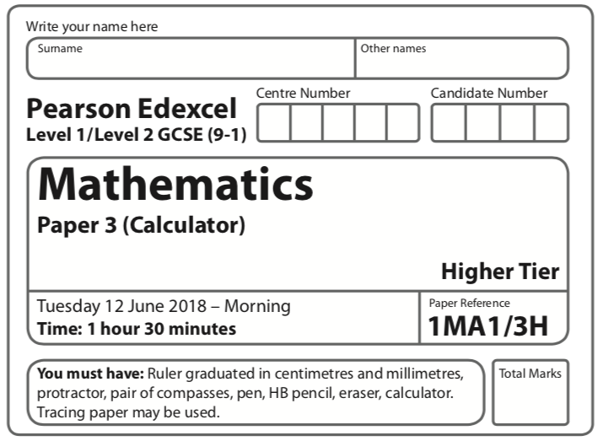

Instructions
- Use black ink or ball-point pen.
  - Fill in the boxes at the top of this page with your name,
centre number and candidate number.
- Answer all questions.
- Answer the questions in the spaces provided
– there may be more space than you need.
- You must show all your working.
- Diagrams are NOT accurately drawn, unless otherwise indicated.
- Calculators may be used.
- If your calculator does not have a π button, take the value of π to be 3.142
unless the question instructs otherwise.
Information
- The total mark for this paper is 80.
- The marks for each question are shown in brackets
– use this as a guide as to how much time to spend on each question.
Advice
- Read each question carefully before you start to answer it.
- Keep an eye on the time.
- Try to answer every question.
- Check your answers if you have time at the end.

Answer ALL questions.

Write your answers in the spaces provided.

You must write down all the stages in your working.

1 The scatter diagram shows information about 12 girls.
It shows the age of each girl and the best time she takes to run 100 metres.
(a) Write down the type of correlation.

..............................................................................................................
(1)

Kristina is 11 years old.
Her best time to run 100 metres is 12 seconds.
The point representing this information would be an outlier on the scatter diagram.
(b) Explain why.
.........................................................................................................................................................

.........................................................................................................................................................
(1)

Debbie is 15 years old.
Debbie says,
“The scatter diagram shows I should take less than 12 seconds to run 100 metres.”
(c) Comment on what Debbie says.
.........................................................................................................................................................
.........................................................................................................................................................
(1)
(Total for Question 1 is 3 marks)
____________________________________________________________________________

2 Expand and simplify 5( p + 3) – 2(1 – 2p)

....................................................
(Total for Question 2 is 2 marks)
____________________________________________________________________________

3 Here is a trapezium drawn on a centimetre grid.

On the grid, draw a triangle equal in area to this trapezium.

(Total for Question 3 is 2 marks)
____________________________________________________________________________
4 When a biased 6-sided dice is thrown once, the probability that it will land on 4 is 0.65
The biased dice is thrown twice.
Amir draws this probability tree diagram.
The diagram is not correct.

Write down two things that are wrong with the probability tree diagram.
1 ......................................................................................................................................................
.........................................................................................................................................................
2................................................................................................................................................................................................................................................................................................................
(Total for Question 4 is 2 marks)
____________________________________________________________________________

5 ABC is a right-angled triangle.

(a) Work out the size of angle ABC.
Give your answer correct to 1 decimal place.

....................................................... °
(2)

The length of the side AB is reduced by 1 cm.
The length of the side BC is still 7 cm.
Angle ACB is still 90°
(b) Will the value of cos ABC increase or decrease?
You must give a reason for your answer.
.........................................................................................................................................................
.........................................................................................................................................................
(1)
(Total for Question 5 is 3 marks)
____________________________________________________________________________

6 There are some counters in a bag.
The counters are red or white or blue or yellow.
Bob is going to take at random a counter from the bag.
The table shows each of the probabilities that the counter will be blue or will be yellow.

Colour | red | white | blue | yellow
Probability |  |  | 0.45 | 0.25

There are 18 blue counters in the bag.
The probability that the counter Bob takes will be red is twice the probability that the
counter will be white.
(a) Work out the number of red counters in the bag.

.......................................................
(4)

A marble is going to be taken at random from a box of marbles.
The probability that the marble will be silver is 0.5.
There must be an even number of marbles in the box.
(b) Explain why.

.........................................................................................................................................................

.........................................................................................................................................................
(1)
(Total for Question 6 is 5 marks)
____________________________________________________________________________
7 Solve = 2x – 7

x = .......................................................
(Total for Question 7 is 3 marks)
____________________________________________________________________________

8 ABCDE is a pentagon.

Angle BCD = 2 × angle ABC
Work out the size of angle BCD.
You must show all your working.

....................................................... °
(Total for Question 8 is 5 marks)
____________________________________________________________________________
9 T =
w = 5.6 × 10^{–5}
d = 1.4 × 10^{–4}
(a) Work out the value of T.
Give your answer in standard form correct to 3 significant figures.

T = .......................................................
(2)

w is increased by 10%
d is increased by 5%
Lottie says,
“The value of T will increase because both w and d are increased.”
(b) Lottie is wrong.
Explain why.

.........................................................................................................................................................

.........................................................................................................................................................
(2)
(Total for Question 9 is 4 marks)
____________________________________________________________________________
10 Here are three lamps.

Lamp A flashes every 20 seconds.
Lamp B flashes every 45 seconds.
Lamp C flashes every 120 seconds.
The three lamps start flashing at the same time.
How many times in one hour will the three lamps flash at the same time?

.......................................................
(Total for Question 10 is 3 marks)
____________________________________________________________________________

11 In 2003, Jerry bought a house.
In 2007, Jerry sold the house to Mia.
He made a profit of 20%
In 2012, Mia sold the house for £162 000.
She made a loss of 10%
Work out how much Jerry paid for the house in 2003.

£.......................................................
(Total for Question 11 is 3 marks)
____________________________________________________________________________

12 The graph shows the volume of liquid (L litres) in a container at time t seconds.

(a) Find the gradient of the graph.

.......................................................
(2)
(b) Explain what this gradient represents.
.........................................................................................................................................................

.........................................................................................................................................................
(1)

The graph intersects the volume axis at L = 4
(c) Explain what this intercept represents.
.........................................................................................................................................................
.........................................................................................................................................................
(1)
(Total for Question 12 is 4 marks)
____________________________________________________________________________

13 Here are two similar solid shapes.

surface area of shape A : surface area of shape B = 3 : 4
The volume of shape B is 10 cm³
Work out the volume of shape A.
Give your answer correct to 3 significant figures.

....................................................... cm³
(Total for Question 13 is 3 marks)
____________________________________________________________________________

14 There are 16 hockey teams in a league.
Each team played two matches against each of the other teams.
Work out the total number of matches played.

.......................................................
(Total for Question 14 is 2 marks)
____________________________________________________________________________

15 The graph shows the speed of a car, in metres per second, during the first 20 seconds of
a journey.

(a) Work out an estimate for the distance the car travelled in the first 20 seconds.
Use 4 strips of equal width.

....................................................... metres
(3)
(b) Is your answer to part (a) an underestimate or an overestimate of the actual distance
the car travelled in the first 20 seconds?
Give a reason for your answer.

.........................................................................................................................................................

.........................................................................................................................................................
(1)
(Total for Question 15 is 4 marks)
____________________________________________________________________________

16 The nth term of a sequence is given by an² + bn where a and b are integers.
The 2nd term of the sequence is –2.
The 4th term of the sequence is 12.
(a) Find the 6th term of the sequence.

.......................................................
(4)

Here are the first five terms of a different quadratic sequence.

0 | 2 | 6 | 12 | 20

(b) Find an expression, in terms of n, for the nth term of this sequence.

.......................................................
(2)
(Total for Question 16 is 6 marks)
____________________________________________________________________________
17

Work out the length of AD.
Give your answer correct to 3 significant figures.

....................................................... cm
(Total for Question 17 is 5 marks)
____________________________________________________________________________
18 (a) Show that the equation x³ + x = 7 has a solution between 1 and 2.

(2)
(b) Show that the equation x³ + x = 7 can be rearranged to give x =

(1)
(c) Starting with x₀ = 2,
use the iteration formula x_{n + 1} = three times to find an estimate for a
solution of x³ + x = 7

.......................................................
(3)
(Total for Question 18 is 6 marks)
____________________________________________________________________________
19 Here are two right-angled triangles.

Given that
tan e = tan f
find the value of x.
You must show all your working.

.......................................................
(Total for Question 19 is 5 marks)
____________________________________________________________________________
20 50 people were asked if they speak French or German or Spanish.
Of these people,
31 speak French
2 speak French, German and Spanish
4 speak French and Spanish but not German
7 speak German and Spanish
8 do not speak any of the languages
all 10 people who speak German speak at least one other language
Two of the 50 people are chosen at random.
Work out the probability that they both only speak Spanish.

.......................................................
(Total for Question 20 is 5 marks)
____________________________________________________________________________
21

ABCD is a parallelogram.
ABP and QDC are straight lines.
Angle ADP = angle CBQ = 90°
(a) Prove that triangle ADP is congruent to triangle CBQ.

(3)
(b) Explain why AQ is parallel to PC.

(2)
(Total for Question 21 is 5 marks)
____________________________________________________________________________

TOTAL FOR PAPER IS 80 MARKS

