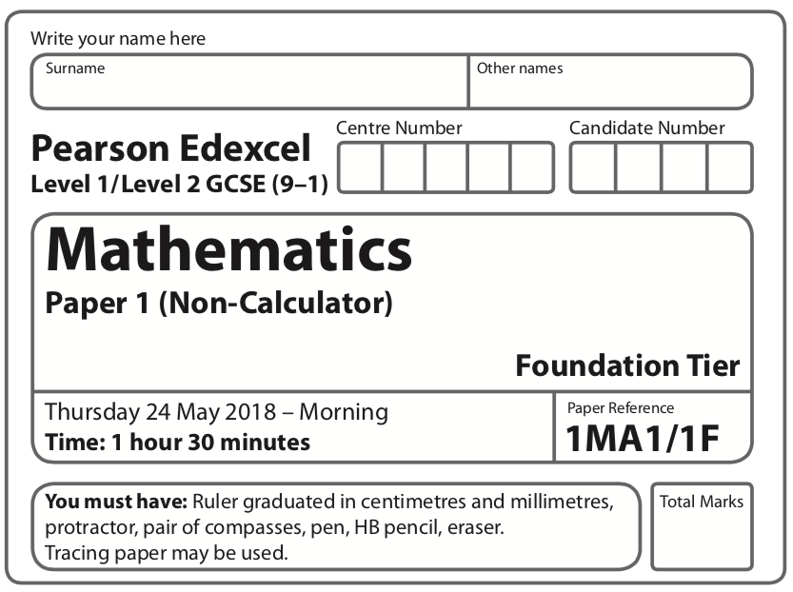

Instructions
- Use black ink or ball-point pen.
  - Fill in the boxes at the top of this page with your name,
centre number and candidate number.
- Answer all questions.
- Answer the questions in the spaces provided
– there may be more space than you need.
- You must show all your working.
- Diagrams are NOT accurately drawn, unless otherwise indicated.
- Calculators may not be used.
Information
- The total mark for this paper is 80.
- The marks for each question are shown in brackets
– use this as a guide as to how much time to spend on each question.
Advice
- Read each question carefully before you start to answer it.
- Keep an eye on the time.
- Try to answer every question.
- Check your answers if you have time at the end.
Answer ALL questions.

Write your answers in the spaces provided.

You must write down all the stages in your working.

1 Write 6324 correct to the nearest thousand.

.......................................................
(Total for Question 1 is 1 mark)
___________________________________________________________________________

2 (a) Write the following numbers in order of size.
Start with the smallest number.

−6 | 6 | −5 | 0 | 12

..............................................................................................................
(1)
(b) Write the following numbers in order of size.
Start with the smallest number.

0.078 | 0.78 | 0.87 | 0.708

.........................................................................................................................................................
(1)
(Total for Question 2 is 2 marks)
____________________________________________________________________________

3 Write 20% as a fraction.

.......................................................
(Total for Question 3 is 1 mark)
____________________________________________________________________________

4 Here is a list of four fractions.

One of these fractions is not equivalent to
Write down this fraction.

.......................................................
(Total for Question 4 is 1 mark)
____________________________________________________________________________

5 Write down the first even multiple of 7.

.......................................................
(Total for Question 5 is 1 mark)
____________________________________________________________________________

6 (a) Simplify 3 × 4t

.......................................................
(1)
(b) Simplify 8a – 3a + 2a

.......................................................
(1)
(Total for Question 6 is 2 marks)
____________________________________________________________________________

7 Here is a probability scale.
It shows the probability of each of the events A, B, C and D.

(a) Write down the letter of the event that is certain.

.......................................................
(1)
(b) Write down the letter of the event that is unlikely.

.......................................................
(1)

There are 12 counters in a bag.
3 of the counters are red.
1 of the counters is blue.
2 of the counters are yellow.
The rest of the counters are green.
Caitlin takes at random a counter from the bag.
(c) Show that the probability that this counter is yellow or green is

(3)
(Total for Question 7 is 5 marks)
____________________________________________________________________________

8 3 kg of meat costs £54.
Nina buys 2 kg of the meat.
Work out how much Nina pays.

£ .......................................................
(Total for Question 8 is 2 marks)
____________________________________________________________________________

9 The centre of this circle is marked with a cross (×).
(a) Write down the mathematical name of the straight line shown in the circle.

........................................................
(1)
(b) Write down the mathematical name of the straight line that is touching the circle.

.......................................................
(1)
(Total for Question 9 is 2 marks)
____________________________________________________________________________
10 Tim and three friends go on holiday together for a week.
The 4 friends will share the costs of the holiday equally.
Here are the costs of the holiday.
£1280 for 4 return plane tickets
£640 for the villa
£220 for hire of a car for the week
Work out how much Tim has to pay for his share of the costs.

£ .......................................................
(Total for Question 10 is 3 marks)
____________________________________________________________________________

11 Write down an example to show that each of the following two statements is not correct.
(a) The factors of an even number are always even.

..........................................................................................................................
(1)
(b) All the digits in odd numbers are odd.

.......................................................
(1)
(Total for Question 11 is 2 marks)
____________________________________________________________________________

12 A shop sells desktop computers, laptops and tablets.
The composite bar chart shows information about sales over the last three years.

(a) Write down the number of desktop computers sold in 2015

.......................................................
(1)
(b) Work out the total number of laptops sold in the 3 years.

.......................................................
(3)
(c) State the item that had the greatest increase in sales over the 3 years.
Give a reason for your answer.
.........................................................................................................................................................
.........................................................................................................................................................
.........................................................................................................................................................
(2)

Alex says,
“In 2017, more tablets were sold than desktop computers. This means the shop makes
more profit from the sale of tablets than from the sale of desktop computers.”
(d) Is Alex correct?
You must justify your answer.
.........................................................................................................................................................
.........................................................................................................................................................
.........................................................................................................................................................
(1)
(Total for Question 12 is 7 marks)
____________________________________________________________________________

13 A piece of wire is 240 cm long.
Peter cuts two 45 cm lengths off the wire.
He then cuts the rest of the wire into as many 40 cm lengths as possible.
Work out how many 40 cm lengths of wire Peter cuts.

.......................................................
(Total for Question 13 is 3 marks)
____________________________________________________________________________

14 Gavin, Harry and Isabel each earn the same monthly salary.
Each month,
Gavin saves 28% of his salary and spends the rest of his salary
Harry spends of his salary and saves the rest of his salary
the amount of salary Isabel saves : the amount of salary she spends = 3 : 7
Work out who saves the most of their salary each month.
You must show how you get your answer.

(Total for Question 14 is 4 marks)
____________________________________________________________________________

15 Work out 15% of 160 grams.

....................................................... grams
(Total for Question 15 is 2 marks)
____________________________________________________________________________
16 P = 4x + 3y
x = 5
y = – 2
(a) Work out the value of P.

.......................................................
(2)
(b) Expand 4e(e + 2)

.......................................................
(2)
(c) Solve 3(m – 4) = 21

m = .......................................................
(2)
(Total for Question 16 is 6 marks)
____________________________________________________________________________

17 There are some chocolates in a box.
of the chocolates contain nuts.
The rest of the chocolates do not contain nuts.
Write down the ratio of the number of chocolates that contain nuts to the number of
chocolates that do not contain nuts.
Give your answer in the form 1 : n

..............................................................................................................
(Total for Question 17 is 2 marks)
____________________________________________________________________________

18 A = {multiples of 5 between 14 and 26}
B = {odd numbers between 14 and 26}

(a) List the members of

.................................................................................................................................................
(2)
(b) Describe the members of

.........................................................................................................................................................
(1)
(Total for Question 18 is 3 marks)
____________________________________________________________________________

19 (a) Work out 2 + 1

.......................................................
(2)
(b) Work out 1 ÷
Give your answer as a mixed number in its simplest form.

.......................................................
(2)
(Total for Question 19 is 4 marks)
____________________________________________________________________________

20 In a village
the number of houses and the number of flats are in the ratio 7 : 4
the number of flats and the number of bungalows are in the ratio 8 : 5
There are 50 bungalows in the village.
How many houses are there in the village?

.......................................................
(Total for Question 20 is 3 marks)
____________________________________________________________________________

21 Renee buys 5 kg of sweets to sell.
She pays £10 for the sweets.
Renee puts all the sweets into bags.
She puts 250 g of sweets into each bag.
She sells each bag of sweets for 65p.
Renee sells all the bags of sweets.
Work out her percentage profit.

........................................................ %
(Total for Question 21 is 4 marks)
____________________________________________________________________________

22 A cycle race across America is 3069.25 miles in length.
Juan knows his average speed for his previous races is 15.12 miles per hour.
For the next race across America he will cycle for 8 hours per day.
(a) Estimate how many days Juan will take to complete the race.

.......................................................
(3)

Juan trains for the race.
The average speed he can cycle at increases.
It is now 16.27 miles per hour.
(b) How does this affect your answer to part (a)?
.........................................................................................................................................................
.........................................................................................................................................................
(1)
(Total for Question 22 is 4 marks)
____________________________________________________________________________

23 Here is a solid square-based pyramid, VABCD.
The base of the pyramid is a square of side 6 cm.
The height of the pyramid is 4 cm.
M is the midpoint of BC and VM = 5 cm.
(a) Draw an accurate front elevation of the pyramid from the direction of the arrow.
(2)
(b) Work out the total surface area of the pyramid.

.......................................................
(4)
(Total for Question 23 is 6 marks)
____________________________________________________________________________

24 A pattern is made from four identical squares.
The sides of the squares are parallel to the axes.

Point A has coordinates (6, 7)
Point B has coordinates (38, 36)
Point C is marked on the diagram.
Work out the coordinates of C.

(................................ , ................................)
(Total for Question 24 is 5 marks)
____________________________________________________________________________

25 On the grid below, draw the graph of y = 1 − 4x for values of x from −3 to 3.

(Total for Question 25 is 3 marks)
____________________________________________________________________________

26 a = b =
Work out 2a + b as a column vector.

(Total for Question 26 is 2 marks)
____________________________________________________________________________

TOTAL FOR PAPER IS 80 MARKS

