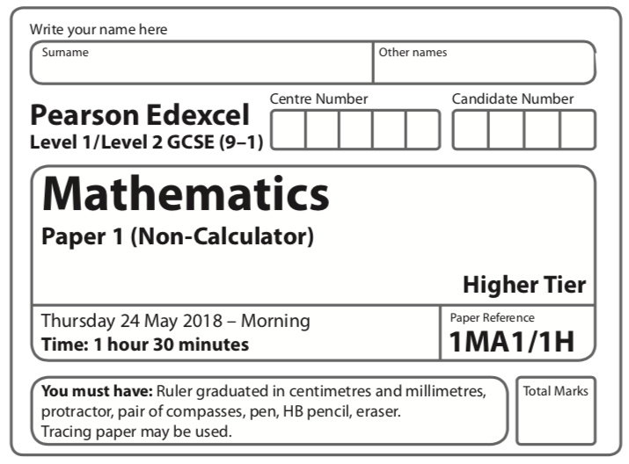
Instructions
- Use black ink or ball-point pen.
  - Fill in the boxes at the top of this page with your name,
centre number and candidate number.
- Answer all questions.
- Answer the questions in the spaces provided
– there may be more space than you need.
- You must show all your working.
- Diagrams are NOT accurately drawn, unless otherwise indicated.
- Calculators may not be used.
Information
- The total mark for this paper is 80.
- The marks for each question are shown in brackets
– use this as a guide as to how much time to spend on each question.
Advice
- Read each question carefully before you start to answer it.
- Keep an eye on the time.
- Try to answer every question.
- Check your answers if you have time at the end.
Answer ALL questions.

Write your answers in the spaces provided.

You must write down all the stages in your working.

1 (a) Work out 2 + 1

.......................................................
(2)
(b) Work out 1 ÷
Give your answer as a mixed number in its simplest form.

.......................................................
(2)
(Total for Question 1 is 4 marks)
____________________________________________________________________________

2 In a village
the number of houses and the number of flats are in the ratio 7 : 4
the number of flats and the number of bungalows are in the ratio 8 : 5
There are 50 bungalows in the village.
How many houses are there in the village?

.......................................................
(Total for Question 2 is 3 marks)
____________________________________________________________________________

3 Renee buys 5 kg of sweets to sell.
She pays £10 for the sweets.
Renee puts all the sweets into bags.
She puts 250 g of sweets into each bag.
She sells each bag of sweets for 65p.
Renee sells all the bags of sweets.
Work out her percentage profit.

.......................................................%
(Total for Question 3 is 4 marks)
____________________________________________________________________________

4 A cycle race across America is 3069.25 miles in length.
Juan knows his average speed for his previous races is 15.12 miles per hour.
For the next race across America he will cycle for 8 hours per day.
(a) Estimate how many days Juan will take to complete the race.

.......................................................
(3)

Juan trains for the race.
The average speed he can cycle at increases.
It is now 16.27 miles per hour.
(b) How does this affect your answer to part (a)?
.........................................................................................................................................................
.........................................................................................................................................................
(1)
(Total for Question 4 is 4 marks)
____________________________________________________________________________

5 Here is a solid square-based pyramid, VABCD.
The base of the pyramid is a square of side 6 cm.
The height of the pyramid is 4 cm.
M is the midpoint of BC and VM = 5 cm.
(a) Draw an accurate front elevation of the pyramid from the direction of the arrow.
(2)
(b) Work out the total surface area of the pyramid.

.......................................................
(4)
(Total for Question 5 is 6 marks)
____________________________________________________________________________

6 A pattern is made from four identical squares.
The sides of the squares are parallel to the axes.

Point A has coordinates (6, 7)
Point B has coordinates (38, 36)
Point C is marked on the diagram.
Work out the coordinates of C.

(................................ , ................................)
(Total for Question 6 is 5 marks)
____________________________________________________________________________

7
Shape T is reflected in the line x = −1 to give shape R.
Shape R is reflected in the line y = −2 to give shape S.
Describe the single transformation that will map shape T to shape S.
.........................................................................................................................................................
.........................................................................................................................................................
.........................................................................................................................................................
(Total for Question 7 is 2 marks)
____________________________________________________________________________

8 The perimeter of a right-angled triangle is 72 cm.
The lengths of its sides are in the ratio 3 : 4 : 5
Work out the area of the triangle.

.......................................................cm²
(Total for Question 8 is 4 marks)
____________________________________________________________________________

9 (a) Write down the value of

.......................................................
(1)
(b) Write down the value of 23⁰

.......................................................
(1)
(c) Work out the value of

.......................................................
(2)
(Total for Question 9 is 4 marks)
____________________________________________________________________________

10 The table gives some information about the heights of 80 girls.

Least height | 133 cm
Greatest height | 170 cm
Lower quartile | 145 cm
Upper quartile | 157 cm
Median | 151 cm

(a) Draw a box plot to represent this information.
(3)
(b) Work out an estimate for the number of these girls with a height between 133 cm and
157 cm.

.......................................................
(2)
(Total for Question 10 is 5 marks)
____________________________________________________________________________

11
A and B are points on a circle, centre O.
BC is a tangent to the circle.
AOC is a straight line.
Angle ABO = x°.
Find the size of angle ACB, in terms of x.
Give your answer in its simplest form.
Give reasons for each stage of your working.

(Total for Question 11 is 5 marks)
____________________________________________________________________________

12 Prove that the square of an odd number is always 1 more than a multiple of 4.

(Total for Question 12 is 4 marks)
____________________________________________________________________________

13 can be written in the form where a is an integer.
Find the value of a.

a = .......................................................
(Total for Question 13 is 3 marks)
____________________________________________________________________________
14 y is inversely proportional to d ²
When d = 10, y = 4
d is directly proportional to x²
When x = 2, d = 24
Find a formula for y in terms of x.
Give your answer in its simplest form.

.......................................................
(Total for Question 14 is 5 marks)
____________________________________________________________________________

15 (a) Factorise a² − b²

.......................................................
(1)
(b) Hence, or otherwise, simplify fully (x² + 4)² – (x² – 2)²

.......................................................
(3)
(Total for Question 15 is 4 marks)
____________________________________________________________________________

16 There are only red counters, blue counters and purple counters in a bag.
The ratio of the number of red counters to the number of blue counters is 3 : 17
Sam takes at random a counter from the bag.
The probability that the counter is purple is 0.2
Work out the probability that Sam takes a red counter.

.......................................................
(Total for Question 16 is 3 marks)
____________________________________________________________________________
17 Simplify fully

.......................................................
(Total for Question 17 is 3 marks)
____________________________________________________________________________

18 Here is the graph of y = sin x° for –180 ⩽ x ⩽ 180

On the grid, sketch the graph of y = sin x° – 2 for –180 ⩽ x ⩽ 180

(Total for Question 18 is 2 marks)
____________________________________________________________________________

19 The point P has coordinates (3, 4)
The point Q has coordinates (a, b)
A line perpendicular to PQ is given by the equation 3x + 2y = 7
Find an expression for b in terms of a.

.......................................................
(Total for Question 19 is 5 marks)
____________________________________________________________________________

20 n is an integer such that 3n + 2 ⩽ 14 and > 1
Find all the possible values of n.

.......................................................
(Total for Question 20 is 5 marks)
____________________________________________________________________________

TOTAL FOR PAPER IS 80 MARKS

