Instructions
- Use black ink or ball-point pen.
  - Fill in the boxes at the top of this page with your name,
centre number and candidate number.
- Answer all questions.
- Answer the questions in the spaces provided
– there may be more space than you need.
- You must show all your working.
- Diagrams are NOT accurately drawn, unless otherwise indicated.
- Calculators may not be used.
Information
- The total mark for this paper is 80.
- The marks for each question are shown in brackets
– use this as a guide as to how much time to spend on each question.
Advice
- Read each question carefully before you start to answer it.
- Keep an eye on the time.
- Try to answer every question.
- Check your answers if you have time at the end.

Answer ALL questions.
Write your answers in the spaces provided.
You must write down all the stages in your working.

1 Write 180 minutes in hours.

....................................................... hours
(Total for Question 1 is 1 mark)
___________________________________________________________________________

2 Write 0.73 as a percentage.

....................................................... %
(Total for Question 2 is 1 mark)
___________________________________________________________________________

3 Work out 10 × (3 + 5)

.......................................................
(Total for Question 3 is 1 mark)
___________________________________________________________________________

4 Write down a prime number that is between 20 and 30

.......................................................
(Total for Question 4 is 1 mark)
___________________________________________________________________________

5 Find the number that is exactly halfway between 7 and 15

.......................................................
(Total for Question 5 is 1 mark)
___________________________________________________________________________

6 Harry is planning a holiday for 4 people for 7 days.
Here are the costs for the holiday for each person.
Travel £150
Hotel £50 for each day
Spending money £250
Work out the total cost of the holiday for 4 people for 7 days.

£.......................................................
(Total for Question 6 is 4 marks)
___________________________________________________________________________

7 In Adam’s garden, the flowers are only red or white or yellow or blue.
The chart shows the number of red flowers, the number of white flowers and the number
of yellow flowers.

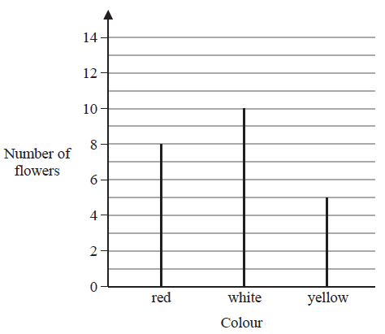

The total number of flowers is 30
(a) Work out the number of blue flowers.

.......................................................
(2)
(b) Write down the mode.

.......................................................
(1)
(Total for Question 7 is 3 marks)
___________________________________________________________________________

8 Write the following fractions in order of size.
Start with the smallest fraction.

......................................................................................................................................
(Total for Question 8 is 2 marks)
___________________________________________________________________________

9 Ruth left her home at 9 am and walked to the library.
She got to the library at 10 30 am.
Ruth walked at a speed of 4 mph.
(a) Work out the distance Ruth walked.

....................................................... miles
(2)

Ruth got to the library at 10 30 am.
She stayed at the library for 50 minutes.
Then she walked home.
Ruth took 1 hours to walk home.
(b) At what time did Ruth get home?

.......................................................
(2)
(Total for Question 9 is 4 marks)
___________________________________________________________________________

10 (a) Solve t + t + t = 12

t = .......................................................
(1)
(b) Solve x – 2 = 6

x = .......................................................
(1)
(c) Solve 6w + 2 = 20

w = .......................................................
(2)
(Total for Question 10 is 4 marks)
___________________________________________________________________________

11 Work out 74 × 58

.......................................................
(Total for Question 11 is 2 marks)
___________________________________________________________________________

12 AB and BC are perpendicular lines.
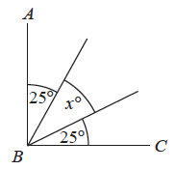
(a) Find the value of x.

x = .......................................................
(2)

RS and TU are parallel lines.
PQ is a straight line.
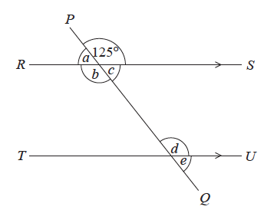
An angle of size 125° is shown on the diagram.
(b) (i) Write down the letter of one other angle of size 125°
Give a reason for your answer.
......................................................................................................................................................
......................................................................................................................................................
(2)
(ii) Explain why a + b + c = 235°
......................................................................................................................................................
......................................................................................................................................................
......................................................................................................................................................
(1)
(Total for Question 12 is 5 marks)
___________________________________________________________________________

13 The length of a line is x centimetres.
Write down an expression, in terms of x, for the length of the line in millimetres.

.......................................................
(Total for Question 13 is 1 mark)
___________________________________________________________________________

14 (a) Work out of 70

.......................................................
(1)

Fiona has to work out the exact value of 48 ÷
She writes
48 ÷ = 24
Fiona’s reason is,
“There are 2 halves in 1, so there will be 24 halves in 48”
(b) Explain what is wrong with Fiona’s reason.
......................................................................................................................................................
......................................................................................................................................................
......................................................................................................................................................
(1)
(Total for Question 14 is 2 marks)
___________________________________________________________________________

15 (a) Write down the value of

.......................................................
(1)
(b) Work out the value of 5³

.......................................................
(1)
(Total for Question 15 is 2 marks)
___________________________________________________________________________

16 (a) Expand 5(2m – 3)

.......................................................
(1)
(b) Factorise 3n + 12

.......................................................
(1)
(Total for Question 16 is 2 marks)
___________________________________________________________________________

17 Stuart throws a biased coin 10 times.
He gets 7 Tails.
Maxine throws the same coin 50 times.
She gets 30 Tails.
Prasha is going to throw the coin once.
(i) Whose results will give the better estimate for the probability that she will get Tails
Stuart’s or Maxine’s?
You must give a reason for your answer.
......................................................................................................................................................
......................................................................................................................................................
......................................................................................................................................................
(1)
(ii) Use Stuart’s and Maxine’s results to work out an estimate for the probability that
Prasha will get Tails.

.......................................................
(1)
(Total for Question 17 is 2 marks)
___________________________________________________________________________

18 The diagram shows a rectangular garden path.

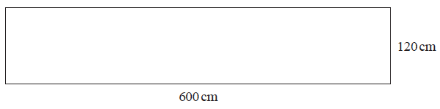

Wasim is going to cover the path with paving stones.
Each paving stone is a square of side 30 cm.
Each paving stone costs £2.50
Wasim has £220 to spend on paving stones.
Show that he has enough money to buy all the paving stones he needs.

(Total for Question 18 is 4 marks)
___________________________________________________________________________

19 (a) Work out

.......................................................
(2)
(b) Work out
Give your answer as a fraction in its simplest form.

.......................................................
(2)
(Total for Question 19 is 4 marks)
___________________________________________________________________________

20 Here are two squares, A and B.

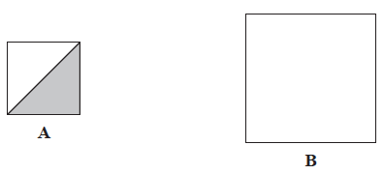

The length of the side of square A is 50% of the length of the side of square B.
Express the area of the shaded region of square A as a percentage of the area of square B.

....................................................... %
(Total for Question 20 is 3 marks)
___________________________________________________________________________

21 There are 40 students in a class.
Each student walks to school or cycles to school or gets the bus to school.
There are 22 girls in the class.
9 of the girls walk to school.
7 of the boys cycle to school.
6 of the 10 students who get the bus to school are boys.
Find the number of these students who walk to school.

.......................................................
(Total for Question 21 is 4 marks)
___________________________________________________________________________

22 There are only blue cubes, red cubes and yellow cubes in a box.
The table shows the probability of taking at random a blue cube from the box.

Colour | blue | red | yellow
Probability | 0.2

The number of red cubes in the box is the same as the number of yellow cubes in the box.
(a) Complete the table.

(2)

There are 12 blue cubes in the box.
(b) Work out the total number of cubes in the box.

.......................................................
(2)
(Total for Question 22 is 4 marks)
___________________________________________________________________________

23 Deon needs 50 g of sugar to make 15 biscuits.
She also needs
three times as much flour as sugar
two times as much butter as sugar
Deon is going to make 60 biscuits.
(a) Work out the amount of flour she needs.

....................................................... g
(3)

Deon has to buy all the butter she needs to make 60 biscuits.
She buys the butter in 250 g packs.
(b) How many packs of butter does Deon need to buy?

.......................................................
(2)
(Total for Question 23 is 5 marks)
___________________________________________________________________________

24 Find the highest common factor (HCF) of 72 and 90

.......................................................
(Total for Question 24 is 2 marks)
___________________________________________________________________________

25 The diagram shows the plan, front elevation and side elevation of a solid shape, drawn
on a centimetre grid.

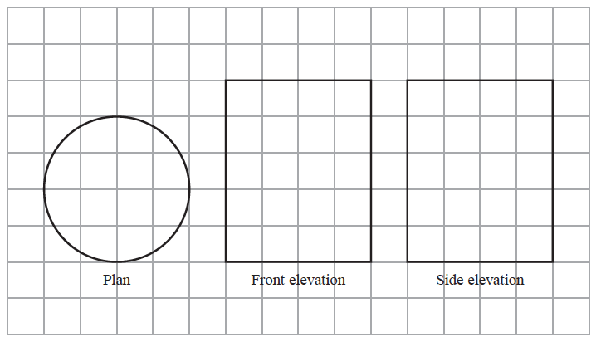

In the space below, draw a sketch of the solid shape.
Give the dimensions of the solid on your sketch.

(Total for Question 25 is 2 marks)
___________________________________________________________________________

26
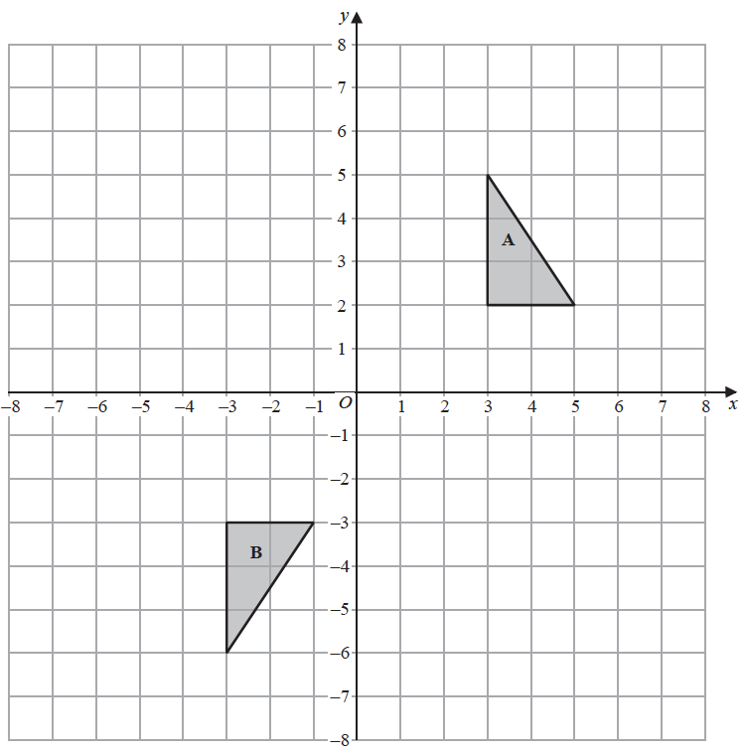

Shape A can be transformed to shape B by a reflection in the x-axis followed by a
translation
Find the value of c and the value of d.

c = .......................................................

d = .......................................................
(Total for Question 26 is 3 marks)
___________________________________________________________________________

27 A shop sells packs of black pens, packs of red pens and packs of green pens.
There are
2 pens in each pack of black pens
5 pens in each pack of red pens
6 pens in each pack of green pens
On Monday,

number of packs  of black pens sold | : | number of packs  of red pens sold | : | number of packs  of green pens sold | = 7 : 3 : 4

A total of 212 pens were sold.
Work out the number of green pens sold.

.......................................................
(Total for Question 27 is 4 marks)
___________________________________________________________________________

28 Here are two rectangles.

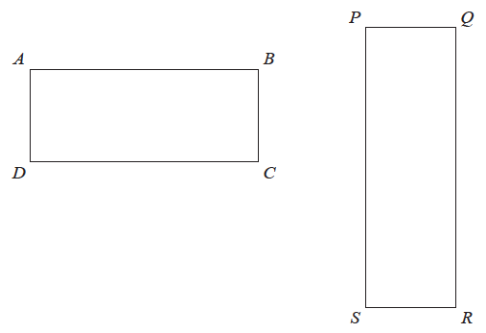

QR = 10 cm
BC = PQ
The perimeter of ABCD is 26 cm
The area of PQRS is 45 cm²
Find the length of AB.

....................................................... cm
(Total for Question 28 is 4 marks)
___________________________________________________________________________

29 Here is the graph of y = x² – 2x – 3
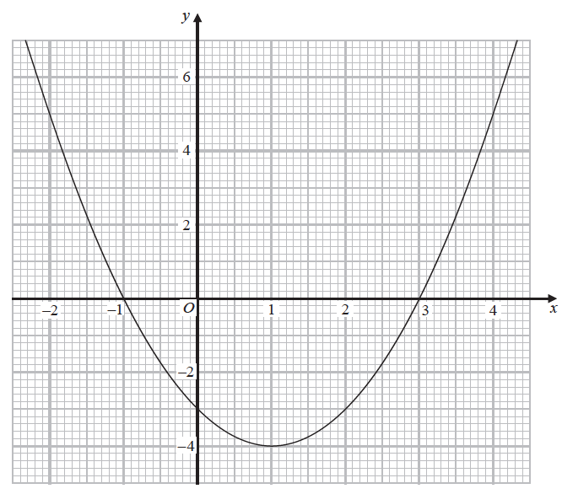

(a) Write down the coordinates of the turning point on the graph of y = x² – 2x – 3

(....................... , .......................)
(1)
(b) Use the graph to find the roots of the equation x² – 2x – 3 = 0

..........................................................................................
(2)
(Total for Question 29 is 3 marks)
TOTAL FOR PAPER IS 80 MARKS

