Instructions
- Use black ink or ball-point pen.
  - Fill in the boxes at the top of this page with your name,
centre number and candidate number.
- Answer all questions.
- Answer the questions in the spaces provided
– there may be more space than you need.
- You must show all your working.
- Diagrams are NOT accurately drawn, unless otherwise indicated.
- Calculators may not be used.
Information
- The total mark for this paper is 80.
- The marks for each question are shown in brackets
– use this as a guide as to how much time to spend on each question.
Advice
- Read each question carefully before you start to answer it.
- Keep an eye on the time.
- Try to answer every question.
- Check your answers if you have time at the end.
Answer ALL questions.
Write your answers in the spaces provided.
You must write down all the stages in your working.

1 There are only blue cubes, red cubes and yellow cubes in a box.
The table shows the probability of taking at random a blue cube from the box.

Colour | blue | red | yellow
Probability | 0.2

The number of red cubes in the box is the same as the number of yellow cubes in the box.
(a) Complete the table.

(2)

There are 12 blue cubes in the box.
(b) Work out the total number of cubes in the box.

.......................................................
(2)
(Total for Question 1 is 4 marks)
___________________________________________________________________________

2 Deon needs 50 g of sugar to make 15 biscuits.
She also needs
three times as much flour as sugar
two times as much butter as sugar
Deon is going to make 60 biscuits.
(a) Work out the amount of flour she needs.

....................................................... g
(3)

Deon has to buy all the butter she needs to make 60 biscuits.
She buys the butter in 250 g packs.
(b) How many packs of butter does Deon need to buy?

.......................................................
(2)
(Total for Question 2 is 5 marks)
___________________________________________________________________________

3 Find the highest common factor (HCF) of 72 and 90

.......................................................
(Total for Question 3 is 2 marks)
___________________________________________________________________________

4 The diagram shows the plan, front elevation and side elevation of a solid shape, drawn
on a centimetre grid.

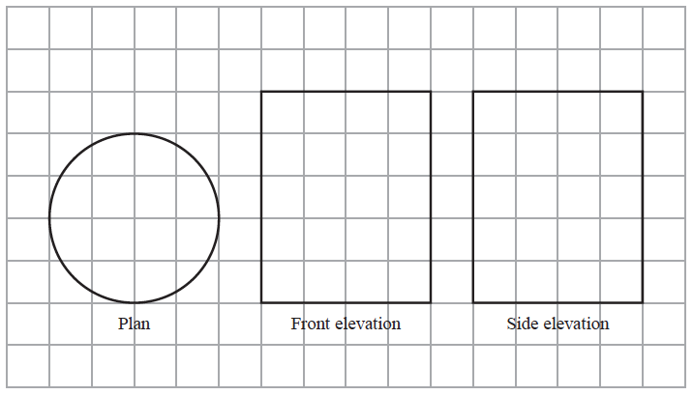

In the space below, draw a sketch of the solid shape.
Give the dimensions of the solid on your sketch.

(Total for Question 4 is 2 marks)
___________________________________________________________________________

5
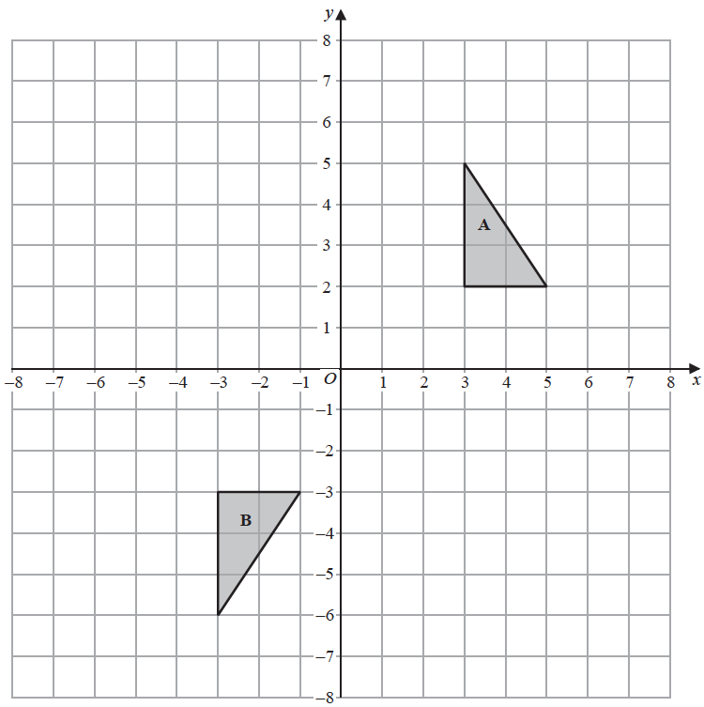
Shape A can be transformed to shape B by a reflection in the x-axis followed by a
translation
Find the value of c and the value of d.

c = .......................................................

d = .......................................................
(Total for Question 5 is 3 marks)
___________________________________________________________________________

6 A shop sells packs of black pens, packs of red pens and packs of green pens.
There are
2 pens in each pack of black pens
5 pens in each pack of red pens
6 pens in each pack of green pens
On Monday,
number of packs  of black pens sold | : | number of packs  of red pens sold | : | number of packs  of green pens sold | = 7 : 3 : 4

A total of 212 pens were sold.
Work out the number of green pens sold.

.......................................................
(Total for Question 6 is 4 marks)
___________________________________________________________________________

7 Here are two rectangles.

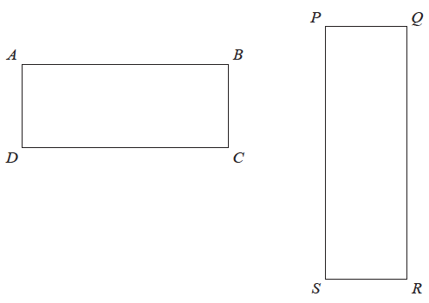

QR = 10 cm
BC = PQ
The perimeter of ABCD is 26 cm
The area of PQRS is 45 cm²
Find the length of AB.

....................................................... cm
(Total for Question 7 is 4 marks)
___________________________________________________________________________

8 (a) Work out an estimate for the value of

.......................................................
(2)

(2.3)⁶ = 148 correct to 3 significant figures.
(b) Find the value of (0.23)⁶ correct to 3 significant figures.

.......................................................
(1)
(c) Find the value of 5^{–2}

.......................................................
(1)
(Total for Question 8 is 4 marks)
___________________________________________________________________________

9 Work out
Give your answer as a mixed number in its simplest form.

.......................................................
(Total for Question 9 is 3 marks)
___________________________________________________________________________

10 The graphs with equations 3y + 2x = and 2y – 3x = have been drawn on the
grid below.

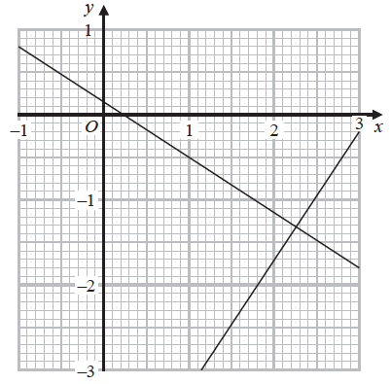

Using the graphs, find estimates of the solutions of the simultaneous equations
3y + 2x =
2y − 3x =

x = .......................................................
y = .......................................................
(Total for Question 10 is 2 marks)
___________________________________________________________________________

11 A bus company recorded the ages, in years, of the people on coach A and the people
on coach B.
Here are the ages of the 23 people on coach A.
41 | 42 | 44 | 48 | 52 | 53 | 53 | 53 | 56 | 57 | 57 | 59
60 | 61 | 63 | 64 | 64 | 66 | 67 | 69 | 74 | 77 | 79

(a) Complete the table below to show information about the ages of the people on coach A.

Median
Lower quartile
Upper quartile
Least age | 41
Greatest age | 79
(2)

Here is some information about the ages of the people on coach B.
Median | 70
Lower quartile | 54
Upper quartile | 73
Least age | 42
Greatest age | 85

Richard says that the people on coach A are younger than the people on coach B.
(b) Is Richard correct?
You must give a reason for your answer.
......................................................................................................................................................
......................................................................................................................................................
......................................................................................................................................................
(1)

Richard says that the people on coach A vary more in age than the people on coach B.
(c) Is Richard correct?
You must give a reason for your answer.
......................................................................................................................................................
......................................................................................................................................................
......................................................................................................................................................
(1)
(Total for Question 11 is 4 marks)
___________________________________________________________________________

12 Here are three spheres.

The volume of sphere Q is 50% more than the volume of sphere P.
The volume of sphere R is 50% more than the volume of sphere Q.
Find the volume of sphere P as a fraction of the volume of sphere R.

.......................................................
(Total for Question 12 is 3 marks)
___________________________________________________________________________

13 Given that n can be any integer such that n > 1, prove that n² – n is never an odd number.

(Total for Question 13 is 2 marks)
___________________________________________________________________________

14 Find the exact value of tan 30° × sin 60°
Give your answer in its simplest form.

.......................................................
(Total for Question 14 is 2 marks)
___________________________________________________________________________

15 The diagram shows a solid shape.
The shape is a cone on top of a hemisphere.

The height of the cone is 10 cm.
The base of the cone has a diameter of 6 cm.
The hemisphere has a diameter of 6 cm.
The total volume of the shape is k π cm³, where k is an integer.
Work out the value of k.

k = .......................................................
(Total for Question 15 is 4 marks)
___________________________________________________________________________

16 There are three dials on a combination lock.
Each dial can be set to one of the numbers 1, 2, 3, 4, 5
The three digit number 553 is one way the dials can be set, as shown in the diagram.

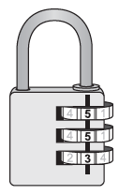

(a) Work out the number of different three digit numbers that can be set for the
combination lock.

.......................................................
(2)
(b) How many of the possible three digit numbers have three different digits?

.......................................................
(2)
(Total for Question 16 is 4 marks)
___________________________________________________________________________

17 Given that
x² : (3x + 5) = 1 : 2
find the possible values of x.

.................................................................................
(Total for Question 17 is 4 marks)
___________________________________________________________________________

18 (a) Express in the form where a is an integer.

.......................................................
(2)
(b) Express in the form where b and c are integers.

.......................................................
(3)
(Total for Question 18 is 5 marks)
___________________________________________________________________________

19 Given that x² – 6x + 1 = (x – a)² – b for all values of x,
(i) find the value of a and the value of b.

a = .......................................................

b = .......................................................
(2)
(ii) Hence write down the coordinates of the turning point on the graph of y = x² – 6x + 1

(............................ , ............................)
(1)
(Total for Question 19 is 3 marks)
___________________________________________________________________________

20 h is inversely proportional to p
p is directly proportional to
Given that h = 10 and t = 144 when p = 6
find a formula for h in terms of t

.................................................................................
(Total for Question 20 is 4 marks)
___________________________________________________________________________

21 The functions f and g are such that
f(x) = 3x – 1 and g(x) = x² + 4
(a) Find f ^{–1}(x)

f ^{–1}(x) = .......................................................
(2)

Given that fg(x) = 2gf(x),
(b) show that 15x² – 12x – 1 = 0

(5)
(Total for Question 21 is 7 marks)
___________________________________________________________________________

22 There are only r red counters and g green counters in a bag.
A counter is taken at random from the bag.
The probability that the counter is green is
The counter is put back in the bag.
2 more red counters and 3 more green counters are put in the bag.
A counter is taken at random from the bag.
The probability that the counter is green is
Find the number of red counters and the number of green counters that were in the bag originally.

red counters.......................................................

green counters.......................................................
(Total for Question 22 is 5 marks)
TOTAL FOR PAPER IS 80 MARKS

