Instructions
- Use black ink or ball-point pen.
  - Fill in the boxes at the top of this page with your name,
centre number and candidate number.
- Answer all questions.
- Answer the questions in the spaces provided
– there may be more space than you need.
- You must show all your working.
- Diagrams are NOT accurately drawn, unless otherwise indicated.
- Calculators may be used.
- If your calculator does not have a π button, take the value of π to be
3.142 unless the question instructs otherwise.
Information
- The total mark for this paper is 80.
- The marks for each question are shown in brackets
– use this as a guide as to how much time to spend on each question.
Advice
- Read each question carefully before you start to answer it.
- Keep an eye on the time.
- Try to answer every question.
- Check your answers if you have time at the end.

Answer ALL questions.
Write your answers in the spaces provided.
You must write down all the stages in your working.

1 Write 0.75 as a fraction.

.......................................................
(Total for Question 1 is 1 mark)
___________________________________________________________________________

2 Write the following numbers in order of size.
Start with the smallest number.
–3 | 4 | 0 | –1 | 2

.............................................................................................................
(Total for Question 2 is 1 mark)
___________________________________________________________________________

3 Write down two factors of 15

.......................................................
(Total for Question 3 is 1 mark)
___________________________________________________________________________

4 Change 1756 grams to kilograms.

.......................................................kg
(Total for Question 4 is 1 mark)
___________________________________________________________________________

5 Write the number two million in figures.

.......................................................
(Total for Question 5 is 1 mark)
___________________________________________________________________________

6 Dave goes into a cafe and buys 2 cups of coffee and a piece of cake.
Each cup of coffee costs £2.75
The cake costs £2.90
Dave pays with a £10 note.
He thinks he will get more than £1.50 in change.
Is Dave correct?
You must show how you get your answer.

(Total for Question 6 is 3 marks)
___________________________________________________________________________

7 There are y boats on a lake.
There are 7 people in each boat.
Write an expression, in terms of y, for the total number of people in the boats.

.......................................................
(Total for Question 7 is 1 mark)
___________________________________________________________________________

8 (a) Simplify a × b × 7

.......................................................
(1)
(b) Simplify y × y × y

.......................................................
(1)
(c) Simplify fully

.......................................................
(2)
(Total for Question 8 is 4 marks)
___________________________________________________________________________

9 The pictogram shows information about the number of vinyl records sold in a shop on
Monday and on Tuesday.

Monday |  |  | Key:  represents  8 vinyl records
Tuesday
Wednesday
Thursday

(a) Write down the number of vinyl records sold
(i) on Monday,

.......................................................
(1)
(ii) on Tuesday.

.......................................................
(1)

On Wednesday and Thursday a total of 36 vinyl records were sold.
The number of records sold on Thursday was 8 times the number of records sold on
Wednesday.
(b) Use this information to complete the pictogram.

(3)
(Total for Question 9 is 5 marks)
___________________________________________________________________________

10 Here are three symbols.

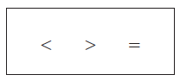

Write one of these symbols in each box to make four true statements.

14 |  |  |  | 21
4 + 7 |  |  |  | 103 − 92
2² |  |  |  | 2 × 2
−3 |  |  |  | −5

(Total for Question 10 is 2 marks)
___________________________________________________________________________

11 P = 7r + 3q
Work out the value of P when r = 5 and q = –4

.......................................................
(Total for Question 11 is 2 marks)
___________________________________________________________________________

12 Here is part of a train timetable.

Brighton | 07 22 | 07 29 | 07 32
London | 09 00 | 08 32 | 08 48

Graham gets to the station in Brighton at 07 15
(a) Work out how many minutes he has to wait until 07 22

....................................................... minutes
(1)
(b) Work out how long it will take the 07 22 train to get to London.

.......................................................................................
(2)
(Total for Question 12 is 3 marks)
___________________________________________________________________________

13 The diagram shows nine identical squares inside a rectangle.

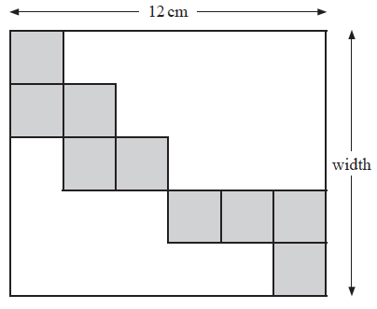

The length of the rectangle is 12 cm.
Work out the width of the rectangle.

.......................................................cm
(Total for Question 13 is 3 marks)
___________________________________________________________________________

14 Write the ratio 4.5 : 2.25 in the form n : 1

.......................................................
(Total for Question 14 is 1 mark)
___________________________________________________________________________
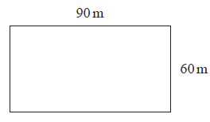
15 A garden is in the shape of a rectangle 90 m by 60 m.
Flowers are grown in 40% of the garden.
The rest of the garden is grass.
Work out the area of the garden that is grass.

.......................................................m²
(Total for Question 15 is 4 marks)
___________________________________________________________________________

16 Four biased coins, A, B, C and D are thrown.
The probability that each coin will land on Heads is shown in the table.

Coin | Probability
A | 0.33
B | 0.033
C
D | 30%

(a) (i) Which coin is least likely to land on Heads?

.......................................................
(1)
(ii) Which coin is most likely to land on Heads?

.......................................................
(1)

Julie says,
“The probability that coin C will land on Heads is the same as the probability that
coin C will land on Tails.”
(b) Is she correct?
Give a reason for your answer.
......................................................................................................................................................
......................................................................................................................................................
......................................................................................................................................................
(1)

Coin B is going to be thrown 4000 times.
(c) Work out an estimate for the number of times coin B will land on Heads.

.......................................................
(2)
(Total for Question 16 is 5 marks)
___________________________________________________________________________

17 There are 84 calories in 100 g of banana.
There are 87 calories in 100 g of yogurt.
Priti has 60 g of banana and 150 g of yogurt for breakfast.
Work out the total number of calories in this breakfast.

.......................................................
(Total for Question 17 is 4 marks)
___________________________________________________________________________

18 Machine A and machine B both make car parts.
Machine A makes 6 parts every 10 minutes.
Machine B makes 13 parts every 15 minutes.
On Monday
machine A makes parts for 12 hours
machine B makes parts for 10 hours
Work out the total number of parts made by the two machines on Monday.

.......................................................
(Total for Question 18 is 4 marks)
___________________________________________________________________________

19 Here is a plan of a kitchen drawn to a scale of 1 : 30

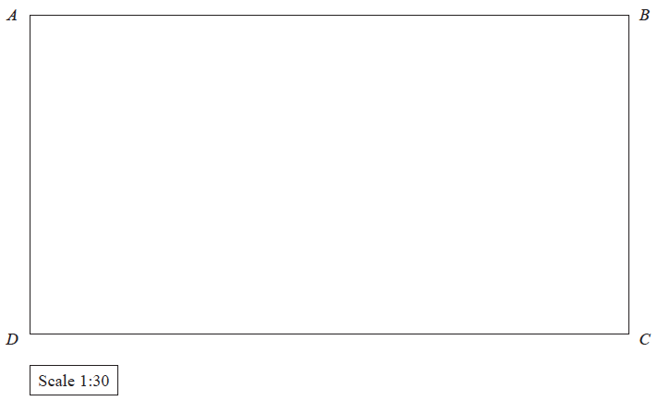

Sam is going to put a small table in the kitchen.
The table has to be
more than 180 cm from A
more than 150 cm from BC
Show, by shading on the diagram, the region where Sam can put the table.

(Total for Question 19 is 4 marks)
___________________________________________________________________________

20 (a) Solve 14n > 11n + 6

.......................................................
(2)
(b) On the number line below, show the set of values of x for which –2 < x + 3 ⩽ 4

(3)
(Total for Question 20 is 5 marks)
___________________________________________________________________________

21 On the grid below, draw the graph of y = 2x – 3 for values of x from –2 to 4

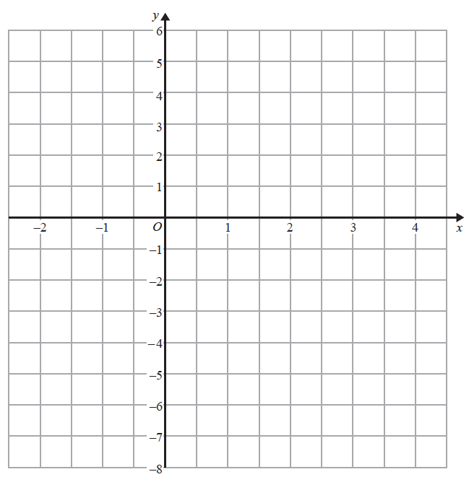

(Total for Question 21 is 3 marks)
___________________________________________________________________________

22 Hannah is planning a day trip for 195 students.
She asks a sample of 30 students where they want to go.
Each student chooses one place.
The table shows information about her results.

Place | Number of students
Theme Park | 10
Theatre | 5
Sports Centre | 8
Seaside | 7

(i) Work out how many of the 195 students you think will want to go to the Theme Park.

.......................................................
(2)
(ii) State any assumption you made and explain how this may affect your answer.
......................................................................................................................................................
......................................................................................................................................................
......................................................................................................................................................
(1)
(Total for Question 22 is 3 marks)
___________________________________________________________________________

23 A container is in the shape of a cuboid.

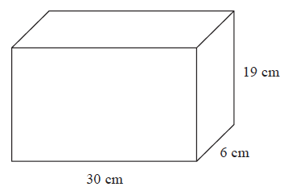

The container is full of water.
A cup holds 275 ml of water.
What is the greatest number of cups that can be completely filled with water from the container?

.......................................................
(Total for Question 23 is 4 marks)
___________________________________________________________________________

24 ABC is a right-angled triangle.

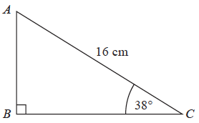

Calculate the length of AB.
Give your answer correct to 2 decimal places.

.......................................................cm
(Total for Question 24 is 2 marks)
___________________________________________________________________________

25 Sally used her calculator to work out the value of a number y.
The answer on her calculator display began
8.3
Complete the error interval for y.

............................ ⩽ y < ...........................
(Total for Question 25 is 2 marks)
___________________________________________________________________________

26 £360 is shared between Abby, Ben, Chloe and Denesh.
The ratio of the amount Abby gets to the amount Ben gets is 2 : 7
Chloe and Denesh each get 1.5 times the amount Abby gets.
Work out the amount of money that Ben gets.

£.......................................................
(Total for Question 26 is 4 marks)
___________________________________________________________________________

27 (a) Write 0.00562 in standard form.

.......................................................
(1)
(b) Write 1.452 × 10³ as an ordinary number.

.......................................................
(1)
(Total for Question 27 is 2 marks)
___________________________________________________________________________

28 Here are the first five terms of a Fibonacci sequence.

3 | 3 | 6 | 9 | 15

(a) Write down the next two terms of the sequence.

............................ , ............................
(1)

The first three terms of a different Fibonacci sequence are

a | a | 2a

(b) Find the 6th term of this sequence.

.......................................................
(2)
(Total for Question 28 is 3 marks)
___________________________________________________________________________

29 a = $\left(\begin{matrix}4 \\ 5\end{matrix}\right)$ b = $\left(\begin{matrix}3 \\ 2\end{matrix}\right)$

Work out a − 2b as a column vector.

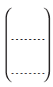

(Total for Question 29 is 2 marks)
TOTAL FOR PAPER IS 80 MARKS

