Instructions
- Use black ink or ball-point pen.
  - Fill in the boxes at the top of this page with your name,
centre number and candidate number.
- Answer all questions.
- Answer the questions in the spaces provided
– there may be more space than you need.
- You must show all your working.
- Diagrams are NOT accurately drawn, unless otherwise indicated.
- Calculators may be used.
- If your calculator does not have a π button, take the value of π to be
3.142 unless the question instructs otherwise.
Information
- The total mark for this paper is 80.
- The marks for each question are shown in brackets
– use this as a guide as to how much time to spend on each question.
Advice
- Read each question carefully before you start to answer it.
- Keep an eye on the time.
- Try to answer every question.
- Check your answers if you have time at the end.
Answer ALL questions.
Write your answers in the spaces provided.
You must write down all the stages in your working.

1 (a) Solve 14n > 11n + 6

.......................................................
(2)
(b) On the number line below, show the set of values of x for which –2 < x + 3 ⩽ 4

(3)
(Total for Question 1 is 5 marks)
___________________________________________________________________________

2 On the grid below, draw the graph of y = 2x – 3 for values of x from –2 to 4

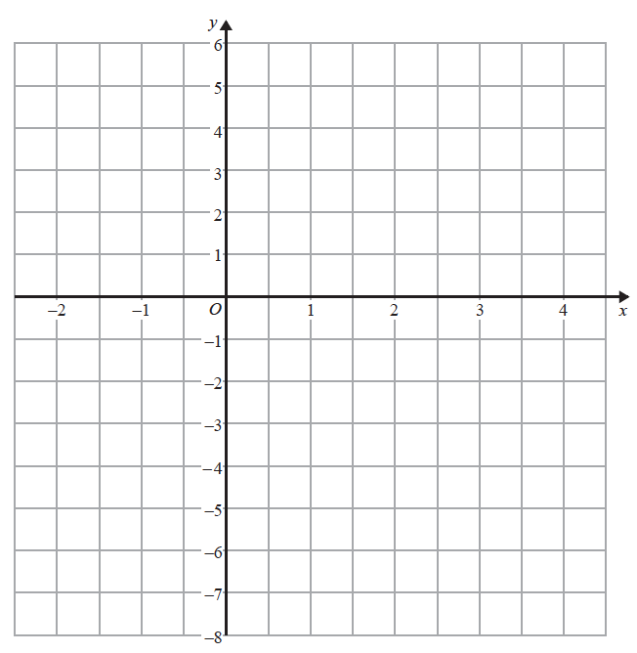

(Total for Question 2 is 3 marks)
___________________________________________________________________________

3 Hannah is planning a day trip for 195 students.
She asks a sample of 30 students where they want to go.
Each student chooses one place.
The table shows information about her results.

Place | Number of students
Theme Park | 10
Theatre | 5
Sports Centre | 8
Seaside | 7

(i) Work out how many of the 195 students you think will want to go to the Theme Park.

.......................................................
(2)
(ii) State any assumption you made and explain how this may affect your answer.
......................................................................................................................................................
......................................................................................................................................................
......................................................................................................................................................
(1)
(Total for Question 3 is 3 marks)
___________________________________________________________________________

4 A container is in the shape of a cuboid.

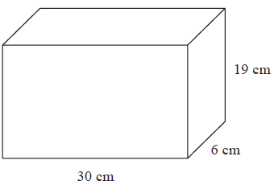

The container is full of water.
A cup holds 275 ml of water.
What is the greatest number of cups that can be completely filled with water from the container?

.......................................................
(Total for Question 4 is 4 marks)
___________________________________________________________________________

5 ABC is a right-angled triangle.

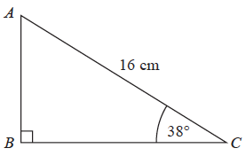

Calculate the length of AB.
Give your answer correct to 2 decimal places.

.......................................................cm
(Total for Question 5 is 2 marks)
___________________________________________________________________________

6 Sally used her calculator to work out the value of a number y.
The answer on her calculator display began
8.3
Complete the error interval for y.

............................ ⩽ y < ............................
(Total for Question 6 is 2 marks)
___________________________________________________________________________

7 £360 is shared between Abby, Ben, Chloe and Denesh.
The ratio of the amount Abby gets to the amount Ben gets is 2 : 7
Chloe and Denesh each get 1.5 times the amount Abby gets.
Work out the amount of money that Ben gets.

£.......................................................
(Total for Question 7 is 4 marks)
___________________________________________________________________________

8 (a) Write 0.00562 in standard form.

.......................................................
(1)
(b) Write 1.452 × 10³ as an ordinary number.

.......................................................
(1)
(Total for Question 8 is 2 marks)
___________________________________________________________________________

9 The circumference of circle B is 90% of the circumference of circle A.
(a) Find the ratio of the area of circle A to the area of circle B.

.......................................................
(2)

Square E has sides of length e cm.
Square F has sides of length f cm.
The area of square E is 44% greater than the area of square F.
(b) Work out the ratio e : f

.......................................................
(2)
(Total for Question 9 is 4 marks)
___________________________________________________________________________

10 Mary travels to work by train every day.
The probability that her train will be late on any day is 0.15
(a) Complete the probability tree diagram for Thursday and Friday.

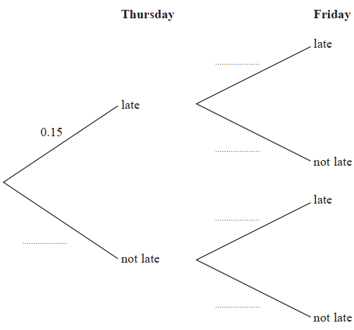
(2)
(b) Work out the probability that her train will be late on at least one of these two days.

.......................................................
(3)
(Total for Question 10 is 5 marks)
___________________________________________________________________________

11 The grouped frequency table gives information about the times, in minutes, that 80 office
workers take to get to work.

Time (t minutes) | Frequency
0 < t ⩽ 20 | 5
20 < t ⩽ 40 | 30
40 < t ⩽ 60 | 20
60 < t ⩽ 80 | 15
80 < t ⩽ 100 | 8
100 < t ⩽ 120 | 2

(a) Complete the cumulative frequency table.

Time (t minutes) | Cumulative frequency
0 < t ⩽ 20
0 < t ⩽ 40
0 < t ⩽ 60
0 < t ⩽ 80
0 < t ⩽ 100
0 < t ⩽ 120

(1)
(b) On the grid, draw the cumulative frequency graph for this information.

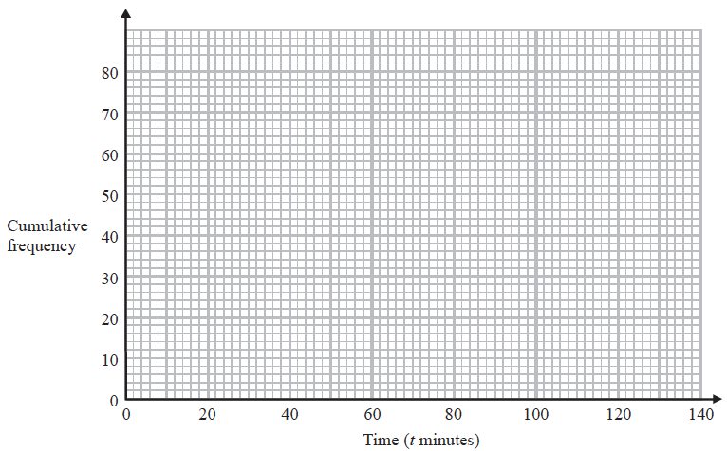
(2)
(c) Use your graph to find an estimate for the percentage of these office workers who
take more than 90 minutes to get to work.

.......................................................%
(3)
(Total for Question 11 is 6 marks)
___________________________________________________________________________

12 OAB is a sector of a circle with centre O and radius 7 cm.

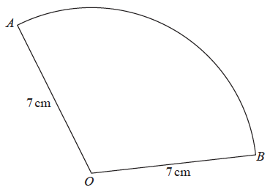

The area of the sector is 40 cm²
Calculate the perimeter of the sector.
Give your answer correct to 3 significant figures.

................................................ cm
(Total for Question 12 is 4 marks)
___________________________________________________________________________

13 Show that 6 + simplifies to where a, b, c and d are integers.

(Total for Question 13 is 4 marks)
___________________________________________________________________________

14 A car moves from rest.
The graph gives information about the speed, v metres per second, of the car t seconds
after it starts to move.

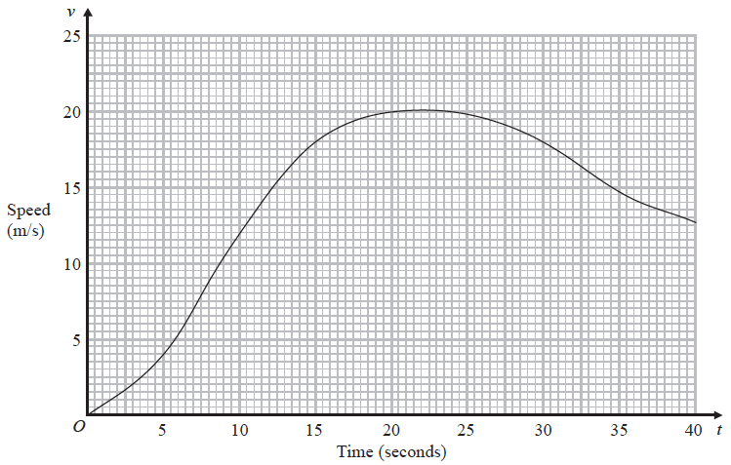

(a) (i) Calculate an estimate of the gradient of the graph at t = 15

.......................................................
(3)
(ii) Describe what your answer to part (i) represents.
......................................................................................................................................................
(1)
(b) Work out an estimate for the distance the car travels in the first 20 seconds of its journey.
Use 4 strips of equal width.

.......................................................m
(3)
(Total for Question 14 is 7 marks)
___________________________________________________________________________

15 Make m the subject of the formula f =

.......................................................
(Total for Question 15 is 3 marks)
___________________________________________________________________________

16 The straight line L has the equation 3y = 4x + 7
The point A has coordinates (3, −5)
Find an equation of the straight line that is perpendicular to L and passes through A.

..................................................................................
(Total for Question 16 is 3 marks)
___________________________________________________________________________

17 There are some small cubes and some large cubes in a bag.
The cubes are red or the cubes are yellow.
The ratio of the number of small cubes to the number of large cubes is 4 : 7
The ratio of the number of red cubes to the number of yellow cubes is 3 : 5
(a) Explain why the least possible number of cubes in the bag is 88
......................................................................................................................................................
......................................................................................................................................................
......................................................................................................................................................
(1)

All the small cubes are yellow.
(b) Work out the least possible number of large yellow cubes in the bag.

.......................................................
(3)
(Total for Question 17 is 4 marks)
___________________________________________________________________________

18 The points A, B, C and D lie on a circle.
CDE is a straight line.

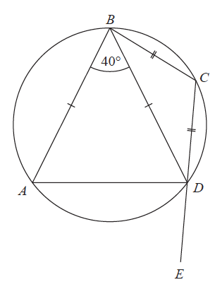

BA = BD
CB = CD
Angle ABD = 40°
Work out the size of angle ADE.
You must give a reason for each stage of your working.

(Total for Question 18 is 5 marks)
___________________________________________________________________________

19 The diagram shows a triangular prism.

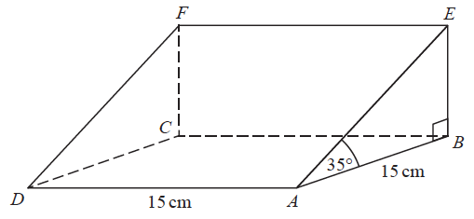

The base, ABCD, of the prism is a square of side length 15 cm.
Angle ABE and angle CBE are right angles.
Angle EAB = 35°
M is the point on DA such that
DM : MA = 2 : 3
Calculate the size of the angle between EM and the base of the prism.
Give your answer correct to 1 decimal place.

....................................................... °
(Total for Question 19 is 4 marks)
___________________________________________________________________________

20 CDEF is a quadrilateral.

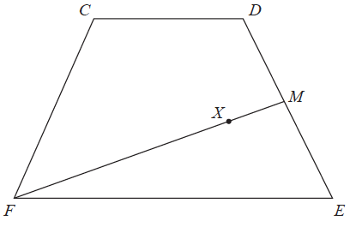

= a, = b and = a – b.
(a) Express in terms of a and/or b.
Give your answer in its simplest form.

.......................................................
(2)

M is the midpoint of DE.
X is the point on FM such that FX : XM = n : 1
CXE is a straight line.
(b) Work out the value of n.

n = .......................................................
(4)
(Total for Question 20 is 6 marks)
TOTAL FOR PAPER IS 80 MARKS

