Instructions
- Use black ink or ball-point pen.
  - Fill in the boxes at the top of this page with your name,
centre number and candidate number.
- Answer all questions.
- Answer the questions in the spaces provided
– there may be more space than you need.
- You must show all your working.
- Diagrams are NOT accurately drawn, unless otherwise indicated.
- Calculators may be used.
- If your calculator does not have a π button, take the value of π to be 3.142 unless
the question instructs otherwise.
Information
- The total mark for this paper is 80.
- The marks for each question are shown in brackets
– use this as a guide as to how much time to spend on each question.
Advice
- Read each question carefully before you start to answer it.
- Keep an eye on the time.
- Try to answer every question.
- Check your answers if you have time at the end.
Answer ALL questions.
Write your answers in the spaces provided.
You must write down all the stages in your working.

1 Write 478 to the nearest hundred.

.......................................................
(Total for Question 1 is 1 mark)
___________________________________________________________________________

2 Write down a multiple of 8 that is between 41 and 60

.......................................................
(Total for Question 2 is 1 mark)
___________________________________________________________________________

3 Change 1.5 kilometres to metres.

....................................................... metres
(Total for Question 3 is 1 mark)
___________________________________________________________________________

4 Here is a list of numbers.

4 | 6 | 9 | 10 | 15 | 27 | 30 | 40

From the list, write down all the numbers that are powers of 3

.................................................................................
(Total for Question 4 is 1 mark)
___________________________________________________________________________

5 Write 19% as a fraction.

.......................................................
(Total for Question 5 is 1 mark)
___________________________________________________________________________

6 Work out 20% of 80

.......................................................
(Total for Question 6 is 2 marks)
___________________________________________________________________________

7 There are four types of counter in a bag.
The table shows the number of each type of counter in the bag.

Type of counter | red circle | green circle | red square | green square
Number of counters | 16 | 26 | 11 | 7

There are more green counters than red counters.
How many more?

.......................................................
(Total for Question 7 is 2 marks)
___________________________________________________________________________

8 Here is the gauge for the fuel tank of a car.

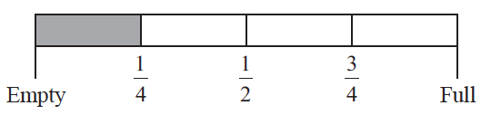

The fuel tank holds 52 litres of fuel when the tank is full.
The tank is full of fuel.
Work out how many more litres of fuel are needed to fill the tank.

....................................................... litres
(Total for Question 8 is 3 marks)
___________________________________________________________________________

9 Simplify 4e + 6f + 7e − f

.......................................................
(Total for Question 9 is 2 marks)
___________________________________________________________________________

10 Bill has 400 counters in a bag.
He gives
35 of the counters to Sameena
50 of the counters to Henry
75 of the counters to Lucas
What fraction of the 400 counters is left in Bill’s bag?
Give your fraction in its simplest form.

.......................................................
(Total for Question 10 is 3 marks)
___________________________________________________________________________

11 The table shows the costs of sending a parcel by the Express service and by the Rapid service.

Type of service | Cost
Express | £15.25
Rapid | £35.38

Brendan has to send 12 parcels.
It will be cheaper to send the parcels by the Express service than by the Rapid service.
(a) How much cheaper?

£.......................................................
(3)

Luke wants to send 21 parcels by the Express service.
He does the calculation 20 × £15 = £300 to estimate the cost.
(b) Explain why Luke’s calculation shows the actual cost will be more than £300
......................................................................................................................................................
......................................................................................................................................................
......................................................................................................................................................
(1)
(Total for Question 11 is 4 marks)
___________________________________________________________________________

12 Ali, Ben and Cathy share an amount of money in the ratio 6 : 9 : 10
What fraction of the money does Ben get?

.......................................................
(Total for Question 12 is 2 marks)
___________________________________________________________________________

13 The first term of a sequence of numbers is 24
The term-to-term rule of this sequence is ‘add 8’
Josie says,
“No number in this sequence is in the 5 times table.”
(a) Give an example to show that Josie is wrong.

.......................................................
(1)
(b) Is 85 a number in this sequence?
Give a reason for your answer.

......................................................................................................................................................
......................................................................................................................................................
(1)
(Total for Question 13 is 2 marks)
___________________________________________________________________________

14 Find the value of
Give your answer as a decimal.
Write down all the figures on your calculator display.

.............................................................................................................
(Total for Question 14 is 2 marks)
___________________________________________________________________________

15 You can use this rule to work out the total hire charge, in pounds (£),
for hiring a 3D printer for a number of weeks.

Total hire charge (£) = number of weeks × 70 + 50

Mia wants to hire a 3D printer for 4 weeks.
(a) Work out the total hire charge.

£.......................................................
(2)

Zahir hires a 3D printer.
The total hire charge is £680
(b) For how many weeks does Zahir hire the 3D printer?

....................................................... weeks
(2)
(Total for Question 15 is 4 marks)
___________________________________________________________________________

16 Here is a rectangle.

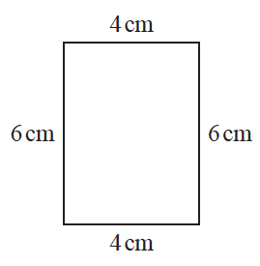

The 6-sided shape below is made from two of these rectangles.

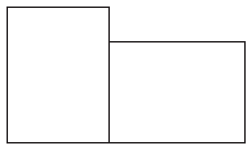

Work out the perimeter of this 6-sided shape.

....................................................... cm
(Total for Question 16 is 3 marks)
___________________________________________________________________________

17 The accurate scale diagram shows a telephone mast and a box.

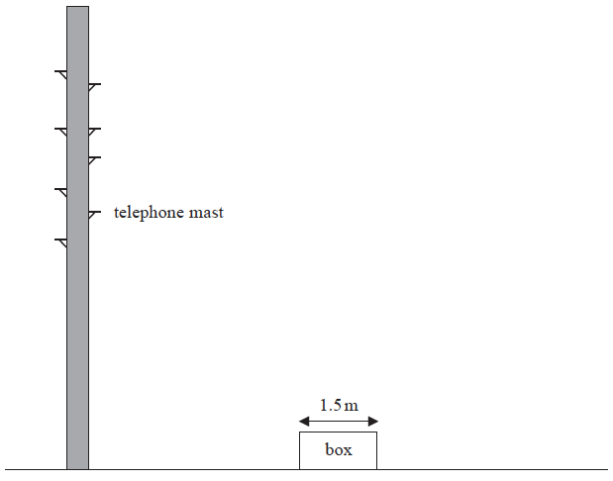

The box has a real width of 1.5 metres.
Find an estimate for the real height, in metres, of the telephone mast.

....................................................... metres
(Total for Question 17 is 2 marks)
___________________________________________________________________________

18 The table shows information about the numbers of points scored by 30 students in a quiz.

Number of points | Frequency
0 | 4
1 | 3
2 | 7
3 | 5
4 | 6
5 | 5

(a) Find the modal number of points.

.......................................................
(1)
(b) Work out the total number of points scored.

.......................................................
(2)
(Total for Question 18 is 3 marks)
___________________________________________________________________________

19 Make x the subject of the formula y = 2x + 4

...............................................................................................
(Total for Question 19 is 2 marks)
___________________________________________________________________________

20 The diagram shows a square ABDE and an equilateral triangle BCD.

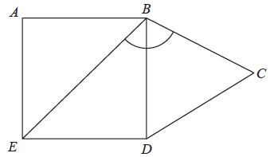

Work out the size of angle EBC.

.......................................................°
(Total for Question 20 is 2 marks)
___________________________________________________________________________

21 Liz goes on holiday to South Africa.
Liz wants to change £850 into South African rand.
She wants to get as many 200 rand notes as possible.
The exchange rate is £1 = 18.53 rand.
Work out the greatest number of 200 rand notes that Liz can get for £850

.......................................................
(Total for Question 21 is 3 marks)
___________________________________________________________________________

22 In October Sally drove 560 miles in her car.
The car travelled 34.5 miles for each gallon of petrol used.
Petrol cost £1.08 per litre.
1 gallon = 4.55 litres.
Work out the cost of the petrol the car used in October.

£.......................................................
(Total for Question 22 is 4 marks)
___________________________________________________________________________

23 Costcorp sells packets of mints to shop owners.
On Monday three shop owners buy mints from Costcorp.
Each shop owner buys small packets, medium packets and large packets of mints.
Alan buys 400 packets of mints.
32 % are small packets.
40 % are large packets.
Beryl buys 500 packets of mints.
are small packets.
are large packets.
Charlie buys 150 small packets of mints so that
number of small packets : number of medium packets = 3 : 4
Work out the total number of medium packets of mints these shop owners buy.
You must show all your working.

.......................................................
(Total for Question 23 is 5 marks)
___________________________________________________________________________

24 E = {1, 2, 3, 4, 5, 6, 7, 8, 9}
A = {1, 5, 6, 8, 9}
B = {2, 6, 9}

E
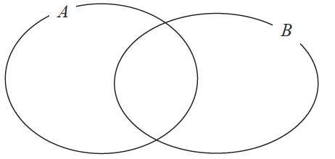

(a) Complete the Venn diagram to represent this information.
(3)

A number is chosen at random from the universal set E.
(b) Find the probability that the number is in the set A B

.......................................................
(2)
(Total for Question 24 is 5 marks)
___________________________________________________________________________

25 Katy invests £200 000 in a savings account for 4 years.
The account pays compound interest at a rate of 1.5 % per annum.
Calculate the total amount of interest Katy will get at the end of 4 years.

£.......................................................
(Total for Question 25 is 3 marks)
___________________________________________________________________________

26 The table shows information about the heights of 80 plants.

Height (h cm) | Frequency
10 < h ⩽ 20 | 7
20 < h ⩽ 30 | 13
30 < h ⩽ 40 | 14
40 < h ⩽ 50 | 12
50 < h ⩽ 60 | 16
60 < h ⩽ 70 | 18

(a) Find the class interval that contains the median.

..................................................................................
(1)
(b) On the grid, draw a frequency polygon for the information in the table.
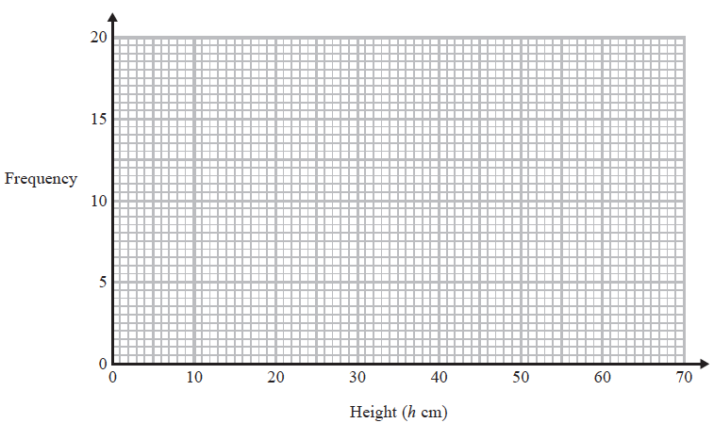
(2)
(Total for Question 26 is 3 marks)
___________________________________________________________________________

27 Sean has drawn a time series graph to show the numbers, in thousands, of visitors to a
fun park.

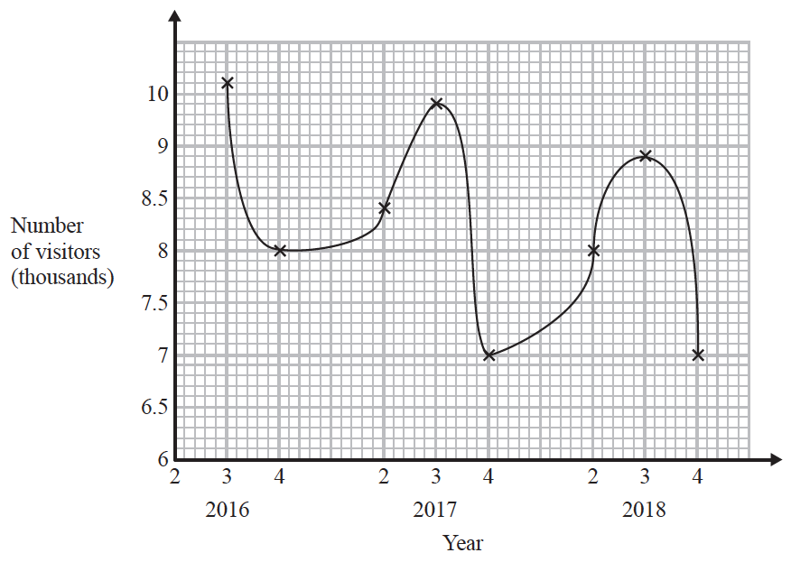

Write down two things that are wrong or could be misleading with this graph.

1 ...................................................................................................................................................
......................................................................................................................................................
......................................................................................................................................................
2 ...................................................................................................................................................
......................................................................................................................................................
......................................................................................................................................................
(Total for Question 27 is 2 marks)
___________________________________________________________________________

28 The diagram shows a hexagon.
The hexagon has one line of symmetry.

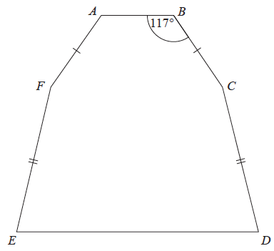

FA = BC
EF = CD
Angle ABC = 117°
Angle BCD = 2 × angle CDE
Work out the size of angle AFE.
You must show all your working.

.......................................................°
(Total for Question 28 is 4 marks)
___________________________________________________________________________

29 Jeremy has to cover 3 tanks completely with paint.
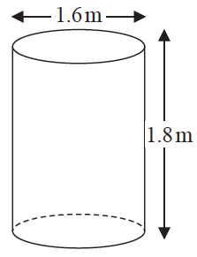
Each tank is in the shape of a cylinder with a top and a bottom.
The tank has a diameter of 1.6 m and a height of 1.8 m.
Jeremy has 7 tins of paint.
Each tin of paint covers 5 m²
Has Jeremy got enough paint to cover completely the 3 tanks?
You must show how you get your answer.

(Total for Question 29 is 5 marks)
___________________________________________________________________________

30 Solve the simultaneous equations

3x − 4y = 11
9x + 2y = 5

x = .......................................................
y = .......................................................
(Total for Question 30 is 3 marks)
TOTAL FOR PAPER IS 80 MARKS

