Instructions
- Use black ink or ball-point pen.
  - Fill in the boxes at the top of this page with your name,
centre number and candidate number.
- Answer all questions.
- Answer the questions in the spaces provided
– there may be more space than you need.
- You must show all your working.
- Diagrams are NOT accurately drawn, unless otherwise indicated.
- Calculators may be used.
- If your calculator does not have a π button, take the value of π to be
3.142 unless the question instructs otherwise.
Information
- The total mark for this paper is 80.
- The marks for each question are shown in brackets
– use this as a guide as to how much time to spend on each question.
Advice
- Read each question carefully before you start to answer it.
- Keep an eye on the time.
- Try to answer every question.
- Check your answers if you have time at the end.
Answer ALL questions.
Write your answers in the spaces provided.
You must write down all the stages in your working.

1 E = {1, 2, 3, 4, 5, 6, 7, 8, 9}
A = {1, 5, 6, 8, 9}
B = {2, 6, 9}

E
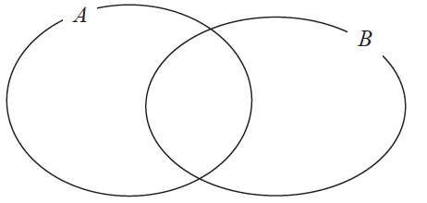

(a) Complete the Venn diagram to represent this information.
(3)

A number is chosen at random from the universal set E.
(b) Find the probability that the number is in the set A B

.......................................................
(2)
(Total for Question 1 is 5 marks)
___________________________________________________________________________

2 Katy invests £200 000 in a savings account for 4 years.
The account pays compound interest at a rate of 1.5 % per annum.
Calculate the total amount of interest Katy will get at the end of 4 years.

£.......................................................
(Total for Question 2 is 3 marks)
___________________________________________________________________________

3 The table shows information about the heights of 80 plants.

Height (h cm) | Frequency
10 < h ⩽ 20 | 7
20 < h ⩽ 30 | 13
30 < h ⩽ 40 | 14
40 < h ⩽ 50 | 12
50 < h ⩽ 60 | 16
60 < h ⩽ 70 | 18

(a) Find the class interval that contains the median.

..................................................................................
(1)
(b) On the grid, draw a frequency polygon for the information in the table.

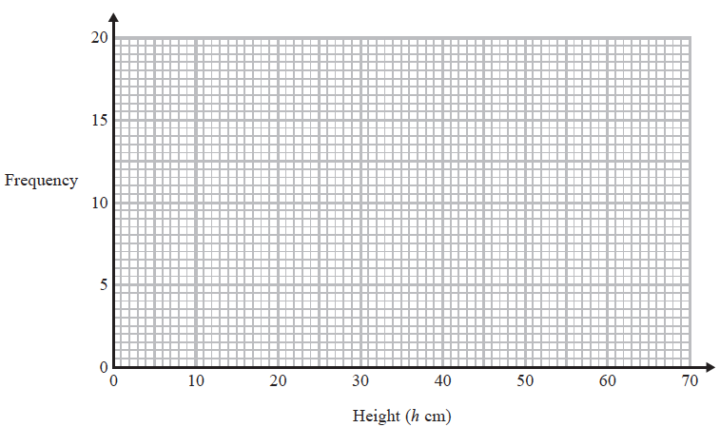
(2)
(Total for Question 3 is 3 marks)
___________________________________________________________________________

4 Sean has drawn a time series graph to show the numbers, in thousands, of visitors to a
fun park.

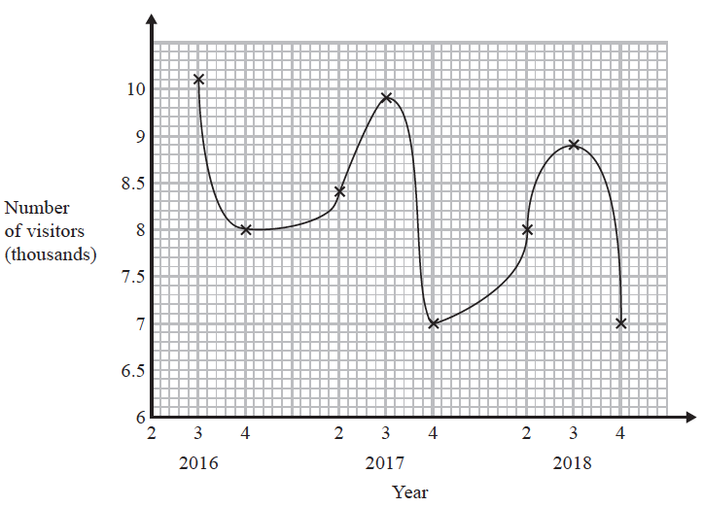

Write down two things that are wrong or could be misleading with this graph.
1 ...................................................................................................................................................
......................................................................................................................................................
......................................................................................................................................................
2 ...................................................................................................................................................
......................................................................................................................................................
......................................................................................................................................................
(Total for Question 4 is 2 marks)
___________________________________________________________________________

5 The diagram shows a hexagon.
The hexagon has one line of symmetry.

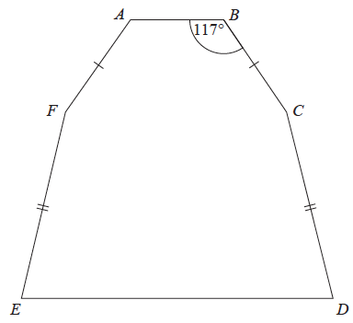

FA = BC
EF = CD
Angle ABC = 117°
Angle BCD = 2 × angle CDE
Work out the size of angle AFE.
You must show all your working.

.......................................................°
(Total for Question 5 is 4 marks)
___________________________________________________________________________

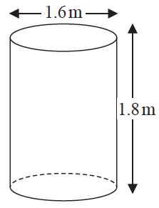
6 Jeremy has to cover 3 tanks completely with paint.
Each tank is in the shape of a cylinder with a top and a bottom.
The tank has a diameter of 1.6 m and a height of 1.8 m.
Jeremy has 7 tins of paint.
Each tin of paint covers 5 m²
Has Jeremy got enough paint to cover completely the 3 tanks?
You must show how you get your answer.

(Total for Question 6 is 5 marks)
___________________________________________________________________________

7 Work out
Give your answer correct to 3 significant figures.

.................................................................................
(Total for Question 7 is 2 marks)
___________________________________________________________________________

8 ABC is a right-angled triangle.

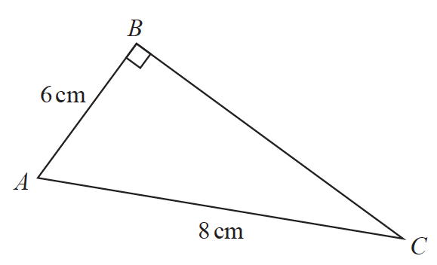
Here is Sarah’s method to find the length of BC.
BC ² = AB ² + AC ²
= 6² + 8²
= 100
BC = 10
(a) What mistake has Sarah made in her method?
......................................................................................................................................................
......................................................................................................................................................
......................................................................................................................................................
(1)

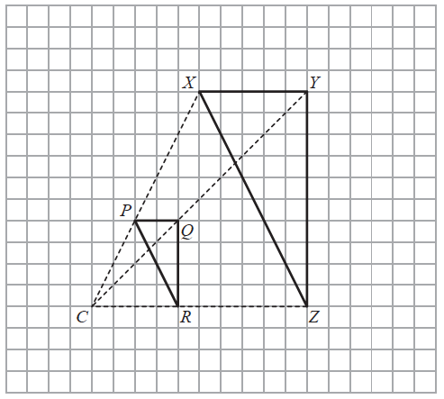

Roy is going to enlarge triangle PQR with centre C and scale factor 1
He draws triangle XYZ.
(b) Explain why Roy’s diagram is not correct.
......................................................................................................................................................
......................................................................................................................................................
......................................................................................................................................................
(1)
(Total for Question 8 is 2 marks)
___________________________________________________________________________

9 A company has to make a large number of boxes.
The company has 6 machines.
All the machines work at the same rate.
When all the machines are working, they can make all the boxes in 9 days.
The table gives the number of machines working each day.

 | day 1 | day 2 | day 3 | all other days
Number of machines working | 3 | 4 | 5 | 6

Work out the total number of days taken to make all the boxes.

.......................................................
(Total for Question 9 is 3 marks)
___________________________________________________________________________

10 Marie invests £8000 in an account for one year.
At the end of the year, interest is added to her account.
Marie pays tax on this interest at a rate of 20%
She pays £28.80 tax.
Work out the percentage interest rate for the account.

....................................................... %
(Total for Question 10 is 3 marks)
___________________________________________________________________________

11 In May 2019, the distance between Earth and Mars was 3.9 × 10⁷ km.
In May 2019, a signal was sent from Earth to Mars.
Assuming that the signal sent from Earth to Mars travelled at a speed of 3 × 10⁵ km per second,
(a) how long did the signal take to get to Mars?

....................................................... seconds
(2)

The speed of the signal sent from Earth to Mars in May 2019 was actually less than
3 × 10⁵ km per second.
(b) How will this affect your answer to part (a)?
......................................................................................................................................................
......................................................................................................................................................
......................................................................................................................................................
(1)
(Total for Question 11 is 3 marks)
___________________________________________________________________________

12 Patrick has to work out the exact value of
Patrick says,
“ of 64 is 16 so = 16 ”
Explain what is wrong with what Patrick says.
......................................................................................................................................................
......................................................................................................................................................
......................................................................................................................................................
(Total for Question 12 is 1 mark)
___________________________________________________________________________

13 The density of ethanol is 1.09 g/cm³
The density of propylene is 0.97 g/cm³
60 litres of ethanol are mixed with 128 litres of propylene to make 188 litres of antifreeze.
Work out the density of the antifreeze.
Give your answer correct to 2 decimal places.

....................................................... g/cm³
(Total for Question 13 is 4 marks)
___________________________________________________________________________

14 The diagram shows a rectangle, ABDE, and two congruent triangles, AFE and BCD.

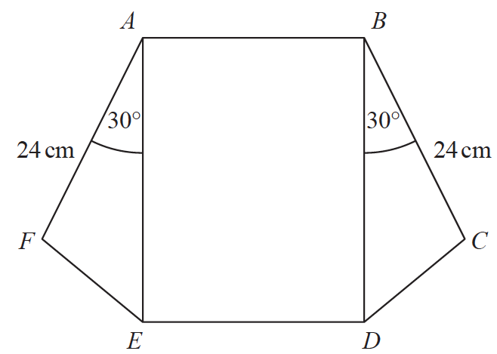

area of rectangle ABDE = area of triangle AFE + area of triangle BCD
AB : AE = 1 : 3
Work out the length of AE.

....................................................... cm
(Total for Question 14 is 4 marks)
___________________________________________________________________________

15 The graph of the curve C with equation y = f(x) is transformed to give the graph of
the curve S with equation y = f(−x) − 3
The point on C with coordinates (7, 2) is mapped to the point Q on S.
Find the coordinates of Q.

(............................ , ............................)
(Total for Question 15 is 2 marks)
___________________________________________________________________________

16 Here are the first six terms of a quadratic sequence.

−1 | 5 | 15 | 29 | 47 | 69

Find an expression, in terms of n, for the nth term of this sequence.

.......................................................
(Total for Question 16 is 3 marks)
___________________________________________________________________________

17 Here are four graphs.

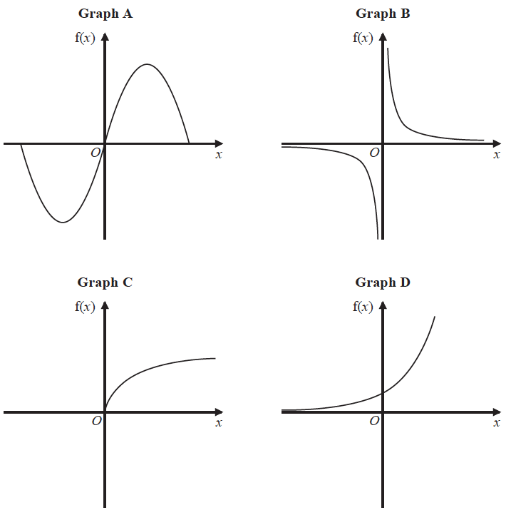

The graphs represent four different types of function f.
Match each description of the function in the table to the letter of its graph.

Description of function | Graph
f(x) is inversely proportional to x
f(x) is a trigonometrical function
f(x) is an exponential function
f(x) is directly proportional to

(Total for Question 17 is 2 marks)
___________________________________________________________________________

18 (a) Show that (2x + 1)(x + 3)(3x + 7) can be written in the form ax³ + bx² + cx + d,
where a, b, c and d are integers.

(3)
(b) Solve (1 – x)² <

.......................................................
(3)
(Total for Question 18 is 6 marks)
___________________________________________________________________________

19 D =
u = 26.2 correct to 3 significant figures
a = 4.3 correct to 2 significant figures
(a) Calculate the upper bound for the value of D.
Give your answer correct to 6 significant figures.
You must show all your working.

....................................................................
(3)

The lower bound for the value of D is 78.6003 correct to 6 significant figures.
(b) By considering bounds, write down the value of D to a suitable degree of accuracy.
You must give a reason for your answer.

......................................................................................................................................................
......................................................................................................................................................
(2)
(Total for Question 19 is 5 marks)
___________________________________________________________________________

20 Solve algebraically the simultaneous equations

x² − 4y² = 9
3x + 4y = 7

.....................................................................................................................................................
(Total for Question 20 is 5 marks)
___________________________________________________________________________
21 The histogram gives information about the distribution of the weights of some onions
grown by a farmer.

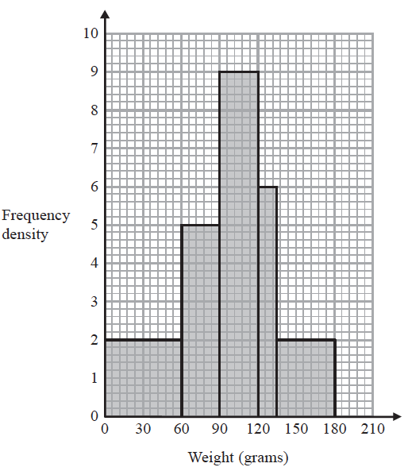

Onions less than 60 grams in weight are used for pickling.
Onions greater than 120 grams in weight are sold at the market.
The rest of the onions are sent to a food processing factory.

A pie chart is drawn using the information opposite to show what the farmer does with
the onions he grows.

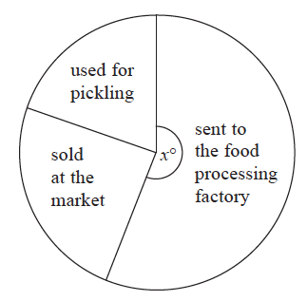

The angle of the sector for the onions sent to the food processing factory is x°.
Work out the value of x.

x = .......................................................
(Total for Question 21 is 4 marks)
___________________________________________________________________________

22 The diagram shows a circle, centre O.

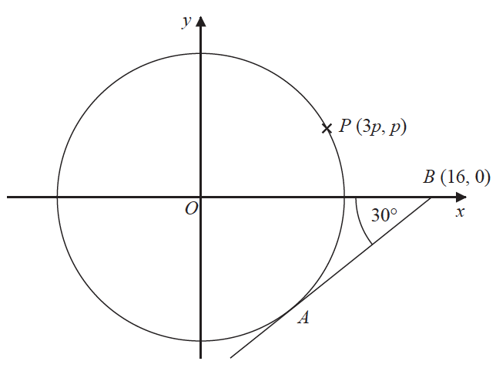

AB is the tangent to the circle at the point A.
Angle OBA = 30°
Point B has coordinates (16, 0)
Point P has coordinates (3p, p)
Find the value of p.
Give your answer correct to 1 decimal place.
You must show all your working.

p = .......................................................
(Total for Question 22 is 4 marks)
___________________________________________________________________________

23 The diagram shows the positions of three towns, Acton (A), Barston (B) and Chorlton (C).

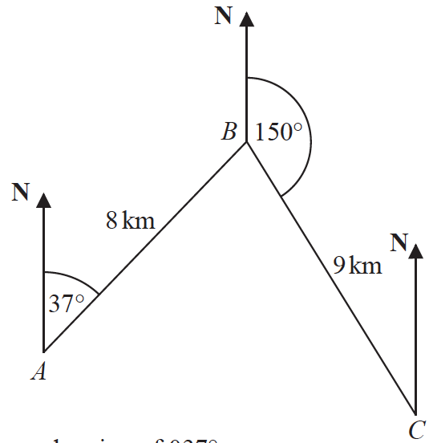


Barston is 8 km from Acton on a bearing of 037°
Chorlton is 9 km from Barston on a bearing of 150°
Find the bearing of Chorlton from Acton.
Give your answer correct to 1 decimal place.
You must show all your working.

.......................................................°
(Total for Question 23 is 5 marks)

TOTAL FOR PAPER IS 80 MARKS

