Answer ALL questions.
Write your answers in the spaces provided.
You must write down all the stages in your working.

1 Write down the value of the 7 in the number 1074

.......................................................
(Total for Question 1 is 1 mark)
___________________________________________________________________________

2 Write 4.58 correct to 1 decimal place.

.......................................................
(Total for Question 2 is 1 mark)
___________________________________________________________________________

3 Work out 31.7 × 100

.......................................................
(Total for Question 3 is 1 mark)
___________________________________________________________________________

4 Write the fraction in its simplest form.

.......................................................
(Total for Question 4 is 1 mark)
___________________________________________________________________________

5 Write 15% as a decimal.

.......................................................
(Total for Question 5 is 1 mark)
___________________________________________________________________________

6 The pictogram shows information about the number of pictures sold in an art shop in
each of January, February and March.

January
February |  |  | Key:
March |  |  |  | represents 8 pictures
April

(a) Write down the number of pictures sold in January.

.......................................................
(1)

12 pictures were sold in April.
(b) Show this information on the pictogram.
(1)
(c) What was the total number of pictures sold in these four months?

.......................................................
(2)
(Total for Question 6 is 4 marks)
___________________________________________________________________________

7 Work out the difference, in minutes, between 1 hour 25 minutes and hours.

....................................................... minutes
(Total for Question 7 is 2 marks)
___________________________________________________________________________

8 Prasha has five blocks of wood.
The total weight of all five blocks of wood is 3 kilograms.
4 of the blocks of wood each have a weight of 650 grams.
Work out the weight, in grams, of the other block of wood.

....................................................... grams
(Total for Question 8 is 3 marks)
___________________________________________________________________________

9 PQR is a straight line.
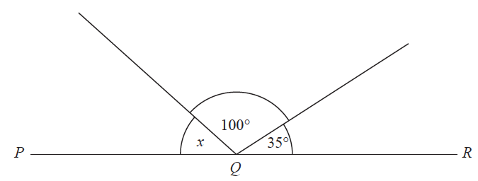

Work out the size of angle x.

....................................................... °
(Total for Question 9 is 2 marks)
___________________________________________________________________________

10
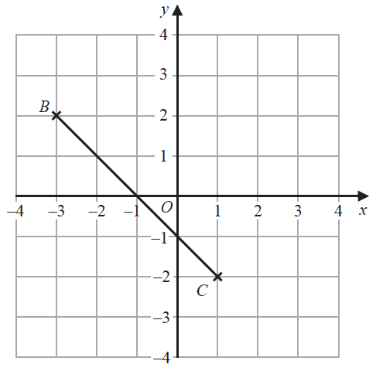

(a) Plot the point with coordinates (3, 2)
Label this point A.
(1)
(b) Write down the coordinates of the midpoint of BC.

(............................ , ............................)
(1)
(Total for Question 10 is 2 marks)
___________________________________________________________________________

11 Mason throws a coin 3 times.
The outcome of each throw is either Heads or Tails.
List all the possible outcomes of the 3 throws.
......................................................................................................................................................
......................................................................................................................................................
......................................................................................................................................................
(Total for Question 11 is 2 marks)
___________________________________________________________________________

12 Rehan is on holiday in the USA.
He has $200 to spend on clothes.
Rehan buys
1 pair of trainers costing $60
3 T-shirts costing $25 each.
He also wants to buy a jacket costing $80
(a) Has Rehan got enough money to buy the jacket?
You must show how you get your answer.

(3)

The trainers cost $60
The exchange rate is $1 = £0.749
Rehan says,
“The trainers cost less than £40”
Rehan is wrong.
(b) Using a suitable approximation, show working to explain why.

(2)
(Total for Question 12 is 5 marks)
___________________________________________________________________________

13 (a) Simplify 2a × 5b

.......................................................
(1)
(b) Simplify 3x + 2y + 5x − y

.......................................................
(2)
(Total for Question 13 is 3 marks)
___________________________________________________________________________

14 Work out 23 × 15

.......................................................
(Total for Question 14 is 2 marks)
___________________________________________________________________________

15 120 people were at a hockey match.
Each person was asked if they wanted to stand or to sit to watch the match.
75 of the people were female
29 of the males wanted to stand
30 of the people wanted to sit
(a) Use this information to complete the frequency tree.

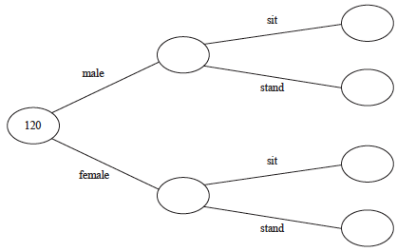
(3)

One of the 120 people is chosen at random.
(b) Write down the probability that this person is a male who wanted to stand.

.......................................................
(1)
(Total for Question 15 is 4 marks)
___________________________________________________________________________

16 Steve drove from his home to his friend’s house.
He stayed at his friend’s house and then drove home.
Here is Steve’s travel graph.

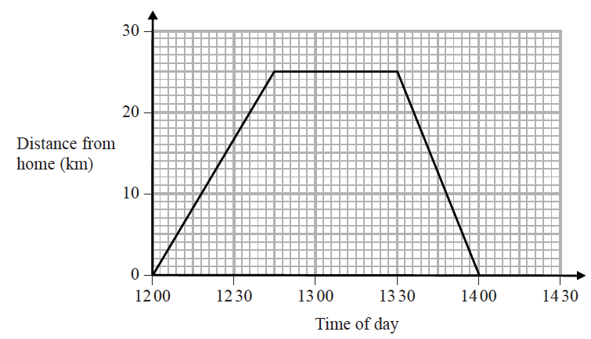

(a) For how many minutes did Steve stay at his friend’s house?

....................................................... minutes
(1)
(b) What was Steve’s average speed on his journey home?

....................................................... km/h
(2)
(Total for Question 16 is 3 marks)
___________________________________________________________________________

17 x – 1 = 2
Work out the value of 2x²

.......................................................
(Total for Question 17 is 3 marks)
___________________________________________________________________________

18 The pie charts show information about the favourite animal of each student at school A
and of each student at school B.

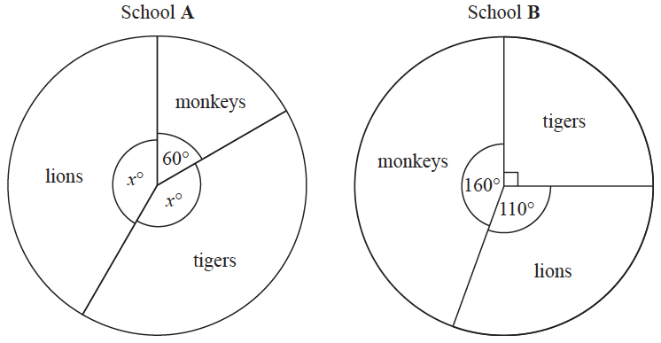
There are 480 students at school A. There are 760 students at school B.
Henry says,
“The same number of students at each school have tigers as their favourite animal.”
Is Henry correct?
You must show how you get your answer.

(Total for Question 18 is 4 marks)
___________________________________________________________________________

19 Here is a number line.

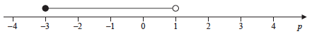

Write down the inequality shown on the number line.

..............................................................................................................
(Total for Question 19 is 2 marks)
___________________________________________________________________________

20 Find the Lowest Common Multiple (LCM) of 108 and 120

.......................................................
(Total for Question 20 is 3 marks)
___________________________________________________________________________

21 There are 60 people in a choir.
Half of the people in the choir are women.
The number of women in the choir is 3 times the number of men in the choir.
The rest of the people in the choir are children.
the number of children in the choir : the number of men in the choir = n : 1
Work out the value of n.
You must show how you get your answer.

n = .......................................................
(Total for Question 21 is 4 marks)
___________________________________________________________________________

22 Work out
Give your answer as a mixed number.

.......................................................
(Total for Question 22 is 3 marks)
___________________________________________________________________________

23 Use a ruler and compasses to construct the line from the point P perpendicular to the line CD.
You must show all construction lines.

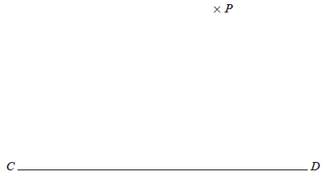

(Total for Question 23 is 2 marks)
___________________________________________________________________________

24 The diagram shows triangle ABC.

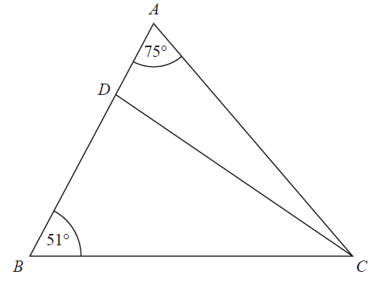

ADB is a straight line.
the size of angle DCB : the size of angle ACD = 2 : 1
Work out the size of angle BDC.

....................................................... °
(Total for Question 24 is 4 marks)
___________________________________________________________________________

25 4 red bricks have a mean weight of 5 kg.
5 blue bricks have a mean weight of 9 kg.
1 green brick has a weight of 6 kg.
Donna says,
“The mean weight of the 10 bricks is less than 7 kg.”
Is Donna correct?
You must show how you get your answer.

(Total for Question 25 is 3 marks)
___________________________________________________________________________

26 (a) Simplify (p²)⁵

.......................................................
(1)
(b) Simplify 12x⁷y³ ÷ 6x³y

.......................................................
(2)
(Total for Question 26 is 3 marks)
___________________________________________________________________________

27 The accurate scale drawing shows the positions of port P and a lighthouse L.

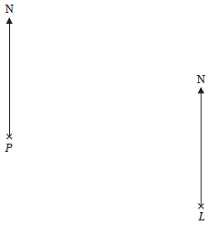

Scale: 1 cm represents 4 km.

Aleena sails her boat from port P on a bearing of 070°
She sails for hours at an average speed of 12 km/h to a port Q.
Find
(i) the distance, in km, of port Q from lighthouse L,
(ii) the bearing of port Q from lighthouse L.

distance QL = ....................................................... km
bearing of Q from L = ....................................................... °
(Total for Question 27 is 5 marks)
___________________________________________________________________________

28 The diagram shows triangle AOB.

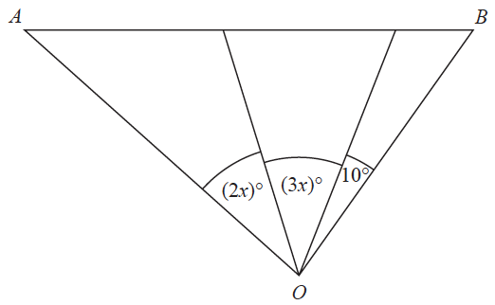

Angle AOB is not an obtuse angle.
Find the greatest value of x.
You must show all your working.

.......................................................
(Total for Question 28 is 3 marks)
___________________________________________________________________________

29 ABC and PQR are similar right-angled triangles.
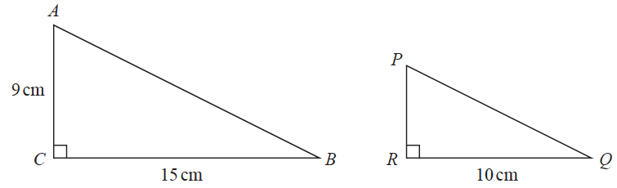
angle ABC = angle PQR
(a) Work out the length of PR.

....................................................... cm
(2)

Triangle EGH is congruent to triangle KGF.
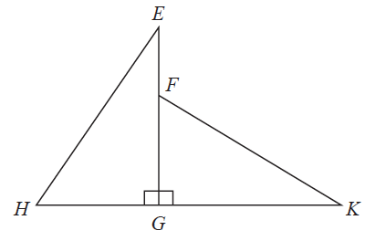
HK = 10 cm.
HG = 4 cm.
(b) Work out the length of EF.
....................................................... cm
(2)
(Total for Question 29 is 4 marks)
TOTAL FOR PAPER: 80 MARKS

