Answer ALL questions.
Write your answers in the spaces provided.
You must write down all the stages in your working.

1 Write these numbers in order of size.
Start with the smallest number.

8 | −4 | 1 | −7 | −2

.......................................................
(Total for Question 1 is 1 mark)
___________________________________________________________________________

2 Write the number 8375 correct to the nearest thousand.

.......................................................
(Total for Question 2 is 1 mark)
___________________________________________________________________________

3 Write 0.23 as a percentage.

....................................................... %
(Total for Question 3 is 1 mark)
___________________________________________________________________________

4 Find the value of

.......................................................
(Total for Question 4 is 1 mark)
___________________________________________________________________________

5 Find the value of 6⁵

.......................................................
(Total for Question 5 is 1 mark)
___________________________________________________________________________

6 There are 14 rows of seats in a cinema.
There are 15 seats in each row.
A film was shown in the cinema on Saturday.
Each ticket for the film cost £6.50
The tickets that were sold cost a total of £1274
How many tickets were not sold?

.......................................................
(Total for Question 6 is 3 marks)
___________________________________________________________________________

7 Harry has 20 sweets.
He gives 7 of the sweets to Nadia.
What fraction of the 20 sweets does Harry have now?

.......................................................
(Total for Question 7 is 2 marks)
___________________________________________________________________________

8 Here is a number machine.

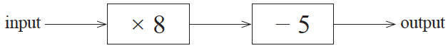

(a) Work out the output when the input is 6

.......................................................
(1)

Here is a different number machine.

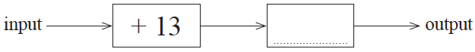

When the input is 17, the output is 10
(b) Complete the number machine.

(1)
(Total for Question 8 is 2 marks)
___________________________________________________________________________

9 Here is a list of numbers.

6 | 4 | 8 | 9 | 4 | 3

(a) Work out the median.

.......................................................
(2)

Aisha picks at random one of the numbers.
(b) What is the probability that she picks an odd number?

.......................................................
(2)

Clara has five cards.
There is a number on each card.
Two of the numbers are hidden.

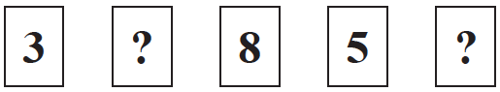

The mode of the five numbers is 3
The mean of the five numbers is 5
(c) Work out the two numbers that are hidden.

......................... , .........................
(2)
(Total for Question 9 is 6 marks)
___________________________________________________________________________

10 Here is the charge at a car park in Spain.

Car park
0.024 euros per minute

Jon parked his car in this car park.
Jon drove into the car park at 10 45
When he drove out of the car park he had to pay 8.40 euros.
At what time did Jon drive out of the car park?

.......................................................
(Total for Question 10 is 3 marks)
___________________________________________________________________________

11 You can use this graph to change between stones and kilograms.
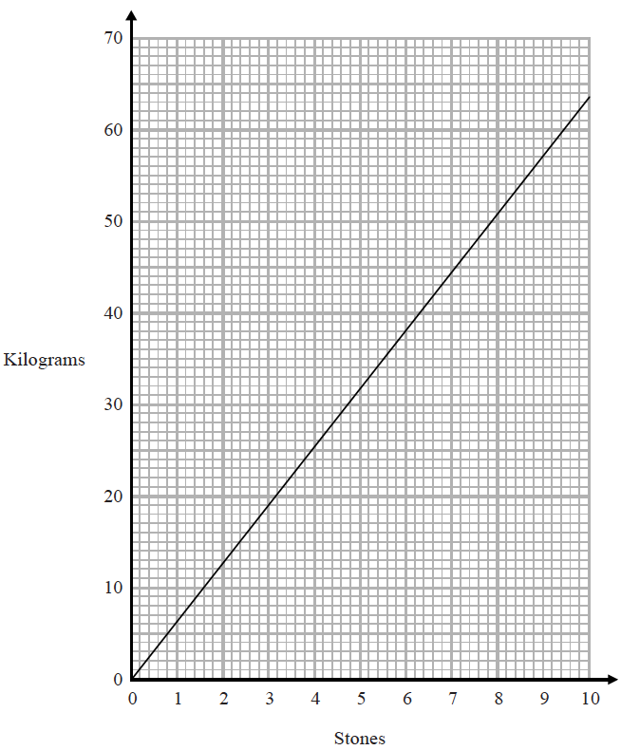
(a) Change 3 stones to kilograms.

....................................................... kilograms
(1)
(b) Change 80 kilograms to stones.

....................................................... stones
(2)
(Total for Question 11 is 3 marks)
___________________________________________________________________________

12 Find the number that is exactly halfway between and

.......................................................
(Total for Question 12 is 2 marks)
___________________________________________________________________________

13
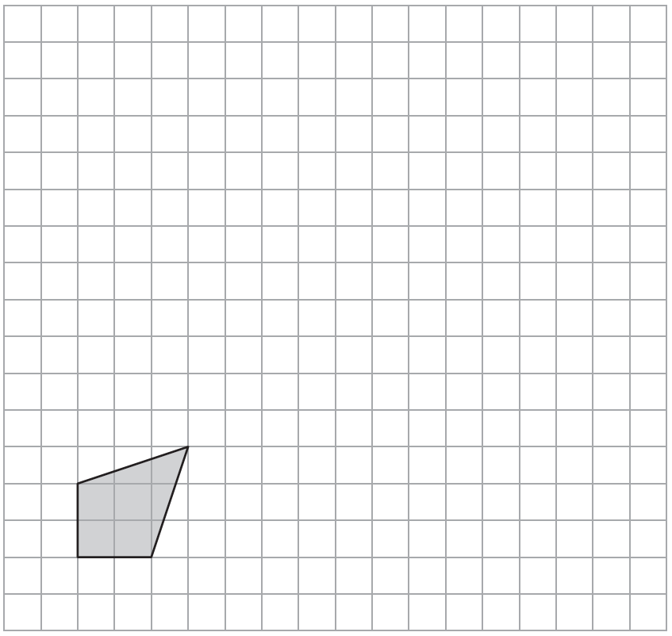

On the grid, draw an enlargement of the shaded shape with a scale factor of 3
(Total for Question 13 is 2 marks)
___________________________________________________________________________

14 A shop sells compost in 20 litre bags and in 40 litre bags.
One day the shop had two special offers for the compost.

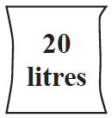 |  | 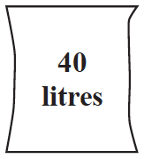
2 bags for £3.50 |  | 3 bags for £9

Which offer is the better value for money?
You must show how you get your answer.

(Total for Question 14 is 3 marks)
___________________________________________________________________________

15 The length of a plane is 19.2 metres.
Lukas buys a scale model of the plane.
The scale of the model is 1 : 24
Work out the length of the scale model of the plane.
Give your answer in centimetres.

....................................................... centimetres
(Total for Question 15 is 3 marks)
___________________________________________________________________________

16 Maria invests £4500 in a savings account for 3 years.
The account pays simple interest at a rate of 1.8% per year.
Work out the total amount of interest Maria gets by the end of the 3 years.

£.......................................................
(Total for Question 16 is 2 marks)
___________________________________________________________________________

17
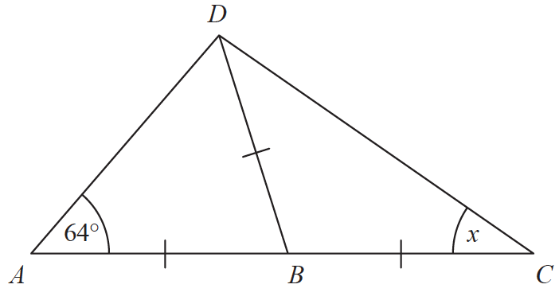

ABC is a straight line.
AB = BC = BD.
Angle DAB = 64°
Work out the size of the angle marked x.
Give a reason for each stage of your working.

(Total for Question 17 is 4 marks)
___________________________________________________________________________

18 Ben is n years old.
Chloe is twice as old as Ben.
Dan is five years younger than Ben.
The total of Ben’s age, Chloe’s age and Dan’s age is T years.
(a) Find a formula for T in terms of n.

..................................................................................
(3)
(b) In the table below, put a tick () in the box next to the identity.

3h + 2 = 14
3a + 4b – 2c
A = πr²
5m – 3m = 2m
x + 7 ⩽ 12
(1)
(Total for Question 18 is 4 marks)
___________________________________________________________________________

19 Here are the ingredients needed to make 16 biscuits.

Biscuits
Ingredients to make 16 biscuits
175 g of butter
75 g of sugar
250 g of flour

Anna has
500 g of butter
300 g of sugar
625 g of flour
Work out the greatest number of biscuits Anna can make.

.......................................................
(Total for Question 19 is 3 marks)
___________________________________________________________________________

20 An estimate of the height, H metres, of a tall building can be found using the formula
H = 4f + 12
where the building is f floors high.
A tall building is 110 floors high.
The real height of the building is 442 m.
Seb uses the formula to find an estimate of the height of this building.
He then finds the difference between his estimate and the real height.
Show that this difference is less than 5% of the real height.

(Total for Question 20 is 4 marks)
___________________________________________________________________________

21 The table shows some information about the weights of 50 potatoes.
Weight (w grams) | Frequency
10 < w ⩽ 20 | 6
20 < w ⩽ 30 | 21
30 < w ⩽ 40 | 13
40 < w ⩽ 50 | 7
50 < w ⩽ 60 | 3

Iveta drew this frequency polygon for the information in the table.
The frequency polygon is not fully correct.

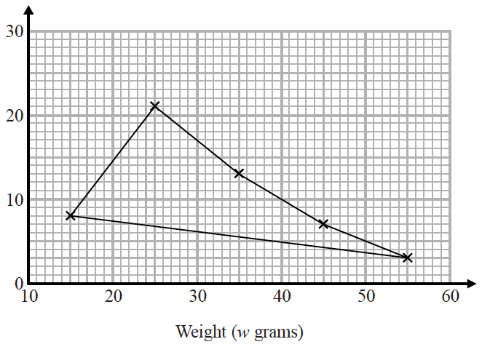

Write down two things that are wrong with the frequency polygon.
1....................................................................................................................................................
......................................................................................................................................................
2....................................................................................................................................................
......................................................................................................................................................(Total for Question 21 is 2 marks)
___________________________________________________________________________

22 The length of a pencil is 128 mm correct to the nearest millimetre.
Complete the error interval for the length of the pencil.

......................... mm ⩽ length < ......................... mm
(Total for Question 22 is 2 marks)
___________________________________________________________________________

23 Tom and Adam have a total of 240 stamps.
The ratio of the number of Tom’s stamps to the number of Adam’s stamps is 3 : 7
Tom buys some stamps from Adam.
The ratio of the number of Tom’s stamps to the number of Adam’s stamps is now 3 : 5
How many stamps does Tom buy from Adam?
You must show all your working.

.......................................................
(Total for Question 23 is 4 marks)
___________________________________________________________________________

24 Each person in a fitness club is going to get a free gift.
Stan is going to order the gifts.
Stan takes a sample of 50 people in the fitness club.
He asks each person to tell him the gift they would like.
The table shows information about his results.

Gift | Number of people
sports bag | 17
gym towel | 7
headphones | 11
voucher | 15

There are 700 people in the fitness club.
(i) Work out how many sports bags Stan should order.

.......................................................
(2)
(ii) Write down any assumption you made and explain how this could affect your answer.
......................................................................................................................................................
......................................................................................................................................................
......................................................................................................................................................
......................................................................................................................................................
(1)
(Total for Question 24 is 3 marks)
___________________________________________________________________________

25 Here are six graphs.

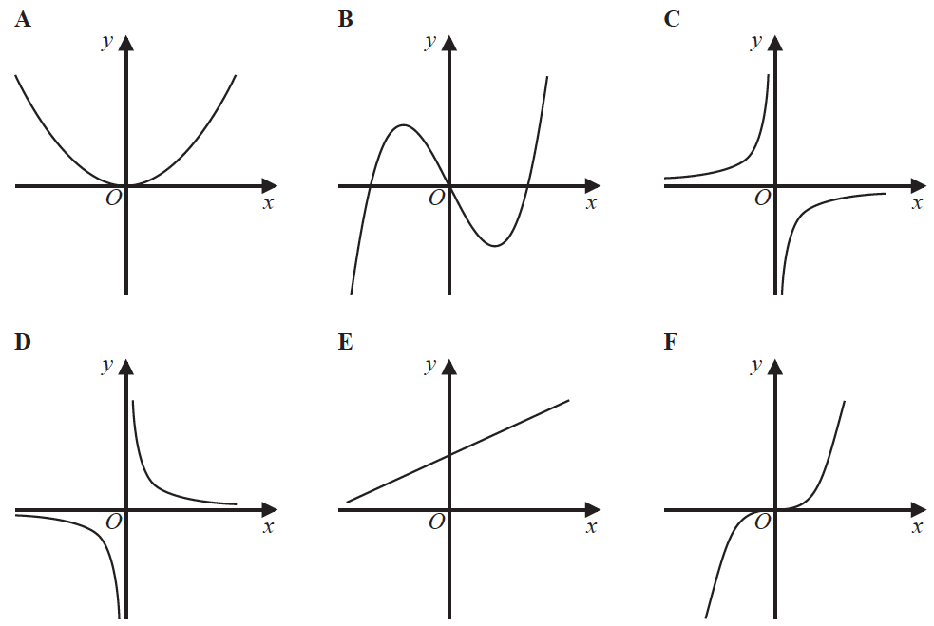

Write down the letter of the graph that could have the equation
(a) y = x³

.......................................................
(1)
(b) y =

.......................................................
(1)
(Total for Question 25 is 2 marks)
___________________________________________________________________________

26 The nth term of a sequence is 2n² − 1
The nth term of a different sequence is 40 − n²
Show that there is only one number that is in both of these sequences.

(Total for Question 26 is 3 marks)
___________________________________________________________________________

27 Work out (3.42 × 10⁻⁷) ÷ (7.5 × 10⁻⁶)
Give your answer in standard form.

.......................................................
(Total for Question 27 is 2 marks)
___________________________________________________________________________

28 The number of days, d, that it will take to build a house is given by
d =
where n is the number of workers used each day.
Ali’s company will take 40 days to build the house.
Hayley’s company will take 30 days to build the house.
Hayley’s company will have to use more workers each day than Ali’s company.
How many more?

.......................................................
(Total for Question 28 is 3 marks)
___________________________________________________________________________

29 The diagram shows a cube and a cuboid.

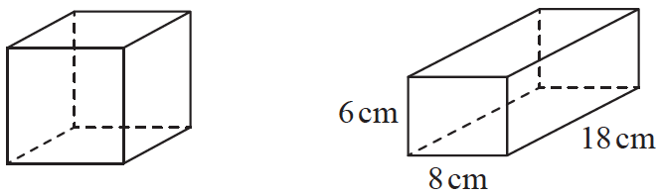

The total surface area of the cube is equal to the total surface area of the cuboid.
Janet says,
“The volume of the cube is equal to the volume of the cuboid.”
Is Janet correct?
You must show how you get your answer.

(Total for Question 29 is 5 marks)
___________________________________________________________________________

30 Here are two column vectors.

a = b =

On the grid below, draw and label the vector a − 2b

(Total for Question 30 is 3 marks)
___________________________________________________________________________

TOTAL FOR PAPER IS 80 MARKS

