Answer ALL questions.
Write your answers in the spaces provided.
You must write down all the stages in your working.

1 Write down two factors of 12

......................................... , .........................................
(Total for Question 1 is 1 mark)
___________________________________________________________________________

2 Find of 30

.......................................................
(Total for Question 2 is 1 mark)
___________________________________________________________________________

3 Write 0.7 as a fraction.

.......................................................
(Total for Question 3 is 1 mark)
___________________________________________________________________________

4 Here is a list of numbers.

7 | 8 | 15 | 16 | 18 | 22

Write down the number from the list that is a multiple of 6

.......................................................
(Total for Question 4 is 1 mark)
___________________________________________________________________________

5 Change 4 kilometres into metres.

.......................................................metres
(Total for Question 5 is 1 mark)
___________________________________________________________________________

6 Here is a grid of squares.

Write down the ratio of the number of shaded squares to the number of unshaded squares.

.......................................................
(Total for Question 6 is 1 mark)
___________________________________________________________________________

7 w = 4u + 3
Find the value of w when u = 8

.......................................................
(Total for Question 7 is 2 marks)
___________________________________________________________________________

8 Here are the first five terms of a sequence.

1 | 3 | 6 | 10 | 15

Write down the next two terms of the sequence.

......................................... , .........................................
(Total for Question 8 is 2 marks)
___________________________________________________________________________

9 Mrs Brown asked each child in her class which pet they liked best.
Here are her results.
dog | rabbit | cat | dog | dog | hamster
cat | dog | rabbit | hamster | cat | cat
dog | dog | cat | dog | rabbit | dog

(a) Complete the frequency table for this information.
Pet | Tally | Frequency
dog
rabbit
cat
hamster
(2)
(b) On the grid below, draw a bar chart for this information.
(3)
(c) Write down the most popular pet.
.......................................................
(1)
(Total for Question 9 is 6 marks)
___________________________________________________________________________

10

(a) On the diagram above, draw a diameter of the circle.
(1)
(b) On the diagram below, draw a segment of the circle.
Shade the segment.

(1)
(Total for Question 10 is 2 marks)
___________________________________________________________________________

11 Dylan buys 13 bicycle lights for £7.50 each.
He pays with five £20 notes.
(a) How much change should Dylan get?

£.......................................................
(3)

The normal price of a bicycle is £120
In a sale, there is off the normal price of the bicycle.
(b) Work out the price of the bicycle in the sale.

£.......................................................
(2)
(Total for Question 11 is 5 marks)
___________________________________________________________________________

12 Cornflakes are sold in two sizes of box.

Size of box | Weight of cornflakes
small | 450 g
large | 750 g

Rae buys 3 small boxes of cornflakes and some large boxes of cornflakes.
In total she buys 5850 g of cornflakes.
Work out the number of large boxes of cornflakes Rae buys.

.......................................................
(Total for Question 12 is 3 marks)
___________________________________________________________________________

13 The stem and leaf diagram below gives information about the ages of people in a social club.

3 | 1 | 4 | 5
4 | 0 | 2 | 2 | 5 | 6
5 | 0 | 1 | 7 | 7 | 8 | 9 |  | Key: 4|2 represents 42 years
6 | 3 | 4 | 5 | 9
7 | 0 | 4

Find the range of these ages.

.......................................................years
(Total for Question 13 is 2 marks)
___________________________________________________________________________

14 Here is a rectangle.
Coby has to find the perimeter of this rectangle.
He writes,
Perimeter = 7 × 3
(a) What mistake has Coby made?
......................................................................................................................................................
......................................................................................................................................................
......................................................................................................................................................
(1)

Here is a triangle.

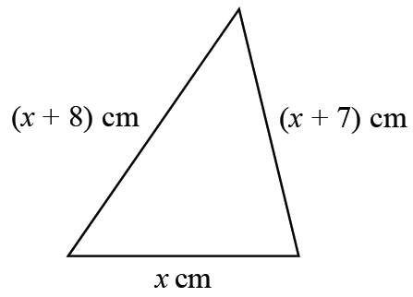

Iram solves a problem about this triangle to find the value of x.
Her answer is
x = −2
(b) Explain why Iram’s answer must be wrong.
......................................................................................................................................................
......................................................................................................................................................
......................................................................................................................................................
(1)
(Total for Question 14 is 2 marks)
___________________________________________________________________________

15 There are 800 students at a school.
Each student has either a school dinner or a packed lunch.
31% of the students have packed lunches.
55% of the students are boys.
60% of the boys have school dinners.
How many girls have packed lunches?
You must show all your working.

.......................................................
(Total for Question 15 is 4 marks)
___________________________________________________________________________

16 In a bag there are only red counters, blue counters, green counters and yellow counters.
A counter is taken at random from the bag.
The table shows the probabilities of getting a red counter or a yellow counter.

Colour | red | blue | green | yellow
Probability | 0.4 | ...................... | ...................... | 0.25

the number of blue counters : the number of green counters = 3 : 4
Complete the table.

(Total for Question 16 is 4 marks)
___________________________________________________________________________

17 (a) Complete the table of values for y = 4x – 6

x | −1 | 0 | 1 | 2 | 3 | 4
y |  |  | −2 |  |  | 10

(2)
(b) On the grid, draw the graph of y = 4x – 6 for values of x from −1 to 4
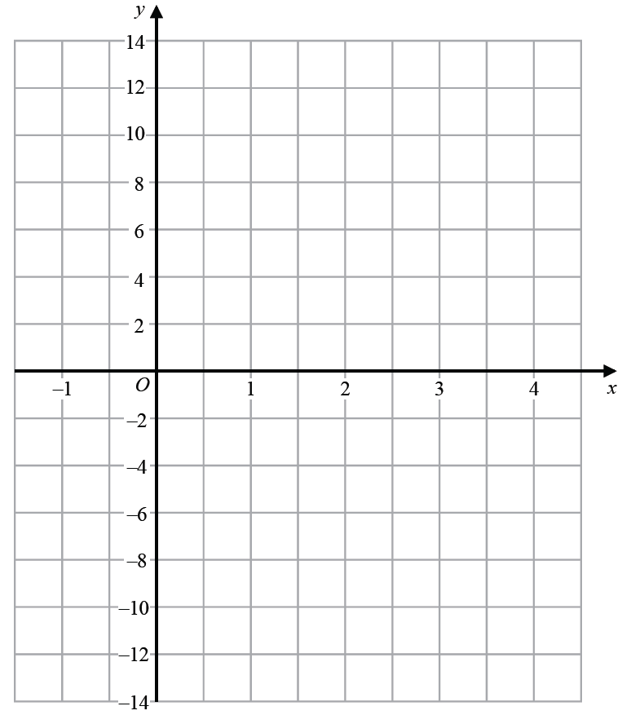
(2)
(Total for Question 17 is 4 marks)
___________________________________________________________________________

18
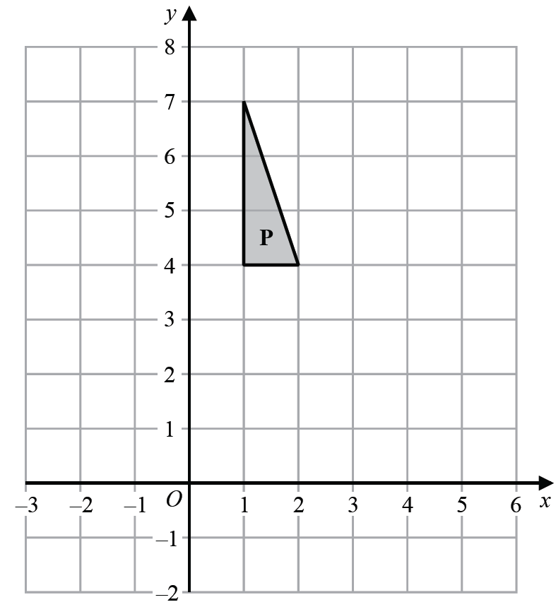

Reflect shape P in the line y = 3
(Total for Question 18 is 2 marks)
___________________________________________________________________________

19 Solve 4(x – 6) = 44

x = .......................................................
(Total for Question 19 is 2 marks)
___________________________________________________________________________

20 E = {1, 2, 3, 4, 5, 6, 7, 8, 9, 10, 11, 12, 13}
A = {multiples of 3}
B = {even numbers}
Complete the Venn diagram for this information.

E

(Total for Question 20 is 4 marks)
___________________________________________________________________________

21 Franco buys a house for £146 500
He sells the house for £158 220
Calculate the percentage profit Franco makes.

.......................................................%
(Total for Question 21 is 3 marks)
___________________________________________________________________________

22 (a) Expand and simplify (x + 5)(x – 9)

.......................................................
(2)
(b) Factorise fully 9x² + 6x

.......................................................
(2)
(Total for Question 22 is 4 marks)
___________________________________________________________________________

23 (a) Use your calculator to work out
Write down all the figures on your calculator display.

..................................................................................
(2)
(b) Write your answer to part (a) correct to 4 significant figures.

.......................................................
(1)
(Total for Question 23 is 3 marks)
___________________________________________________________________________

24 The scatter graph shows information about the marks a group of students got in a Science
test and in a Maths test.

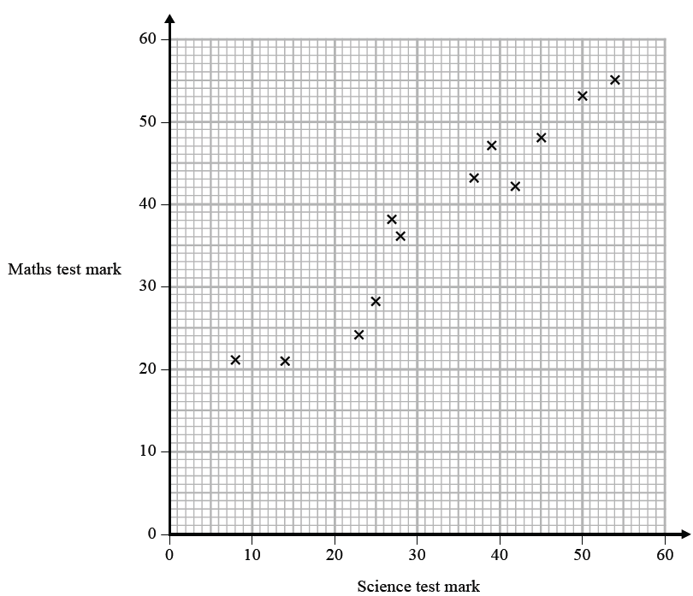

Jamie got a mark of 34 in the Science test.
Using the scatter graph, find an estimate for Jamie’s mark in the Maths test.

.......................................................
(Total for Question 24 is 2 marks)
___________________________________________________________________________

25 The table gives information about the times taken, in seconds, by 18 students to run a race.

Time (t seconds) | Frequency
5 < t ⩽ 10 | 1
10 < t ⩽ 15 | 2
15 < t ⩽ 20 | 7
20 < t ⩽ 25 | 8

Work out an estimate for the mean time.
Give your answer correct to 3 significant figures.

....................................................... seconds
(Total for Question 25 is 3 marks)
___________________________________________________________________________

26 Write 37 cm³ in mm³

.......................................................mm³
(Total for Question 26 is 1 mark)
___________________________________________________________________________

27 Nimer was driving to a hotel.
He looked at his Sat Nav at 13 30

Time | 13 30
Distance to destination | 65 miles

Nimer arrived at the hotel at 14 48
Work out the average speed of the car from 13 30 to 14 48
You must show all your working.

.......................................................mph
(Total for Question 27 is 4 marks)
___________________________________________________________________________

28 (a) Write 32 460 000 in standard form.

.......................................................
(1)
(b) Write 4.96 × 10⁻³ as an ordinary number.

.......................................................
(1)

Asma was asked to compare the following two numbers.
A = 6.212 × 10⁸ and B = 4.73 × 10⁹
She says,
“6.212 is bigger than 4.73 so A is bigger than B.”
(c) Is Asma correct?
You must give a reason for your answer.
......................................................................................................................................................
......................................................................................................................................................
......................................................................................................................................................
(1)
(Total for Question 28 is 3 marks)
___________________________________________________________________________

29 The diagram shows a regular pentagon and a parallelogram.

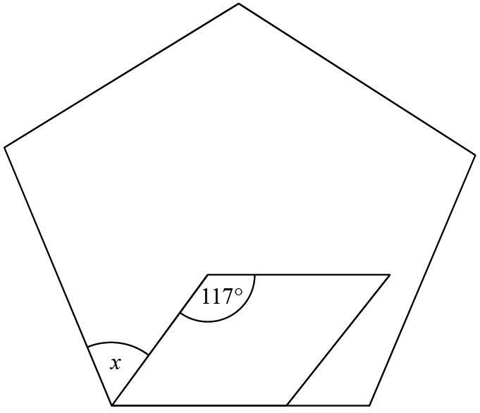

Work out the size of the angle marked x.
You must show all your working.

.......................................................°
(Total for Question 29 is 4 marks)
___________________________________________________________________________

30 A is in the shape of a quarter circle of radius 15 cm.
B is in the shape of a circle.

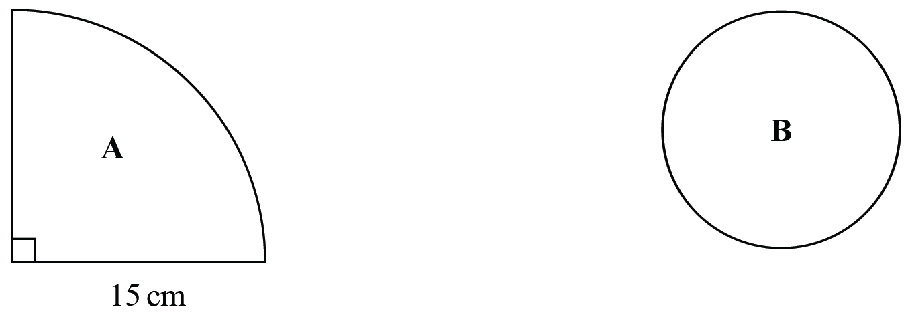

The area of A is 9 times the area of B.
Show that the radius of B is 2.5 cm.

(Total for Question 30 is 3 marks)

TOTAL FOR PAPER IS 80 MARKS

