Answer ALL questions.
Write your answers in the spaces provided.
You must write down all the stages in your working.

1 The table shows some information about the weights of 50 potatoes.
Weight (w grams) | Frequency
10 < w ⩽ 20 | 6
20 < w ⩽ 30 | 21
30 < w ⩽ 40 | 13
40 < w ⩽ 50 | 7
50 < w ⩽ 60 | 3

Iveta drew this frequency polygon for the information in the table.
The frequency polygon is not fully correct.
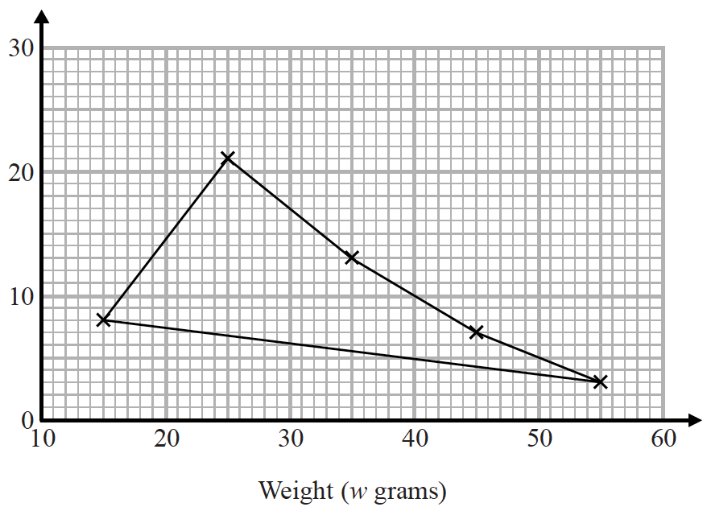
Write down two things that are wrong with the frequency polygon.
1....................................................................................................................................................
......................................................................................................................................................
2....................................................................................................................................................
......................................................................................................................................................
(Total for Question 1 is 2 marks)
___________________________________________________________________________

2 The length of a pencil is 128 mm correct to the nearest millimetre.
Complete the error interval for the length of the pencil.

......................... mm ⩽ length < ......................... mm
(Total for Question 2 is 2 marks)
___________________________________________________________________________

3 Tom and Adam have a total of 240 stamps.
The ratio of the number of Tom’s stamps to the number of Adam’s stamps is 3 : 7
Tom buys some stamps from Adam.
The ratio of the number of Tom’s stamps to the number of Adam’s stamps is now 3 : 5
How many stamps does Tom buy from Adam?
You must show all your working.

.......................................................
(Total for Question 3 is 4 marks)
___________________________________________________________________________

4 Each person in a fitness club is going to get a free gift.
Stan is going to order the gifts.
Stan takes a sample of 50 people in the fitness club.
He asks each person to tell him the gift they would like.
The table shows information about his results.

Gift | Number of people
sports bag | 17
gym towel | 7
headphones | 11
voucher | 15

There are 700 people in the fitness club.
(i) Work out how many sports bags Stan should order.

.......................................................
(2)
(ii) Write down any assumption you made and explain how this could affect your answer.
......................................................................................................................................................
......................................................................................................................................................
......................................................................................................................................................
......................................................................................................................................................
(1)
(Total for Question 4 is 3 marks)
___________________________________________________________________________

5 Here are six graphs.

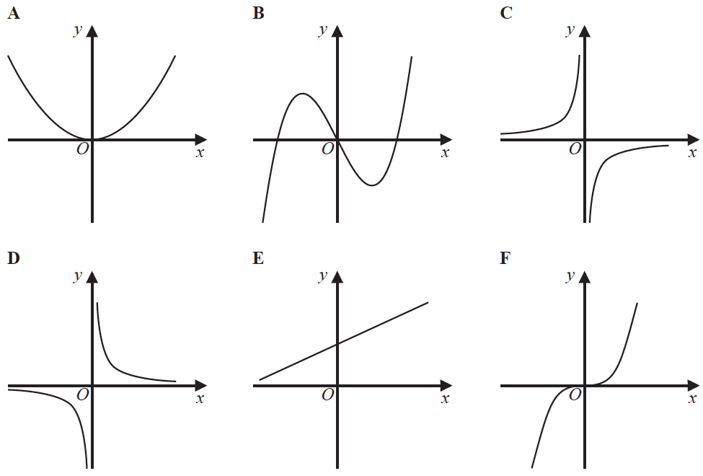

Write down the letter of the graph that could have the equation
(a) y = x³

.......................................................
(1)
(b) y =

.......................................................
(1)
(Total for Question 5 is 2 marks)
___________________________________________________________________________

6 The nth term of a sequence is 2n² − 1
The nth term of a different sequence is 40 − n²
Show that there is only one number that is in both of these sequences.

(Total for Question 6 is 3 marks)
___________________________________________________________________________

7 Work out (3.42 × 10⁻⁷) ÷ (7.5 × 10⁻⁶)
Give your answer in standard form.

.......................................................
(Total for Question 7 is 2 marks)
___________________________________________________________________________

8 The number of days, d, that it will take to build a house is given by
d =
where n is the number of workers used each day.
Ali’s company will take 40 days to build the house.
Hayley’s company will take 30 days to build the house.
Hayley’s company will have to use more workers each day than Ali’s company.
How many more?

.......................................................
(Total for Question 8 is 3 marks)
___________________________________________________________________________

9 The diagram shows a cube and a cuboid.

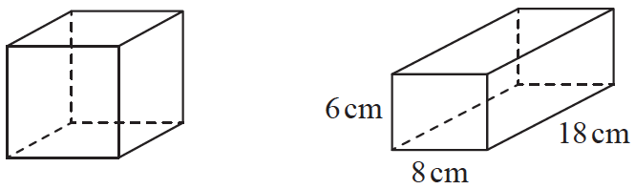

The total surface area of the cube is equal to the total surface area of the cuboid.
Janet says,
“The volume of the cube is equal to the volume of the cuboid.”
Is Janet correct?
You must show how you get your answer.

(Total for Question 9 is 5 marks)
___________________________________________________________________________

10 Make k the subject of the formula y =

..................................................................................
(Total for Question 10 is 2 marks)
___________________________________________________________________________

11 Megan grows potatoes.
The box plot below shows information about the weights of Megan’s potatoes.
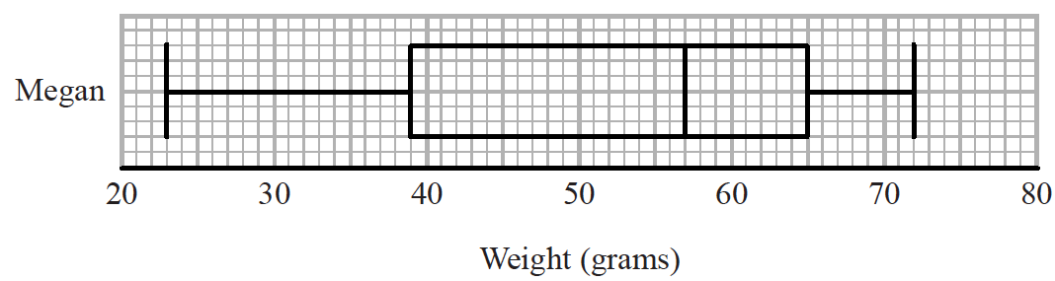
Megan says that half of her potatoes weigh less than 50 grams each.
(a) Is Megan correct?
Give a reason for your answer.
......................................................................................................................................................
......................................................................................................................................................
......................................................................................................................................................
(1)

Amy also grows potatoes.
The box plot below shows information about the weights of Amy’s potatoes.
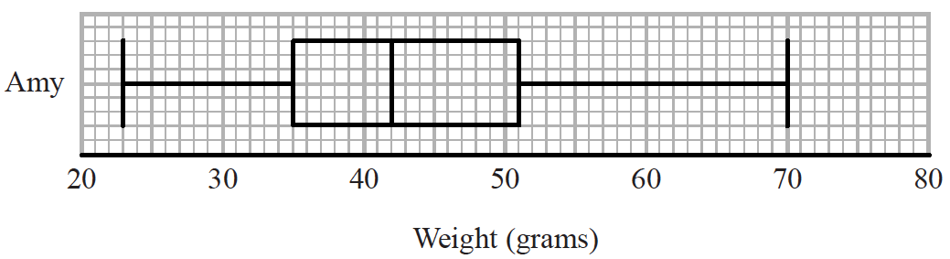
(b) Compare the distribution of the weights of Megan’s potatoes with the distribution of
the weights of Amy’s potatoes.
......................................................................................................................................................
......................................................................................................................................................
......................................................................................................................................................
......................................................................................................................................................
......................................................................................................................................................
(2)
(Total for Question 11 is 3 marks)
___________________________________________________________________________

12 The diagram shows triangle ABC.

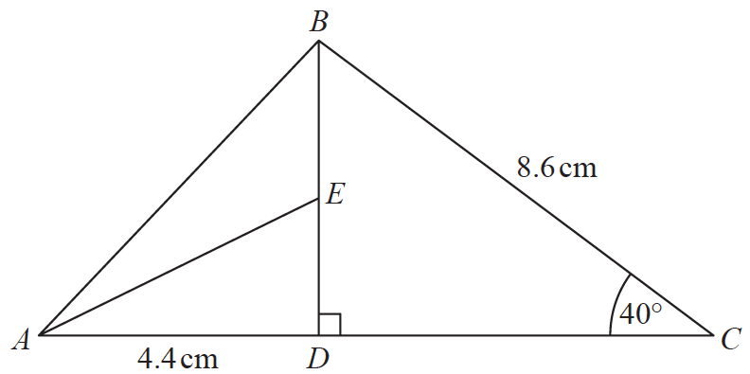

ADC and DEB are straight lines.
AD = 4.4 cm
BC = 8.6 cm
E is the midpoint of DB.
Angle CDB = 90°
Angle DCB = 40°
Work out the size of angle EAD.
Give your answer correct to 1 decimal place.
You must show all your working.

.......................................................°
(Total for Question 12 is 4 marks)
___________________________________________________________________________

13 Sakira invested £3550 in a savings account for 3 years.
She was paid 2.6% per annum compound interest for each of the first 2 years.
She was paid R% interest for the third year.
Sakira had £3819.21 in her savings account at the end of the 3 years.
Work out the value of R.
Give your answer correct to 1 decimal place.

.......................................................
(Total for Question 13 is 3 marks)
___________________________________________________________________________

14 Sadia is going to buy a new car.
For the car, she can choose one body colour, one roof colour and one wheel type.
She can choose from
19 different body colours
25 different wheel types
The total number of ways Sadia can choose the body colour and the roof colour and the
wheel type is 3325
Work out the number of different roof colours that Sadia can choose from.

.......................................................
(Total for Question 14 is 2 marks)
___________________________________________________________________________

15 Expand and simplify (3x + 2)(2x + 1)(x − 5)

..............................................................................................................
(Total for Question 15 is 3 marks)
___________________________________________________________________________

16 Marek has 9 cards.
There is a number on each card.

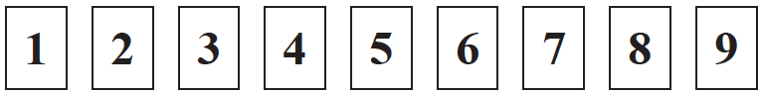

Marek takes at random two of the cards.
He works out the product of the numbers on the two cards.
Work out the probability that the product is an even number.

.......................................................
(Total for Question 16 is 3 marks)
___________________________________________________________________________

17
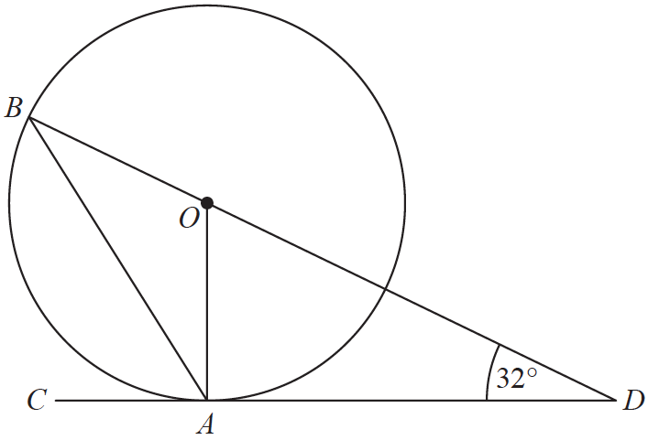

A and B are points on a circle with centre O.
CAD is the tangent to the circle at A.
BOD is a straight line.
Angle ODA = 32°
Work out the size of angle CAB.
You must show all your working.

.......................................................°
(Total for Question 17 is 3 marks)
___________________________________________________________________________

18 The histogram gives information about the heights, in metres, of the trees in a park.
The histogram is incomplete.

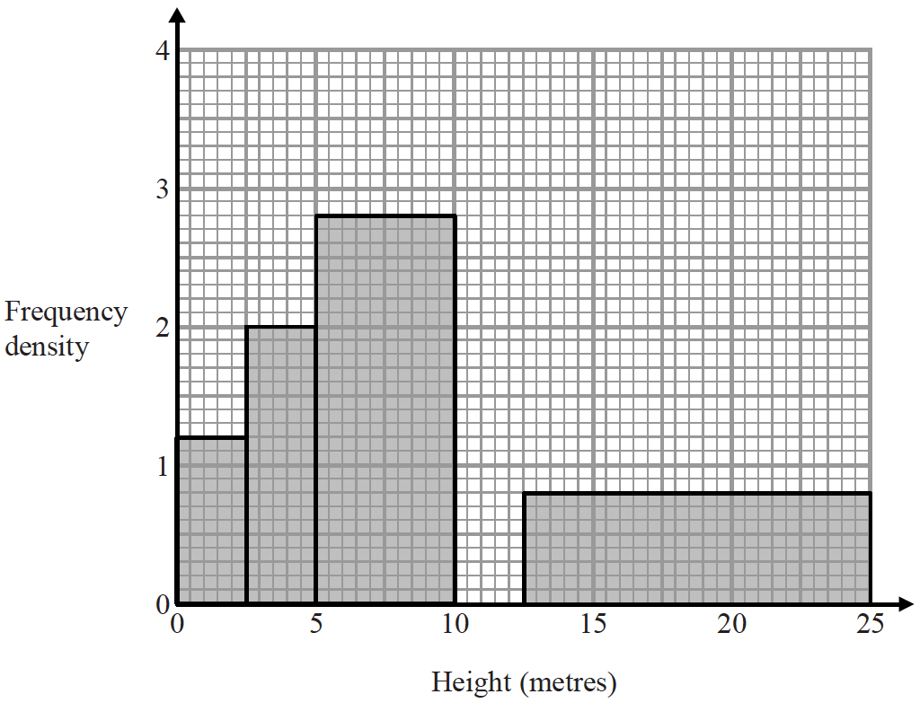

20% of the trees in the park have a height between 10 metres and 12.5 metres.
None of the trees in the park have a height greater than 25 metres.
Complete the histogram.

(Total for Question 18 is 3 marks)
___________________________________________________________________________

19 The diagram shows a hemisphere with diameter 8.4 cm.

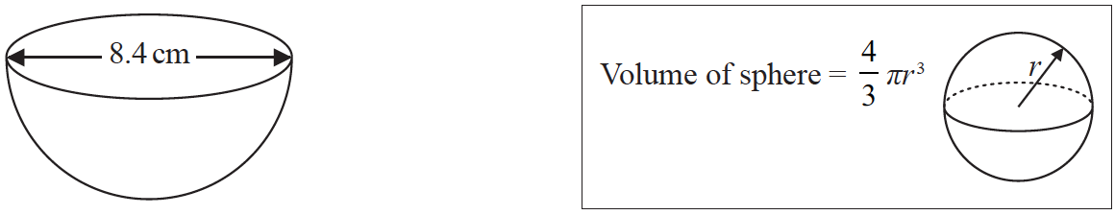

Work out the volume of the hemisphere.
Give your answer correct to 3 significant figures.

....................................................... cm³
(Total for Question 19 is 2 marks)
___________________________________________________________________________

20 d = c³
c = 10.9 correct to 3 significant figures.
By considering bounds, work out the value of d to a suitable degree of accuracy.
Give a reason for your answer.

(Total for Question 20 is 4 marks)
___________________________________________________________________________

21 Here is a speed-time graph for a train journey between two stations.
The journey took 100 seconds.

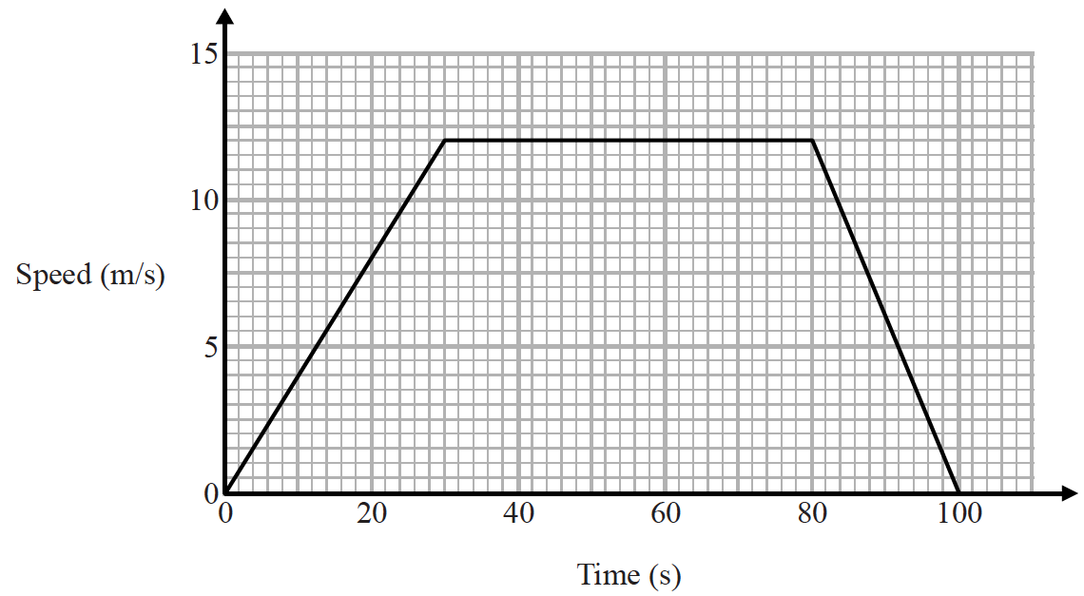

(a) Calculate the time taken by the train to travel half the distance between the two stations.
You must show all your working.

....................................................... seconds
(4)
(b) Compare the acceleration of the train during the first part of its journey with the
acceleration of the train during the last part of its journey.
......................................................................................................................................................
......................................................................................................................................................
......................................................................................................................................................
(1)
(Total for Question 21 is 5 marks)
___________________________________________________________________________

22 The number of rabbits on a farm at the end of month n is P_{n}
The number of rabbits at the end of the next month is given by P_{n +1} = 1.2P_{n} − 50
At the end of March there are 200 rabbits on the farm.
(a) Work out how many rabbits there will be on the farm at the end of June.

.......................................................
(3)
(b) Considering your results in part (a), suggest what will happen to the number of
rabbits on the farm after a long time.
......................................................................................................................................................
......................................................................................................................................................
(1)
(Total for Question 22 is 4 marks)
___________________________________________________________________________

23 The diagram shows a parallelogram.

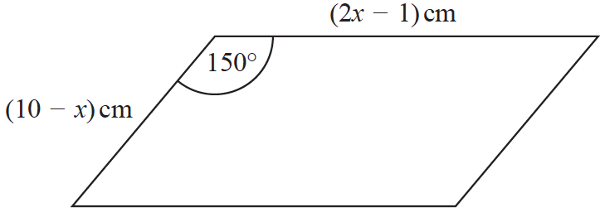

The area of the parallelogram is greater than 15 cm²
(a) Show that 2x² – 21x + 40 < 0

(3)
(b) Find the range of possible values of x.

.......................................................
(3)
(Total for Question 23 is 6 marks)
___________________________________________________________________________

24
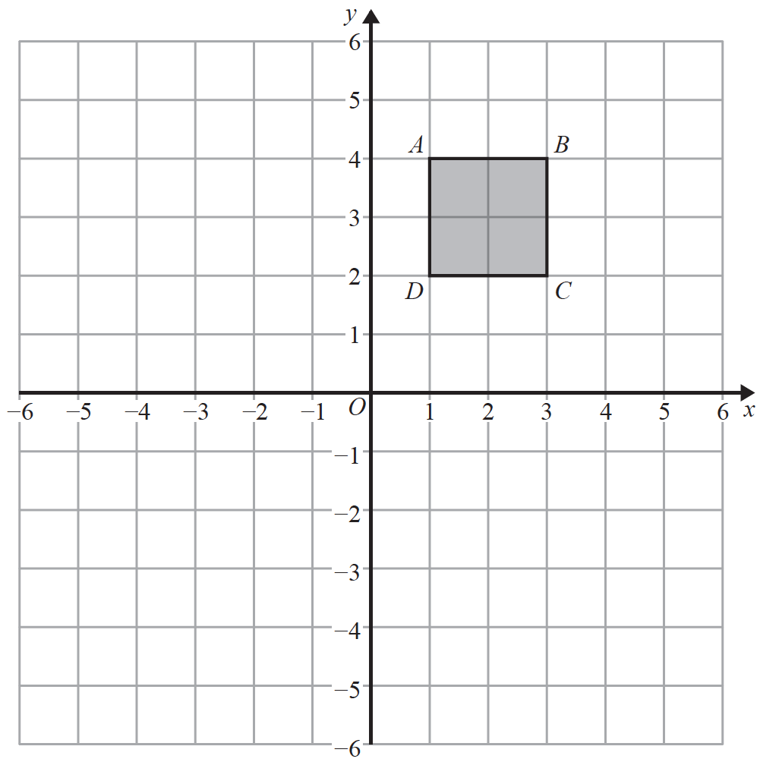

Square ABCD is transformed by a combined transformation of a reflection in the line x = −1
followed by a rotation.
Under the combined transformation, two vertices of the square ABCD are invariant.
Describe fully one possible rotation.

......................................................................................................................................................
(Total for Question 24 is 2 marks)
___________________________________________________________________________

25 The straight line L has equation 3x + 2y = 17
The point A has coordinates (0, 2)
The straight line M is perpendicular to L and passes through A.
Line L crosses the y-axis at the point B.
Lines L and M intersect at the point C.
Work out the area of triangle ABC.
You must show all your working.

.......................................................
(Total for Question 25 is 5 marks)
___________________________________________________________________________

TOTAL FOR PAPER: 80 MARKS

