Answer ALL questions.
Write your answers in the spaces provided.
You must write down all the stages in your working.

1 (a) Expand and simplify (x + 5)(x – 9)

.......................................................
(2)
(b) Factorise fully 9x² + 6x

.......................................................
(2)
(Total for Question 1 is 4 marks)
___________________________________________________________________________

2 (a) Use your calculator to work out
Write down all the figures on your calculator display.

..................................................................................
(2)
(b) Write your answer to part (a) correct to 4 significant figures.

.......................................................
(1)
(Total for Question 2 is 3 marks)
___________________________________________________________________________

3 The scatter graph shows information about the marks a group of students got in a Science
test and in a Maths test.

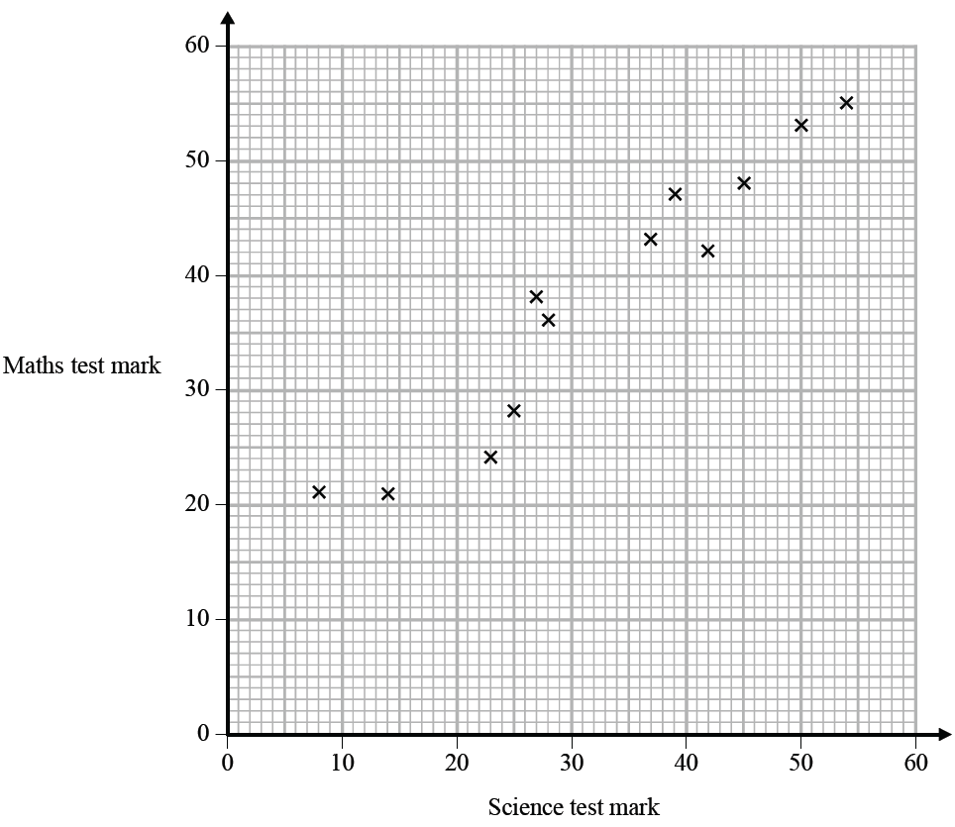

Jamie got a mark of 34 in the Science test.
Using the scatter graph, find an estimate for Jamie’s mark in the Maths test.

.......................................................
(Total for Question 3 is 2 marks)
___________________________________________________________________________

4 The table gives information about the times taken, in seconds, by 18 students to run a race.

Time (t seconds) | Frequency
5 < t ⩽ 10 | 1
10 < t ⩽ 15 | 2
15 < t ⩽ 20 | 7
20 < t ⩽ 25 | 8

Work out an estimate for the mean time.
Give your answer correct to 3 significant figures.

....................................................... seconds
(Total for Question 4 is 3 marks)
___________________________________________________________________________

5 Write 37 cm³ in mm³

.......................................................mm³
(Total for Question 5 is 1 mark)
___________________________________________________________________________

6 Nimer was driving to a hotel.
He looked at his Sat Nav at 13 30

Time | 13 30
Distance to destination | 65 miles

Nimer arrived at the hotel at 14 48
Work out the average speed of the car from 13 30 to 14 48
You must show all your working.

.......................................................mph
(Total for Question 6 is 4 marks)
___________________________________________________________________________

7 (a) Write 32 460 000 in standard form.

.......................................................
(1)
(b) Write 4.96 × 10⁻³ as an ordinary number.

.......................................................
(1)

Asma was asked to compare the following two numbers.
A = 6.212 × 10⁸ and B = 4.73 × 10⁹
She says,
“6.212 is bigger than 4.73 so A is bigger than B.”
(c) Is Asma correct?
You must give a reason for your answer.
......................................................................................................................................................
......................................................................................................................................................
......................................................................................................................................................
(1)
(Total for Question 7 is 3 marks)
___________________________________________________________________________

8 The diagram shows a regular pentagon and a parallelogram.

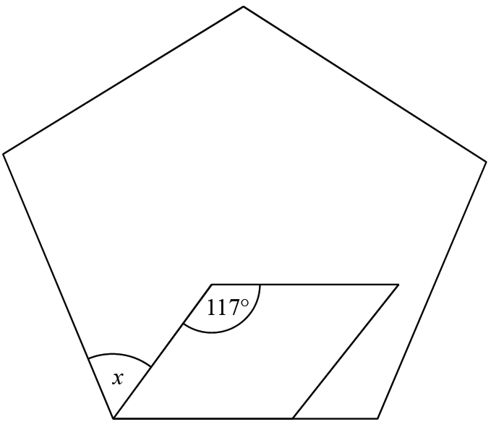

Work out the size of the angle marked x.
You must show all your working.

.......................................................°
(Total for Question 8 is 4 marks)
___________________________________________________________________________

9
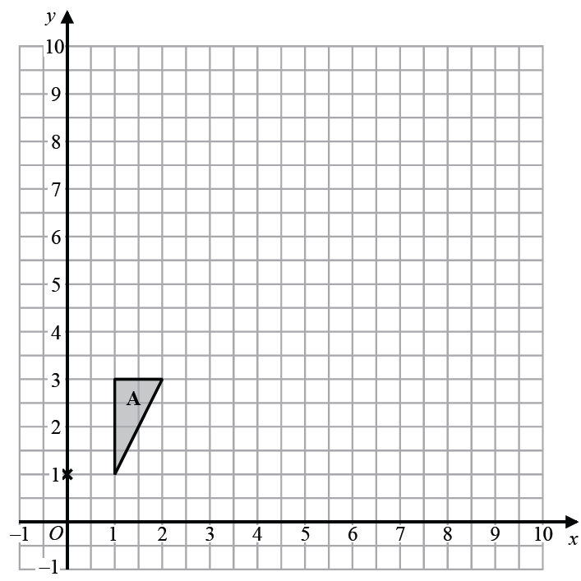

Enlarge triangle A by scale factor 2.5 with centre (0, 1)
(Total for Question 9 is 2 marks)
___________________________________________________________________________

10 (a) Solve = 11 − x

x = .......................................................
(3)
(b) Simplify

.......................................................
(1)
(Total for Question 10 is 4 marks)
___________________________________________________________________________

11 The probability tree diagram shows the probabilities that Bismah will be late for work on
two days next week.

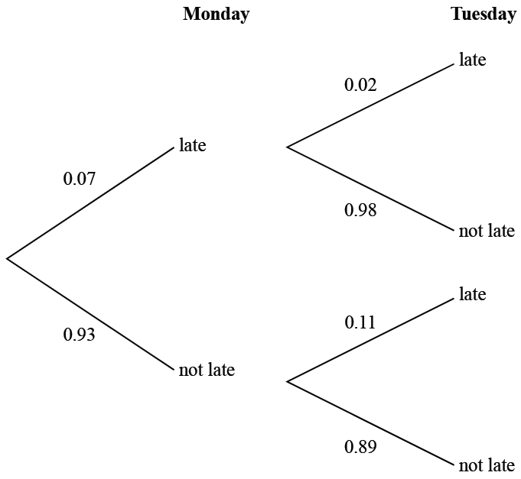

Calculate the probability that Bismah will be late on exactly one of the two days.

.......................................................
(Total for Question 11 is 3 marks)
___________________________________________________________________________

12 The stem and leaf diagram shows information about the heights, in cm, of 23 sunflowers.

17 | 3 | 4 | 9
18 | 6 | 8 | 8
19 | 0 | 0 | 1 | 4 | 6 | 7 | 8 |  | Key: 17|3 represents 173 cm
20 | 1 | 4 | 7 | 7 | 9 | 9
21 | 4 | 8 | 8 | 9

On the grid, draw a box plot for this information.

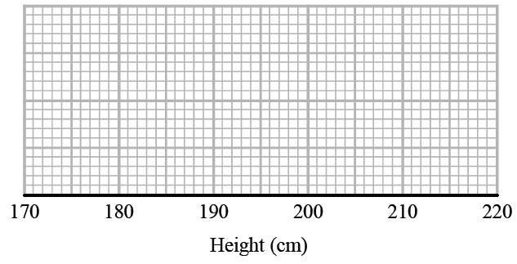
(Total for Question 12 is 3 marks)
___________________________________________________________________________

13 Liquid A and liquid B are mixed together in the ratio 2 : 13 by volume to make liquid C.
Liquid A has density 1.21 g/cm³
Liquid B has density 1.02 g/cm³
A cylindrical container is filled completely with liquid C.
The cylinder has radius 3 cm and height 25 cm.
Work out the mass of the liquid in the container.
Give your answer correct to 3 significant figures.
You must show all your working.

.......................................................g
(Total for Question 13 is 4 marks)
___________________________________________________________________________

14 A group of people went to a restaurant.
Each person chose one starter and one main course.

starter | main course
soup | lasagne
prawns | curry

the number of people who chose soup : the number of people who chose prawns = 2 : 3
Of those who chose soup,
the number of people who chose lasagne : the number of people who chose curry = 5 : 3
Of those who chose prawns,
the number of people who chose lasagne : the number of people who chose curry = 1 : 5
What fraction of the people chose curry?
You must show how you get your answer.

.......................................................
(Total for Question 14 is 4 marks)
___________________________________________________________________________

15 Prove algebraically that the sum of the squares of any two consecutive even numbers is
always a multiple of 4

(Total for Question 15 is 3 marks)
___________________________________________________________________________

16 y is inversely proportional to the square of x.
y = 8 when x = 2.5
Find the negative value of x when y =

.......................................................
(Total for Question 16 is 3 marks)
___________________________________________________________________________

17 Here is the graph of y = x² – 3

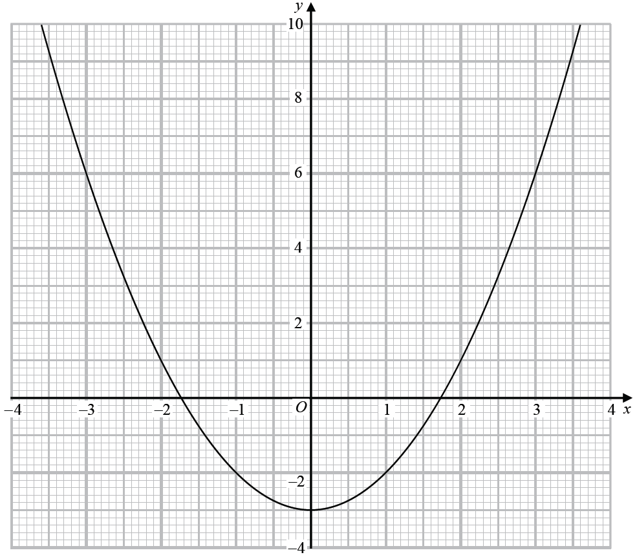

Use the graph to find estimates for the solutions to the equation x² – 2x – 2 = 0
You must show how you get your solutions.

..............................................................................................................
(Total for Question 17 is 4 marks)
___________________________________________________________________________

18 The diagram shows triangle ABC.

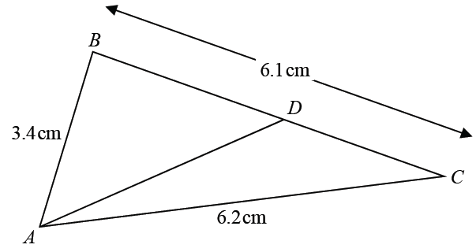

AB = 3.4 cm AC = 6.2 cm BC = 6.1 cm
D is the point on BC such that
size of angle DAC = × size of angle BCA
Calculate the length DC.
Give your answer correct to 3 significant figures.
You must show all your working.

.......................................................cm
(Total for Question 18 is 5 marks)
___________________________________________________________________________

19 The graph shows information about part of a cyclist’s journey.

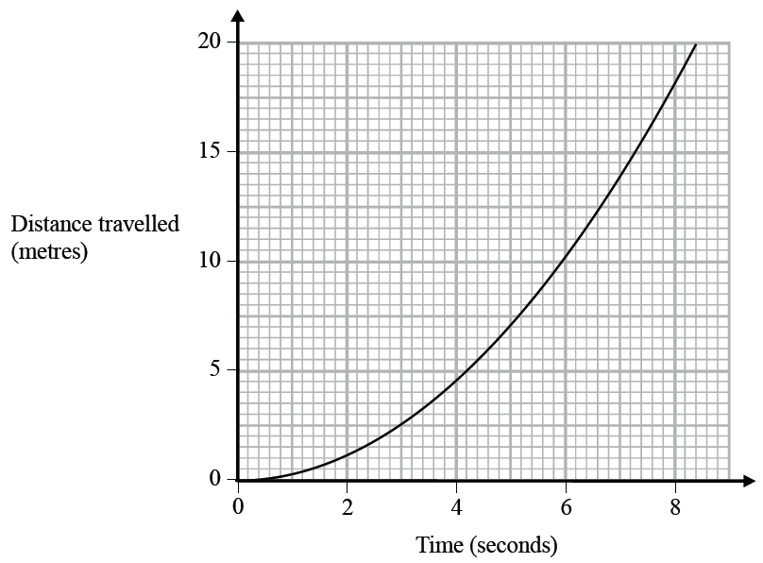

Work out an estimate of the speed, in m/s, of the cyclist at time 6 seconds.

.......................................................m/s
(Total for Question 19 is 3 marks)
___________________________________________________________________________

20 Here are the first five terms of a sequence.

−1 | 0 | 3 | 8 | 15

Find an expression, in terms of n, for the nth term of this sequence.

.......................................................
(Total for Question 20 is 2 marks)
___________________________________________________________________________

21 When a biased coin is thrown 4 times, the probability of getting 4 heads is
Work out the probability of getting 4 tails when the coin is thrown 4 times.

.......................................................
(Total for Question 21 is 2 marks)
___________________________________________________________________________

22 Show that simplifies to ax where a is an integer.

(Total for Question 22 is 4 marks)
___________________________________________________________________________

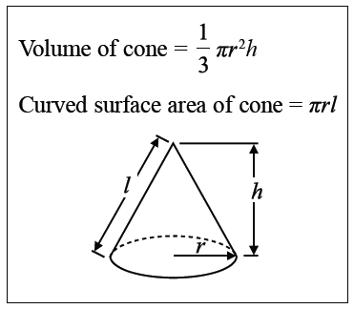
23 The diagram shows a sector OACB of a circle with centre O.
The point C is the midpoint of the arc AB.
The diagram also shows a hollow cone with vertex O.
The cone is formed by joining OA and OB.

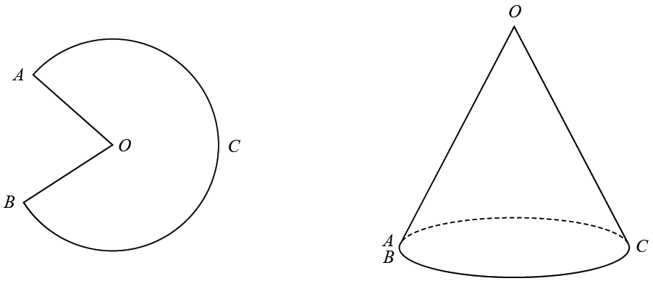

The cone has volume 56.8 cm³ and height 3.6 cm.
Calculate the size of angle AOB of sector OACB.
Give your answer correct to 3 significant figures.
You must show all your working.

....................................................... °
(Total for Question 23 is 5 marks)
___________________________________________________________________________

24 OXYZ is a parallelogram.

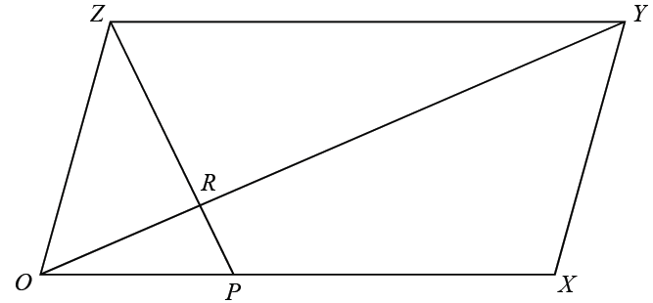

= a
= b

P is the point on OX such that OP : PX = 1 : 2
R is the point on OY such that OR : RY = 1 : 3
Work out, in its simplest form, the ratio ZP : ZR
You must show all your working.

.......................................................
(Total for Question 24 is 5 marks)

TOTAL FOR PAPER IS 80 MARKS

