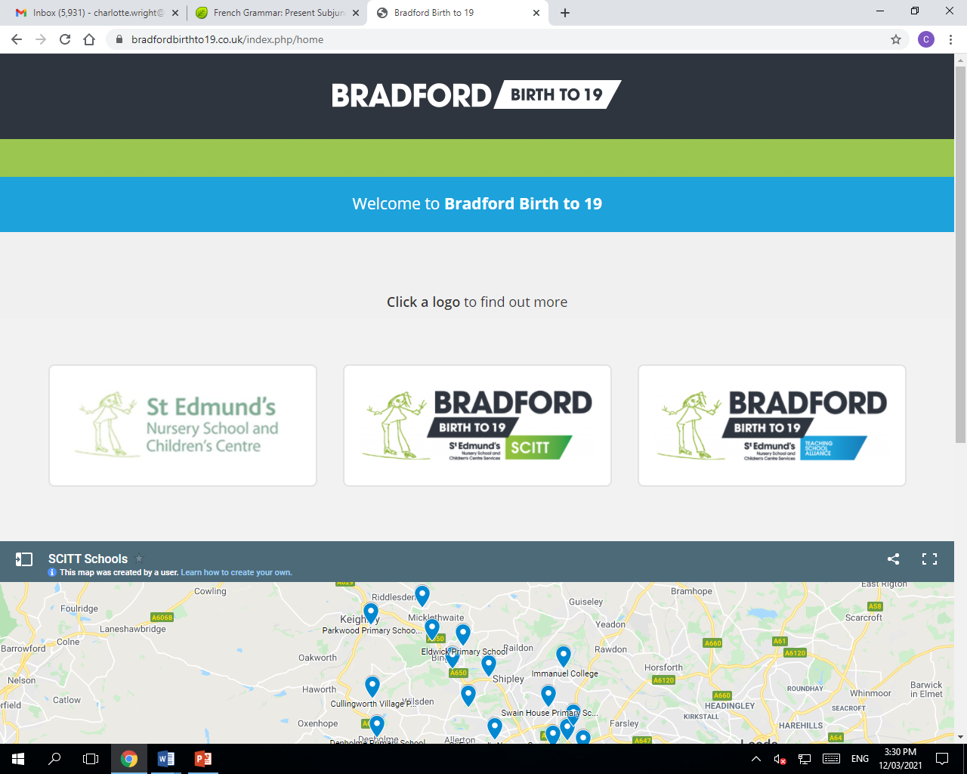

**Secondary PGCE – MFL**

¡Hola! Bonjour!

Welcome to the secondary PGCE MFL course! We are looking forward to welcoming you as a trainee teacher with Bradford Birth to 19 SCITT. In preparation for your course in September, please read the information provided in this letter and complete any suggested reading or pre-course tasks.

**Pre-course tasks**

Familiarise yourself with current GCSE exam specifications for Spanish and/or French (AQA / Edexcel). Look at past GCSE papers for Reading, Writing, Listening and Speaking at both Higher tier and Foundation tier. This will give you a clear understanding of what is expected at GCSE level.

Go through a GCSE Spanish and/or French revision guide and gain an insight into the different topic areas and key vocabulary covered at GCSE level. Have a go at these GCSE-level tasks yourself to test your current subject knowledge. Do the same with an A-level Spanish and/or French revision guide to get a flavour for post-16 languages.

Gain a clear understanding of current educational issues by reading articles on the T.E.S website (Times Educational Supplement). It is important that you have a good understanding of the current educational climate prior to embarking on your teacher-training journey.

**Pre-course reading**

The following texts provide interesting and creative ideas regarding secondary MFL teaching. You might find it useful to read these books and make a note of language-learning

Conti, Gianfranco (2019) Breaking the Sound Barrier: Teaching Languages Learners How to Listen

Pachler, Norbert (2013) Learning to Teacher Foreign Languages in the Secondary School.

Smith, Steven (2017) Becoming and Outstanding Languages Teacher

Smith, Steven; Conti, Gianfranco (2021) Memory: What Every Language Teacher Should Know

**Pre-course subject-knowledge audit**

Before starting your training, please complete the subject knowledge audit. This will provide you with a clear picture of which subject areas you need to develop prior to teaching. For languages, there a number of great websites and apps which you could use to help boost your subject knowledge:

www.duolingo.com

www.quizlet.com

www.conjuguemos.com

www.studyspanish.com

www.senecalearning.com

We are really looking forward to welcoming you onto the course and we hope that this letter has provided you with helpful pre-course information and resources. If you have any further questions regarding the course, please don’t hesitate to contact Bradford Birth to 19 SCITT.

See you soon!