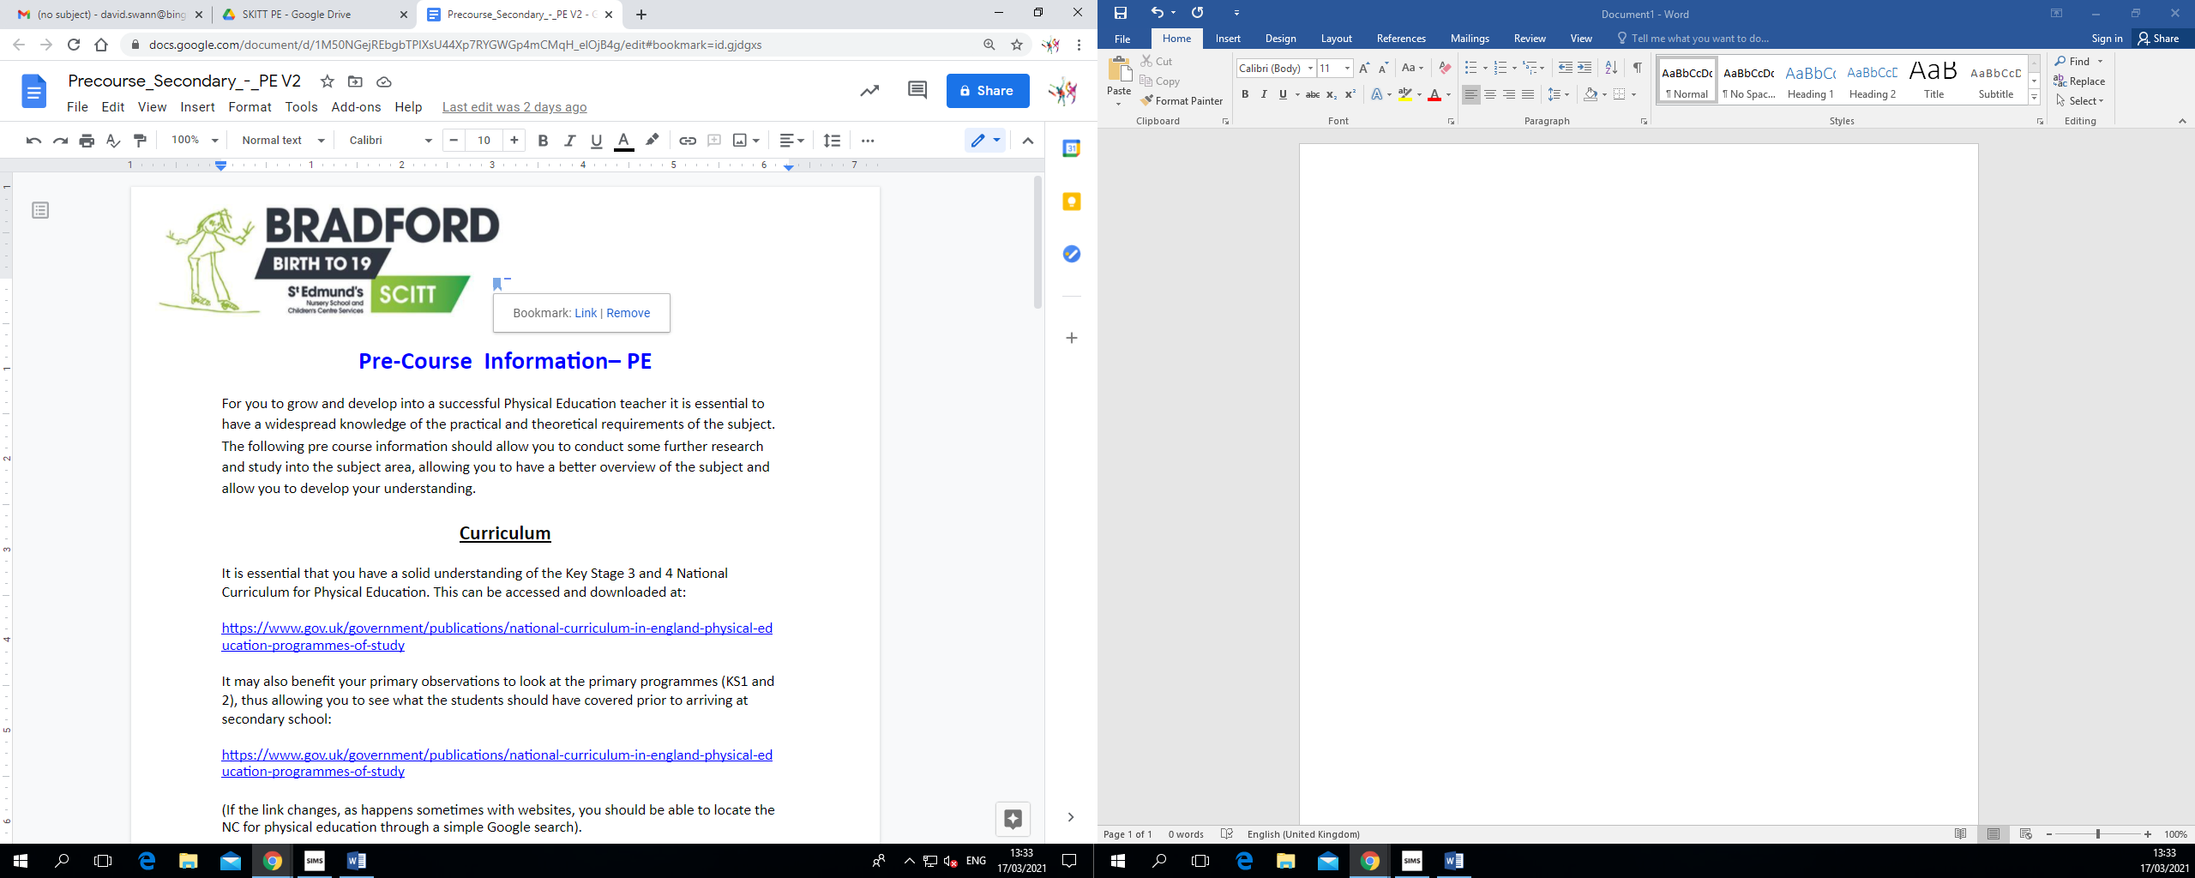

**Pre-Course Information– PE**

For you to grow and develop into a successful Physical Education teacher it is essential to have a widespread knowledge of the practical and theoretical requirements of the subject. The following pre course information should allow you to conduct some further research and study into the subject area, allowing you to have a better overview of the subject and allow you to develop your understanding.

**Curriculum**

It is essential that you have a solid understanding of the Key Stage 3 and 4 National Curriculum for Physical Education. This can be accessed and downloaded at:

<https://www.gov.uk/government/publications/national-curriculum-in-england-physical-education-programmes-of-study>

It may also benefit your primary observations to look at the primary programmes (KS1 and 2), thus allowing you to see what the students should have covered prior to arriving at secondary school:

<https://www.gov.uk/government/publications/national-curriculum-in-england-physical-education-programmes-of-study>

(If the link changes, as happens sometimes with websites, you should be able to locate the NC for physical education through a simple Google search).

**Practical Subject Knowledge**

By the end of the course you need to be able to demonstrate secure knowledge and understanding in all practical areas of the Physical Education National Curriculum.

The STEPS TO SUCCESS SERIES (Human Kinetics) offers a sound and comprehensive approach to the delivery of practical sessions across a range of sports, focusing on technique, including progression of skills, concepts and strategies.

In addition, accessing a range of National Governing body websites can help with rules and initiatives that are designed to raise skill levels and participation within their activity.

**Guidance for GCSE Physical Education:**

The following links are to allow you to develop a broad understanding of the components of the variety of GCSE PE courses available.

<https://www.gov.uk/government/publications/gcse-physical-education>

**OCR:**

<http://www.ocr.org.uk/Images/234822-specification-accredited-gcse-physicaleducation-j587.pdf>

**AQA:**

<http://www.aqa.org.uk/subjects/physical-education/gcse/physical-education-8582>

**Pearson Edexcel/ London Examinations:**

<https://qualifications.pearson.com/en/qualifications/edexcel-gcses/physical-education2016.html>

**Other useful sites for school physical education:**

You should find time to familiarise yourself with some of the many websites which are designed to support physical education teachers The internet is now an invaluable resource for physical education teachers, and the sooner you learn to ‘tap in’ to this resource, the better.

Youth Sport Trust: <https://www.youthsporttrust.org/>

Physical Education information: [www.teachpe.com](http://www.teachpe.com/)

**The Association for Physical Education:**

The Association for Physical Education is the main professional association for physical education teachers, which keeps physical education teachers up to date with current pedagogy, health and safety and ideas for creative and engaging teaching and learning.

It is strongly recommended that you consider becoming a member of this association. Membership to AfPE brings a broad range of additional benefits, including a journal with articles on current issues and developments within physical education, a monthly newsletter, 30% off publications and resources, insurance cover and access to a range of continuing professional development courses, workshops and conferences. Find out further details on: [www.afpe.org.uk.](http://www.afpe.org.uk/)

**Reading List**

1. Association for Physical Education (2012.) Safe Practice in Physical Education andSport 2012. Association for Physical Education.
2. Bailey, R. (ed) (2010). Physical Education for Learning. A guide for secondary schools.Continuum.
3. Bailey, R. & Kirk, D. (eds) (2009). The Routledge Physical Education Reader.Routledge.
4. Capel, S. & Whitehead, M. (eds) (2012). Debates in Physical Education. Routledge.
5. Capel, S. & Whitehead M. (eds) (2010). Learning to Teach Physical Education in the Secondary School (3rd Edition). Routledge.
6. Green, K. (2008). Understanding Physical Education. Sage Publications Ltd.
7. Green, K. & Hardman, K. (2005). Physical Education: Essential Issues. SagePublications Ltd.
8. Grout, H. & Long. G. (2009). Improving Teaching & Learning in Physical Education. McGrawHill.
9. Hayes, S. & Stidder, G. (eds) (2013). Equity & Inclusion in Physical Education & Sport (2nd Ed). Routledge.