End of topic quiz

Topic C3: Chemical Reactions

Learner Activity

Topic: C3 of J250
Total marks: 43

- Calcium forms Ca²⁺ ions. What is the formula of calcium chloride? [1 mark]
A | CaCl
B | CaCl₂
C | Ca₂Cl
D | Ca₂Cl₂
Your answer

- Which statement best describes neutralisation? [1 mark]
A | An acid reacting with an alkali and a salt to form water.
B | An acid reacting with water and a salt to form an alkali or base.
C | An acid reacting with an alkali or base to form a salt plus water.
D | An acid reacting with a salt to form an alkali or base.
Your answer

- What is the correct formula for sodium chloride? [1 mark]
A | Na₂Cl₂
B | NaCl₂
C | Na₂Cl
D | NaCl
Your answer

- Which of the following is an ionic compound? [1 mark]
A | Ammonia
B | Carbon dioxide
C | Magnesium Oxide
D | Methane
Your answer

- What are the symbols s, l, g and aq used to describe? [1 mark]
A | Chemical properties
B | Elements
C | Physical states
D | Molecules
Your answer

- Bill weighs a piece of magnesium. He then heats it in air, where it reacts with oxygen. Bill weighs the product of the reaction.
(a) | (i) | What are the chemical symbols for magnesium and oxygen? [1 mark]
 |  | Magnesium
 |  | Oxygen
 | (ii) | Write a balanced symbol equation for the reaction of magnesium with oxygen.  [1 mark]
(b) | (i) | How much product is made if 5.0g of magnesium reacts with 5.0 g of oxygen?  [4 marks]  Give your answer to 2 significant figures.

- Jill mixes ethanoic acid and sodium carbonate together. She measures the temperature of the reaction and draws a graph of the energy against progress of reaction.
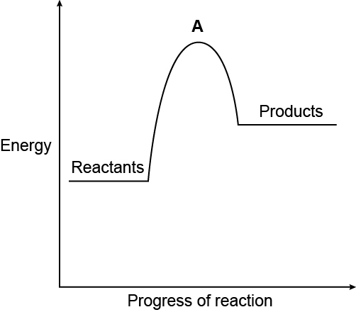
(a) | (i) | What is the type of reaction in Jill’s experiment? [1 mark]
 | (ii) | Why does the graph peak at A? [2 marks]
(b) | (i) | Jill does another experiment. She notices the reaction mixture gets warm. Sketch the reaction profile below for this experiment. [2 marks]
 | (ii) | How and why are endothermic and exothermic reactions different? [4 marks]

- Manraj studies how iron is extracted from iron ore in his science lesson. His teacher writes this equation on the board.
Fe₂O₃ + 3CO 2Fe + 3CO₂
(a) | (i) | Define the term ‘oxidation’. [1 mark]
 | (ii) | Manraj’s teacher says there is a reducing agent in this reaction.  Which substance is the reducing agent in this reaction? What does it do?  [2 marks]
(b) | (i) | Which reactant is reduced? [1 mark]
 | (ii) | Complete the half equation for this reaction. [1 mark]
 |  | 2Fe ³⁺ +………. e⁻ ………. Fe

- pH scales are often used in laboratories.
(a) |  | Complete the sentences. Use the words from the list below. [2 marks]  hydrogen acidity hydroxide alkalinity alkali corrosive
The pH scale is used to measure the relative …………….….or.........................
of a substance.
Acids form ....................... ions when they dissolve in water, and solutions of
alkalis contain ......................... ions.
(b) |  | Why is water formed in neutralisation reactions? [1 mark]
(c) |  | A bottle is labelled as concentrated acid and has a hazard symbol on it.  What does the term ‘concentrated’ mean? [1 mark]

- The picture shows electrolysis of sodium chloride solution.
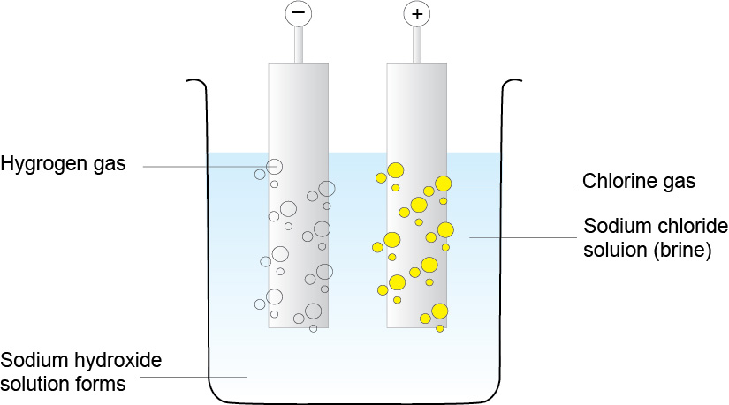
(a) | (i) | The electrolysis reaction above uses inert electrodes. What does ‘inert’ mean?  [1 mark]
 | (ii) | At which electrode do the cations form? [1 mark]
(b) | (i) | What are the products of electrolysis of sodium chloride solution? [3 marks]
 | (ii) | In electrolysis, what happens at each electrode? [2 marks]

- Neutralisation can be used to produce salts.
Sodium hydroxide and sulfuric acid react together to produce sodium sulfate.
(a) |  | Complete the balanced symbol equation. [1 mark]
 |  | ..........NaOH + H₂SO₄ ……………... + 2H₂O
(b) |  | What is mass sodium hydroxide needed to make 25.0g of sodium sulfate?  [3 marks]  Use the periodic table to help you.
- Combustion is another type of chemical reaction. Hydrogen can be oxidised by combustion.
Bond | Bond Energy (kJ/mol)
H-H | 426
O=O | 495
H-O-H | 920

(a) |  | Using the bond energies in the table above, show that the oxidation of hydrogen is exothermic. [3 marks]

