# End of topic quiz

# Topic C4: Predicting chemical reactions

## Learner Activity

### Topic: C4 of J250

**Total marks: 40**

1. Which group of elements in the Periodic Table are unreactive? **[1 mark]**

|  |  |  |
| --- | --- | --- |
| **A** | Group 7 |  |
| **B** | Group 1 |  |
| **C** | Group 0 |  |
| **D** | Group 4 |  |

Your answer

1. Which of the statements is a property of Group 0? **[1 mark]**

|  |  |  |
| --- | --- | --- |
| **A** | High density |  |
| **B** | High boiling points |  |
| **C** | Low boiling points |  |
| **D** | Malleable |  |

Your answer

1. What colour flame is produced when potassium reacts with water? **[1 mark]**

|  |  |  |
| --- | --- | --- |
| **A** | Blue |  |
| **B** | Lilac |  |
| **C** | Orange |  |
| **D** | Red |  |

Your answer

1. Which of the statements is a trend of Group 7 elements? **[1 mark]**

|  |  |  |
| --- | --- | --- |
| **A** | Elements change state from liquid to gas as you go down the group |  |
| **B** | Melting and boiling points increase as you go down the group |  |
| **C** | Melting and boiling points decrease as you go down the group |  |
| **D** | Colour of the elements get lighter as you go down the group |  |

Your answer

1. What colour is astatine, a Group 7 element? **[1 mark]**

|  |  |  |
| --- | --- | --- |
| **A** | Black |  |
| **B** | Lilac |  |
| **C** | Purple |  |
| **D** | Red |  |

Your answer

1. Fluorine reacts with iron wool to form iron(III)fluoride.

Which equation is the balance symbol equation for this reaction? **[1 mark]**

|  |  |  |
| --- | --- | --- |
| **A** | F2 + Fe FeF3 |  |
| **B** | F + Fe FeF |  |
| **C** | 3F2 + 2Fe 2FeF3 |  |
| **D** | 3F + Fe FeF3 |  |

Your answer

1. Group 7 elements are also known as the halogens.

|  |  |  |  |
| --- | --- | --- | --- |
| **(a)** | **(i)** | They react with Group 1 metals to produce white salts.  Write the word equation for the reaction of lithium with chlorine. **[1 mark]** | |
|  |  |  | |
|  |  |  |  |
|  | **(ii)** | Write the balanced symbol equation for this reaction. **[2 marks]** | |
|  |  |  | |
|  |  |  |  |
|  | **(iii)** | What happens to the outer shell of electrons of chlorine when it reacts with lithium? **[2 marks]** | |
|  |  |  | |
|  |  |  |  |
| **(b)** | **(i)** | Write the word and balanced symbol equation for the reaction of chlorine with sodium bromide. **[2 marks]** | |
|  |  |  | |
|  |  |  |  |
|  | **(ii)** | What is the type of reaction shown in **(b)(i)** and why does it happen? **[2 marks]** | |
|  |  |  | |

|  |  |  |  |  |  |  |  |  |  |  |  |  |
| --- | --- | --- | --- | --- | --- | --- | --- | --- | --- | --- | --- | --- |
| **(c)** |  | Group 7 elements react with hydrogen. The results are in the table below.   | **Elements** | **Reaction with hydrogen** | | --- | --- | | Bromine | Mild explosion with a flame | | Iodine | Only combine partially | | Fluorine | Combines explosively | | Chlorine | Explode if exposed to sunlight or flame |   Using the information above put the elements in order from most reactive to least reactive. **[1 mark]** |
|  |  |  |

1. The most well know Group 0 element is helium.

|  |  |  |  |
| --- | --- | --- | --- |
| **(a)** | **(i)** | What are the general properties of Group 0 elements? **[3 marks]** | |
|  |  |  | |
|  |  |  |  |
|  | **(ii)** | Why do Group 0 elements have these properties? **[1 mark]** | |
|  |  |  | |
|  |  |  |  |
| **(b)** | **(i)** | Helium is often used in balloons. Which property makes helium useful in balloons? [**1 mark]** | |
|  |  |  | |
|  |  |  |  |
|  | **(ii)** | Using knowledge of properties and reactivity, why is helium used in airships? **[3 marks]** | |
|  |  |  | |

1. Group 1 is located on the left side of the Periodic Table. The elements have similar properties.

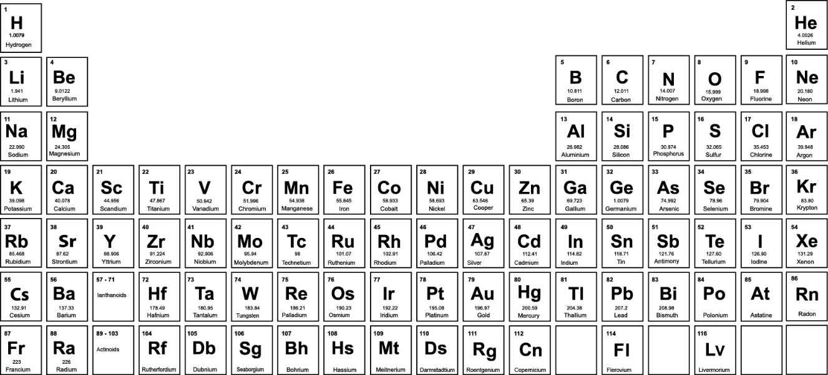

|  |  |  |  |
| --- | --- | --- | --- |
| **(a)** | **(i)** | How do Group 1 metals react with oxygen? **[1 mark]** | |
|  |  |  | |
|  |  |  |  |
|  | **(ii)** | Why is rubidium more reactive than lithium? **[2 marks]** | |
|  |  |  | |
|  |  |  |  |
| **(b)** | **(i)** | Jon does some experiments with Group 1 elements. He drops them into water. What does Jon observe when sodium is added to water? **[3 marks]** | |
|  |  |  | |
|  |  |  |  |
|  | **(ii)** | Sodium reacts with water to produce hydrogen gas and sodium hydroxide solution.  Complete the balanced symbol equation for this reaction. **[2 marks]** | |
|  |  | ...........Na + ................ 🡪 ..............H2 +…….......... | |

1. Raj adds some metals to metal salts.

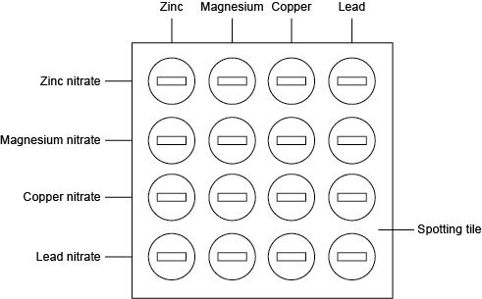

Raj records her results in the table below.

|  | **Zinc** | **Magnesium** | **Copper** | **Lead** |
| --- | --- | --- | --- | --- |
| **Zinc nitrate** | No change | Colour change | No change | No change |
| **Magnesium nitrate** | No change | No change | No change | No change |
| **Copper nitrate** | Colour change | Colour change | No change | Colour change |
| **Lead nitrate** | Colour change | Colour change | No change | No change |

|  |  |  |  |
| --- | --- | --- | --- |
| **(a)** |  | The solution of zinc nitrate does not change colour when zinc is added. Why does no change happen? **[1 mark]** | |
|  |  |  | |
|  |  |  |  |
| **(b)** |  | Why is there no change when copper is added to magnesium nitrate? **[2 marks]** | |
|  |  |  | |
|  |  |  |  |
| **(c)** |  | What is the order of reactivity of the metals? Start with the most reactive. **[2 marks]** | |
|  |  |  | |
|  |  |  |  |
| **(d)** |  | What would happen if iron is added to each of the metal salt solutions? Give a reason for your answer. **[3 marks]** | |
|  |  |  | |