# End of topic quiz

# Topic C5: Monitoring and controlling chemical reactions

## Learner Activity

### Topic: C5 of J250

**Total marks: 40**

1. During the Haber process, hydrogen and nitrogen gas are converted into ammonia.

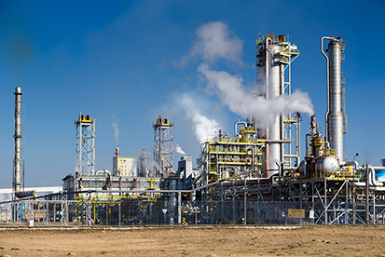

Here is the equation for the reaction.

H2 (g) + N2 (g)  2NH3 (g)

Iron is also added to the reaction. The iron acts as a catalyst.

How can a catalyst increase the rate of reaction? **[1 mark]**

|  |  |  |
| --- | --- | --- |
| **A** | Lowers the activation energy for the reaction to occur |  |
| **B** | Removes any excess reactants from the reaction |  |
| **C** | Raises the temperature of the reaction |  |
| **D** | Reduces the production of any unwanted chemicals |  |

Your answer

1. The sign  means that a reaction is… **[1 mark]**

|  |  |  |
| --- | --- | --- |
| **A** | Complete |  |
| **B** | Incomplete |  |
| **C** | Irreversible |  |
| **D** | Reversible |  |

Your answer

1. Anna tests four powders to find a catalyst for the reaction of zinc with sulphuric acid.

Zn + H2SO4 🡪 ZnSO4 + H2

Here are her results.

| **Powder** | **Powder colour at start** | **Powder colour at end** | **Volume of gas made (cm3)** |
| --- | --- | --- | --- |
| **1** | orange | orange | 5 |
| **2** | green | black | 50 |
| **3** | black | black | 50 |
| **4** | blue | blue | 30 |

Which powder is the best catalyst for the reaction? **[1 mark]**

|  |  |  |
| --- | --- | --- |
| **A** | 1 |  |
| **B** | 2 |  |
| **C** | 3 |  |
| **D** | 4 |  |

Your answer

1. Enzymes are biological catalysts, used in processes such as brewing. Yeast contains an enzyme which reacts with glucose to produce alcohol.

Which of these factors **will not** affect the rate of reaction? **[1 mark]**

|  |  |  |
| --- | --- | --- |
| **A** | Temperature |  |
| **B** | pH |  |
| **C** | Light intensity |  |
| **D** | Glucose concentration |  |

Your answer

1. A student is looking at the rate of reaction of hydrochloric acid reacting with sodium thiosulfate at different temperatures.

Here is a graph of his results.

Graph: rate of reaction of hydrochloric acid reacting with sodium thiosulfate at different temperatures

What is the trend of this graph? **[1 mark]**

|  |  |  |
| --- | --- | --- |
| **A** | The higher the temperature the slower the reaction. |  |
| **B** | The higher the temperature the faster the reaction. |  |
| **C** | The temperature does not affect the rate of reaction. |  |
| **D** | The lower the temperature the faster reaction. |  |

Your answer

1. A student sets up apparatus to measure the volume of gas produced when marble chips are reacted with hydrochloric acid.

Which piece of apparatus would you use to measure the volume of gas produced? **[1 mark]**

|  |  |  |
| --- | --- | --- |
| **A** | Beaker |  |
| **B** | Gas syringe |  |
| **C** | Pipette |  |
| **D** | Balance |  |

Your answer

1. The equation shows the reaction of copper carbonate with hydrochloric acid.

CuCO3 (s) + 2HCl(aq) CuCl2 (aq) + H2O (l) + CO2 (g)

The rate of this reaction can be increased by various different methods.

|  |  |  |  |
| --- | --- | --- | --- |
| **(a)** |  | Why will increasing the temperature of the reaction increase the rate? **[4 marks]** | |
|  |  |  | |
|  |  |  |  |
| **(b)** |  | Why will increasing the concentration of the reactants increase the rate? **[3 marks]** | |
|  |  |  | |
|  |  |  |  |
| **(c)** |  | Why will cutting the CuCO3 into smaller pieces increase the rate? **[3 marks]** | |
|  |  |  | |

1. The Haber process is where hydrogen and nitrogen are reacted to produce ammonia.

3H2 (g) + N2(g)   2NH3(g)

The production of ammonia is an **exothermic** process.

|  |  |  |  |
| --- | --- | --- | --- |
| **(a)** |  | This reaction is in **dynamic equilibrium**.  What is a dynamic equilibrium? **[1 mark]** | |
|  |  |  | |
|  |  |  |  |
| **(b)** | **(i)** | It has been found that if the reaction is heated too much the production of ammonia drops. Due to this, a compromise temperature of 450 oC is used.  Why does the yield of ammonia drop when the reaction is heated? **[2 marks]** | |
|  |  |  | |
|  |  |  |  |
|  | **(ii)** | Changing the pressure will also affect the yield of ammonia produced.  How and why should the pressure be changed to increase the yield? **[2 marks]** | |
|  |  |  | |
|  |  |  |  |
|  | **(iii)** | 10gof hydrogen reacts with excess nitrogen gas.  If only 28% of the hydrogen is converted into ammonia, what mass of ammonia is produced? Include units and give your answer to 3 significant figures.  **[5 marks]** | |
|  |  |  | |

1. During a chemical reaction, the change in concentration was recorded over the duration of the reaction.

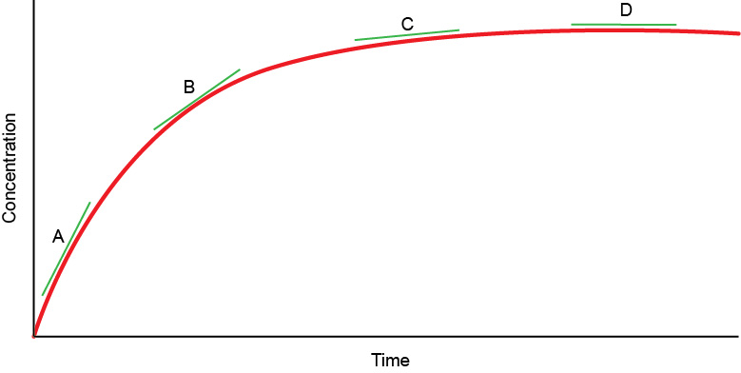

|  |  |  |  |
| --- | --- | --- | --- |
| **(a)** | **(i)** | At which part of the graph, **A**, **B** or **C**, is the rate of reaction the greatest?  **[1 mark]** | |
|  |  |  | |
|  |  |  |  |
|  | **(ii)** | What happens to the reaction at the end of the graph, **D**? **[1 mark]** | |
|  |  |  | |
|  |  |  |  |
| **(b)** |  | On the graph above, draw an additional line for a reaction using the **same quantities** of reactants, but at a lower temperature. **[2 marks]** | |
|  |  |  |  |
| **(c)** | **(i)** | A student investigates the rate of reaction for the reaction of hydrochloric acid and iron by recording the volume of hydrogen produced.  6HCl (aq) + 2Fe (s) FeCl3(aq) + H2 (g)  Here are his results.   | **Time (Mins)** | **Volume of Hydrogen (cm3)** | | --- | --- | | 0 | 0 | | 1 | 14 | | 2 | 25 | | 3 | 34 | | 4 | 36 | | 5 | 39 | | 6 | 41 | | 7 | 41 | | 8 | 41 | | 9 | 41 |   Plot a graph of the student’s results on the grid over page. **[4 marks]** | |

|  |  |  |  |
| --- | --- | --- | --- |
|  |  | **Graph paper** | |
|  |  |  |  |
|  | **(ii)** | Find the average rate of reaction from the data, or your graph. **[2 marks]** | |
|  |  |  | |

1. Catalytic converters are fitted to a car’s exhaust system to reduce pollution caused by carbon monoxide.

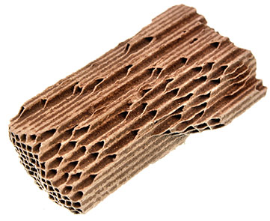

|  |  |  |  |
| --- | --- | --- | --- |
| **(a)** |  | The inside of the catalytic converter has a high surface area.  Why is this important? **[1 mark]** | |
|  |  |  | |
|  |  |  |  |
| **(b)** |  | Here is the reaction that happens in the catalytic converter between carbon monoxide and oxygen.  2CO (g) + O2(g) 2CO2 (g)  The reaction is exothermic.  Draw a reaction profile to show the effect of using a catalyst on the energy involved in the reaction. **[3 marks]** | |
|  |  |  | |