# End of topic quiz

# Topic C6: Global Challenges

## Learner Activity

### Topic: C6 of J250

**Total marks: 40**

1. Here is the reactivity series for metals.

|  |  |  |
| --- | --- | --- |
| potassium | **most reactive** | K |
| sodium |  | Na |
| calcium | Ca |
| magnesium | Mg |
| aluminium | Al |
| carbon | C |
| zinc | Zn |
| iron | Fe |
| tin | Sn |
| lead | Pb |
| hydrogen | H |
| copper | Cu |
| silver | Ag |
| gold | Au |
| platinum | **least reactive** | Pt |

An industrial company wants to extract aluminium from its ore, bauxite. How can aluminium be extracted? **[1 mark]**

|  |  |  |
| --- | --- | --- |
| **A** | Reduction with carbon |  |
| **B** | Electrolysis |  |
| **C** | Panning |  |
| **D** | No extraction required |  |

Your answer

1. Crude oil can be separated by fractional distillation.

When the oil is heated, the fractions separate. Which statement below is **not** true? **[1 mark]**

|  |  |  |
| --- | --- | --- |
| **A** | Smaller fractions are more viscous. |  |
| **B** | Smaller fractions have lower melting points. |  |
| **C** | Smaller fractions are more volatile. |  |
| **D** | Smaller fractions are more useful. |  |

Your answer

1. Cracking is widely used in the chemical industry to make shorter hydrocarbons.

Below is octane. The formula for octane is C8H18.

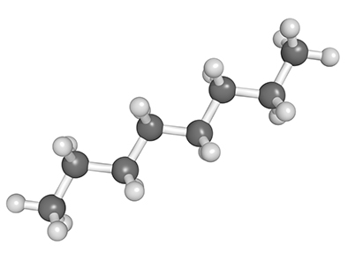

Which are possible products of cracking octane? **[1 mark]**

|  |  |  |
| --- | --- | --- |
| **A** | C4H12 and C4H12 |  |
| **B** | C3H8 and C5H12 |  |
| **C** | C2H6 and C6H12 |  |
| **D** | C4H8 and C5H10 |  |

Your answer

1. The early Earth was very different than it is today.

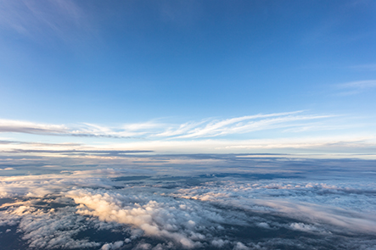

The early Earth was very hot and had much higher levels of water vapour in its atmosphere. Over time the Earth cooled and oceans formed.

By what process did the oceans form? **[1 mark]**

|  |  |  |
| --- | --- | --- |
| **A** | Evaporation |  |
| **B** | Condensation |  |
| **C** | Combustion |  |
| **D** | Decomposition |  |

Your answer

1. Over the past 200 years the amount of carbon dioxide in the atmosphere has been slowly increasing.

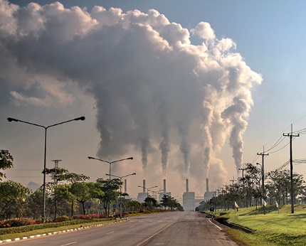

What environmental factor has the increase in carbon dioxide levels helped to cause?   
**[1 mark]**

|  |  |  |
| --- | --- | --- |
| **A** | Depletion of oil, coal and gas |  |
| **B** | Increased antibiotic resistance |  |
| **C** | Depletion of the ozone layer |  |
| **D** | Rise in the average temperature of the Earth |  |

Your answer

1. Use the reactivity series below to help you answer the following questions on extraction of metals.

|  |  |  |
| --- | --- | --- |
| potassium | **most reactive** | K |
| sodium |  | Na |
| calcium | Ca |
| magnesium | Mg |
| aluminium | Al |
| carbon | C |
| zinc | Zn |
| iron | Fe |
| tin | Sn |
| lead | Pb |
| hydrogen | H |
| copper | Cu |
| silver | Ag |
| gold | Au |
| platinum | **least reactive** | Pt |

|  |  |  |  |
| --- | --- | --- | --- |
| **(a)** | **(i)** | What industrial process can be used to extract metals **below** carbon in the reactivity series? **[1 mark]** | |
|  |  |  | |
|  |  |  |  |
|  | **(ii)** | What process can be used to extract metals **below** copper? **[1 mark]** | |
|  |  |  | |
|  |  |  |  |
| **(b)** | **(i)** | What process can be used to extract potassium? **[1 mark]** | |
|  |  |  | |
|  |  |  |  |
|  | **(ii)** | Explain how potassium can be extracted by this method? **[4 marks]** | |
|  |  |  | |
|  |  |  |  |
| **(c)** |  | Some metals can also be extracted by biological methods, such as by bioleaching and phytomining.  Write down **three** advantages and disadvantages of these methods, giving at least one of each. **[3 marks]** | |
|  |  |  | |

1. Crude oil can be purified and separated by fractional distillation. This process is essential before the hydrocarbons can be used for any other process or function.

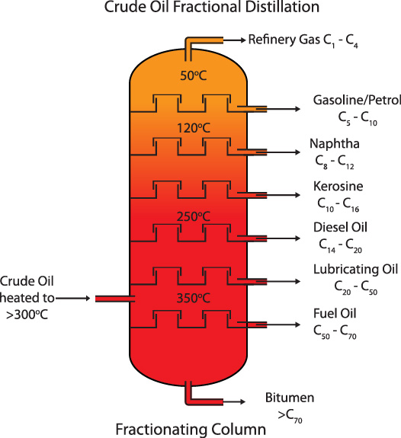

|  |  |  |  |
| --- | --- | --- | --- |
| **(a)** | **(i)** | Describe the process of fractional distillation. **[5 marks]** | |
|  |  |  | |
|  |  |  |  |
|  | **(ii)** | To which homologous series do the hydrocarbons belong? **[1 mark]** | |
|  |  |  | |
|  |  |  |  |
|  | **(iii)** | What is the general formula of this homologous series? **[1 mark]** | |
|  |  |  | |
|  |  |  |  |
| **(b)** | **(i)** | Give one use for the products of fractional distillation. **[1 mark]** | |
|  |  |  | |
|  |  |  |  |
|  | **(ii)** | How can a hydrocarbon be cracked to produce smaller molecules, and what type of molecules are formed? **[2 mark]** | |
|  |  |  | |

1. Below is a graph of how the levels of oxygen in the atmosphere have changed over time.

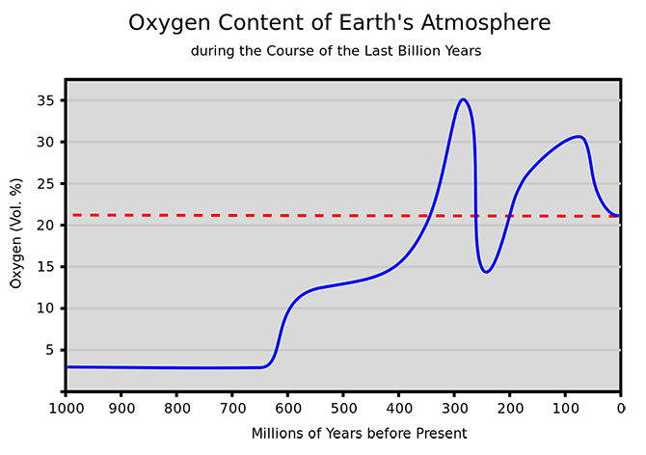

|  |  |  |  |
| --- | --- | --- | --- |
| **(a)** | **(i)** | What caused the sudden increase in oxygen levels at around 620 million years before the present day? **[2 marks]** | |
|  |  |  | |
|  |  |  |  |
|  | **(ii)** | Before the large increase in oxygen, what were the main components of the atmosphere and how was this atmosphere formed? **[2 marks]** | |
|  |  |  | |
|  |  |  |  |
| **(b)** | **(i)** | There are concerns that recent changes to the atmosphere are leading to global warming.  Name the gas most linked to global warming, and explain how this gas contributes to global warming. **[4 marks]** | |
|  |  |  | |
|  |  |  |  |
|  | **(ii)** | What evidence is there that human activity is to blame for global warming?  **[2 marks]** | |
|  |  |  | |

1. This question is about the Life Cycle Assessment (LCA) of a polymer.

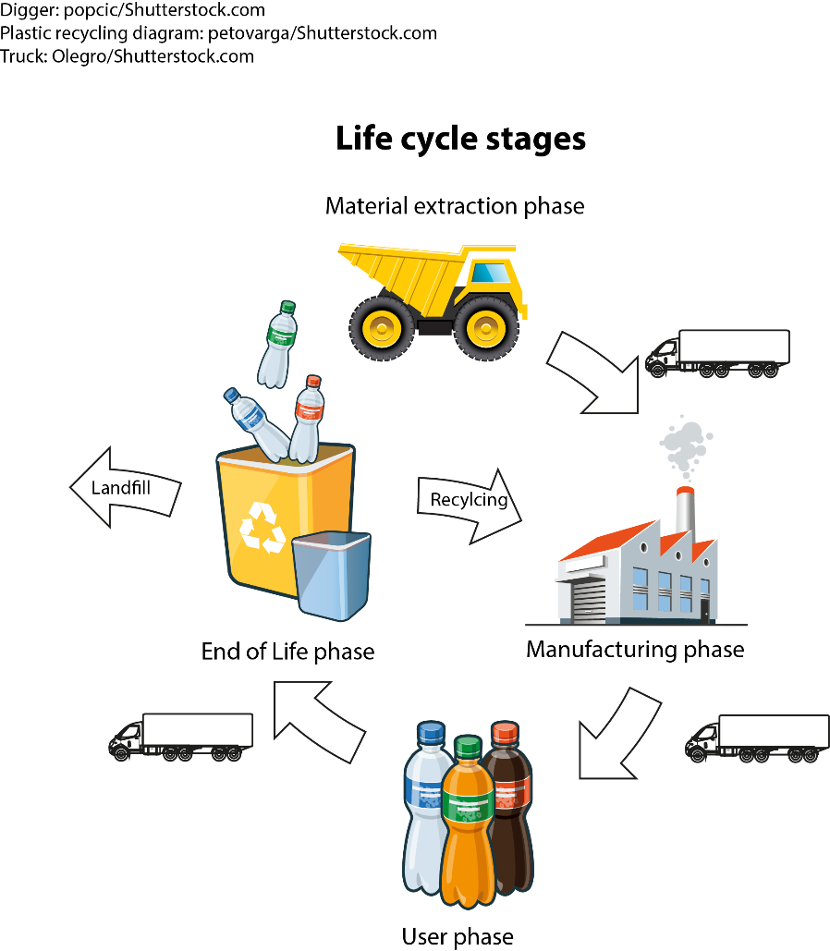

|  |  |  |  |
| --- | --- | --- | --- |
| **(a)** | **(i)** | Give **three** reasons that affect the decision about whether a material should be recycled or not. **[3 marks]** | |
|  |  |  | |
|  |  |  |  |
|  | **(ii)** | All polymers have a life-span, as indicated here in the end-of-life phase.  Give **two** environmental factors that should be considered at this point.  **[2 marks]** | |
|  |  |  | |