End of topic quiz

Topic C1 & C2: Particles & Elements, compounds and mixtures

Instructions and answers for teachers
These instructions cover the learner activity section which can be found on page 19. This end of topic quiz supports OCR GCSE (1-9) Combined Science A, topic C1 & C2.
When distributing the activity section to the learners either as a printed copy or as a Word file you will need to remove the teacher instructions section.

The Activity
This end of topic quiz comprises of 82 marks covering a range of question types. The quiz starts with some multiple choice questions and them moves on to some short answer questions and then finally on to some longer answer questions.
The question worksheet can be used to consolidate understanding at the end of teaching the chapter, to revisit and refresh knowledge at a later point in the course, or during exam preparation.

Learning Outcomes
This end of topic quiz relates to the specification learning outcomes in Topic C1 & C2: Particles & Elements, compounds and mixtures. The quiz covers the following topics:
C1.1 The particle model
C1.2 Atomic structure
C2.1 Purity and separating mixtures
C2.2 Bonding
C2.3 Properties of materials

Topic: C1 & C2 of J250 - Answers
Total marks: 82

- The table shows the melting points and boiling points of a number of different elements and compounds.
Substance | Melting point (ºC) | Boiling point (ºC)
Bromine | -7 | 58
Iodine | 114 | 183
Krypton | -157 | -153
Mercury | -39 | 357
Radon | -70 | -60
pentane | --130 | 36

Which substances are liquid at room temperature? [1 mark]
A | Iodine, krypton and radon
B | Bromine, krypton and radon
C | Mercury and pentane only
D | Bromine, mercury and pentane
Your answer
D

- What is the relative formula mass (Mr) for the compound Na₂CO₃.10H₂O? [1 mark]
A | 286
B | 180
C | 106
D | 83
Your answer
A

- The following statements describe the properties of different substances.
Which statement, A, B, C or D, describes a metal? [1 mark]
A | Shiny, black, brittle, low density, melting point of 3550ºC, conducts electricity when solid
B | Shiny, grey, bends easily, melting point of 1538ºC, conducts electricity when solid
C | White, brittle, melting point of 801ºC, conducts electricity when molten
D | Dull grey, brittle, melting point of 114ºC, does not conduct electricity
Your answer
B

- Reactions can involve either physical changes or chemical changes.
Which answer contains chemical changes only? [1 mark]
A | Iron rusting, dissolving sugar in water and fireworks exploding
B | Eggs cooking, methane burning and bread rising
C | Burning a sugar cube, toasting bread and breaking a test tube
D | Ice-cream melting, iodine changing colour in the presence of starch and milk going sour
Your answer
B

- Which of the statements A, B, C or D show the correct order of substances from the smallest to the largest? [1 mark]
A | An atom of hydrogen, a molecule of hydrogen gas, a crystal of sodium chloride, a molecule of carbon dioxide
B | A molecule of hydrogen gas, an atom of hydrogen, a crystal of sodium chloride, a molecule of carbon dioxide
C | A molecule of hydrogen gas, an atom of hydrogen, a molecule of carbon dioxide, a crystal of sodium chloride
D | An atom of hydrogen, a molecule of hydrogen gas, a molecule of carbon dioxide, a crystal of sodium chloride
Your answer
D

- The diagrams show the particles in four substances.
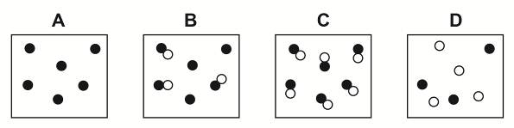
(a) | (i) | Which diagram(s) A, B, C and/or D show a ‘pure’ substance in chemical terms? [1 mark]
 |  | A and C✓
 | (ii) | Why is mineral water not classed as a ‘pure’ substance in chemistry? [1 mark]
 |  | It contains minerals/other particles in addition to water particles/ It doesn’t contain just/only water particles✓
 | (iii) | Scientists can use melting point data to distinguish pure from impure substances.  The graph shows the heating curve for a pure substance and an impure substance.  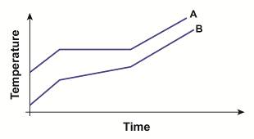  Which substance, A or B, is an impure substance? Give a reason for your answer. [2 marks]
B ✓
It has a range of melting points/the line showing the melting point is sloped ✓
(b) | (i) | Crude oil is a mixture of different substances.  The substances in crude oil can be separated using fractional distillation.  The diagram shows a fractionating column.  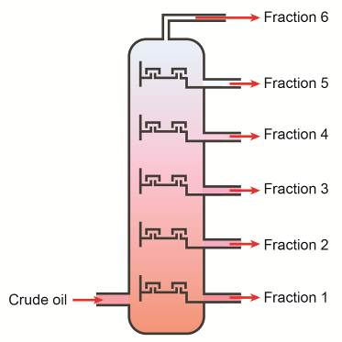  How is crude oil separated into different fractions? [4 marks]
(crude oil) heated till evaporates/boils ✓
Temperature of the column decreases up the column ✓
Vapours/gases condense/turn back to liquid at different temperatures ✓
Each fraction/substance has a different boiling point ✓

 | (ii) | How is fraction 1 different to fraction 6? [4 marks]
Any four from:
Fraction 1:
Larger molecules ✓
Higher boiling point ✓
Less volatile ✓
More viscous ✓
Less flammable✓
Darker ✓
Denser ✓
OR similar for fraction 6
(c) | (i) | Many useful materials, particularly metals are formulations of mixtures.  What name do we give a substance such as brass and bronze that is a mixture of elements, at least one being a metal? [1 mark]
 |  | Alloy✓
 | (ii) | Mild steel is made by adding up to 0.25% carbon to iron.  Mild steel is more suitable than iron when building bridges, car bodies and ships.  What properties does mild steel have as a result of adding carbon that makes it more suitable for these structural purposes? [2 marks]
Increased hardness/harder ✓
Increased strength/stronger✓
 | (iii) | Iron can also be mixed with chromium and nickel to make stainless steel.  Stainless steel is often used to make cutlery (knives, forks and spoons).  What property does the stainless steel have that iron does not, allowing it to be used as cutlery? [1 mark]
 |  | (stainless steel) resists corrosion/doesn’t rust✓

- The image is a diagrammatic representation of an atom.
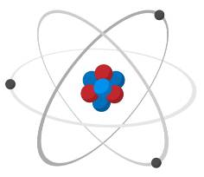
(a) | (i) | An atom of an element is made up of electrons, protons and another sub-atomic particle. What is this other sub-atomic particle? [1 mark]
 |  | Neutrons✓
 | (ii) | Where in the atom is this sub-atomic particle found? [1 mark]
 |  | Nucleus✓
(b) | (i) | Draw the electron configuration of a potassium atom on the diagram below.  Use the periodic table to help. [2 marks]
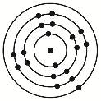
Correct number of electrons✓
Correct number of electrons in each shell✓
 | (ii) | Potassium reacts with chlorine to form the ionic compound potassium chloride. How does this happen? [5 marks]
Potassium loses its outer electron ✓
Potassium ion now has a 1 positive/+/1+/+1 charge ✓
(chlorine) gains one electron ✓
Chloride ion now has a 1 negative/1-/-1/- charge ✓
Strong attraction between the two ions/an ionic bond forms ✓
(c) | (i) | Sodium can also react with chlorine to make the ionic compound sodium chloride.  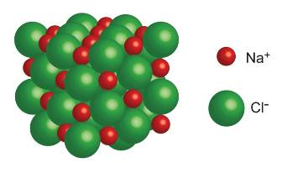  Sodium chloride has a high melting point of 801ºC and conducts electricity when molten.  A chlorine atom can also react with another chlorine atom to form chlorine gas.  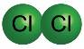  Chlorine gas has a low melting point of -101.5ºC and does not conduct electricity at all.  Both compounds contain chlorine but sodium chloride has a high melting point and chlorine gas has a low melting point.  Why is this? [5 marks]

In sodium chloride the (ionic) bonds between ions are strong in all directions ✓
So lots of energy required to break them ✓
In chlorine there are strong covalent bonds between atoms ✓
But weak attractions between molecules ✓
So less energy is needed to break them ✓
 | (i) | Why does sodium chloride conduct electricity when molten or dissolved in solution but chlorine gas does not? [2 marks]
In sodium chloride the ions are free to move ✓
In chlorine, there are no ions or electrons free to move/molecules don’t have an overall charge ✓
- Water, H₂0, can be found in three states, solid ice, liquid water and steam.
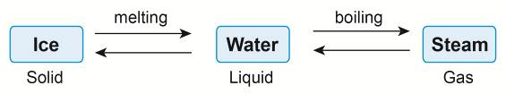
A
(a) | (i) | What is the process labelled A on the diagram? [1 mark]
 |  | Condensation ✓
 | (ii) | What are the differences in the particles in water compared with steam? [2 marks]
In water particles are closer together/still touching, in steam they are far apart ✓
In water particles flow/move slower than in steam/ particles in water have less energy than in steam ✓
(b) |  | Melting ice is an example of a physical change.  What are the differences between physical changes and chemical changes? [2 marks]
In chemical changes bonds are broken and created whereas in physical changes no bonds are broken/created ✓
In chemical changes one or more new substances are formed whereas in physical changes, the molecules of the substance are still the same ✓

- The Food Standards Agency has received complaints that the farmer growing tomatoes used in making an organic pasta sauce is using a pesticide that is banned for organic produce.
Scientists from the Food Standards Agency are investigating whether this pasta sauce contains a banned pesticide.
They use thin-layer chromatography (TLC) to separate out the components of the pasta sauce and compare them with four known, banned pesticides: P1, P2, P3 and P4.
The chromatogram shows their results.
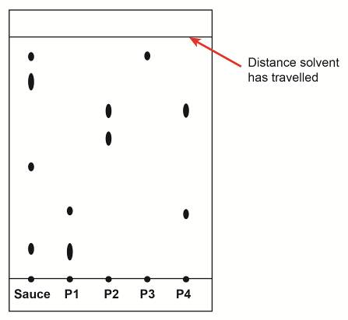

(a) |  | What is used as the stationary phase in thin-layer chromatography?  [1 mark]
 |  | Silica gel or alumina✓
(b) | (i) | Does the pasta sauce contain a banned pesticide? Give a reason for your answer. [2 marks]
Yes ✓
It contains pesticide P3/ P3 has a dot/circle/spot at the same height as the top dot/circle/spot in the pasta sauce ✓
 | (ii) | Which two other conclusions can be drawn from the chromatogram of the pasta sauce and the pesticides? [2 marks]
Two from:
The sauce is made up of 4 components/substances ✓
One of the substances is found in pesticide P1 is present in the sauce (but not the second substance in P1) ✓
No components of P2 or P4 are present in the pasta sauce ✓
 | (iii) | The distance travelled by the solvent is 14cm.  The distance moved by the ‘spot’ for pesticide P3 is 12.6cm.  What is the Rf value for this ‘spot’? [2 marks]
12.6/14✓
0.9✓
(c) |  | Which two properties of the sauce and pesticides will affect the speed they separate up the chromatogram? [2 marks]
How soluble they are in the solvent ✓
How much they ‘stick’ to the stationary phase/silica gel ✓
- The diagram shows the atomic number and mass number of two isotopes of carbon.
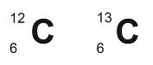
(a) | (i) | What are the similarities and differences between the two isotopes?  [3 marks]
Any three from
Same number of/6 protons/same atomic/proton number ✓
Same number of/6 electrons ✓
Different mass numbers ✓
Different number of /6 vs 7 neutrons ✓
(b) | 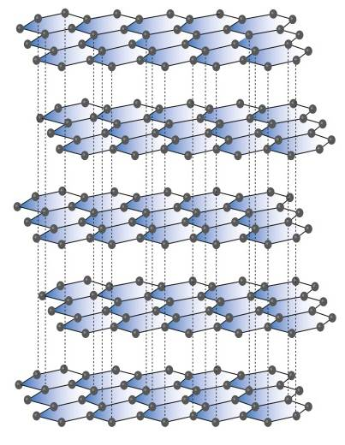  (i) | Carbon atoms can be arranged to form different giant covalent structures such as diamond, graphite and buckminsterfullerene.  The diagrams show the arrangement of carbon atoms in these three substances.  A B C  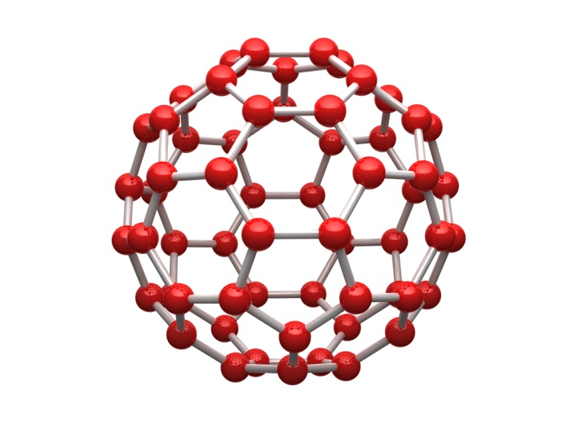  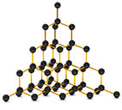  Which diagram A, B or C shows the arrangement of carbon in diamond? [1 mark]
 |  | C✓
 | (ii) | Which diagram shows the arrangement of carbon in buckminsterfullerene? [1 mark]
 |  | B✓
 | (iii) | Diamond is often used on drill bits to cut through rock when drilling for oil.  What property makes diamond a suitable material for this and how does diamond’s structure give diamond this property? [2 marks]
Very hard ✓
Each C atom bonded strongly with 4 other C atoms in different directions ✓
 | (iv) | Graphite powder is often used as a lubricant and as ‘lead’ in pencils.  How does the structure of graphite make it suitable for these uses?  [2 marks]
Strong covalent bonds between neighbouring C atoms in one layer ✓
Weak bonds/attractions between layers of C atoms allow them to slide over each other ✓
 | (v) | Why can graphite conduct electricity? [1 mark]
 |  | Free/delocalised electrons between the layers are able to move✓
 | (vi) | Buckminsterfullerene can be used to make tennis rackets.  What two properties does buckminsterfullerene have that makes it suitable for this use? [1 mark]
 |  | Strong and light✓
 | (vii) | There is another form of carbon that takes the form of a single sheet of carbon atoms, one atom thick.  What is the name given to this form of carbon? [1 mark]
 |  | Graphene✓

- An atom is the basic unit of an element.
Scientists have refined their ideas about the structure of atoms over time.
In the 1800s, the English chemist, John Dalton believed atoms were the smallest particles and that everything on Earth was made up of them. He believed they could not be broken down into anything simpler and that atoms of a particular element were all the same.
In 1904, Physicist Sir J.J. Thomson refined Dalton’s atomic model and described what was called a ‘plum-pudding’ model of the atom.
(a) |  | What is JJ Thomson’s ‘plum-pudding’ model of the atom? [1 mark]
 |  | Negative charges/electrons floating in a sea/ball of positive charges✓
(b) |  | In 1911, Ernest Rutherford designed an experiment that was carried out by his students, Geiger and Marsden.  They passed positively charged alpha particles through very thin gold leaf.  They found:  - Most of the alpha particles passed straight through the gold leaf.  - A small fraction of the alpha particles were deflected at all angles, some bouncing back towards the source of alpha particles.  How did Rutherford change J.J. Thomson’s atomic model based on these findings? [2 marks]
(atom) contains mostly space/air ✓
Positive charges were densely packed in a small volume/nucleus ✓
(c) | 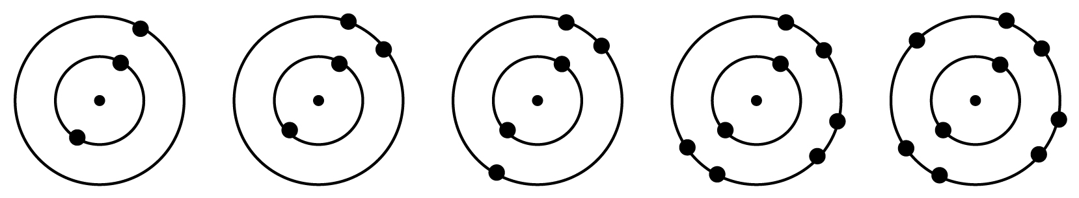 | In 1913, Niels Bohr changed Rutherford’s atomic model further by suggesting electrons orbit a nucleus in shells of differing energy levels.  The diagrams show the electron configuration of five atoms based on Bohr’s idea.  A  E  D  C  B
 | (i) | Which atom A, B, C, D or E shows an element in group 3 of the periodic table? Justify your answer. [2 marks]
C✓
It has 3 electrons in its outer shell/energy level✓
 | (ii) | All of the atoms in the diagram above are of elements in the same period of the periodic table.  Which period can they be found in? Justify your answer. [2 marks]
2/second ✓
All have 2 shells/energy levels ✓
 | (iii) | Which of the diagrams A, B, C, D and E show an atom of a metal? [1 mark]
 |  | A and B✓

 | (iv) | Metals have different physical properties to non-metals.  For example metals have high melting and boiling points whereas non-metals tend to have lower melting and boiling points.  What are three other differences in the physical properties of metals and non-metals? [3 marks]
Any three from:
Metals are good conductors of heat, non-metals are insulators ✓
Metals are good conductors of electricity, non-metals are electrical insulators✓
Metals are malleable, non-metals are brittle ✓
Metals are shiny, non-metals are dull ✓
Metals are sonorous, non-metals aren’t ✓
Metals have a high density, non-metals have a low density ✓
Metals are strong, non-metals are weaker ✓

- A scientist in a pharmaceutical company has an impure white substance that he wants to purify. The impurities are insoluble in ethanol.
He starts by dissolving the substance in ethanol.
(a) | (i) | What are the techniques he would use to separate the impurities from the pure substance and describe a method he could use to do this? [6 marks]
Filtration ✓
Crystallisation ✓
Filter the solution to remove the impurities (using filter paper and funnel)✓
Warm the solution (using a water bath) ✓
Let solution cool until crystals form ✓
Filter to remove the crystals (using filter paper and funnel) ✓

 | (ii) | Why is it important to control the purity of chemicals in the pharmaceutical sector? [2 marks]
(pharmaceuticals) are eaten/taken into/absorbed by the body ✓
Impurities could be harmful/dangerous/not safe/ scientists don’t know how the impurities may affect the body or impurities may cause (allergic) reactions ✓
OCR Resources: the small print
OCR’s resources are provided to support the teaching of OCR specifications, but in no way constitute an endorsed teaching method that is required by the Board, and the decision to use them lies with the individual teacher. Whilst every effort is made to ensure the accuracy of the content, OCR cannot be held responsible for any errors or omissions within these resources.
© OCR 2016 - This resource may be freely copied and distributed, as long as the OCR logo and this message remain intact and OCR is acknowledged as the originator of this work.
OCR acknowledges the use of the following content: Page 9 and 31: Atom – Juliar Studio/Shutterstock.com; Page 10 and 32: Sodium Chloride and chlorine atoms – magnetix/Shutterstock.com; Page 17 and 36: Graphite – magnetix/Shutterstock.com; Nano sphere – Harper 3D/Shutterstock.com; diamond – AndrisTorms/Shutterstock.com
Please get in touch if you want to discuss the accessibility of resources we offer to support delivery of our qualifications: resources.feedback@ocr.org.uk
We’d like to know your view on the resources we produce. By clicking on ‘Like’ or ‘Dislike’ you can help us to ensure that our resources work for you. When the email template pops up please add additional comments if you wish and then just click ‘Send’. Thank you.
Whether you already offer OCR qualifications, are new to OCR, or are considering switching from your current provider/awarding organisation, you can request more information by completing the Expression of Interest form which can be found here: www.ocr.org.uk/expression-of-interest
Looking for a resource? There is now a quick and easy search tool to help find free resources for your qualification:
www.ocr.org.uk/i-want-to/find-resources/

This formative assessment resource has been produced as part of our free GCSE teaching and learning support package. All the GCSE teaching and learning resources, including delivery guides, topic exploration packs, lesson elements and more are available on the qualification webpages.
If you are looking for examination practice materials, you can find the Sample Assessment Materials (SAMs) on the qualification webpage: Combined Science A (9-1).

End of topic quiz

Topic C1 & C2: Particles & Elements, compounds and mixtures

Learner Activity

Topic: C1 & C2 of J250
Total marks: 82

- The table shows the melting points and boiling points of a number of different elements and compounds.
Substance | Melting point (ºC) | Boiling point (ºC)
Bromine | -7 | 58
Iodine | 114 | 183
Krypton | -157 | -153
Mercury | -39 | 357
Radon | -70 | -60
pentane | --130 | 36

Which substances are liquid at room temperature? [1 mark]
A | Iodine, krypton and radon
B | Bromine, krypton and radon
C | Mercury and pentane only
D | Bromine, mercury and pentane
Your answer

- What is the relative formula mass (Mr) for the compound Na₂CO₃.10H₂O? [1 mark]
A | 286
B | 180
C | 106
D | 83
Your answer

- The following statements describe the properties of different substances.
Which statement, A, B, C or D, describes a metal? [1 mark]
A | Shiny, black, brittle, low density, melting point of 3550ºC, conducts electricity when solid
B | Shiny, grey, bends easily, melting point of 1538ºC, conducts electricity when solid
C | White, brittle, melting point of 801ºC, conducts electricity when molten
D | Dull grey, brittle, melting point of 114ºC, does not conduct electricity
Your answer

- Reactions can involve either physical changes or chemical changes.
Which answer contains chemical changes only? [1 mark]
A | Iron rusting, dissolving sugar in water and fireworks exploding
B | Eggs cooking, methane burning and bread rising
C | Burning a sugar cube, toasting bread and breaking a test tube
D | Ice-cream melting, iodine changing colour in the presence of starch and milk going sour
Your answer

- Which of the statements A, B, C or D show the correct order of substances from the smallest to the largest? [1 mark]
A | An atom of hydrogen, a molecule of hydrogen gas, a crystal of sodium chloride, a molecule of carbon dioxide
B | A molecule of hydrogen gas, an atom of hydrogen, a crystal of sodium chloride, a molecule of carbon dioxide
C | A molecule of hydrogen gas, an atom of hydrogen, a molecule of carbon dioxide, a crystal of sodium chloride
D | An atom of hydrogen, a molecule of hydrogen gas, a molecule of carbon dioxide, a crystal of sodium chloride
Your answer

- The diagrams show the particles in four substances.
(a) | (i) | Which diagram(s) A, B, C and/or D show a ‘pure’ substance in chemical terms? [1 mark]
 | (ii) | Why is mineral water not classed as a ‘pure’ substance in chemistry? [1 mark]
 | (iii) | Scientists can use melting point data to distinguish pure from impure substances.  The graph shows the heating curve for a pure substance and an impure substance.  Which substance, A or B, is an impure substance? Give a reason for your answer. [2 marks]
(b) | (i) | Crude oil is a mixture of different substances.  The substances in crude oil can be separated using fractional distillation.  The diagram shows a fractionating column.  How is crude oil separated into the different fractions? [4 marks]
 | (ii) | How is fraction 1 different to fraction 6? [4 marks]
(c) | (i) | Many useful materials, particularly metals are formulations of mixtures.  What name do we give a substance such as brass and bronze that is a mixture of elements, at least one being a metal? [1 mark]
 | (ii) | Mild steel is made by adding up to 0.25% carbon to iron.  Mild steel is more suitable than iron when building bridges, car bodies and ships.  What properties does mild steel have as a result of adding carbon that makes it more suitable for these structural purposes? [2 marks]
 | (iii) | Iron can also be mixed with chromium and nickel to make stainless steel.  Stainless steel is often used to make cutlery (knives, forks and spoons).  What property does the stainless steel have that iron does not, allowing it to be used as cutlery? [1 mark]

- The image is a diagrammatic representation of an atom.
(a) | (i) | An atom of an element is made up of electrons, protons and another sub-atomic particle. What is this other sub-atomic particle? [1 mark]
 | (ii) | Where in the atom is this sub-atomic particle found? [1 mark]
(b) | (i) | Draw the electron configuration of a potassium atom on the diagram below.  Use the periodic table to help. [2 marks]
 |  | 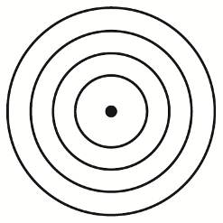
 | (ii) | Potassium reacts with chlorine to form the ionic compound potassium chloride. How does this happen? [5 marks]
(c) | (i) | Sodium can also react with chlorine to make the ionic compound sodium chloride.  Sodium chloride has a high melting point of 801ºC and conducts electricity when molten.  A chlorine atom can also react with another chlorine atom to form chlorine gas.  Chlorine gas has a low melting point of -101.5ºC and does not conduct electricity at all.  Both compounds contain chlorine but sodium chloride has a high melting point and chlorine gas has a low melting point.  Why is this? [5 marks]

 | (i) | Why does sodium chloride conduct electricity when molten or dissolved in solution but chlorine gas does not? [2 marks]

- Water, H₂0, can be found in three states, solid ice, liquid water and steam.
A
(a) | (i) | What is the process labelled A on the diagram? [1 mark]
 | (ii) | What are the differences in particles in water compared with particles in steam? [2 marks]
(b) | (i) | Melting ice is an example of a physical change.  What are the differences between physical changes and chemical changes? [2 marks]

- The Food Standards Agency has received complaints that the farmer growing tomatoes used in making an organic pasta sauce is using a pesticide that is banned for organic produce.
Scientists from the Food Standards Agency are investigating whether this pasta sauce contains a banned pesticide.
They use thin-layer chromatography (TLC) to separate out the components of the pasta sauce and compare them with four known, banned pesticides: P1, P2, P3 and P4.
The chromatogram shows their results.

(a) |  | What is used as the stationary phase in thin-layer chromatography? [1 mark]
(b) | (i) | Does the pasta sauce contain a banned pesticide? Give a reason for your answer. [2 marks]
 | (ii) | Which two other conclusions can be drawn from the chromatogram of the pasta sauce and the pesticides? [2 marks]
 | (iii) | The distance travelled by the solvent is 14cm.  The distance moved by the ‘spot’ for pesticide P3 is 12.6cm.  What is the Rf value for this ‘spot’? [2 marks]
(c) |  | Which two properties of the sauce and pesticides will affect the speed they separate up the chromatogram? [2 marks]
- The diagram shows the atomic number and mass number of two isotopes of carbon.
(a) | (i) | What are the similarities and differences between the two isotopes? [3 marks]
(b) | (i) | Carbon atoms can be arranged to form different giant covalent structures such as diamond, graphite and buckminsterfullerene.  The diagrams show the arrangement of carbon atoms in these three substances.  A B C  Which diagram A, B or C shows the arrangement of carbon in diamond? [1 mark]
 | (ii) | Which diagram shows the arrangement of carbon in buckminsterfullerene? [1 mark]
 | (iii) | Diamond is often used on drill bits to cut through rock when drilling for oil.  What property makes diamond a suitable material for this and how does diamond’s structure give diamond this property? [2 marks]
 | (iv) | Graphite powder is often used as a lubricant and as ‘lead’ in pencils.  How does the structure of graphite make it suitable for these uses?  [2 marks]
 | (v) | Why can graphite conduct electricity? [1 mark]
 | (vi) | Buckminsterfullerene can be used to make tennis rackets.  What two properties does buckminsterfullerene have that makes it suitable for this use? [1 mark]
 | (vii) | There is another form of carbon that takes the form of a single sheet of carbon atoms, one atom thick.  What is the name given to this form of carbon? [1 mark]

- An atom is the basic unit of an element.
Scientists have refined their ideas about the structure of atoms over time.
In the 1800s, the English chemist, John Dalton believed atoms were the smallest particles and that everything on Earth was made up of them. He believed they could not be broken down into anything simpler and that atoms of a particular element were all the same.
In 1904, Physicist Sir J.J. Thomson refined Dalton’s atomic model and described what was called a ‘plum-pudding’ model of the atom.
(a) |  | What is JJ Thomson’s ‘plum-pudding’ model of the atom? [1 mark]
(b) |  | In 1911, Ernest Rutherford designed an experiment that was carried out by his students, Geiger and Marsden.  They passed positively charged alpha particles through very thin gold leaf.  They found:  - Most of the alpha particles passed straight through the gold leaf.  - A small fraction of the alpha particles were deflected at all angles, some bouncing back towards the source of alpha particles.  How did Rutherford change J.J. Thomson’s atomic model based on these findings? [2 marks]
(c) |  | In 1913, Niels Bohr changed Rutherford’s atomic model further by suggesting electrons orbit a nucleus in shells of differing energy levels.  The diagrams show the electron configuration of five atoms based on Bohr’s idea.  A  E  D  C  B
 | (i) | Which atom A, B, C, D or E shows an element in group 3 of the periodic table? Justify your answer. [2 marks]
 | (ii) | All of the atoms in the diagram above are of elements in the same period of the periodic table.  Which period can they be found in? Justify your answer. [2 marks]
 | (iii) | Which of the diagrams A, B, C, D and E show an atom of a metal? [1 mark]
 | (iv) | Metals have different physical properties to non-metals.  For example metals have high melting and boiling points whereas non-metals tend to have lower melting and boiling points.  What are three differences in the physical properties of metals and non-metals? [3 marks]

- A scientist in a pharmaceutical company has an impure white substance that he wants to purify. The impurities are insoluble in ethanol.
He starts by dissolving the substance in ethanol.
(a) | (i) | What are the techniques he would use to separate the impurities from the pure substance and describe a method he could use to do this? [6 marks]
 | (ii) | Why is it important to control the purity of chemicals in the pharmaceutical sector? [2 marks]

