# End of topic quiz

# Topic C6: Global Challenges

## Instructions and answers for teachers

These instructions cover the learner activity section which can be found on page 11. This end of topic quiz supports OCR GCSE (9–1) Combined Science A (J250), Topic C6.

**When distributing the activity section to the learners either as a printed copy or as a Word file you will need to remove the teacher instructions section.**

### The Activity

This end of topic quiz comprises of 40 marks covering a range of question types. The quiz starts with some multiple choice questions and then moves on to some short answer questions and then finally on to some longer answer questions.

The question worksheet can be used to consolidate understanding at the end of teaching the chapter, to revisit and refresh knowledge at a later point in the course, or during exam preparation.

### Learning Outcomes

This end of topic quiz relates to the specification learning outcomes in Topic C6: Global Challenges. The quiz covers the following topics:

C6.1 Improving processes and products

C6.2 Interpreting and interacting with earth systems

### Topic: C6 of J250 - Answers

**Total marks: 40**

1. Here is the reactivity series for metals.

|  |  |  |
| --- | --- | --- |
| potassium | **most reactive** | K |
| sodium |  | Na |
| calcium | Ca |
| magnesium | Mg |
| aluminium | Al |
| carbon | C |
| zinc | Zn |
| iron | Fe |
| tin | Sn |
| lead | Pb |
| hydrogen | H |
| copper | Cu |
| silver | Ag |
| gold | Au |
| platinum | **least reactive** | Pt |

An industrial company wants to extract aluminium from its ore, bauxite. How can aluminium be extracted? **[1 mark]**

|  |  |  |
| --- | --- | --- |
| **A** | Reduction with carbon |  |
| **B** | Electrolysis |  |
| **C** | Panning |  |
| **D**  **B** | No extraction required |  |

Your answer

1. Crude oil can be separated by fractional distillation.

When the oil is heated, the fractions separate. Which statement below is **not** true? **[1 mark]**

|  |  |  |
| --- | --- | --- |
| **A** | Smaller fractions are more viscous. |  |
| **B** | Smaller fractions have lower melting points. |  |
| **C** | Smaller fractions are more volatile. |  |
| **D**  **A** | Smaller fractions are more useful. |  |

Your answer

1. Cracking is widely used in the chemical industry to make shorter hydrocarbons.

Below is octane. The formula for octane is C8H18.

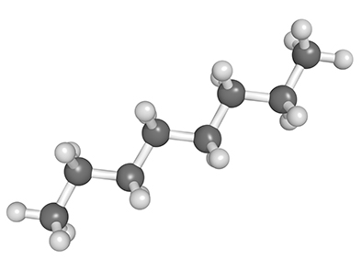

Which are possible products of cracking octane? **[1 mark]**

|  |  |  |
| --- | --- | --- |
| **A** | C4H12 and C4H12 |  |
| **B** | C3H8 and C5H12 |  |
| **C** | C2H6 and C6H12 |  |
| **D**  **C** | C4H8 and C5H10 |  |

Your answer

1. The early Earth was very different than it is today.



The early Earth was very hot and had much higher levels of water vapour in its atmosphere. Over time the Earth cooled and oceans formed.

By what process did the oceans form? **[1 mark]**

|  |  |  |
| --- | --- | --- |
| **A** | Evaporation |  |
| **B** | Condensation |  |
| **C** | Combustion |  |
| **D**  **B** | Decomposition |  |

Your answer

1. Over the past 200 years the amount of carbon dioxide in the atmosphere has been slowly increasing.

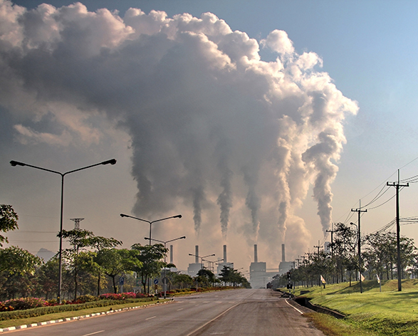

What environmental factor has the increase in carbon dioxide levels helped to cause?   
**[1 mark]**

|  |  |  |
| --- | --- | --- |
| **A** | Depletion of oil, coal and gas |  |
| **B** | Increased antibiotic resistance |  |
| **C** | Depletion of the ozone layer |  |
| **D** | Rise in the average temperature of the Earth |  |

Your answer

**D**

1. Use the reactivity series below to help you answer the following questions on extraction of metals.

|  |  |  |
| --- | --- | --- |
| potassium | **most reactive** | K |
| sodium |  | Na |
| calcium | Ca |
| magnesium | Mg |
| aluminium | Al |
| carbon | C |
| zinc | Zn |
| iron | Fe |
| tin | Sn |
| lead | Pb |
| hydrogen | H |
| copper | Cu |
| silver | Ag |
| gold | Au |
| platinum | **least reactive** | Pt |

|  |  |  |  |
| --- | --- | --- | --- |
| **(a)** | **(i)** | What industrial process can be used to extract metals **below** carbon in the reactivity series? **[1 mark]** | |
|  |  | Reduction with carbon ✓ | |
|  |  |  |  |
|  | **(ii)** | What process can be used to extract metals **below** copper? **[1 mark]** | |
|  |  | Panning/no process required ✓ | |
|  |  |  |  |
| **(b)** | **(i)** | What process can be used to extract potassium? **[1 mark]** | |
|  |  | Electrolysis ✓ | |
|  |  |  |  |
|  | **(ii)** | Explain how potassium can be extracted by this method? **[4 marks]** | |
|  |  | Ore containing potassium is melted ✓  When melted, potassium ions are free to move ✓  (Positive) potassium ions are attracted to cathode or negative electrode ✓  The positive potassium ions gain one electron or are reduced and potassium metal is formed at the cathode or negative electrode ✓ | |
|  |  |  |  |
| **(c)** |  | Some metals can also be extracted by biological methods, such as by bioleaching and phytomining.  Write down **three** advantages and disadvantages of these methods, giving at least one of each. **[3 marks]** | |
|  |  | One advantage, one disadvantage and one other point  Advantages:   * Able to obtain metals from low yield ores ✓ * Energy efficient ✓ * No greenhouse gas emissions ✓   Disadvantages:   * Slow ✓ * Small quantities produced ✓ | |

1. Crude oil can be purified and separated by fractional distillation. This process is essential before the hydrocarbons can be used for any other process or function.

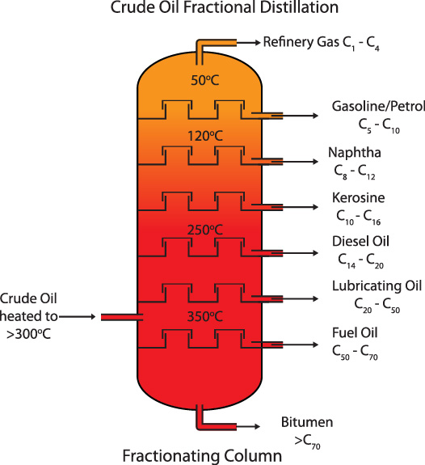

|  |  |  |  |
| --- | --- | --- | --- |
| **(a)** | **(i)** | Describe the process of fractional distillation. **[5 marks]** | |
|  |  | Crude oil is heated ✓  Crude oil vaporises ✓  As hydrocarbons travel up column they cool down and condense ✓  Smaller hydrocarbons have lowest boiling points and go to the top of the column ✓  Largest hydrocarbons do not vaporise and are collected at the bottom of the column ✓ | |
|  |  |  |  |
|  | **(ii)** | To which homologous series do the hydrocarbons belong? **[1 mark]** | |
|  |  | Alkanes ✓ | |
|  |  |  |  |
|  | **(iii)** | What is the general formula of this homologous series? **[1 mark]** | |
|  |  | CnH2n+2 ✓ | |
|  |  |  |  |
| **(b)** | **(i)** | Give one use for the products of fractional distillation. **[1 mark]** | |
|  |  | Any one from:   * Making plastics ✓ * Petrol/diesel in vehicles ✓ * Making medicines ✓ * Heating ✓ * Covering roads ✓ * Other credible suggestions ✓ | |
|  |  |  |  |
|  | **(ii)** | How can a hydrocarbon be cracked to produce smaller molecules, and what type of molecules are formed? **[2 mark]** | |
|  |  | Hydrocarbon is vaporised and passed over a hot catalyst or heated to a high temperature under high pressure ✓  Products of cracking are a mixture of smaller alkanes and alkenes ✓ | |

1. Below is a graph of how the levels of oxygen in the atmosphere have changed over time.

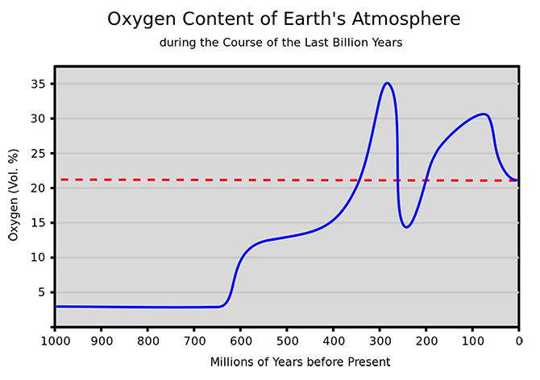

|  |  |  |  |
| --- | --- | --- | --- |
| **(a)** | **(i)** | What caused the sudden increase in oxygen levels at around 620 million years before the present day? **[2 marks]** | |
|  |  | Algae and other plant life started to photosynthesise ✓  Photosynthesis took in carbon dioxide and produced oxygen ✓ | |
|  |  |  |  |
|  | **(ii)** | Before the large increase in oxygen, what were the main components of the atmosphere and how was this atmosphere formed? **[2 marks]** | |
|  |  | Volcanic activity ✓  Early atmosphere composed of carbon dioxide, methane, ammonia, water vapour ✓ | |
|  |  |  |  |
| **(b)** | **(i)** | There are concerns that recent changes to the atmosphere are leading to global warming.  Name the gas most linked to global warming, and explain how this gas contributes to global warming. **[4 marks]** | |
|  |  | Carbon dioxide ✓  Solar radiation warms Earth ✓  Excess radiation reflected out into space ✓  Layer of carbon dioxide absorbs excess radiation and raises temperature ✓ | |
|  |  |  |  |
|  | **(ii)** | What evidence is there that human activity is to blame for global warming?  **[2 marks]** | |
|  |  | Increase in fossil fuel use over past hundred year ✓  Increase correlates with increased carbon dioxide levels ✓ | |

1. This question is about the Life Cycle Assessment (LCA) of a polymer.

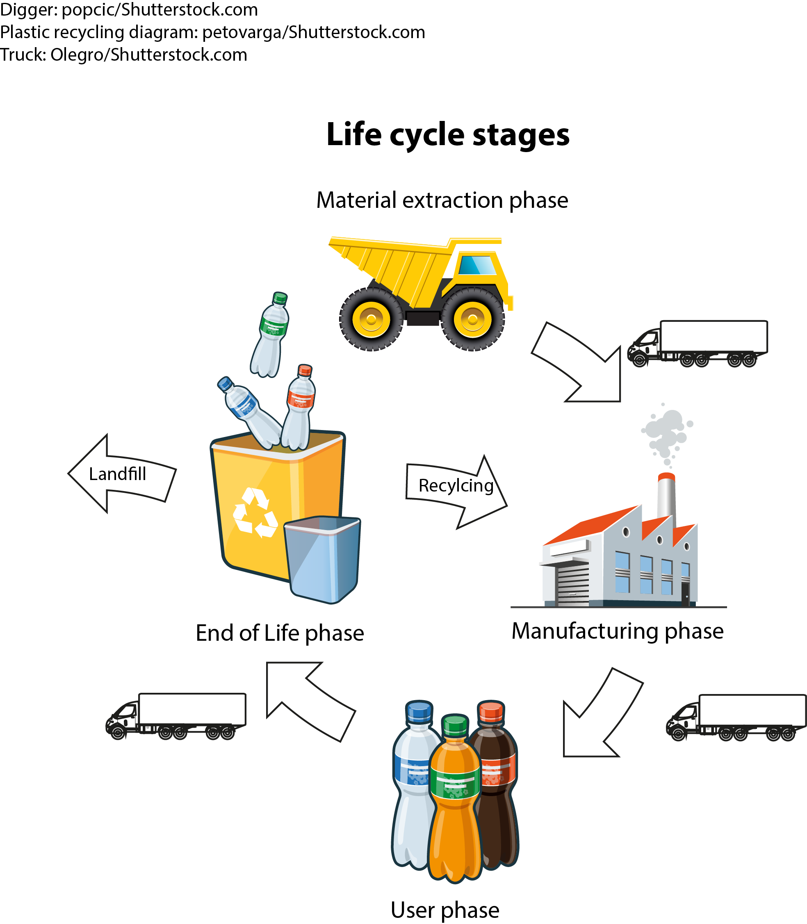

|  |  |  |  |
| --- | --- | --- | --- |
| **(a)** | **(i)** | Give **three** reasons that affect the decision about whether a material should be recycled or not. **[3 marks]** | |
|  |  | Any **three** from the following:   * Saves energy ✓ * Saves resources ✓ * Cheaper than extracting ✓ * Carbon footprint of recycling ✓ | |
|  |  |  |  |
|  | **(ii)** | All polymers have a life-span, as indicated here in the end-of-life phase.  Give **two** environmental factors that should be considered at this point.  **[2 marks]** | |
|  |  | Any **two** from the following:   * bio-degradability of polymer ✓ * use of polluting vehicles in transport of waste ✓ * use of landfill sites ✓ * potential atmospheric pollution from incineration ✓ | |

This formative assessment resource has been produced as part of our free GCSE teaching and learning support package. All the GCSE teaching and learning resources, including delivery guides, topic exploration packs, lesson elements and more are available on the qualification webpages.

If you are looking for examination practice materials, you can find the Sample Assessment Materials (SAMs) on the qualification webpage: [Combined Science A (9–1).](http://www.ocr.org.uk/qualifications/gcse-gateway-science-suite-combined-science-a-j250-from-2016/)

**OCR Resources**: *the small print*OCR’s resources are provided to support the delivery of OCR qualifications, but in no way constitute an endorsed teaching method that is required by the Board, and the decision to use them lies with the individual teacher. Whilst every effort is made to ensure the accuracy of the content, OCR cannot be held responsible for any errors or omissions within these resources.  
© OCR 2016 - This resource may be freely copied and distributed, as long as the OCR logo and this message remain intact and OCR is acknowledged as the originator of this work.

OCR acknowledges the use of the following content: Chemical structure of octane hydrocarbon, Shutterstock/ibreakstock; Blue sky and Clouds, Shutterstock/Pigdevil Photo; smoke from coal power plant, Industry pollution, Shutterstock/Ungnoi Lookjeab; Fractional distillation of crude oil, Shutterstock/photoiconix; Oxygen content of Earth’s atmosphere, Sauerstoffgehalt/Wikimedia Commons;

Please get in touch if you want to discuss the accessibility of resources we offer to support delivery of our qualifications: [resources.feedback@ocr.org.uk](mailto:resources.feedback@ocr.org.uk)

We’d like to know your view on the resources we produce. By clicking on ‘[Like](mailto:resources.feedback@ocr.org.uk?subject=I%20liked%20the%20GCSE%20(9-1)%20Gateway%20Science%20Combined%20Science%20A%20End%20of%20Topic%20Quiz%20(Topic%20C6:%20Global%20Challenges))’ or ‘[Dislike](mailto:resources.feedback@ocr.org.uk?subject=I%20liked%20the%20GCSE%20(9-1)%20Gateway%20Science%20Combined%20Science%20A%20End%20of%20Topic%20Quiz%20(Topic%20C6:%20Global%20Challenges))’ you can help us to ensure that our resources work for you. When the email template pops up please add additional comments if you wish and then just click ‘Send’. Thank you.

If you do not currently offer this OCR qualification but would like to do so, please complete the Expression of Interest Form which can be found here: [www.ocr.org.uk/expression-of-interest](http://www.ocr.org.uk/expression-of-interest)

Looking for a resource? There is now a quick and easy search tool to help find free resources for your qualification:   
[www.ocr.org.uk/i-want-to/find-resources/](http://www.ocr.org.uk/i-want-to/find-resources/)

# 

# End of topic quiz

# Topic C6: Global Challenges

## Learner Activity

### Topic: C6 of J250

**Total marks: 40**

1. Here is the reactivity series for metals.

|  |  |  |
| --- | --- | --- |
| potassium | **most reactive** | K |
| sodium |  | Na |
| calcium | Ca |
| magnesium | Mg |
| aluminium | Al |
| carbon | C |
| zinc | Zn |
| iron | Fe |
| tin | Sn |
| lead | Pb |
| hydrogen | H |
| copper | Cu |
| silver | Ag |
| gold | Au |
| platinum | **least reactive** | Pt |

An industrial company wants to extract aluminium from its ore, bauxite. How can aluminium be extracted? **[1 mark]**

|  |  |  |
| --- | --- | --- |
| **A** | Reduction with carbon |  |
| **B** | Electrolysis |  |
| **C** | Panning |  |
| **D** | No extraction required |  |

Your answer

1. Crude oil can be separated by fractional distillation.

When the oil is heated, the fractions separate. Which statement below is **not** true? **[1 mark]**

|  |  |  |
| --- | --- | --- |
| **A** | Smaller fractions are more viscous. |  |
| **B** | Smaller fractions have lower melting points. |  |
| **C** | Smaller fractions are more volatile. |  |
| **D** | Smaller fractions are more useful. |  |

Your answer

1. Cracking is widely used in the chemical industry to make shorter hydrocarbons.

Below is octane. The formula for octane is C8H18.



Which are possible products of cracking octane? **[1 mark]**

|  |  |  |
| --- | --- | --- |
| **A** | C4H12 and C4H12 |  |
| **B** | C3H8 and C5H12 |  |
| **C** | C2H6 and C6H12 |  |
| **D** | C4H8 and C5H10 |  |

Your answer

1. The early Earth was very different than it is today.



The early Earth was very hot and had much higher levels of water vapour in its atmosphere. Over time the Earth cooled and oceans formed.

By what process did the oceans form? **[1 mark]**

|  |  |  |
| --- | --- | --- |
| **A** | Evaporation |  |
| **B** | Condensation |  |
| **C** | Combustion |  |
| **D** | Decomposition |  |

Your answer

1. Over the past 200 years the amount of carbon dioxide in the atmosphere has been slowly increasing.



What environmental factor has the increase in carbon dioxide levels helped to cause?   
**[1 mark]**

|  |  |  |
| --- | --- | --- |
| **A** | Depletion of oil, coal and gas |  |
| **B** | Increased antibiotic resistance |  |
| **C** | Depletion of the ozone layer |  |
| **D** | Rise in the average temperature of the Earth |  |

Your answer

1. Use the reactivity series below to help you answer the following questions on extraction of metals.

|  |  |  |
| --- | --- | --- |
| potassium | **most reactive** | K |
| sodium |  | Na |
| calcium | Ca |
| magnesium | Mg |
| aluminium | Al |
| carbon | C |
| zinc | Zn |
| iron | Fe |
| tin | Sn |
| lead | Pb |
| hydrogen | H |
| copper | Cu |
| silver | Ag |
| gold | Au |
| platinum | **least reactive** | Pt |

|  |  |  |  |
| --- | --- | --- | --- |
| **(a)** | **(i)** | What industrial process can be used to extract metals **below** carbon in the reactivity series? **[1 mark]** | |
|  |  |  | |
|  |  |  |  |
|  | **(ii)** | What process can be used to extract metals **below** copper? **[1 mark]** | |
|  |  |  | |
|  |  |  |  |
| **(b)** | **(i)** | What process can be used to extract potassium? **[1 mark]** | |
|  |  |  | |
|  |  |  |  |
|  | **(ii)** | Explain how potassium can be extracted by this method? **[4 marks]** | |
|  |  |  | |
|  |  |  |  |
| **(c)** |  | Some metals can also be extracted by biological methods, such as by bioleaching and phytomining.  Write down **three** advantages and disadvantages of these methods, giving at least one of each. **[3 marks]** | |
|  |  |  | |

1. Crude oil can be purified and separated by fractional distillation. This process is essential before the hydrocarbons can be used for any other process or function.



|  |  |  |  |
| --- | --- | --- | --- |
| **(a)** | **(i)** | Describe the process of fractional distillation. **[5 marks]** | |
|  |  |  | |
|  |  |  |  |
|  | **(ii)** | To which homologous series do the hydrocarbons belong? **[1 mark]** | |
|  |  |  | |
|  |  |  |  |
|  | **(iii)** | What is the general formula of this homologous series? **[1 mark]** | |
|  |  |  | |
|  |  |  |  |
| **(b)** | **(i)** | Give one use for the products of fractional distillation. **[1 mark]** | |
|  |  |  | |
|  |  |  |  |
|  | **(ii)** | How can a hydrocarbon be cracked to produce smaller molecules, and what type of molecules are formed? **[2 mark]** | |
|  |  |  | |

1. Below is a graph of how the levels of oxygen in the atmosphere have changed over time.



|  |  |  |  |
| --- | --- | --- | --- |
| **(a)** | **(i)** | What caused the sudden increase in oxygen levels at around 620 million years before the present day? **[2 marks]** | |
|  |  |  | |
|  |  |  |  |
|  | **(ii)** | Before the large increase in oxygen, what were the main components of the atmosphere and how was this atmosphere formed? **[2 marks]** | |
|  |  |  | |
|  |  |  |  |
| **(b)** | **(i)** | There are concerns that recent changes to the atmosphere are leading to global warming.  Name the gas most linked to global warming, and explain how this gas contributes to global warming. **[4 marks]** | |
|  |  |  | |
|  |  |  |  |
|  | **(ii)** | What evidence is there that human activity is to blame for global warming?  **[2 marks]** | |
|  |  |  | |

1. This question is about the Life Cycle Assessment (LCA) of a polymer.



|  |  |  |  |
| --- | --- | --- | --- |
| **(a)** | **(i)** | Give **three** reasons that affect the decision about whether a material should be recycled or not. **[3 marks]** | |
|  |  |  | |
|  |  |  |  |
|  | **(ii)** | All polymers have a life-span, as indicated here in the end-of-life phase.  Give **two** environmental factors that should be considered at this point.  **[2 marks]** | |
|  |  |  | |