# End of topic quiz

# Topic B1: Cell level systems

## Learner Activity

**Topic: B1 of J250**

**Total marks: 40**

1. Where is the genetic material in a **prokaryotic** cell? **[1 mark]**

|  |  |  |
| --- | --- | --- |
| **A** | Chloroplast |  |
| **B** | Cytoplasm |  |
| **C** | Mitochondria |  |
| **D** | Nucleus |  |

Your answer

1. Which of the following statements best describe respiration? **[1 mark]**

|  |  |
| --- | --- |
| **A** | An endothermic process which supplies ATP. |
| **B** | An endothermic process which uses up ATP. |
| **C** | An exothermic process which supplies ATP. |
| **D** | An exothermic process which uses up ATP. |

Your answer

1. Which of the following are the product(s) of anaerobic respiration in fungi? **[1 mark]**

|  |  |  |
| --- | --- | --- |
| **A** | Alcohol + carbon dioxide |  |
| **B** | Carbon dioxide + water |  |
| **C** | Lactic acid |  |
| **D** | Starch |  |

Your answer

1. How many stages are there in the process of photosynthesis? **[1 mark]**

|  |  |  |
| --- | --- | --- |
| **A** | One |  |
| **B** | Two |  |
| **C** | Three |  |
| **D** | Four |  |

Your answer

1. An investigation is done to test the effect of light intensity on photosynthesis.

With a light source 2 cm from the leaf (distance A) the light intensity is 100 cd (intensity A).

What distance would you need between the light source and leaf to get a light intensity of 50 cd (intensity B). **[1 mark]**

Use the formula to help you answer the question:

distanceB2 = distance A2 x intensity A

intensity B

|  |  |  |
| --- | --- | --- |
| **A** | 1.41 cm |  |
| **B** | 2.83 cm |  |
| **C** | 4 cm |  |
| **D** | 8 cm |  |

Your answer

1. DNA and proteins are examples of biological polymers.

|  |  |  |  |
| --- | --- | --- | --- |
| **(a)** |  | Complete the table about biological polymers. **[3 marks]** |  |
|  |  | |  |  | | --- | --- | | **polymer** | **monomer** | | DNA |  | |  | sugar | | protein |  | |  |
|  |  |  |  |
| **(b)** | The enzyme pepsin digests proteins.  When egg-white (a protein) is digested by pepsin the liquid it is in goes from cloudy to clear.  The amount of egg-white left can be measured using a colorimeter.  The effect of pH on pepsin can be investigated using this method.  Method:  1. Label 6 test tubes 1 to 6.  2. In each test tube place 5.0 cm3 of egg-white.  3. Into each test tube place 2.0 cm3 of the relevant buffer as shown in the table.   |  |  |  |  |  |  |  | | --- | --- | --- | --- | --- | --- | --- | | test tube | 1 | 2 | 3 | 4 | 5 | 6 | | buffer pH | 1 | 3 | 6 | 7 | 8 | 9 |   4. Add 1.0 cm3 of pepsin solution to test tubes 1 to 6.  5. Immediately measure the amount of light passing through each tube using a colorimeter.  6. Every 30 seconds measure the amount of light passing through each tube until the tube is clear. | | |
|  | **(i)** | Pepsin only digests proteins.  This is because of the shape of the active site.  What is the active site? **[1 mark]** | |
|  |  |  | |
|  | **(ii)** | Pepsin works in the stomach.  The stomach is acidic.  What is the optimum pH for pepsin? **[1 mark]** | |
|  |  |  | |
|  | **(iii)** | Write down one way this method could be improved. **[1 mark]** | |
|  |  |  | |
|  | **(iv)** | How can the method above be changed to test the effect of **temperature** on pepsin? **[3 marks]** |  |
|  |  |  | |

1. The diagram shows a labelled drawing of onion epidermis cells as seen through a light microscope.

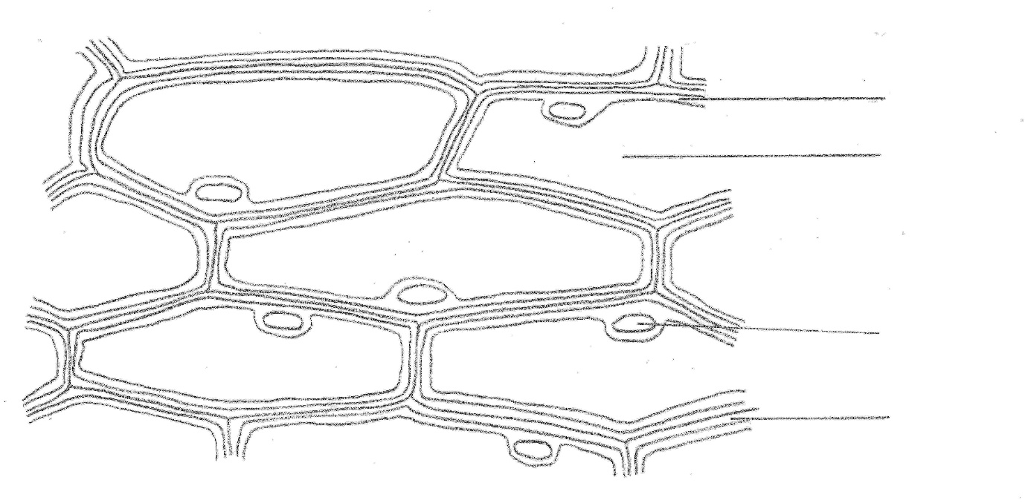

cytoplasm

vacuole

**A**

nucleus

cell wall

|  |  |  |  |
| --- | --- | --- | --- |
| **(a)** | How do you prepare a slide to view onion epidermis cells using a light microscope? **[3 marks]** | | |
|  |  | | |
| **(b)** | Methylene blue stain can be added to slides.  It stains DNA.  Which structure labelled on the diagram will be stained by methylene blue? **[1 mark]** | | |
|  |  | | |
| **(c)** | The drawing is x350 magnification.  Work out an estimate for the actual length of the cell labelled **A**.  Show your working. **[2 marks]** | | |
|  |  | | |
| **(d)** |  | Some subcellular structures are **not** visible using a light microscope.  Using an electron microscope has allowed more sub-cellular structures to be seen and studied. |  |
|  | **(i)** | Write down one sub-cellular structure that can only be seen using electron microscopy. **[1 mark]** | |
|  |  |  | |
|  | **(ii)** | Why can more sub-cellular structures be seen using an electron microscope? **[1 mark]** | |
|  |  |  | |

1. Photosynthesis takes place in chloroplasts.

|  |  |  |  |
| --- | --- | --- | --- |
| **(a)** | What is the role of chloroplasts in photosynthesis? **[2 marks]** | | |
|  |  | | |
| **(b)** |  | Carbon dioxide is needed for photosynthesis. |  |
|  | **(i)** | Finish the balanced symbol equation for photosynthesis. **[3 marks]**  6CO2 + 6……….… ……………..… + 6…………….… |  |
| dish containing sodium hydrogencarbonate which produces carbon dioxide |  | The following experiments can be done to show that carbon dioxide is needed for photosynthesis.  Two plants are destarched by leaving them in a dark cupboard for 24 hours.  The two plants are then set up as shown below.  Plant **A** Plant **B**  dish containing soda-lime which absorbs carbon dioxide  The plants are then placed in the light for two days.  PlantPlantA leaf from each plant is then tested for starch using iodine solution.  The leaf from plant **A** turns blue/black when tested.  The leaf from plant **B** does **not** turn blue/black. | |
|  | **(ii)** | Why are both plants destarched? **[1 mark]** | |
|  |  |  | |
|  | **(iii)** | How does this experiment show that carbon dioxide is necessary for photosynthesis? **[3 marks]** | |
|  |  |  | |
|  |  |  | |
| **(c)** |  | The graph shows the effect of carbon dioxide concentration on the rate of photosynthesis at high light intensity.  rate of photosynthesis  0 0.02 0.04 0.06 0.08 0.10 0.12 0.14  carbon dioxide concentration (%) |  |
|  | **(i)** | Why is the graph this shape? **[3 marks]** | |
|  |  |  | |

|  |  |  |  |  |  |  |  |  |  |  |  |  |  |  |  |  |  |  |
| --- | --- | --- | --- | --- | --- | --- | --- | --- | --- | --- | --- | --- | --- | --- | --- | --- | --- | --- |
|  | **(ii)** | Look at the table showing the carbon dioxide concentration, mean temperature and light intensity for three different growing conditions.   |  |  |  |  | | --- | --- | --- | --- | | Growing condition | Carbon dioxide concentration (%) | Mean temperature (ºC) | Light intensity | | Cool climate | 0.04 | 17 | low | | Hot climate | 0.04 | 29 | high | | Greenhouse | 0.10 | 28 | high |   Using information from the graph and the table, predict which growing condition will have the highest rate of photosynthesis and indicate why you have come to that conclusion. **[6 marks]** |
|  |  |  |