# End of topic quiz

# Topic B2: Scaling up

## Learner Activity

### Topic: B2 of J250

**Total marks: 40**

1. Look at these descriptions of a blood vessel.

* Carries blood away from the heart
* Has thick walls containing elastic tissue and muscle fibres.

Which type of blood vessel is this? **[1 mark]**

|  |  |  |
| --- | --- | --- |
| **A** | Artery |  |
| **B** | Capillary |  |
| **C** | Vein |  |
| **D** | Venule |  |

Your answer

1. A student investigates osmosis.

A cylinder of potato is put in distilled water for a few hours.

At the start, the potato has a mass of 3.0 g.

At the end, the potato has a mass of 3.4 g.

What is the percentage change in mass? **[1 mark]**

|  |  |
| --- | --- |
| **A** | +13% |
| **B** | -13% |
| **C** | +88% |
| **D** | +113% |

Your answer

1. Look at the graph showing the results of the osmosis investigation.

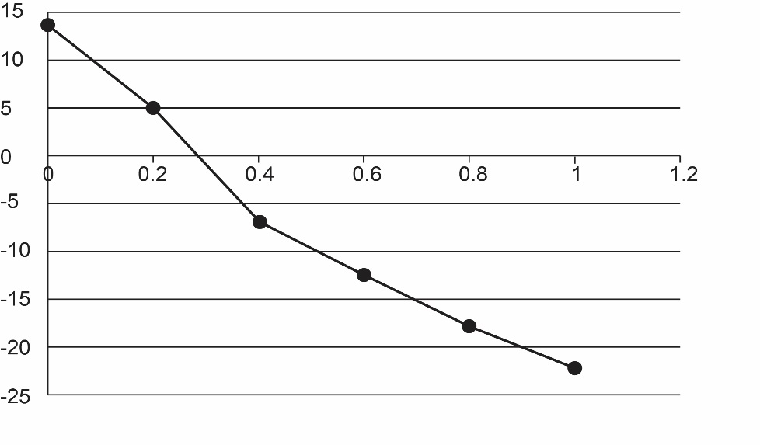

Change in mass (%)

concentration of sucrose solution (mol/dm3)

Use the graph to estimate the concentration of the solution inside the potato.   
**[1 mark]**

|  |  |
| --- | --- |
| **A** | 0.3 mol/dm3 |
| **B** | 1 mol/dm3 |
| **C** | 5 mol/dm3 |
| **D** | 13 mol/dm3 |

Your answer

1. The stages of cell division are listed below.
2. DNA replication.
3. Cytoplasm divided by membrane to make separate cells.
4. Growth of cell.
5. Movement of chromosomes.

Put the stages of cell division in the **correct** order. **[1 mark]**

|  |  |  |
| --- | --- | --- |
| **A** | 1 → 2 → 3 → 4 |  |
| **B** | 1 → 4 → 2 → 3 |  |
| **C** | 1 → 3 → 2 → 4 |  |
| **D** | 4 → 3 → 2 → 1 |  |

1. Thrombocytopenia is a medical condition of the blood.

Look at the diagram showing the blood composition of a person with thrombocytopenia and a person without the condition.

**With thrombocytopenia**

**Without thrombocytopenia**

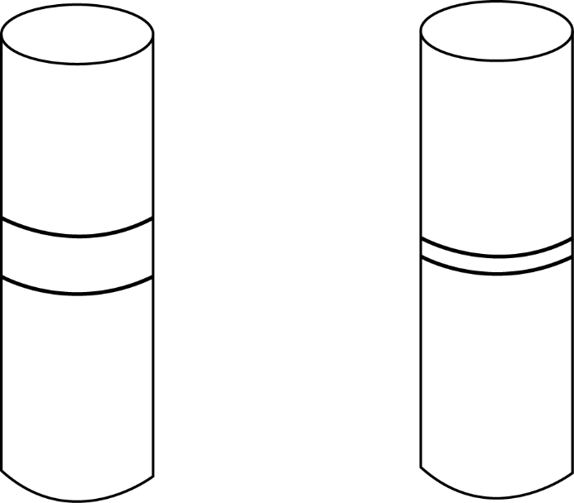

plasma

platelets and white blood cells

**normal**

red blood cells

**normal**

Which of the options is a symptom of thrombocytopenia? **[1 mark]**

|  |  |  |
| --- | --- | --- |
| **A** | Lack of blood clotting. |  |
| **B** | Lack of oxygen in the blood. |  |
| **C** | Too much carbon dioxide in tissues. |  |
| **D** | Too much urea left in the liver. |  |

Your answer

1. Cells must divide for an organism to grow.

Cells which can develop into different cell types are called stem cells.

|  |  |  |
| --- | --- | --- |
| **(a)** |  | Where are stem cells found in plants? **[1 mark]** |
|  |  |  |
|  |  | cells |
| **(b)** |  | How do the data provide evidence that minerals are taken up by active transport? **[1 mark]** |
|  | **(i)** | Choose the correct words to describe the processes and cells in the diagram. **[3 marks]** |
|  |  | **differentiation diffusion leaf meiosis mitosis specialised stem**  Process **A** …………………….…  Process **B** ……………………….  Cell **C** is a ……………………….cell |
|  | **(ii)** | **Cell D** is only able to produce one type of cell.  **Cell D** is likely to be an adult stem cell, what information in the diagram indicates this? **[1 mark]** |
|  |  |  |
|  |  |  |
| **(c)** |  | The cells produced by cell division can be used for growth of a tissue.  Write down one other use of the cells produced by this type of division.  **[1 mark]** |
|  |  |  |

1. Oxygen is needed by all organisms.

Oxygen is carried in the blood by red blood cells.

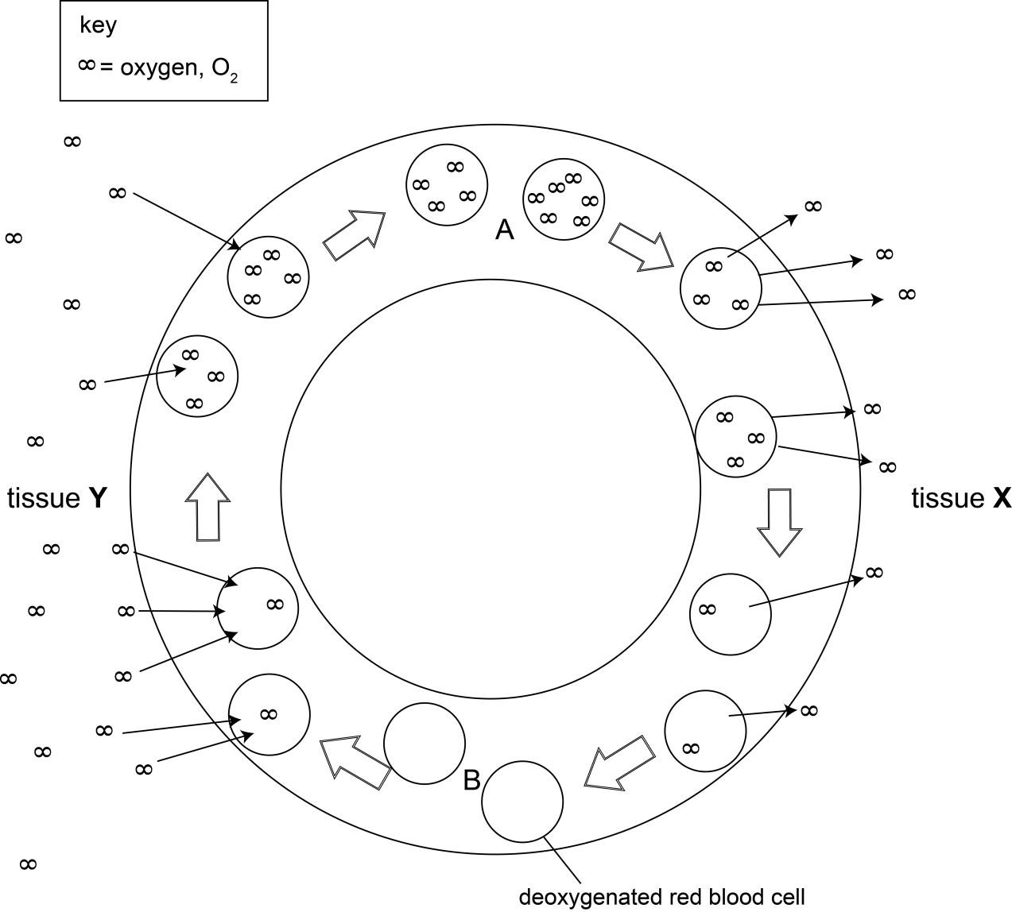Look at the diagram showing the movement of oxygen in mammals.

|  |  |  |
| --- | --- | --- |
| **(a)** |  | How does oxygen enter a red blood cell? **[2 marks]** |
|  |  |  |
|  |  |  |
| **(b)** |  | How are red blood cells are adapted to carry oxygen? **[2 marks]** |
|  |  |  |
|  |  |  |

|  |  |  |
| --- | --- | --- |
| **(c)** |  | Why does the rate at which oxygen leaves the red blood cell changes as it moves through tissue **X**. **[2 marks]** |
|  |  |  |
|  |  |  |
| **(d)** | **(i)** | What type of tissue is tissue **Y**? **[1 mark]** |
|  |  |  |
|  |  |  |
|  | **(ii)** | Tissue **Y** is made up of a specialised exchange surface.  Why are specialised exchange surfaces and transport systems needed for the movement of oxygen? **[3 marks]** |
|  |  |  |
|  |  |  |
| **(e)** |  | Red blood cells at **A** and **B** pass through different chambers of the heart.  Write down a chamber of the heart which the cells pass through at each point. **[2 marks]**  **A** …………………………………………..  **B** ………………………………………….. |

1. Plants need water for photosynthesis.

Water is taken in from the soil through root hair cells.

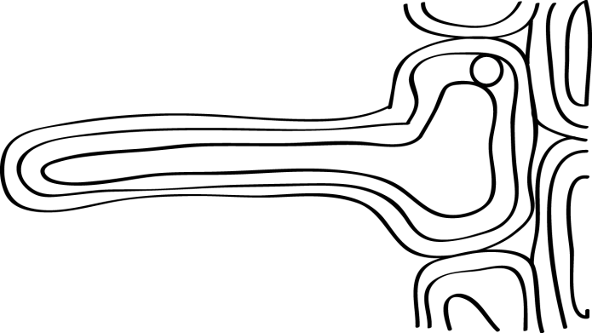Look at the diagram of a root hair cell.

|  |  |  |
| --- | --- | --- |
| **(a)** | **(i)** | Why are root hair cells good at taking in water? **[1 mark]** |
|  |  |  |
|  |  |  |
|  | **(ii)** | Root hair cells also take up mineral ions from the soil.  Look at the data.   |  |  |  |  | | --- | --- | --- | --- | |  | **ion concentration (mmol/kg)** | | | | **calcium** | **magnesium** | **potassium** | | root | 250.0 | 80.0 | 250.0 | | soil | 120.0 | 3.1 | 1.2 |   How do the data provide evidence that minerals are taken up by active transport? **[1 mark]** |
|  |  |  |
|  |  |  |

|  |  |  |  |
| --- | --- | --- | --- |
| **(b)** |  | The process of drawing water through a plant is called transpiration.  This movement of water can be investigated using a simple potometer. | |
|  | **(i)** | Show how to set up a potometer to investigate water loss.  You may use a labelled diagram to help you answer. **[3 marks]** | |
|  |  |  | |
|  |  |  | |
|  | **(ii)** | Explain why the potometer is **not** an accurate measure of water **lost**. **[1 mark]** | |
|  |  |  | |
|  |  |  | |
|  | **(iii)** | Look at the results collected from a potometer experiment.  The level was taken at the start and then 30 minutes later.  The test was repeated three times.   |  |  |  |  | | --- | --- | --- | --- | |  | **repeat 1** | **repeat 2** | **repeat 3** | | water level at start (cm3) | 0.02 | 0.04 | 0.02 | | water level at end (cm3) | 0.13 | 0.14 | 0.17 | | change in water level (cm3) | 0.11 | 0.10 | 0.15 |   Calculate the mean change in water level and use this to calculate the rate of water loss. **[2 marks]** | |
|  |  | rate of water loss………..cm3/min | |
|  |  |  |  |

|  |  |  |  |  |  |  |  |  |  |  |  |
| --- | --- | --- | --- | --- | --- | --- | --- | --- | --- | --- | --- |
|  | **(iv)** | The conditions for the experiment are then changed in three different ways.  Predict the effect of each change on the rate of water loss. **[1 mark]**  The first one has been completed for you.   |  |  | | --- | --- | | **change in conditions** | **effect** | | Move apparatus into bright sunlight | Increases rate | | Place apparatus in front of a fan | ... increases (rate) ... | | Place shoot inside a sealed plastic bag | ... decreases (rate) ...  (both needed for mark 🗸) | |  |
|  |  |  | |
|  | **(v)** | Why does moving the apparatus into bright sunlight increases the rate of water loss. **[2 marks]** | |
|  |  |  | |
|  |  |  | |
| **(c)** |  | Water is transported up the stem of a plant through xylem tissue.  The other main transport tissue in plants is the phloem.  What are the difference and similarities of xylem and phloem tissues? You may want to focus on their structure and function. **[6 marks]** | |
|  |  |  | |