End of topic quiz

Topic B3: Organism Level Systems

Learner Activity

Topic: B3 of J250
Total marks: 40
- Which of the following is the correct order for a reflex action? [1 mark]
A | Effector → sensory neurone → relay neurone → motor neurone → receptor
B | Receptor → sensory neurone → relay neurone → motor neurone → effector
C | Receptor → relay neurone → motor neurone → sensory neurone → effector
D | Sensory neurone → receptor → relay neurone → motor neurone → effector
Your answer

- Which of the following hormones are used by infertility treatments in women? [1 mark]
A | FSH and LH
B | Oestrogen
C | Oestrogen and progesterone
D | Testosterone
Your answer

- People exposed to very cold conditions struggle to maintain a constant internal environment.
Why is it important to stop internal temperature being too low? [1 mark]
A | Because all the bodies energy will be used up shivering.
B | Because the body will not lose enough water through sweating.
C | Because the enzymes will denature.
D | Because the metabolic reactions will be too slow.
Your answer

- Which of the following statements is not true about type II diabetes? [1 mark]
A | Glucose builds up in the body.
B | The body cells can be resistant to insulin.
C | The body does not produce insulin.
D | Type II diabetes can develop at any age.
Your answer

- The level of thyroxine in the body is controlled by negative feedback.
What would lead to a decrease in the secretion of thyroxine? [1 mark]
A | A low level of thyroxine in the blood.
B | The breakdown of thyroxine by the liver.
C | The hypothalamus detecting a high level of thyroxine in the blood.
D | The secretion of thyroid stimulating hormone (TSH) from the pituitary gland.
Your answer

- The nervous system can produce coordinated responses because of its many links.
(a) |  |  | Many of the links are in the central nervous system (CNS).  Which two parts of the body make up the CNS? [2 marks]
1 ...............................................
2 .....................................
(b) |  |  | Look at the labelled diagrams of a sensory neurone and a motor neurone.  Sensory neurone  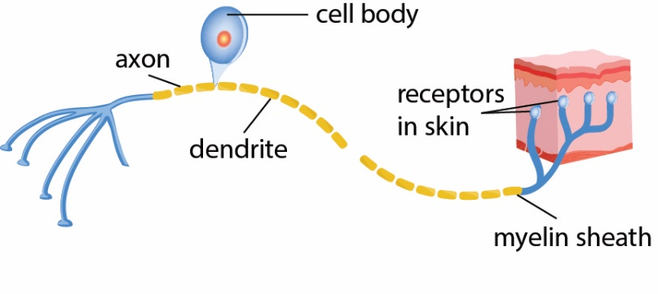  Motor neurone  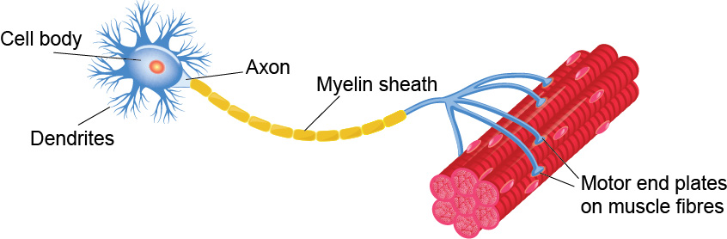  Use the diagrams and your own knowledge to compare the structure and function of sensory and motor neurones. [4 marks]
(c) |  |  | Reflexes are very fast reactions.  A reflex action is often quicker than other reactions.  Reaction times can be estimated using computer programs.  The reaction times for a sample of 16-year-olds and 70-year-olds were taken.  age of sample mean time (s) range (s)  16 0.25 0.20 – 0.29  70 0.27 0.20 – 0.30  The results were shown on a chart.  X 16 year old  70 year old  0.18 0.20 0.22 0.24 0.26 0.28 0.30 0.32  reaction time (s)
 | (i) |  | Finish the chart for the 70 year old sample. [2 marks]
 |  |  | X |  |  | 16 year old
 |  |  |  |  |  | 70 year old
0.18 0.20 0.22 0.24 0.26 0.28 0.30 0.32
reaction time (s)
 | (ii) |  | Are the reaction times slower for 70 year olds and how good is the data?  [3 marks]
 | (iii) |  | Why could reflex actions be quicker than the times above? [1 mark]

- People with diabetes have difficulty maintaining a constant internal environment.
(a) |  | What is the process of maintaining a constant internal environment called?  [1 mark]
(b) | (i) | Look at the graphs for two people.  One person has diabetes, which they manage by injecting insulin, the other person does not.  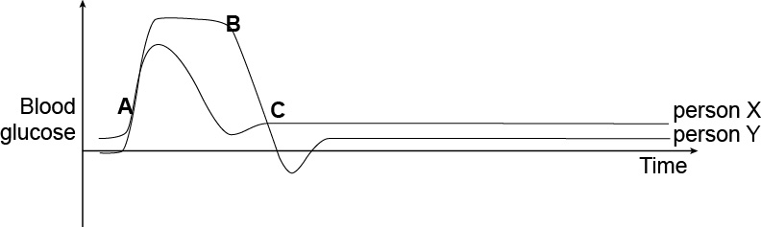  Why is the graph this shape? Use the labels to help you. [6 marks]
 | (ii) | Why is the blood glucose level between A and B a problem? [1 mark]
(c) |  | Patients can manage diabetes by injecting insulin.  Name one other treatment that can be used by people with diabetes and why this helps. [1 mark]

- Hormones are involved in coordination and control.
(a) |  | What is a hormone? [1 mark]
(b) | (i) | Adrenalin is a hormone released in response to stressful situations.  Complete the flow chart to show the effect of adrenalin on different organs.  [3 marks]
Stressful situation

Brain sends message along nerve

Adrenal gland secretes adrenalin into blood

organ.........................
effect......................................................................................................
organ.........................
effect......................................................................................................
organ.........................
effect......................................................................................................
 | (iii) | For one of the organs you gave as an answer in part (i), explain how the effect helps the body to respond to the stressful situation. [2 marks]
Organ ..............................................

Explanation:

(c) |  | Hormones are also used to control the menstrual cycle.  The process of ovulation is shown by the diagram below.    0 2 4 6 8 10 12 14 16 18 20 22 24 26 28
 | (i) | Between days 2 and 12 the follicle is developing.  Which hormone is realised to cause this? [1 mark]
 | (ii) | The developing follicle secretes oestrogen.  Oestrogen peaking stimulates the release of another hormone at about day 14.  Which hormone? [1 mark]
 | (iii) | The corpeus luteum secretes progesterone.  What are the roles of progesterone? [2 marks]
(d) |  | The table shows the effectiveness of the combined pill and male condom as contraceptives.  The theoretical effectiveness is how well the birth control works when used correctly.  The actual effectiveness is how well the birth control works in ‘typical use’, taking into account human error and other factors.  Birth control method Theoretical effectiveness Actual effectiveness  combined pill 99% 92%  male condom 98% 85%  Which is the better method of birth control and why? [4 marks]  You should consider the effectiveness and method of action.

