End of topic quiz

Topic B1: Cell level systems

Instructions and answers for teachers
These instructions cover the learner activity section which can be found on page 12. This end of topic quiz supports OCR GCSE (9–1) Combined Science A (J250), Topic B1.
When distributing the activity section to the learners either as a printed copy or as a Word file you will need to remove the teacher instructions section.

The Activity
This end of topic quiz is a teaching and learning resource comprised of 40 marks covering a range of question types. The quiz starts with some multiple choice questions (MCQs) and them moves on to some short answer questions and then finally on to some longer answer questions.
This resource can be used to test and consolidate understanding at the end of teaching the topic or to revisit and refresh knowledge at a later point in the course.

Learning Outcomes
This end of topic quiz relates to the specification learning outcomes in Topic B1: Cell level systems. The questions in this quiz cover a range of the following topics:
B1.1 Cell structures
B1.2 What happens in cells (and what do cells need)?
B1.3 Respiration
B1.4 Photosynthesis

Topic: B1 of J250 - Answers
Total marks: 40
- Where is the genetic material in a prokaryotic cell? [1 mark]
A | Chloroplast
B | Cytoplasm
C | Mitochondria
D | Nucleus
Your answer
B
- Which of the following statements best describe respiration? [1 mark]
A | An endothermic process which supplies ATP.
B | An endothermic process which uses up ATP.
C | An exothermic process which supplies ATP.
D | An exothermic process which uses up ATP.
Your answer
C

- Which of the following are the product(s) of anaerobic respiration in fungi? [1 mark]
A | Alcohol + carbon dioxide
B | Carbon dioxide + water
C | Lactic acid
D | Starch
Your answer
A
- How many stages are there in the process of photosynthesis? [1 mark]
A | One
B | Two
C | Three
D | Four
Your answer
B

- An investigation is done to test the effect of light intensity on photosynthesis.
With a light source 2 cm from the leaf (distance A) the light intensity is 100 cd (intensity A).
What distance would you need between the light source and leaf to get a light intensity of 50 cd (intensity B). [1 mark]
Use the formula to help you answer the question:

distance B² = distance A² x intensity A
_{intensity B}
A | 1.41 cm
B | 2.83 cm
C | 4 cm
D | 8 cm
Your answer
B

- DNA and proteins are examples of biological polymers.
(a) |  | Complete the table about biological polymers. [3 marks]
polymer | monomer
DNA | …nucleotide / all four: adenine (A), cytosine (C), guanine (G), thymine (T)… 
...carbohydrate / polysaccharide… | sugar
protein | …amino acid…

(b) | The enzyme pepsin digests proteins.  When egg-white (a protein) is digested by pepsin the liquid it is in goes from cloudy to clear.  The amount of egg-white left can be measured using a colorimeter.  The effect of pH on pepsin can be investigated using this method.  Method:  1. Label 6 test tubes 1 to 6.  2. In each test tube place 5.0 cm³ of egg-white.  3. Into each test tube place 2.0 cm³ of the relevant buffer as shown in the table.  4. Add 1.0 cm³ of pepsin solution to test tubes 1 to 6.  5. Immediately measure the amount of light passing through each tube using a colorimeter.  6. Every 30 seconds measure the amount of light passing through each tube until the tube is clear.
  test tube | 1 | 2 | 3 | 4 | 5 | 6
  buffer pH | 1 | 3 | 6 | 7 | 8 | 9
 | (i) | Pepsin only digests proteins.  This is because of the shape of the active site.  What is the active site? [1 mark]
 |  | where the substrate binds / AW / idea of part of the enzyme where its shape matches the shape of the substrate 
 | (ii) | Pepsin works in the stomach.  The stomach is acidic.  What is the optimum pH for pepsin? [1 mark]
 |  | (pH) between 0 and 5 
 | (iii) | Write down one way this method could be improved. [1 mark]
 |  | idea of doing repeats for each pH / idea of wider range of buffer pH / idea of controlling other named variable (e.g. temperature) 
 | (iv) | How can the method above be changed to test the effect of temperature on pepsin? [3 marks]
idea of controlling pH e.g. use the same buffer in all the repeats 

suitable range of temperatures e.g. 10 ºC, 20 ºC, 30 ºC, 40 ºC, 50 ºC, 60 ºC 

use a suitable method to control temperature e.g. water baths 
- The diagram shows a labelled drawing of onion epidermis cells as seen through a light microscope.
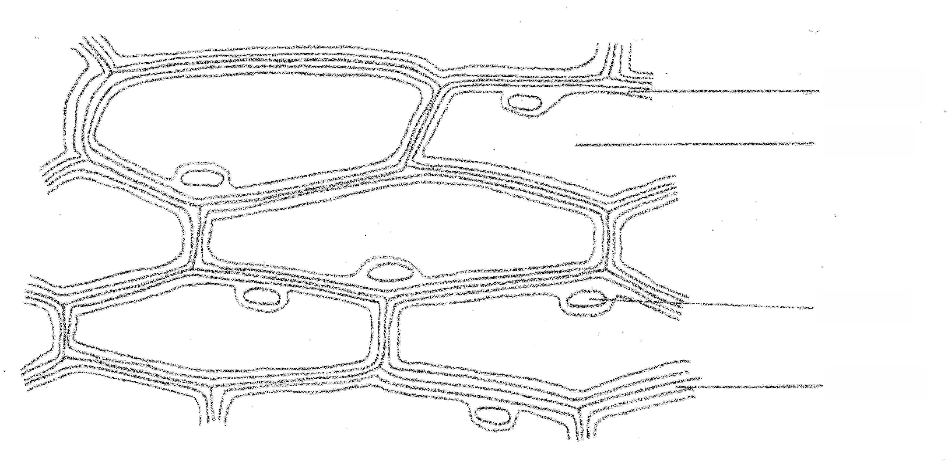
cytoplasm
vacuole

A

nucleus

cell wall

(a) | How do you prepare a slide to view onion epidermis cells using a light microscope? [3 marks]
Any three from:

cut up onion/remove epidermis from onion 

put a drop of water/iodine onto a slide 

spread epidermis flat 

lower coverslip 

remove excess liquid (using filter paper) 
(b) | Methylene blue stain can be added to slides.  It stains DNA.  Which structure labelled on the diagram will be stained by methylene blue?  [1 mark]
 | nucleus 
(c) | The drawing is x350 magnification.  Work out an estimate for the actual length of the cell labelled A.  Show your working. [2 marks]
0.0262-0.0272 cm / 0.262-0.272 mm / 262-272 μm 

BUT if answer incorrect

incorrect measurement ÷ 350 
(d) |  | Some subcellular structures are not visible using a light microscope.  Using an electron microscope has allowed more sub-cellular structures to be seen and studied.
 | (i) | Write down one sub-cellular structure that can only be seen using electron microscopy. [1 mark]
 |  | ribosomes /endoplasmic reticulum /Golgi apparatus /nucleolus /microtubules /(cell) membranes /vesicles 
 | (ii) | Why can more sub-cellular structures be seen using an electron microscope? [1 mark]
 |  | greater resolution / AW 
- Photosynthesis takes place in chloroplasts.
(a) | What is the role of chloroplasts in photosynthesis? [2 marks]
contain chlorophyll 

which absorb light 
(b) |  | Carbon dioxide is needed for photosynthesis.
 | (i) | Finish the balanced symbol equation for photosynthesis. [3 marks]  6CO₂ + 6…H₂O … …C₆H₁₂O₆ … + 6…O₂ …
dish containing sodium hydrogencarbonate which produces carbon dioxide |  | The following experiments can be done to show that carbon dioxide is needed for photosynthesis.  Two plants are destarched by leaving them in a dark cupboard for 24 hours.  The two plants are then set up as shown below.  Plant A Plant B  dish containing soda-lime which absorbs carbon dioxide  The plants are then placed in the light for two days.  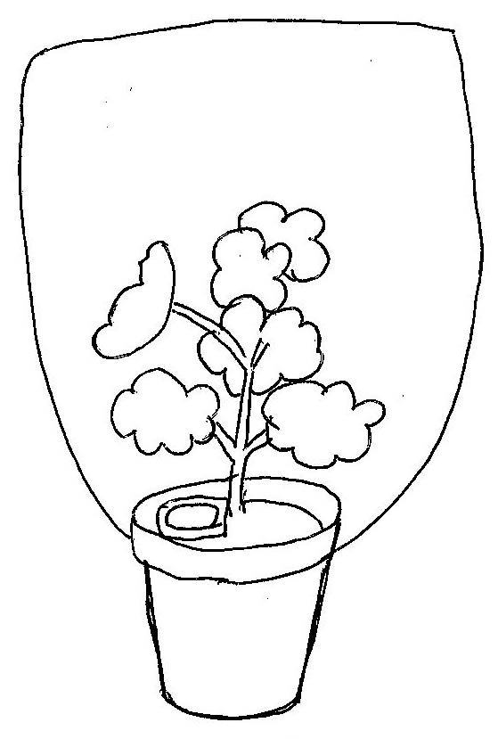  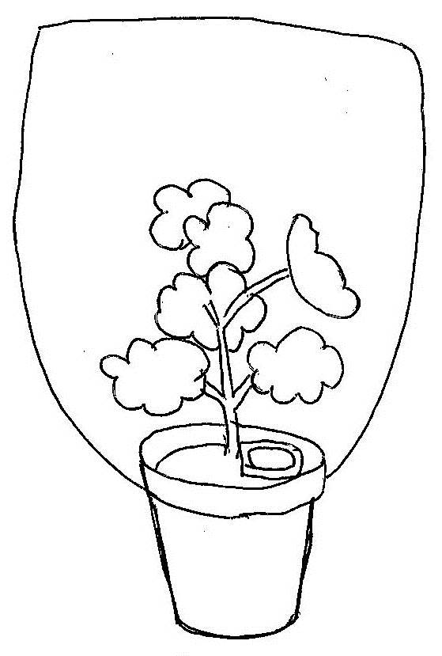  A leaf from each plant is then tested for starch using iodine solution.  The leaf from plant A turns blue/black when tested.  The leaf from plant B does not turn blue/black.
 | (ii) | Why are both plants destarched? [1 mark]
 |  | to show any starch produced was not there already/AW 
 | (iii) | How does this experiment show that carbon dioxide is necessary for photosynthesis? [3 marks]
any three from:

only plant A has access to carbon dioxide/ora 

blue is a positive test for starch 

only plant A produces starch 

starch can only be made from glucose produced by photosynthesis/the presence of starch shows photosynthesis is taking place/AW 
(c) |  | The graph shows the effect of carbon dioxide concentration on the rate of photosynthesis at high light intensity.  rate of photosynthesis  0 0.02 0.04 0.06 0.08 0.10 0.12 0.14  carbon dioxide concentration (%)
 | (i) | Why is the graph this shape? [3 marks]
increasing carbon dioxide allows rate to increase as more substrate/AW 

at high concentrations carbon dioxide no longer a limiting factor so rate no longer increases/AW 

correct use of data from the graph e.g. between 0 and 0.08%/between 0.12% and 0.20% 

 | (ii) | Look at the table showing the carbon dioxide concentration, mean temperature and light intensity for three different growing conditions.  Using information from the graph and the table, predict which growing condition will have the highest rate of photosynthesis and indicate why you have come to that conclusion. [6 marks]
  Growing condition | Carbon dioxide concentration (%) | Mean temperature (ºC) | Light intensity
  Cool climate | 0.04 | 17 | low
  Hot climate | 0.04 | 29 | high
  Greenhouse | 0.10 | 28 | high
Any six from:

cool climate lowest rate of photosynthesis 

higher temperatures increase the rate of photosynthesis by increasing the rate of collisions 

in hot climate or greenhouse higher light intensity increases the rate of photosynthesis 

in greenhouse

light intensity high 

CO₂ higher 

higher CO₂ concentration increases substrate concentration 

CO₂ not limiting factor as above 0.10%, from graph 

temperature lower than hot climate, but effect on rate less than effect of
higher CO₂ 

hot climate: evidence:

light intensity high 

CO₂ is limiting factor Approx. half maximum rate 

but temperature highest increasing rate more than CO₂ limits 

We’d like to know your view on the resources we produce. By clicking on ‘Like’ or ‘Dislike’ you can help us to ensure that our resources work for you. When the email template pops up please add additional comments if you wish and then just click ‘Send’. Thank you.
If you do not currently offer this OCR qualification but would like to do so, please complete the Expression of Interest Form which can be found here: www.ocr.org.uk/expression-of-interest
OCR Resources: the small print
OCR’s resources are provided to support the teaching of OCR specifications, but in no way constitute an endorsed teaching method that is required by the Board, and the decision to use them lies with the individual teacher. Whilst every effort is made to ensure the accuracy of the content, OCR cannot be held responsible for any errors or omissions within these resources.
© OCR 2016 - This resource may be freely copied and distributed, as long as the OCR logo and this message remain intact and OCR is acknowledged as the originator of this work.
OCR acknowledges the use of the following content: n/a
Please get in touch if you want to discuss the accessibility of resources we offer to support delivery of our qualifications: resources.feedback@ocr.org.uk
This formative assessment resource has been produced as part of our free GCSE teaching and learning support package. All the GCSE teaching and learning resources, including delivery guides, topic exploration packs, lesson elements and more are available on the qualification webpages.
If you are looking for examination practice materials, you can find the Sample Assessment Materials (SAMs) on the qualification webpage: Combined Science A (9–1).

End of topic quiz

Topic B1: Cell level systems

Learner Activity

Topic: B1 of J250
Total marks: 40
- Where is the genetic material in a prokaryotic cell? [1 mark]
A | Chloroplast
B | Cytoplasm
C | Mitochondria
D | Nucleus
Your answer

- Which of the following statements best describe respiration? [1 mark]
A | An endothermic process which supplies ATP.
B | An endothermic process which uses up ATP.
C | An exothermic process which supplies ATP.
D | An exothermic process which uses up ATP.
Your answer

- Which of the following are the product(s) of anaerobic respiration in fungi? [1 mark]
A | Alcohol + carbon dioxide
B | Carbon dioxide + water
C | Lactic acid
D | Starch
Your answer
- How many stages are there in the process of photosynthesis? [1 mark]
A | One
B | Two
C | Three
D | Four
Your answer

- An investigation is done to test the effect of light intensity on photosynthesis.
With a light source 2 cm from the leaf (distance A) the light intensity is 100 cd (intensity A).
What distance would you need between the light source and leaf to get a light intensity of 50 cd (intensity B). [1 mark]
Use the formula to help you answer the question:

distance B² = distance A² x intensity A
_{intensity B}
A | 1.41 cm
B | 2.83 cm
C | 4 cm
D | 8 cm
Your answer
- DNA and proteins are examples of biological polymers.
(a) |  | Complete the table about biological polymers. [3 marks]
polymer | monomer
DNA

 | sugar
protein

(b) | The enzyme pepsin digests proteins.  When egg-white (a protein) is digested by pepsin the liquid it is in goes from cloudy to clear.  The amount of egg-white left can be measured using a colorimeter.  The effect of pH on pepsin can be investigated using this method.  Method:  1. Label 6 test tubes 1 to 6.  2. In each test tube place 5.0 cm³ of egg-white.  3. Into each test tube place 2.0 cm³ of the relevant buffer as shown in the table.  4. Add 1.0 cm³ of pepsin solution to test tubes 1 to 6.  5. Immediately measure the amount of light passing through each tube using a colorimeter.  6. Every 30 seconds measure the amount of light passing through each tube until the tube is clear.
  test tube | 1 | 2 | 3 | 4 | 5 | 6
  buffer pH | 1 | 3 | 6 | 7 | 8 | 9
 | (i) | Pepsin only digests proteins.  This is because of the shape of the active site.  What is the active site? [1 mark]
 | (ii) | Pepsin works in the stomach.  The stomach is acidic.  What is the optimum pH for pepsin? [1 mark]
 | (iii) | Write down one way this method could be improved. [1 mark]
 | (iv) | How can the method above be changed to test the effect of temperature on pepsin? [3 marks]
- The diagram shows a labelled drawing of onion epidermis cells as seen through a light microscope.
cytoplasm
vacuole

A

nucleus

cell wall

(a) | How do you prepare a slide to view onion epidermis cells using a light microscope? [3 marks]
(b) | Methylene blue stain can be added to slides.  It stains DNA.  Which structure labelled on the diagram will be stained by methylene blue?  [1 mark]
(c) | The drawing is x350 magnification.  Work out an estimate for the actual length of the cell labelled A.  Show your working. [2 marks]
(d) |  | Some subcellular structures are not visible using a light microscope.  Using an electron microscope has allowed more sub-cellular structures to be seen and studied.
 | (i) | Write down one sub-cellular structure that can only be seen using electron microscopy. [1 mark]
 | (ii) | Why can more sub-cellular structures be seen using an electron microscope? [1 mark]

- Photosynthesis takes place in chloroplasts.
(a) | What is the role of chloroplasts in photosynthesis? [2 marks]
(b) |  | Carbon dioxide is needed for photosynthesis.
 | (i) | Finish the balanced symbol equation for photosynthesis. [3 marks]  6CO₂ + 6……….… ……………..… + 6…………….…
dish containing sodium hydrogencarbonate which produces carbon dioxide |  | The following experiments can be done to show that carbon dioxide is needed for photosynthesis.  Two plants are destarched by leaving them in a dark cupboard for 24 hours.  The two plants are then set up as shown below.  Plant A Plant B  dish containing soda-lime which absorbs carbon dioxide  The plants are then placed in the light for two days.  A leaf from each plant is then tested for starch using iodine solution.  The leaf from plant A turns blue/black when tested.  The leaf from plant B does not turn blue/black.
 | (ii) | Why are both plants destarched? [1 mark]
 | (iii) | How does this experiment show that carbon dioxide is necessary for photosynthesis? [3 marks]
(c) |  | The graph shows the effect of carbon dioxide concentration on the rate of photosynthesis at high light intensity.  rate of photosynthesis  0 0.02 0.04 0.06 0.08 0.10 0.12 0.14  carbon dioxide concentration (%)
 | (i) | Why is the graph this shape? [3 marks]

 | (ii) | Look at the table showing the carbon dioxide concentration, mean temperature and light intensity for three different growing conditions.  Using information from the graph and the table, predict which growing condition will have the highest rate of photosynthesis and indicate why you have come to that conclusion. [6 marks]
  Growing condition | Carbon dioxide concentration (%) | Mean temperature (ºC) | Light intensity
  Cool climate | 0.04 | 17 | low
  Hot climate | 0.04 | 29 | high
  Greenhouse | 0.10 | 28 | high

