# End of topic quiz

# Topic B2: Scaling up

## Instructions and answers for teachers

These instructions cover the learner activity section which can be found on page 12. This end of topic quiz supports OCR GCSE (9–1) Combined Science A (J250), Topic B2.

**When distributing the activity section to the learners either as a printed copy or as a Word file you will need to remove the teacher instructions section.**

### The Activity

This end of topic quiz is a teaching and learning resource comprised of 40 marks covering a range of question types. The quiz starts with some multiple choice questions (MCQs) and then moves on to some short answer questions and then finally on to some longer answer questions.

This resource can be used to test and consolidate understanding at the end of teaching the topic or to revisit and refresh knowledge at a later point in the course.

### Learning Outcomes

This end of topic quiz relates to the specification learning outcomes in Topic B2: Scaling up. The questions in this quiz cover a range of the following topics:

B2.1 Supplying the cell

B2.2 The challenges of size

### Topic: B2 of J250 - Answers

**Total marks: 40**

1. Look at these descriptions of a blood vessel.

* Carries blood away from the heart
* Has thick walls containing elastic tissue and muscle fibres.

Which type of blood vessel is this? **[1 mark]**

|  |  |  |
| --- | --- | --- |
| **A** | Artery |  |
| **B** | Capillary |  |
| **C** | Vein |  |
| **D** | Venule |  |

Your answer

A

1. A student investigates osmosis.

A cylinder of potato is put in distilled water for a few hours.

At the start, the potato has a mass of 3.0 g.

At the end, the potato has a mass of 3.4 g.

What is the percentage change in mass? **[1 mark]**

|  |  |
| --- | --- |
| **A** | +13% |
| **B** | -13% |
| **C** | +88% |
| **D** | +113% |

Your answer

A

1. Look at the graph showing the results of the osmosis investigation.

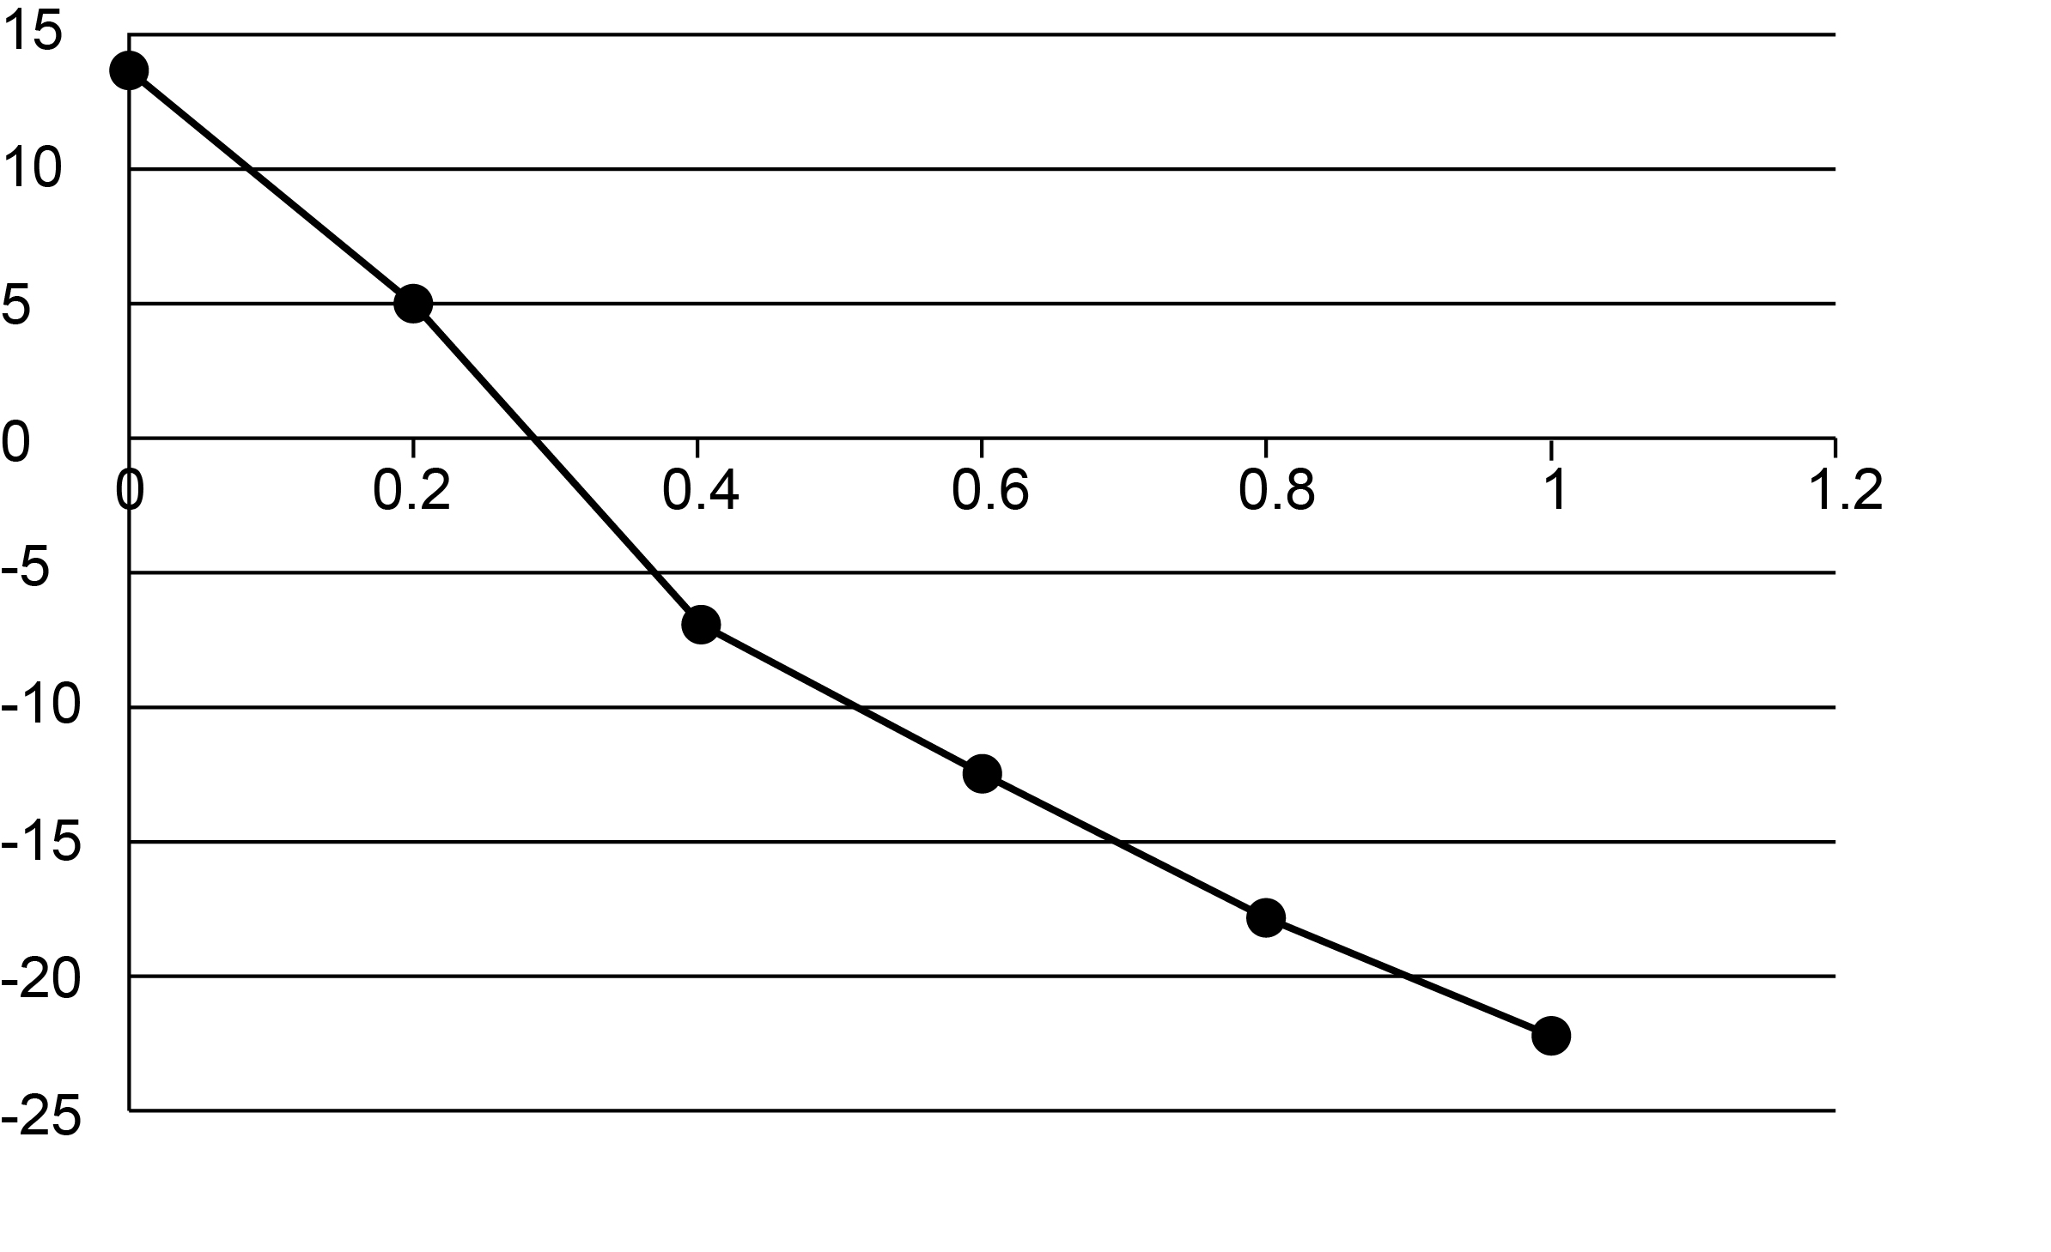

Change in mass (%)

concentration of sucrose solution (mol/dm3)

Use the graph to estimate the concentration of the solution inside the potato.   
**[1 mark]**

|  |  |
| --- | --- |
| **A** | 0.3 mol/dm3 |
| **B** | 1 mol/dm3 |
| **C** | 5 mol/dm3 |
| **D**  A | 13 mol/dm3 |

Your answer

1. The stages of cell division are listed below.
2. DNA replication.
3. Cytoplasm divided by membrane to make separate cells.
4. Growth of cell.
5. Movement of chromosomes.

Put the stages of cell division in the **correct** order. **[1 mark]**

|  |  |  |
| --- | --- | --- |
| **A** | 1 → 2 → 3 → 4 |  |
| **B** | 1 → 4 → 2 → 3 |  |
| **C** | 1 → 3 → 2 → 4 |  |
| **D**  B | 4 → 3 → 2 → 1 |  |

1. Thrombocytopenia is a medical condition of the blood.

Look at the diagram showing the blood composition of a person with thrombocytopenia and a person without the condition.

**With thrombocytopenia**

**Without thrombocytopenia**

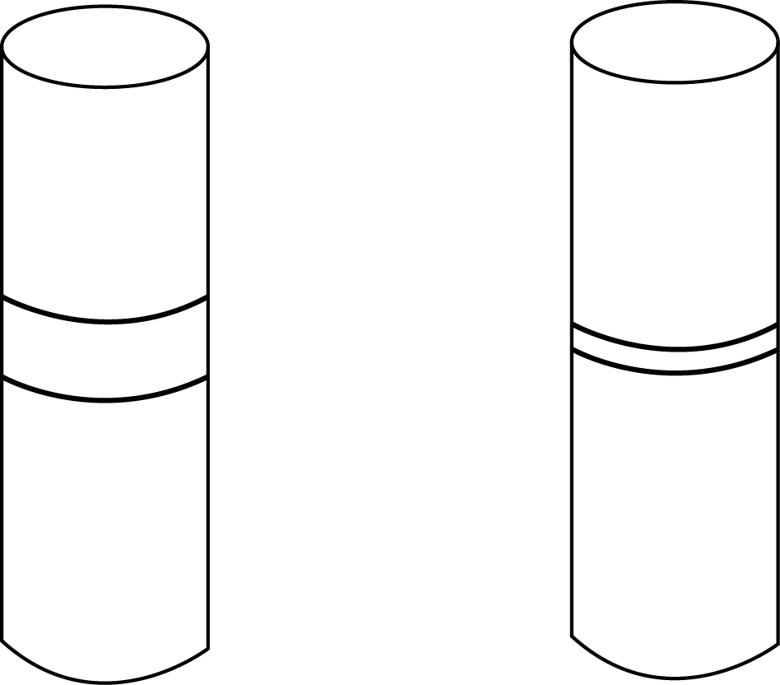

plasma

platelets and white blood cells

**normal**

red blood cells

**normal**

Which of the options is a symptom of thrombocytopenia? **[1 mark]**

|  |  |  |
| --- | --- | --- |
| **A** | Lack of blood clotting. |  |
| **B** | Lack of oxygen in the blood. |  |
| **C** | Too much carbon dioxide in tissues. |  |
| **D** | Too much urea left in the liver. |  |

Your answer

A

1. Cells must divide for an organism to grow.

Cells which can develop into different cell types are called stem cells.

|  |  |  |
| --- | --- | --- |
| **(a)** |  | Where are stem cells found in plants? **[1 mark]** |
|  |  | Meristems / root tips / buds 🗸 |
|  |  | cells |
| **(b)** |  | How do the data provide evidence that minerals are taken up by active transport? **[1 mark]** |
|  | **(i)** | Choose the correct words to describe the processes and cells in the diagram. **[3 marks]** |
|  |  | **differentiation diffusion leaf meiosis mitosis specialised stem**  Process **A** … mitosis 🗸…  Process **B** … differentiation 🗸…  Cell **C** is a … specialised 🗸… cell |
|  | **(ii)** | **Cell D** is only able to produce one type of cell.  **Cell D** is likely to be an adult stem cell, what information in the diagram indicates this? **[1 mark]** |
|  |  | because it can only produce a limited range of cells / because embryonic stem cells can produce all types of cell / AW 🗸 |
|  |  |  |
| **(c)** |  | The cells produced by cell division can be used for growth of a tissue.  Write down one other use of the cells produced by this type of division.  **[1 mark]** |
|  |  | development / repair / asexual reproduction 🗸 |

1. Oxygen is needed by all organisms.

Oxygen is carried in the blood by red blood cells.

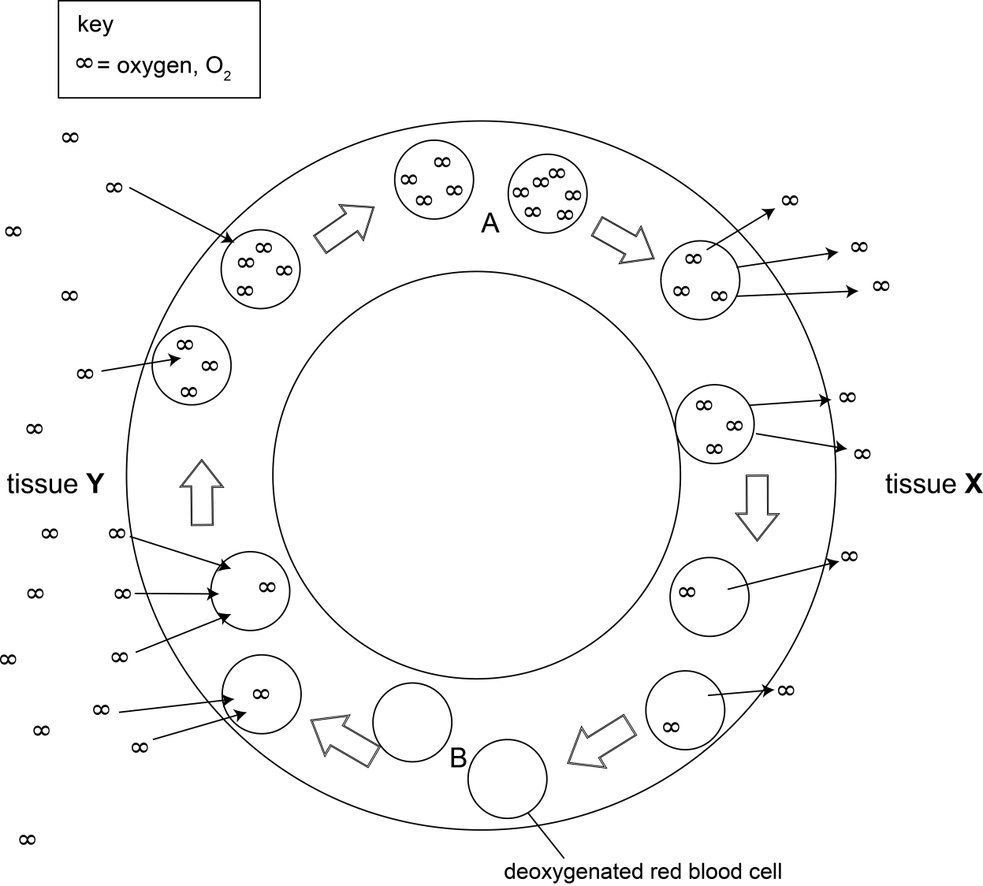Look at the diagram showing the movement of oxygen in mammals.

|  |  |  |
| --- | --- | --- |
| **(a)** |  | How does oxygen enter a red blood cell? **[2 marks]** |
|  |  | diffusion 🗸  through the cell membrane / from alveoli / through capillary walls 🗸 |
|  |  |  |
| **(b)** |  | How are red blood cells are adapted to carry oxygen? **[2 marks]** |
|  |  | any **two** from:  contain haemoglobin to efficiently carry oxygen / AW 🗸  lacking nucleus so more space for haemoglobin / AW 🗸  (biconcave) shape to increase surface area (for diffusion) 🗸  flexible to enable it to be deformed to pass through small blood vessels 🗸 |
|  |  |  |
| **(c)** |  | Why does the rate at which oxygen leaves the red blood cell changes as it moves through tissue **X**. **[2 marks]** |
|  |  | any **two** from:  as oxygen enters tissue / leaves cell 🗸  more oxygen in tissue / less oxygen in red blood cell 🗸  concentration gradient decreases 🗸 |
|  |  |  |
| **(d)** | **(i)** | What type of tissue is tissue **Y**? **[1 mark]** |
|  |  | lung / alveolus 🗸 |
|  |  |  |
|  | **(ii)** | Tissue **Y** is made up of a specialised exchange surface.  Why are specialised exchange surfaces and transport systems needed for the movement of oxygen? **[3 marks]** |
|  |  | any **three** from:  oxygen needed in all cells for respiration 🗸  without (these systems) the rate of diffusion is too slow / ora 🗸  without (these systems) surface area: volume ratio is too small / ora 🗸  exchange surface increases surface area (for diffusion) 🗸  (associated) transport system decreases diffusion distances (of oxygen) 🗸 |
|  |  |  |
| **(e)** |  | Red blood cells at **A** and **B** pass through different chambers of the heart.  Write down a chamber of the heart which the cells pass through at each point. **[2 marks]**  **A** …left atrium / left ventricle 🗸…  **B** … right atrium / right ventricle (1) 🗸… |

1. Plants need water for photosynthesis.

Water is taken in from the soil through root hair cells.

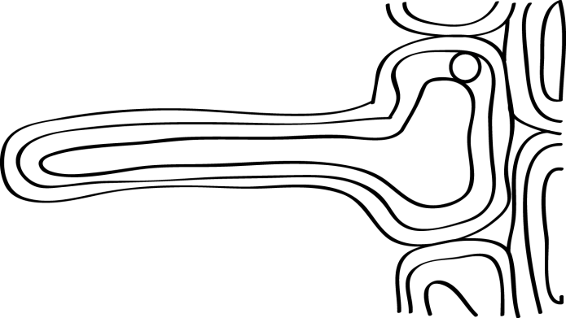Look at the diagram of a root hair cell.

|  |  |  |  |
| --- | --- | --- | --- |
| **(a)** | **(i)** | Why are root hair cells good at taking in water? **[1 mark]** | |
|  |  | large surface area / contains concentrated solution / has lower water potential (than soil) 🗸 | |
|  |  |  | |
|  | **(ii)** | Root hair cells also take up mineral ions from the soil.  Look at the data.   |  |  |  |  | | --- | --- | --- | --- | |  | **ion concentration (mmol/kg)** | | | | **calcium** | **magnesium** | **potassium** | | root | 250.0 | 80.0 | 250.0 | | soil | 120.0 | 3.1 | 1.2 |   How do the data provide evidence that minerals are taken up by active transport? **[1 mark]** | |
|  |  | concentration is (much) greater in the cell / against concentration gradient / AW 🗸 | |
|  |  |  | |
| **(b)** |  | The process of drawing water through a plant is called transpiration.  This movement of water can be investigated using a simple potometer. | |
|  | **(i)** | Show how to set up a potometer to investigate water loss.  You may use a labelled diagram to help you answer. **[3 marks]** | |
|  |  |  | |
|  |  | Any **three** from:  leafy shoot attached securely without gaps 🗸  capillary tube and ruler/burette/graduated pipette 🗸  mechanism to ensure shoot has water 🗸  mechanisms which would allow the amount of water taken up to be measured 🗸  a syringe and three-way tap / a reservoir with screw clip 🗸  cutting of stem and connecting under water 🗸 | |
|  |  |  | |
|  | **(ii)** | Explain why the potometer is **not** an accurate measure of water **lost**. **[1 mark]** | |
|  |  | water uptake measured / includes water used in photosynthesis / includes water stored to support plant / providing turgor pressure 🗸 | |
|  |  |  | |
|  | **(iii)** | Look at the results collected from a potometer experiment.  The level was taken at the start and then 30 minutes later.  The test was repeated three times.   |  |  |  |  | | --- | --- | --- | --- | |  | **repeat 1** | **repeat 2** | **repeat 3** | | water level at start (cm3) | 0.02 | 0.04 | 0.02 | | water level at end (cm3) | 0.13 | 0.14 | 0.17 | | change in water level (cm3) | 0.11 | 0.10 | 0.15 |   Calculate the mean change in water level and use this to calculate the rate of water loss. **[2 marks]** | |
|  |  | mean = 0.12 cm3 🗸  rate of water loss... 0.004 🗸...cm3/min | |
|  |  |  |  |

|  |  |  |  |  |  |  |  |  |  |  |  |
| --- | --- | --- | --- | --- | --- | --- | --- | --- | --- | --- | --- |
|  | **(iv)** | The conditions for the experiment are then changed in three different ways.  Predict the effect of each change on the rate of water loss. **[1 mark]**  The first one has been completed for you.   |  |  | | --- | --- | | **change in conditions** | **effect** | | Move apparatus into bright sunlight | Increases rate | | Place apparatus in front of a fan | ... increases (rate) ... | | Place shoot inside a sealed plastic bag | ... decreases (rate) ...  (both needed for mark 🗸) | |  |
|  |  |  | |
|  | **(v)** | Why does moving the apparatus into bright sunlight increases the rate of water loss. **[2 marks]** | |
|  |  | any **two** from:  stomata open 🗸  allows more water to diffuse out 🗸  warmth increases evaporation 🗸 | |
|  |  |  | |
| **(c)** |  | Water is transported up the stem of a plant through xylem tissue.  The other main transport tissue in plants is the phloem.  What are the difference and similarities of xylem and phloem tissues? You may want to focus on their structure and function. **[6 marks]** | |
|  |  | Any **six** from:  Structural similarities   * present in vascular bundles 🗸 * present in roots, stem and leaves 🗸 * made of many cells joined end to end 🗸   Structural differences   * xylem dead cells with no end walls, forming continuous column 🗸 * phloem living, end walls form sieve plates, companion cells present with nucleus and other organelles 🗸 * xylem walls contain lignin, phloem do not 🗸   Functional similarities   * movement of substances to different parts of plant 🗸 * movement within tubes due to differences in pressure 🗸   Functional differences   * xylem moves water and minerals 🗸 * phloem moves food/sugars and nutrients 🗸 * transport in xylem only from root to tip, phloem can be either direction 🗸 * substances diffuse into phloem but xylem relies on mass flow 🗸 * movement in phloem is an active process, movement in xylem is passive 🗸 | |

We’d like to know your view on the resources we produce. By clicking on ‘[Like](mailto:resources.feedback@ocr.org.uk?subject=I%20liked%20this%20GCSE%20(9-1)%20Gateway%20Science%20Combined%20A%20Chapter%20B2:%20Scaling%20up)’ or ‘[Dislike](mailto:resources.feedback@ocr.org.uk?subject=I%20disliked%20this%20GCSE%20(9-1)%20Gateway%20Science%20Combined%20A%20Chapter%20B2:%20Scaling%20up)’ you can help us to ensure that our resources work for you. When the email template pops up please add additional comments if you wish and then just click ‘Send’. Thank you.

Whether you already offer OCR qualifications, are new to OCR, or are considering switching from your current provider/awarding organisation, you can request more information by completing the Expression of Interest form which can be found here: [www.ocr.org.uk/expression-of-interest](http://www.ocr.org.uk/expression-of-interest)

Looking for a resource? There is now a quick and easy search tool to help find free resources for your qualification:

[www.ocr.org.uk/i-want-to/find-resources/](http://www.ocr.org.uk/i-want-to/find-resources/)

**OCR Resources**: *the small print*OCR’s resources are provided to support the delivery of OCR qualifications, but in no way constitute an endorsed teaching method that is required by the Board, and the decision to use them lies with the individual teacher. Whilst every effort is made to ensure the accuracy of the content, OCR cannot be held responsible for any errors or omissions within these resources.   
© OCR 2016 - This resource may be freely copied and distributed, as long as the OCR logo and this message remain intact and OCR is acknowledged as the originator of this work.

OCR acknowledges the use of the following content: n/a

Please get in touch if you want to discuss the accessibility of resources we offer to support delivery of our qualifications: [resources.feedback@ocr.org.uk](mailto:resources.feedback@ocr.org.uk)

This formative assessment resource has been produced as part of our free GCSE teaching and learning support package. All the GCSE teaching and learning resources, including delivery guides, topic exploration packs, lesson elements and more are available on the qualification webpages.

If you are looking for examination practice materials, you can find the Sample Assessment Materials (SAMs) on the qualification webpage: [Combined Science A (9–1).](http://www.ocr.org.uk/qualifications/gcse-gateway-science-suite-combined-science-a-j250-from-2016/)

# End of topic quiz

# Topic B2: Scaling up

## Learner Activity

### Topic: B2 of J250

**Total marks: 40**

1. Look at these descriptions of a blood vessel.

* Carries blood away from the heart
* Has thick walls containing elastic tissue and muscle fibres.

Which type of blood vessel is this? **[1 mark]**

|  |  |  |
| --- | --- | --- |
| **A** | Artery |  |
| **B** | Capillary |  |
| **C** | Vein |  |
| **D** | Venule |  |

Your answer

1. A student investigates osmosis.

A cylinder of potato is put in distilled water for a few hours.

At the start, the potato has a mass of 3.0 g.

At the end, the potato has a mass of 3.4 g.

What is the percentage change in mass? **[1 mark]**

|  |  |
| --- | --- |
| **A** | +13% |
| **B** | -13% |
| **C** | +88% |
| **D** | +113% |

Your answer

1. Look at the graph showing the results of the osmosis investigation.



Change in mass (%)

concentration of sucrose solution (mol/dm3)

Use the graph to estimate the concentration of the solution inside the potato.   
**[1 mark]**

|  |  |
| --- | --- |
| **A** | 0.3 mol/dm3 |
| **B** | 1 mol/dm3 |
| **C** | 5 mol/dm3 |
| **D** | 13 mol/dm3 |

Your answer

1. The stages of cell division are listed below.
2. DNA replication.
3. Cytoplasm divided by membrane to make separate cells.
4. Growth of cell.
5. Movement of chromosomes.

Put the stages of cell division in the **correct** order. **[1 mark]**

|  |  |  |
| --- | --- | --- |
| **A** | 1 → 2 → 3 → 4 |  |
| **B** | 1 → 4 → 2 → 3 |  |
| **C** | 1 → 3 → 2 → 4 |  |
| **D** | 4 → 3 → 2 → 1 |  |

1. Thrombocytopenia is a medical condition of the blood.

Look at the diagram showing the blood composition of a person with thrombocytopenia and a person without the condition.

**With thrombocytopenia**

**Without thrombocytopenia**



plasma

platelets and white blood cells

**normal**

red blood cells

**normal**

Which of the options is a symptom of thrombocytopenia? **[1 mark]**

|  |  |  |
| --- | --- | --- |
| **A** | Lack of blood clotting. |  |
| **B** | Lack of oxygen in the blood. |  |
| **C** | Too much carbon dioxide in tissues. |  |
| **D** | Too much urea left in the liver. |  |

Your answer

1. Cells must divide for an organism to grow.

Cells which can develop into different cell types are called stem cells.

|  |  |  |
| --- | --- | --- |
| **(a)** |  | Where are stem cells found in plants? **[1 mark]** |
|  |  |  |
|  |  | cells |
| **(b)** |  | How do the data provide evidence that minerals are taken up by active transport? **[1 mark]** |
|  | **(i)** | Choose the correct words to describe the processes and cells in the diagram. **[3 marks]** |
|  |  | **differentiation diffusion leaf meiosis mitosis specialised stem**  Process **A** …………………….…  Process **B** ……………………….  Cell **C** is a ……………………….cell |
|  | **(ii)** | **Cell D** is only able to produce one type of cell.  **Cell D** is likely to be an adult stem cell, what information in the diagram indicates this? **[1 mark]** |
|  |  |  |
|  |  |  |
| **(c)** |  | The cells produced by cell division can be used for growth of a tissue.  Write down one other use of the cells produced by this type of division.  **[1 mark]** |
|  |  |  |

1. Oxygen is needed by all organisms.

Oxygen is carried in the blood by red blood cells.

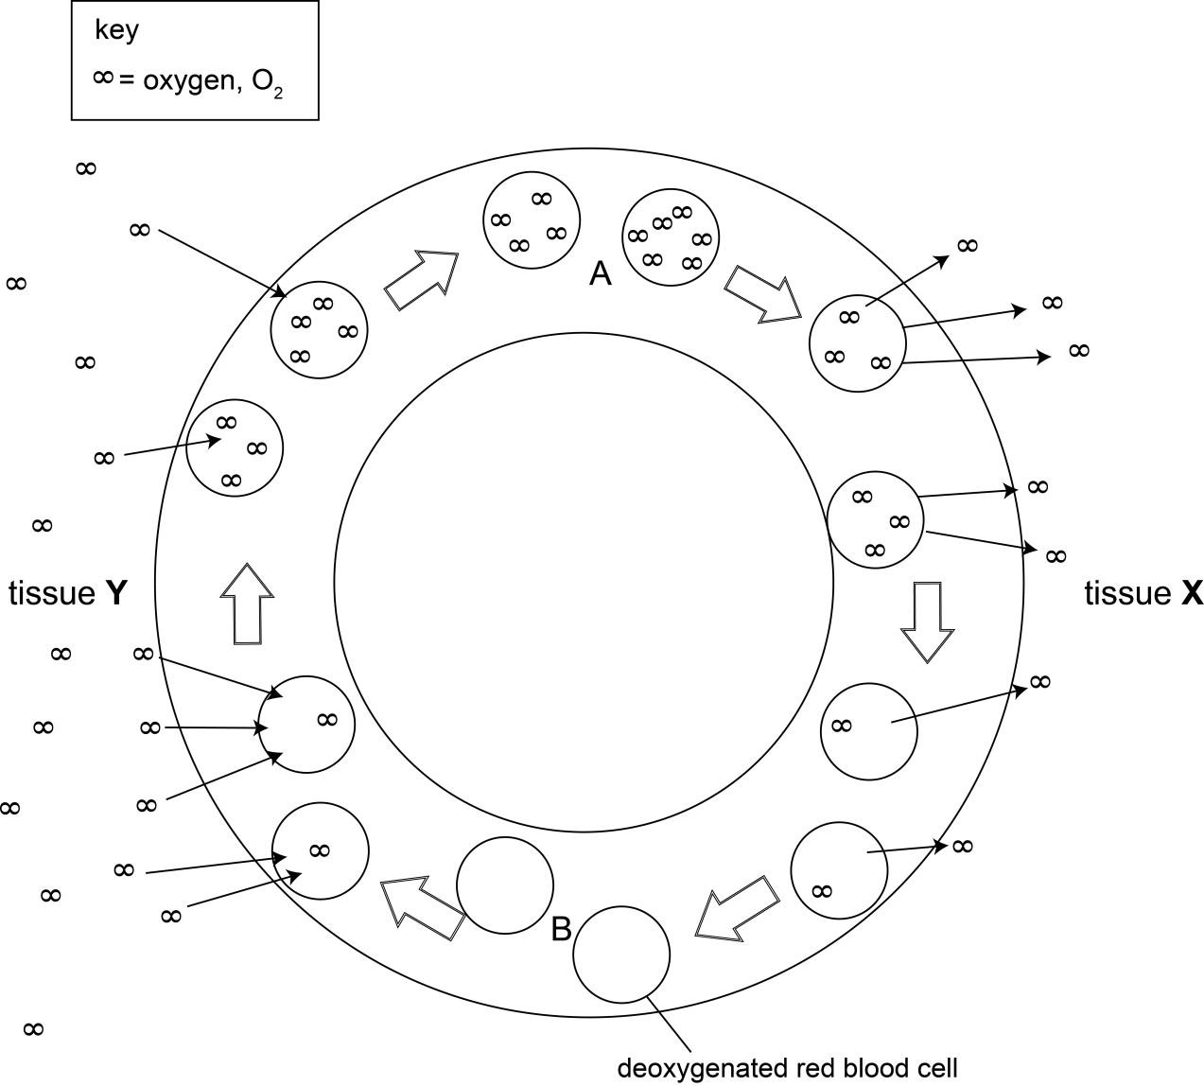Look at the diagram showing the movement of oxygen in mammals.

|  |  |  |
| --- | --- | --- |
| **(a)** |  | How does oxygen enter a red blood cell? **[2 marks]** |
|  |  |  |
|  |  |  |
| **(b)** |  | How are red blood cells are adapted to carry oxygen? **[2 marks]** |
|  |  |  |
|  |  |  |

|  |  |  |
| --- | --- | --- |
| **(c)** |  | Why does the rate at which oxygen leaves the red blood cell changes as it moves through tissue **X**. **[2 marks]** |
|  |  |  |
|  |  |  |
| **(d)** | **(i)** | What type of tissue is tissue **Y**? **[1 mark]** |
|  |  |  |
|  |  |  |
|  | **(ii)** | Tissue **Y** is made up of a specialised exchange surface.  Why are specialised exchange surfaces and transport systems needed for the movement of oxygen? **[3 marks]** |
|  |  |  |
|  |  |  |
| **(e)** |  | Red blood cells at **A** and **B** pass through different chambers of the heart.  Write down a chamber of the heart which the cells pass through at each point. **[2 marks]**  **A** …………………………………………..  **B** ………………………………………….. |

1. Plants need water for photosynthesis.

Water is taken in from the soil through root hair cells.

Look at the diagram of a root hair cell.

|  |  |  |
| --- | --- | --- |
| **(a)** | **(i)** | Why are root hair cells good at taking in water? **[1 mark]** |
|  |  |  |
|  |  |  |
|  | **(ii)** | Root hair cells also take up mineral ions from the soil.  Look at the data.   |  |  |  |  | | --- | --- | --- | --- | |  | **ion concentration (mmol/kg)** | | | | **calcium** | **magnesium** | **potassium** | | root | 250.0 | 80.0 | 250.0 | | soil | 120.0 | 3.1 | 1.2 |   How do the data provide evidence that minerals are taken up by active transport? **[1 mark]** |
|  |  |  |
|  |  |  |

|  |  |  |  |
| --- | --- | --- | --- |
| **(b)** |  | The process of drawing water through a plant is called transpiration.  This movement of water can be investigated using a simple potometer. | |
|  | **(i)** | Show how to set up a potometer to investigate water loss.  You may use a labelled diagram to help you answer. **[3 marks]** | |
|  |  |  | |
|  |  |  | |
|  | **(ii)** | Explain why the potometer is **not** an accurate measure of water **lost**. **[1 mark]** | |
|  |  |  | |
|  |  |  | |
|  | **(iii)** | Look at the results collected from a potometer experiment.  The level was taken at the start and then 30 minutes later.  The test was repeated three times.   |  |  |  |  | | --- | --- | --- | --- | |  | **repeat 1** | **repeat 2** | **repeat 3** | | water level at start (cm3) | 0.02 | 0.04 | 0.02 | | water level at end (cm3) | 0.13 | 0.14 | 0.17 | | change in water level (cm3) | 0.11 | 0.10 | 0.15 |   Calculate the mean change in water level and use this to calculate the rate of water loss. **[2 marks]** | |
|  |  | rate of water loss………..cm3/min | |
|  |  |  |  |

|  |  |  |  |  |  |  |  |  |  |  |  |
| --- | --- | --- | --- | --- | --- | --- | --- | --- | --- | --- | --- |
|  | **(iv)** | The conditions for the experiment are then changed in three different ways.  Predict the effect of each change on the rate of water loss. **[1 mark]**  The first one has been completed for you.   |  |  | | --- | --- | | **change in conditions** | **effect** | | Move apparatus into bright sunlight | Increases rate | | Place apparatus in front of a fan | ... increases (rate) ... | | Place shoot inside a sealed plastic bag | ... decreases (rate) ...  (both needed for mark 🗸) | |  |
|  |  |  | |
|  | **(v)** | Why does moving the apparatus into bright sunlight increases the rate of water loss. **[2 marks]** | |
|  |  |  | |
|  |  |  | |
| **(c)** |  | Water is transported up the stem of a plant through xylem tissue.  The other main transport tissue in plants is the phloem.  What are the difference and similarities of xylem and phloem tissues? You may want to focus on their structure and function. **[6 marks]** | |
|  |  |  | |