End of topic quiz

Topic B3: Organism Level Systems

Instructions and answers for teachers
These instructions cover the learner activity section which can be found on page 11. This end of topic quiz supports OCR GCSE (9–1) Combined Science A (J250), Topic B3.
When distributing the activity section to the learners either as a printed copy or as a Word file you will need to remove the teacher instructions section.

The Activity
This end of topic quiz is a teaching and learning resource comprised of 40 marks covering a range of question types. The quiz starts with some multiple choice questions (MCQs) and then moves on to some short answer questions and then finally on to some longer answer questions.
This resource can be used to test and consolidate understanding at the end of teaching the topic or to revisit and refresh knowledge at a later point in the course.

Learning Outcomes
This end of topic quiz relates to the specification learning outcomes in Topic B3: Organism Level Systems. The questions in this quiz cover a range of the following topics:
B3.1 Coordination and control – the nervous system
B3.2 Coordination and control – the endocrine system
B3.3 Maintaining internal environments

Topic: B3 of J250 - Answers
Total marks: 40

- Which of the following is the correct order for a reflex action? [1 mark]
A | Effector → sensory neurone → relay neurone → motor neurone → receptor
B | Receptor → sensory neurone → relay neurone → motor neurone → effector
C | Receptor → relay neurone → motor neurone → sensory neurone → effector
D | Sensory neurone → receptor → relay neurone → motor neurone → effector
Your answer
B
- Which of the following hormones are used by infertility treatments in women? [1 mark]
A | FSH and LH
B | Oestrogen
C | Oestrogen and progesterone
D | Testosterone
Your answer
A
- People exposed to very cold conditions struggle to maintain a constant internal environment.
Why is it important to stop internal temperature being too low? [1 mark]
A | Because all the bodies energy will be used up shivering.
B | Because the body will not lose enough water through sweating.
C | Because the enzymes will denature.
D | Because the metabolic reactions will be too slow.
Your answer
D
- Which of the following statements is not true about type II diabetes? [1 mark]
A | Glucose builds up in the body.
B | The body cells can be resistant to insulin.
C | The body does not produce insulin.
D | Type II diabetes can develop at any age.
Your answer
C
- The level of thyroxine in the body is controlled by negative feedback.
What would lead to a decrease in the secretion of thyroxine? [1 mark]
A | A low level of thyroxine in the blood.
B | The breakdown of thyroxine by the liver.
C | The hypothalamus detecting a high level of thyroxine in the blood.
D | The secretion of thyroid stimulating hormone (TSH) from the pituitary gland.
Your answer
C
- The nervous system can produce coordinated responses because of its many links.
(a) |  |  | Many of the links are in the central nervous system (CNS).  Which two parts of the body make up the CNS? [2 marks]
1 brain ...............................................
2 spinal cord .....................................
(b) |  |  | Look at the labelled diagrams of a sensory neurone and a motor neurone.  Sensory neurone  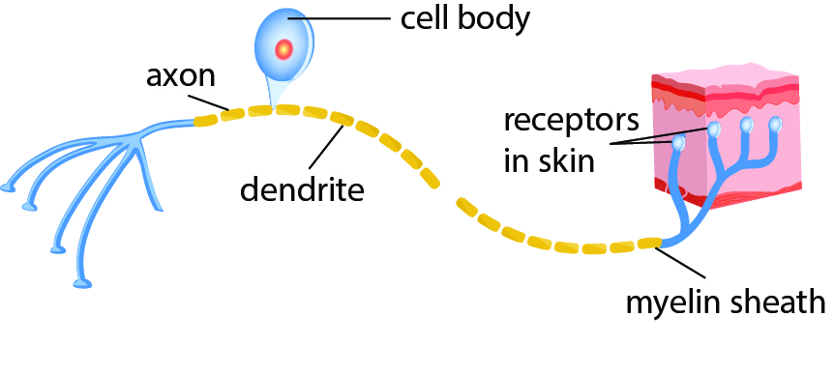  Motor neurone  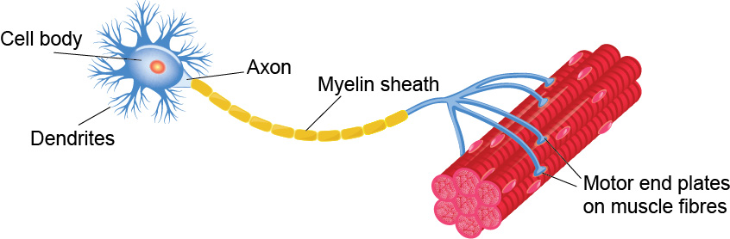  Use the diagrams and your own knowledge to compare the structure and function of sensory and motor neurones. [4 marks]
Any four from the following:
different position of cell body/nucleus
both long
idea of both going between effector and receptor
idea of signal travelling in different directions
both carry nerve impulses
(c) |  |  | Reflexes are very fast reactions.  A reflex action is often quicker than other reactions.  Reaction times can be estimated using computer programs.  The reaction times for a sample of 16-year-olds and 70-year-olds were taken.  age of sample mean time (s) range (s)  16 0.25 0.20 – 0.29  70 0.27 0.20 – 0.30  The results were shown on a chart.  X 16 year old  70 year old  0.18 0.20 0.22 0.24 0.26 0.28 0.30 0.32  reaction time (s)
 | (i) |  | Finish the chart for the 70 year old sample. [2 marks]
average plotted correctly
range plotted correctly
 | (ii) |  | Are the reaction times slower for 70 year olds and how good is the data?  [3 marks]
Three from the following:
mean reaction slower (in 70 year old)
fastest 70 year old had the same reaction time as fastest 16 year old
idea that only a sample
idea that trend may not hold in individual cases
 | (iii) |  | Why could reflex actions be quicker than the times above? [1 mark]
 |  |  | reflex does not involve thinking/processing time / AW

- People with diabetes have difficulty maintaining a constant internal environment.
(a) |  | What is the process of maintaining a constant internal environment called?  [1 mark]
 |  | Homeostasis
(b) | (i) | Look at the graphs for two people.  One person has diabetes, which they manage by injecting insulin, the other person does not.  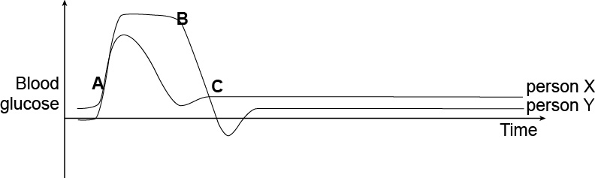  Why is the graph this shape? Use the labels to help you. [6 marks]
Six marks from the following:
- (high-GI) food intake causes increase in blood sugar
- insulin causes drop in graph as glucose converted to glycogen
- glucagon released when blood glucose too low
- glucagon causes glycogen to be converted to glucose to restore blood sugar to normal
- At A ate (high GI) meal
- At B injected insulin
- At C glucagon released
- Person X has diabetes because the blood sugar rises much higher
- Person Y does not have diabetes
Any valid answer
 | (ii) | Why is the blood glucose level between A and B a problem? [1 mark]
 |  | idea that high solute level causes water to move out of cells into tissues
(c) |  | Patients can manage diabetes by injecting insulin.  Name one other treatment that can be used by people with diabetes and why this helps. [1 mark]
One from the following:
controlling diet – not eating food high in sugar/carbohydrate
regular exercise – helps to keep glucose within suitable range
weight reduction – extra fat increases insulin resistance

- Hormones are involved in coordination and control.
(a) |  | What is a hormone? [1 mark]
 |  | chemical messenger
(b) | (i) | Adrenalin is a hormone released in response to stressful situations.  Complete the flow chart to show the effect of adrenalin on different organs.  [3 marks]  Stressful situation  Brain sends message along nerve  Adrenal gland secretes adrenalin into blood  organ.........................  effect......................................................................................................  organ.........................  effect......................................................................................................  organ.........................  effect......................................................................................................
Three from the following:
heart – beats faster
brain/lungs – increase rate of breathing
skin – constricts arterioles/less blood near surface
muscles – tense
digestive system – constricts arterioles / relaxes muscles / slows down digestion
liver – converts glycogen to glucose
 | (iii) | For one of the organs you gave as an answer in part (i), explain how the effect helps the body to respond to the stressful situation. [2 marks]
Organ ..............................................

Explanation
Any one from:
heart – more glucose and oxygen to muscles for respiration
brain/lungs – more oxygen available / carbon dioxide removed quickly
skin – more blood available to muscles
muscles – ready for immediate action
(c) |  | Hormones are also used to control the menstrual cycle.  The process of ovulation is shown by the diagram below.    0 2 4 6 8 10 12 14 16 18 20 22 24 26 28
 | (i) | Between days 2 and 12 the follicle is developing.  Which hormone is realised to cause this? [1 mark]
 |  | FSH/follicle stimulating hormone
 | (ii) | The developing follicle secretes oestrogen.  Oestrogen peaking stimulates the release of another hormone at about day 14.  Which hormone? [1 mark]
 |  | LH/lutenising hormone
 | (iii) | The corpeus luteum secretes progesterone.  What are the roles of progesterone? [2 marks]
maintains thick uterus lining
inhibits LH/LSH/inhibits follicle developing
(d) |  | The table shows the effectiveness of the combined pill and male condom as contraceptives.  The theoretical effectiveness is how well the birth control works when used correctly.  The actual effectiveness is how well the birth control works in ‘typical use’, taking into account human error and other factors.  Birth control method Theoretical effectiveness Actual effectiveness  combined pill 99% 92%  male condom 98% 85%  Which is the better method of birth control and why? [4 marks]  You should consider the effectiveness and method of action.
Three from the following:
effectiveness similar when used correctly/slightly better when used correctly
difference much greater when in typical use
side effects with pill
pills must be taken at the right time
condom must be applied correctly
condom helps prevent STDs
AND
idea of making a judgement combined with any of the above e.g. difference much greater when in typical use so pill is better/effectiveness similar when used correctly but has side effects so condom better

This formative assessment resource has been produced as part of our free GCSE teaching and learning support package. All the GCSE teaching and learning resources, including delivery guides, topic exploration packs, lesson elements and more are available on the qualification webpages.
If you are looking for examination practice materials, you can find the Sample Assessment Materials (SAMs) on the qualification webpage: Combined Science A (9–1).

OCR Resources: the small print
OCR’s resources are provided to support the delivery of OCR qualifications, but in no way constitute an endorsed teaching method that is required by the Board, and the decision to use them lies with the individual teacher. Whilst every effort is made to ensure the accuracy of the content, OCR cannot be held responsible for any errors or omissions within these resources.
© OCR 2016 - This resource may be freely copied and distributed, as long as the OCR logo and this message remain intact and OCR is acknowledged as the originator of this work.
OCR acknowledges the use of the following content: Motor neuron and sensory neuron: Designua/Shutterstock.com; Ovulation cycle: Ptaha I/Shutterstock.com
Please get in touch if you want to discuss the accessibility of resources we offer to support delivery of our qualifications: resources.feedback@ocr.org.uk

We’d like to know your view on the resources we produce. By clicking on ‘Like’ or ‘Dislike’ you can help us to ensure that our resources work for you. When the email template pops up please add additional comments if you wish and then just click ‘Send’. Thank you.
If you do not currently offer this OCR qualification but would like to do so, please complete the Expression of Interest Form which can be found here: www.ocr.org.uk/expression-of-interest
Looking for a resource? There is now a quick and easy search tool to help find free resources for your qualification:
www.ocr.org.uk/i-want-to/find-resources/

End of topic quiz

Topic B3: Organism Level Systems

Learner Activity

Topic: B3 of J250
Total marks: 40
- Which of the following is the correct order for a reflex action? [1 mark]
A | Effector → sensory neurone → relay neurone → motor neurone → receptor
B | Receptor → sensory neurone → relay neurone → motor neurone → effector
C | Receptor → relay neurone → motor neurone → sensory neurone → effector
D | Sensory neurone → receptor → relay neurone → motor neurone → effector
Your answer

- Which of the following hormones are used by infertility treatments in women? [1 mark]
A | FSH and LH
B | Oestrogen
C | Oestrogen and progesterone
D | Testosterone
Your answer

- People exposed to very cold conditions struggle to maintain a constant internal environment.
Why is it important to stop internal temperature being too low? [1 mark]
A | Because all the bodies energy will be used up shivering.
B | Because the body will not lose enough water through sweating.
C | Because the enzymes will denature.
D | Because the metabolic reactions will be too slow.
Your answer

- Which of the following statements is not true about type II diabetes? [1 mark]
A | Glucose builds up in the body.
B | The body cells can be resistant to insulin.
C | The body does not produce insulin.
D | Type II diabetes can develop at any age.
Your answer

- The level of thyroxine in the body is controlled by negative feedback.
What would lead to a decrease in the secretion of thyroxine? [1 mark]
A | A low level of thyroxine in the blood.
B | The breakdown of thyroxine by the liver.
C | The hypothalamus detecting a high level of thyroxine in the blood.
D | The secretion of thyroid stimulating hormone (TSH) from the pituitary gland.
Your answer

- The nervous system can produce coordinated responses because of its many links.
(a) |  |  | Many of the links are in the central nervous system (CNS).  Which two parts of the body make up the CNS? [2 marks]
1 ...............................................
2 .....................................
(b) |  |  | Look at the labelled diagrams of a sensory neurone and a motor neurone.  Sensory neurone  Motor neurone  Use the diagrams and your own knowledge to compare the structure and function of sensory and motor neurones. [4 marks]
(c) |  |  | Reflexes are very fast reactions.  A reflex action is often quicker than other reactions.  Reaction times can be estimated using computer programs.  The reaction times for a sample of 16-year-olds and 70-year-olds were taken.  age of sample mean time (s) range (s)  16 0.25 0.20 – 0.29  70 0.27 0.20 – 0.30  The results were shown on a chart.  X 16 year old  70 year old  0.18 0.20 0.22 0.24 0.26 0.28 0.30 0.32  reaction time (s)
 | (i) |  | Finish the chart for the 70 year old sample. [2 marks]
 |  |  | X |  |  | 16 year old
 |  |  |  |  |  | 70 year old
0.18 0.20 0.22 0.24 0.26 0.28 0.30 0.32
reaction time (s)
 | (ii) |  | Are the reaction times slower for 70 year olds and how good is the data?  [3 marks]
 | (iii) |  | Why could reflex actions be quicker than the times above? [1 mark]

- People with diabetes have difficulty maintaining a constant internal environment.
(a) |  | What is the process of maintaining a constant internal environment called?  [1 mark]
(b) | (i) | Look at the graphs for two people.  One person has diabetes, which they manage by injecting insulin, the other person does not.  Why is the graph this shape? Use the labels to help you. [6 marks]
 | (ii) | Why is the blood glucose level between A and B a problem? [1 mark]
(c) |  | Patients can manage diabetes by injecting insulin.  Name one other treatment that can be used by people with diabetes and why this helps. [1 mark]

- Hormones are involved in coordination and control.
(a) |  | What is a hormone? [1 mark]
(b) | (i) | Adrenalin is a hormone released in response to stressful situations.  Complete the flow chart to show the effect of adrenalin on different organs.  [3 marks]
Stressful situation

Brain sends message along nerve

Adrenal gland secretes adrenalin into blood

organ.........................
effect......................................................................................................
organ.........................
effect......................................................................................................
organ.........................
effect......................................................................................................
 | (iii) | For one of the organs you gave as an answer in part (i), explain how the effect helps the body to respond to the stressful situation. [2 marks]
Organ ..............................................

Explanation:

(c) |  | Hormones are also used to control the menstrual cycle.  The process of ovulation is shown by the diagram below.  0 2 4 6 8 10 12 14 16 18 20 22 24 26 28
 | (i) | Between days 2 and 12 the follicle is developing.  Which hormone is realised to cause this? [1 mark]
 | (ii) | The developing follicle secretes oestrogen.  Oestrogen peaking stimulates the release of another hormone at about day 14.  Which hormone? [1 mark]
 | (iii) | The corpeus luteum secretes progesterone.  What are the roles of progesterone? [2 marks]
(d) |  | The table shows the effectiveness of the combined pill and male condom as contraceptives.  The theoretical effectiveness is how well the birth control works when used correctly.  The actual effectiveness is how well the birth control works in ‘typical use’, taking into account human error and other factors.  Birth control method Theoretical effectiveness Actual effectiveness  combined pill 99% 92%  male condom 98% 85%  Which is the better method of birth control and why? [4 marks]  You should consider the effectiveness and method of action.

