# End of topic quiz

# Topic B4: Community Level Systems

## Instructions and answers for teachers

These instructions cover the learner activity section which can be found on page 12. This end of topic quiz supports OCR GCSE (9–1) Combined Science A (J250), Topic B4.

**When distributing the activity section to the learners either as a printed copy or as a Word file you will need to remove the teacher instructions section.**

### The Activity

This end of topic quiz is a teaching and learning resource comprised of 40 marks covering a range of question types. The quiz starts with some multiple choice questions (MCQs) and them moves on to some short answer questions and then finally on to some longer answer questions.

This resource can be used to test and consolidate understanding at the end of teaching the topic or to revisit and refresh knowledge at a later point in the course.

### Learning Outcomes

This end of topic quiz relates to the specification learning outcomes in Topic B4: Community Level Systems. The questions in this quiz cover a range of the following topics:

B4.1 Ecosystems

### Topic: B4 of J250 - Answers

**Total marks: 40**

1. Which term is used to describe a group of individuals of the same species? **[1 mark]**

|  |  |  |
| --- | --- | --- |
| **A** | Community |  |
| **B** | Ecology |  |
| **C** | Habitat |  |
| **D** | Population |  |

Your answer

**D**

1. Which process removes carbon dioxide from the air? **[1 mark]**

|  |  |  |
| --- | --- | --- |
| **A** | Combustion |  |
| **B** | Decomposition |  |
| **C** | Photosynthesis |  |
| **D** | Respiration |  |

Your answer

**C**

1. What is an ecosystem? **[1 mark]**

|  |  |  |
| --- | --- | --- |
| **A** | A community of interdependent organisms and the environment in which  they live. |  |
| **B** | The living organisms which coexist in a habitat. |  |
| **C** | The part of the Earth which contains living organisms. |  |
| **D** | The producers and consumers in an environment. |  |

Your answer

**A**

1. The kite diagram shows the distribution of a species of invertebrates living in a stream.

0 2 4 6 8 10 12

Distance downstream (m)

How far down the stream was the highest number of invertebrates? **[1 mark]**

|  |  |  |
| --- | --- | --- |
| **A** | 3 m |  |
| **B** | 6 m |  |
| **C** | 8 m |  |
| **D** | 12 m |  |

Your answer

**B**

1. Which of the following is a biotic factor? **[1 mark]**

|  |  |  |
| --- | --- | --- |
| **A** | Availability of food |  |
| **B** | Moisture level |  |
| **C** | pH of soil |  |
| **D** | Temperature |  |

Your answer

**A**

1. The diagram shows part of a food web for an African plain.

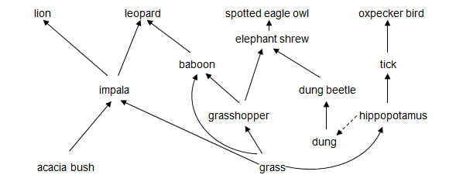

|  |  |  |  |
| --- | --- | --- | --- |
| **(a)** |  | The diagram shows part of a community.  What is a community? **[1 mark]** | |
|  |  | all living organisms in a habitat 🗸  **ALLOW** all plants and animals in a habitat 🗸 | |
|  |  |  |  |
| **(b)** | **(i)** | The tick is a parasite.  What is a parasite? **[1 mark]** | |
|  |  | an organism which lives on or in another organism and feeds off it/an organism which benefits from another organism which suffers 🗸  **ALLOW** idea of benefitting while causing host to suffer 🗸 | |
|  |  |  |  |
|  | **(ii)** | Oxpeckers live on the back of hippopotamus.  What is the ecological relationship between the oxpecker and the hippopotamus? **[3 marks]** | |
|  |  | idea of mutualistic relationship which benefits both oxpecker and hippo 🗸  oxpecker gets food/ticks 🗸  parasitic ticks removed from hippo 🗸 | |

|  |  |  |  |
| --- | --- | --- | --- |
| **(c)** |  | The baboon is an omnivore. | |
|  | **(i)** | Why is being an omnivore an advantage when there is a low number of grasshoppers? **[1 mark]** | |
|  |  | able to get food from grass instead / AW 🗸 | |
|  |  |  | |
|  | **(ii)** | Why is a shortage of grass a greater problem than a low number of grasshoppers? **[1 mark]** | |
|  |  | organisms that feed on grass will also die so no alternative food source / AW 🗸 | |
|  |  |  | |
| **(d)** |  | Leopard and lion are competitors.  Both are hunted by humans.  If the number of leopards falls due to hunting.  What will happen to the population of: | |
|  | **(i)** | Lion? **[1 mark]** | |
|  |  | increased prey due to less predation on impala 🗸  **not** just increase in lion | |
|  |  |  | |
|  | **(ii)** | Impala? **[1 mark]** | |
|  |  | less predator so increase in impala 🗸 | |
|  |  |  | |
|  | **(iii)** | Hippopotamus? **[1 mark]** | |
|  |  | little change/no effect as the leopard has little effect on the food chain containing the hippopotamus 🗸 | |
|  |  |  |  |
| **(e)** |  | The number of dung beetles can be monitored using a capture-mark-recapture method of sampling.  The number of dung beetles can be estimated using this formula:   |  |  | | --- | --- | | population size = | number in 1st sample × number in 2nd sample | | number in 2nd sample previously marked |   The sampling data is shown in the table below.   |  | 1st sample | 2nd sample | | --- | --- | --- | | number in sample | 100 | 120 | | number marked in sample |  | 30 | | |
|  | **(i)** | Use the formula to estimate the number dung beetles. **[2 marks]** | |
|  |  | 400 🗸🗸  **if incorrect**  12000 /   |  | | --- | | 100 × 120 | | 30 |   🗸 | |
|  |  |  | |
|  | **(ii)** | Why might this number not be accurate? **[2 marks]** | |
|  |  | **Two from the following:**  idea of unrepresentative sample 🗸  marking affects survival 🗸  no death, immigration or emigration assumed 🗸  **ALLOW** just a sample 🗸  **ALLOW** example of unrepresentative sample e.g. only big beetles sampled 🗸 | |

|  |  |  |
| --- | --- | --- |
|  |  |  |
|  | **(iii)** | Dung beetles are detritivores.  Detritivores feed on waste matter.  They break down organic material. This process is similar to decomposition.  Use the food web and your own knowledge to explain why this is an important role. **[2 marks]** |
|  |  | **Two from the following:**  makes nutrients available 🗸  dung beetles eaten by elephant shrews 🗸  waste matter re-enters food web 🗸 |

1. In many ecosystems abiotic factors change from one place to another.

The table below shows abiotic factors in a tropical rainforest, going from the ground up to the tops of the trees.

| **distance from ground (m)** | **0** | **5** | **10** | **15** | **22** | **30** |
| --- | --- | --- | --- | --- | --- | --- |
| light intensity (%) | 2 | 3 | 8 | 15 | 50 | 70 |
| wind speed (km/h) | 0 | 3 | 5 | 9 | 12 | 15 |
| humidity (%) | 98 | 90 | 85 | 80 | 75 | 67 |

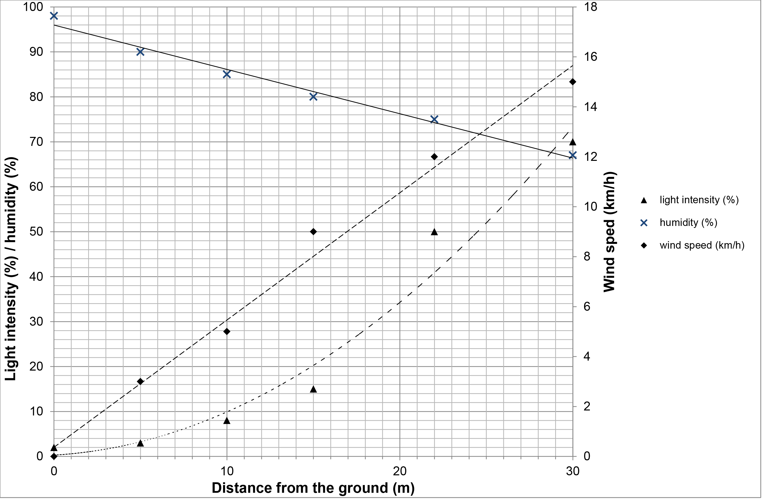

|  |  |  |  |
| --- | --- | --- | --- |
| **(a)** |  | Plot, using the left hand axis, the data for humidity.  Draw a curved line through the points. **[3 marks]** | |
|  |  | all points plotted correctly 🗸🗸  smooth line passing through points 🗸  **if points not correctly plotted:**  4 or 5 correct points 🗸  **ALLOW** straight line connecting the points 🗸 | |
|  |  |  |  |
| **(b)** |  | What trends and patterns shown in the graph? **[3 marks]** | |
|  |  | light intensity increases going up (through the trees)/ora 🗸  wind speed increases going up (through the trees)/ora 🗸  humidity decreases going up (through the trees)/ora 🗸 | |
|  |  |  |  |
| **(c)** |  | Name one advantage and one disadvantage for plants growing near the ground in the forest. **[2 marks]**  Use the data and your own knowledge to help you. | |
|  |  | **Advantage:**  **One from the following:**  high humidity decreases water loss through transpiration/AW 🗸  low wind speed decreases water loss from leaves/AW 🗸  idea of supply of nutrients from leaf litter/organic matter on ground 🗸  **Disadvantage:**  lack of light prevents photosynthesis/AW 🗸 | |
|  |  |  |  |

|  |  |  |
| --- | --- | --- |
| **(d)** |  | Forests are an important part of both the water cycle and the carbon cycle.  Forests are being cut down and cleared.  What are the possible consequences of this disruption of the water and carbon cycles? **[3 marks]** |
|  |  | **Three from the following:**  less carbon fixed in trees (by photosynthesis) 🗸  more CO2 in atmosphere 🗸  increased greenhouse effect/global warming 🗸  less transpiration from trees returning water to atmosphere 🗸  less (local) rainfall 🗸  less water uptake by trees/more surface runoff of water 🗸  more erosion 🗸 |

1. Different materials cycle through ecosystems.

The diagram shows the nitrogen cycle.

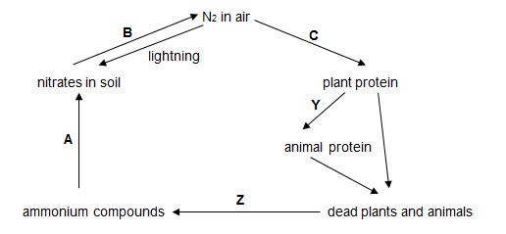

|  |  |  |  |
| --- | --- | --- | --- |
| **(a)** |  | What are processes **Y** and **Z**? **[2 marks]** | |
|  |  | **Y**  feeding/AW 🗸  **Z**  decomposition 🗸 | |
|  |  |  |  |
| **(b)** | **(i)** | In which stage, **A**, **B** or **C**, is nitrogen moved from an abiotic to a biotic component of the ecosystem? **[1 mark]** | |
|  |  | **C** 🗸 | |
|  |  |  |  |
|  | **(ii)** | Microorganisms are involved at stages **A**, **B,** **C** and **Z**.  What is the role of microorganisms in the cycling of nitrogen? **[2 marks]** | |
|  |  | **Any two from:**  at **A** (nitrifying) bacteria convert ammonium compounds to a form that can be used by plants 🗸  at **B** (denitrifying) bacteria return nitrogen to air 🗸  at **C** (nitrogen-fixing) bacteria make nitrogen available to plants/bacteria living in roots make nitrogen available/AW 🗸  at **Z** microbes/bacteria/fungi are involved in decomposition/releasing nitrogen from dead plants and animals 🗸 | |
|  |  |  |  |
| **(c)** |  | Sometimes the microorganisms at **C** are in a mutualistic relationship with the plants.  The microorganisms live in root nodules on the plants.  How could the relationship be beneficial to both the plant and microorganism?  **[2 marks]** | |
|  |  | plant gets (access to) nitrates/nitrogen 🗸  microorganism gets sugar/nutrients from plant 🗸 | |
|  |  |  |  |
| **(d)** |  | Humans affect the nitrogen cycle by applying large amounts of nitrogen fertiliser.  This increases the level of nitrates in the soil.  Why do humans apply fertiliser? **[1 mark]** | |
|  |  | to increase crop yield/to grow more plants/to produce more plant protein 🗸 | |

This formative assessment resource has been produced as part of our free GCSE teaching and learning support package. All the GCSE teaching and learning resources, including delivery guides, topic exploration packs, lesson elements and more are available on the qualification webpages.

If you are looking for examination practice materials, you can find the Sample Assessment Materials (SAMs) on the qualification webpage: [Combined Science A (9–1).](http://www.ocr.org.uk/qualifications/gcse-gateway-science-suite-combined-science-a-j250-from-2016/)

We’d like to know your view on the resources we produce. By clicking on ‘[Like](mailto:resources.feedback@ocr.org.uk?subject=I%20liked%20the%20GCSE%20(9-1)%20Gateway%20Science%20Combined%20Science%20A%20End%20of%20Topic%20Quiz%20(Topic%20B4:%20Community%20Level%20Systems))’ or ‘[Dislike](mailto:resources.feedback@ocr.org.uk?subject=I%20liked%20the%20GCSE%20(9-1)%20Gateway%20Science%20Combined%20Science%20A%20End%20of%20Topic%20Quiz%20(Topic%20B4:%20Community%20Level%20Systems))’ you can help us to ensure that our resources work for you. When the email template pops up please add additional comments if you wish and then just click ‘Send’. Thank you.

If you do not currently offer this OCR qualification but would like to do so, please complete the Expression of Interest Form which can be found here: [www.ocr.org.uk/expression-of-interest](http://www.ocr.org.uk/expression-of-interest)

Looking for a resource? There is now a quick and easy search tool to help find free resources for your qualification:   
[www.ocr.org.uk/i-want-to/find-resources/](http://www.ocr.org.uk/i-want-to/find-resources/)

**OCR Resources**: *the small print*OCR’s resources are provided to support the delivery of OCR qualifications, but in no way constitute an endorsed teaching method that is required by the Board, and the decision to use them lies with the individual teacher. Whilst every effort is made to ensure the accuracy of the content, OCR cannot be held responsible for any errors or omissions within these resources.  
© OCR 2016 - This resource may be freely copied and distributed, as long as the OCR logo and this message remain intact and OCR is acknowledged as the originator of this work.

OCR acknowledges the use of the following content: n/a

Please get in touch if you want to discuss the accessibility of resources we offer to support delivery of our qualifications: [resources.feedback@ocr.org.uk](mailto:resources.feedback@ocr.org.uk)

# 

# End of topic quiz

# Topic B4: Community Level Systems

## Learner Activity

### Topic: B4 of J250

**Total marks: 40**

1. Which term is used to describe a group of individuals of the same species? **[1 mark]**

|  |  |  |
| --- | --- | --- |
| **A** | Community |  |
| **B** | Ecology |  |
| **C** | Habitat |  |
| **D** | Population |  |

Your answer

1. Which process removes carbon dioxide from the air? **[1 mark]**

|  |  |  |
| --- | --- | --- |
| **A** | Combustion |  |
| **B** | Decomposition |  |
| **C** | Photosynthesis |  |
| **D** | Respiration |  |

Your answer

1. What is an ecosystem? **[1 mark]**

|  |  |  |
| --- | --- | --- |
| **A** | A community of interdependent organisms and the environment in which  they live. |  |
| **B** | The living organisms which coexist in a habitat. |  |
| **C** | The part of the Earth which contains living organisms. |  |
| **D** | The producers and consumers in an environment. |  |

Your answer

1. The kite diagram shows the distribution of a species of invertebrates living in a stream.

0 2 4 6 8 10 12

Distance downstream (m)

How far down the stream was the highest number of invertebrates? **[1 mark]**

|  |  |  |
| --- | --- | --- |
| **A** | 3 m |  |
| **B** | 6 m |  |
| **C** | 8 m |  |
| **D** | 12 m |  |

Your answer

1. Which of the following is a biotic factor? **[1 mark]**

|  |  |  |
| --- | --- | --- |
| **A** | Availability of food |  |
| **B** | Moisture level |  |
| **C** | pH of soil |  |
| **D** | Temperature |  |

Your answer

1. The diagram shows part of a food web for an African plain.



|  |  |  |  |  |
| --- | --- | --- | --- | --- |
| **(a)** |  | The diagram shows part of a community.  What is a community? **[1 mark]** | | |
|  |  |  | | |
|  |  |  |  | |
| **(b)** | **(i)** | The tick is a parasite.  What is a parasite? **[1 mark]** | | |
|  |  |  | | |
|  |  |  |  | |
|  | **(ii)** | Oxpeckers live on the back of hippopotamus.  What is the ecological relationship between the oxpecker and the hippopotamus? **[3 marks]** | | |
|  |  |  | | |
| **(c)** | **(i)**  **(ii)** | The baboon is an omnivore.  Why is being an omnivore an advantage when there is a low number of grasshoppers? **[1 mark]** | |  |
|  | |
| Why is a shortage of grass a greater problem than a low number of grasshoppers? **[1 mark]** | |
|  | |

|  |  |  |  |
| --- | --- | --- | --- |
|  |  |  |  |
| **(d)** |  | Leopard and lion are competitors.  Both are hunted by humans.  If the number of leopards falls due to hunting.  What will happen to the population of: | |
|  | **(i)** | Lion?**[1 mark]** | |
|  |  |  | |
|  |  |  | |
|  | **(ii)** | Impala? **[1 mark]** | |
|  |  |  | |
|  |  |  | |
|  | **(iii)** | Hippopotamus? **[1 mark]** | |
|  |  |  | |
|  |  |  |  |

|  |  |  |  |  |  |  |  |  |  |  |  |  |  |  |
| --- | --- | --- | --- | --- | --- | --- | --- | --- | --- | --- | --- | --- | --- | --- |
| **(e)** |  | The number of dung beetles can be monitored using a capture-mark-recapture method of sampling.  The number of dung beetles can be estimated using this formula:   |  |  | | --- | --- | | population size = | number in 1st sample × number in 2nd sample | | number in 2nd sample previously marked |   The sampling data is shown in the table below.   |  | 1st sample | 2nd sample | | --- | --- | --- | | number in sample | 100 | 120 | | number marked in sample |  | 30 | |
|  |  |  |
|  | **(i)** | Use the formula to estimate the number dung beetles. **[2 marks]** |
|  |  |  |
|  |  |  |
|  | **(ii)** | Why might this number not be accurate? **[2 marks]** |
|  |  |  |
|  |  |  |
|  | **(iii)** | Dung beetles are detritivores.  Detritivores feed on waste matter.  They break down organic material. This process is similar to decomposition.  Use the food web and your own knowledge to explain why this is an important role. **[2 marks]** |
|  |  |  |

1. In many ecosystems abiotic factors change from one place to another.

The table below shows abiotic factors in a tropical rainforest, going from the ground up to the tops of the trees.

| **distance from ground (m)** | **0** | **5** | **10** | **15** | **22** | **30** |
| --- | --- | --- | --- | --- | --- | --- |
| light intensity (%) | 2 | 3 | 8 | 15 | 50 | 70 |
| wind speed (km/h) | 0 | 3 | 5 | 9 | 12 | 15 |
| humidity (%) | 98 | 90 | 85 | 80 | 75 | 67 |

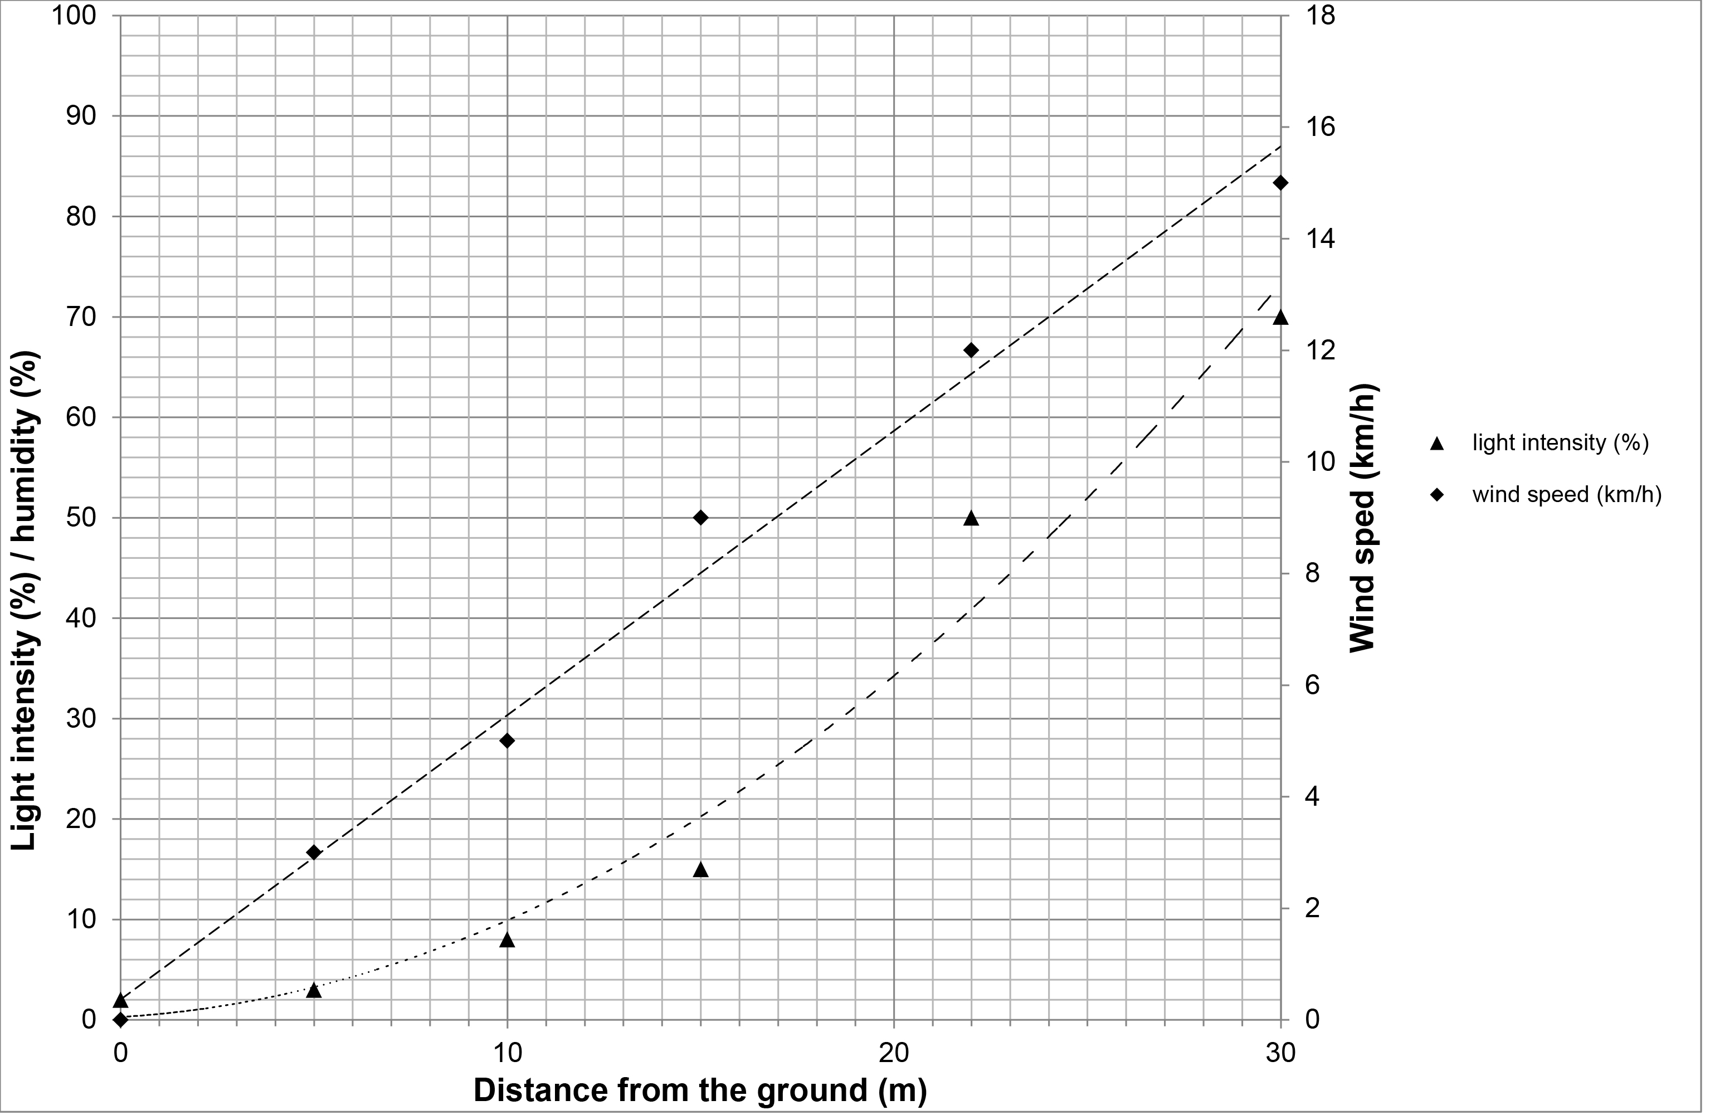

|  |  |  |  |
| --- | --- | --- | --- |
| **(a)** |  | Plot, using the left hand axis, the data for humidity.  Draw a curved line through the points. **[3 marks]** | |
|  |  |  |  |

|  |  |  |  |
| --- | --- | --- | --- |
| **(b)** |  | What trends and patterns are shown in the graph? **[3 marks]** | |
|  |  |  | |
|  |  |  |  |
| **(c)** |  | Name one advantage and one disadvantage for plants growing near the ground in the forest. **[2 marks]**  Use the data and your own knowledge to help you. | |
|  |  | **Advantage:**  **Disadvantage:** | |
|  |  |  |  |
| **(d)** |  | Forests are an important part of both the water cycle and the carbon cycle.  Forests are being cut down and cleared.  What are the possible consequences of this disruption of the water and carbon cycles? **[3 marks]** | |
|  |  |  | |

1. Different materials cycle through ecosystems.

The diagram shows the nitrogen cycle.



|  |  |  |  |
| --- | --- | --- | --- |
| **(a)** |  | What are processes **Y** and **Z**? **[2 marks]** | |
|  |  |  | |
|  |  |  |  |
| **(b)** | **(i)** | In which stage, **A**, **B** or **C**, is nitrogen moved from an abiotic to a biotic component of the ecosystem? **[1 mark]** | |
|  |  |  | |
|  |  |  |  |
|  | **(ii)** | Microorganisms are involved at stages **A**, **B,** **C** and **Z.**  What is the role of microorganisms in the cycling of nitrogen? **[2 marks]** | |
|  |  |  | |
|  |  |  |  |
| **(c)** |  | Sometimes the microorganisms at **C** are in a mutualistic relationship with the plants.  The microorganisms live in root nodules on the plants.  How could the relationship be beneficial to both the plant and microorganism?  **[2 marks]** | |
|  |  |  | |
|  |  |  |  |
| **(d)** |  | Humans affect the nitrogen cycle by applying large amounts of nitrogen fertiliser.  This increases the level of nitrates in the soil.  Why do humans apply fertiliser? **[1 mark]** | |
|  |  |  | |