End of topic quiz

Topic P4: Waves and radioactivity

Instructions and answers for teachers
These instructions cover the learner activity section which can be found on page 9. This end of topic quiz supports OCR GCSE (9–1) Combined Science A (J250), Topic P4.
When distributing the activity section to the learners either as a printed copy or as a Word file you will need to remove the teacher instructions section.

The Activity
This end of topic quiz is a teaching and learning resource comprised of 40 marks covering a range of question types. The quiz starts with some multiple choice questions (MCQs) and then moves on to some short answer questions and then finally on to some longer answer questions.
This resource can be used to test and consolidate understanding at the end of teaching the topic or to revisit and refresh knowledge at a later point in the course.

Learning Outcomes
This end of topic quiz relates to the specification learning outcomes in Topic P4: Waves and radioactivity. The questions in this quiz cover a range of the following topics:
P4.1 Wave behaviour
P4.2 The electromagnetic spectrum
P4.3 Radioactivity

Topic: P4 of J250 - Answers

Total marks: 40

1. | Which of the following definitions are true? [1 mark]  - Wavelength is the length a wave travels in one second.  - Wavelength is the length of one wave.  - Frequency is the number of waves that occur in one second.  - Frequency is time it takes for one wave to occur.
 | A | 1 and 3
 | B | 1 and 4
 | C | 2 and 3
 | D | 2 and 4
C | Your answer

2. | Which type of radiation is missing from the following list? [1 mark]  X Rays  ---------------  Visible Light
 | A | Radio waves
 | B | Infra-Red
 | C | Ultraviolet
C | D | Microwaves
 | Your answer

3. | Which of the following is the least penetrating? [1 mark]
 | A | Alpha
 | B | Beta
 | C | Gamma
 | D | X-Rays
A | Your answer

4. | What is the speed of a wave of wavelength 4 mm and a frequency of 10 Hz? [1 mark]
 | A | 0.04 m/s
 | B | 0.4 m/s
 | C | 4 m/s
 | D | 40 m/s
A | Your answer
5. | The diagram below shows light being passed through a glass block.  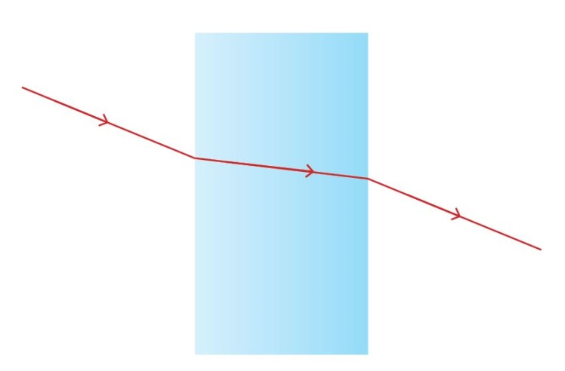  What property of waves is shown above? [1 mark]
 | A | Reflection
 | B | Refraction
 | C | Diffraction
 | D | Dispersion
B | Your answer
[1]
[1]
6. | Plutonium undergoes radioactive decay to become Uranium. The incomplete decay equation for this is shown below.  $${}_{94}^{239}{Pu} → {}_{…..}^{235}U + {}_{2}^{……}{….}$$
 | (a)  92  4  α | (i) | Complete the above decay equation. [3 marks]
 | Beta | (ii) | What is the other type of particle radiation? [1 mark]
 | (b)  An atom of an element with a different number of neutrons. | (i) | Plutonium- 239 is an isotope. What is an isotope? [2 marks]
7. | Light travels at a speed of 300,000,000 m/s.
 | (a)  Transverse | (i) | What sort of wave is light? [1 mark]
 | Transverse waves particle movement is perpendicular  to transfer of energy  Longitudinal waves it is parallel | (ii) | What are the main differences between transverse and longitudinal waves in terms of energy and particle movement? [3 marks]
 | (b)  Frequency used 300 GHz  300,000,000 ÷ 300,000,000,000  = 0.001 m | (i) | Radio waves have a frequency which ranges from 3 kHz to 300 GHz. What is the smallest possible wavelength they could have? [2 marks]

8. | Microwave ovens use microwaves to heat food.  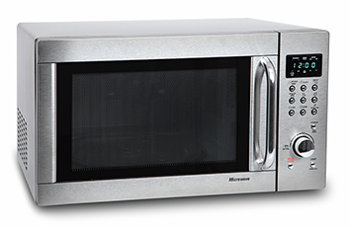
 | (a) | (i)  Microwaves gives energy to water molecules  Water molecules vibrate  Water molecules cause nearby molecules to vibrate  Energy transfers causes temperature to rise. | How does this happen? [4 marks]
 |  | (ii)  300000000 ÷ 2450000000  = 0.12 m | Microwaves have a frequency of 2,450 MHz. What is their wavelength? [2 marks]
 | (b) | (i)  Communication/radar | Name another use of microwaves. [1 mark]

 | 9.  Activity | The graph below shows the decay curve of a radioactive substance.  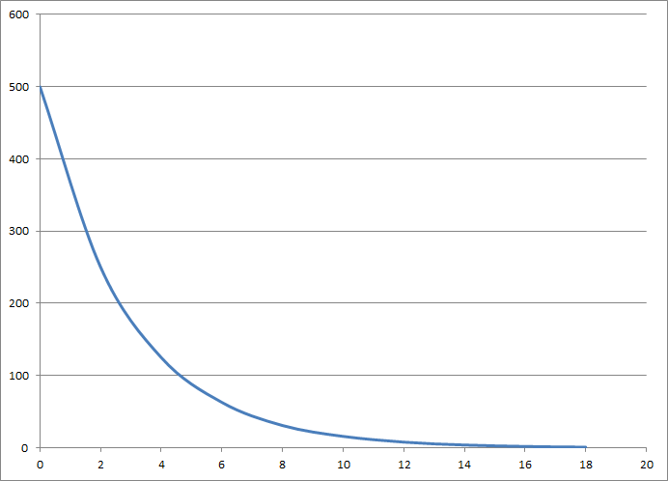  Time / days
 |  | (a) | (i)  Lines drawn on graph to find time for half starting number  2 days | Use the above graph to work out the half-life of this isotope. [2 marks]
 |  |  | (ii)  Time taken  For number of atoms/activity to drop by half. | What is meant by half life? [2 marks]
 |  | (b) | (i)  Gamma can be recorded outside the body  It will drop to harmless levels of radiation quickly  But not so quickly that readings cannot be taken. | The above isotope is a gamma emitter. Why would it be suitable for use as a tracking isotope in a human? [3 marks]
 |  |  | (ii)  No particles are released/Only energy given out  So no change to structure. | When an isotope emits gamma radiation it does not change to a different atom or isotope. Why not? [2 marks]
10. |  | X Rays and Gamma Rays are both ionising Electromagnetic Waves.
 |  | (a) | (i)  Damages DNA  Can cause mutation/cancer. | Why is ionisation dangerous to humans? [2 marks]
 |  |  | (ii)  Leave the room/stand behind lead shielding  Minimises amount of radiation reaching body  Film badge to check total exposure  Minimises amount of radiation reaching body over a period of time. | What safety precautions can be taken by medical staff to minimise their exposure to this radiation? [4 marks]
 |  | (b) | (i)  Risk of developing cancer from ionisation  Less than the risk of not knowing what is inside the chest. | A chest CT scan exposes the patient to a large amount of ionising radiation. Why are chest CT scans used, even though they are risky? [2 marks]
This formative assessment resource has been produced as part of our free GCSE teaching and learning support package. All the GCSE teaching and learning resources, including delivery guides, topic exploration packs, lesson elements and more are available on the qualification webpages.
If you are looking for examination practice materials, you can find the Sample Assessment Materials (SAMs) on the qualification webpage: Combined Science A (9–1).

OCR Resources: the small print
OCR’s resources are provided to support the teaching of OCR specifications, but in no way constitute an endorsed teaching method that is required by the Board, and the decision to use them lies with the individual teacher. Whilst every effort is made to ensure the accuracy of the content, OCR cannot be held responsible for any errors or omissions within these resources.
© OCR 2016 - This resource may be freely copied and distributed, as long as the OCR logo and this message remain intact and OCR is acknowledged as the originator of this work.
OCR acknowledges the use of the following content: n/a
Please get in touch if you want to discuss the accessibility of resources we offer to support delivery of our qualifications: resources.feedback@ocr.org.uk
This formative assessment resource has been produced as part of our free GCSE teaching and learning support package. All the GCSE teaching and learning resources, including delivery guides, topic exploration packs, lesson elements and more are available on the qualification webpages.
If you are looking for examination practice materials, you can find the Sample Assessment Materials (SAMs) on the qualification webpage: Combined Science B (9-1).

This formative assessment resource has been produced as part of our free GCSE teaching and learning support package. All the GCSE teaching and learning resources, including delivery guides, topic exploration packs, lesson elements and more are available on the qualification webpages.
If you are looking for examination practice materials, you can find the Sample Assessment Materials (SAMs) on the qualification webpage: Combined Science B (9-1).

We’d like to know your view on the resources we produce. By clicking on ‘Like’ or ‘Dislike’ you can help us to ensure that our resources work for you. When the email template pops up please add additional comments if you wish and then just click ‘Send’. Thank you.
If you do not currently offer this OCR qualification but would like to do so, please complete the Expression of Interest Form which can be found here: www.ocr.org.uk/expression-of-interest
OCR Resources: the small print
OCR’s resources are provided to support the teaching of OCR specifications, but in no way constitute an endorsed teaching method that is required by the Board, and the decision to use them lies with the individual teacher. Whilst every effort is made to ensure the accuracy of the content, OCR cannot be held responsible for any errors or omissions within these resources.
© OCR 2016 - This resource may be freely copied and distributed, as long as the OCR logo and this message remain intact and OCR is acknowledged as the originator of this work.
OCR acknowledges the use of the following content: n/a
Please get in touch if you want to discuss the accessibility of resources we offer to support delivery of our qualifications: resources.feedback@ocr.org.uk
This formative assessment resource has been produced as part of our free GCSE teaching and learning support package. All the GCSE teaching and learning resources, including delivery guides, topic exploration packs, lesson elements and more are available on the qualification webpages.
If you are looking for examination practice materials, you can find the Sample Assessment Materials (SAMs) on the qualification webpage: Combined Science B (9-1).

We’d like to know your view on the resources we produce. By clicking on ‘Like’ or ‘Dislike’ you can help us to ensure that our resources work for you. When the email template pops up please add additional comments if you wish and then just click ‘Send’. Thank you.
If you do not currently offer this OCR qualification but would like to do so, please complete the Expression of Interest Form which can be found here: www.ocr.org.uk/expression-of-interest
OCR Resources: the small print
OCR’s resources are provided to support the teaching of OCR specifications, but in no way constitute an endorsed teaching method that is required by the Board, and the decision to use them lies with the individual teacher. Whilst every effort is made to ensure the accuracy of the content, OCR cannot be held responsible for any errors or omissions within these resources.
© OCR 2016 - This resource may be freely copied and distributed, as long as the OCR logo and this message remain intact and OCR is acknowledged as the originator of this work.
OCR acknowledges the use of the following content: n/a
Please get in touch if you want to discuss the accessibility of resources we offer to support delivery of our qualifications: resources.feedback@ocr.org.uk
We’d like to know your view on the resources we produce. By clicking on ‘Like’ or ‘Dislike’ you can help us to ensure that our resources work for you. When the email template pops up please add additional comments if you wish and then just click ‘Send’. Thank you.
If you do not currently offer this OCR qualification but would like to do so, please complete the Expression of Interest Form which can be found here: www.ocr.org.uk/expression-of-interest
Looking for a resource? There is now a quick and easy search tool to help find free resources for your qualification:
www.ocr.org.uk/i-want-to/find-resources/

OCR Resources: the small print
OCR’s resources are provided to support the teaching of OCR specifications, but in no way constitute an endorsed teaching method that is required by the Board, and the decision to use them lies with the individual teacher. Whilst every effort is made to ensure the accuracy of the content, OCR cannot be held responsible for any errors or omissions within these resources.
© OCR 2016 - This resource may be freely copied and distributed, as long as the OCR logo and this message remain intact and OCR is acknowledged as the originator of this work.
OCR acknowledges the use of the following content: n/a
Please get in touch if you want to discuss the accessibility of resources we offer to support delivery of our qualifications: resources.feedback@ocr.org.uk
This formative assessment resource has been produced as part of our free GCSE teaching and learning support package. All the GCSE teaching and learning resources, including delivery guides, topic exploration packs, lesson elements and more are available on the qualification webpages.
If you are looking for examination practice materials, you can find the Sample Assessment Materials (SAMs) on the qualification webpage: Combined Science A (9–1).
We’d like to know your view on the resources we produce. By clicking on ‘Like’ or ‘Dislike’ you can help us to ensure that our resources work for you. When the email template pops up please add additional comments if you wish and then just click ‘Send’. Thank you.
If you do not currently offer this OCR qualification but would like to do so, please complete the Expression of Interest Form which can be found here: www.ocr.org.uk/expression-of-interest
Looking for a resource? There is now a quick and easy search tool to help find free resources for your qualification:
www.ocr.org.uk/i-want-to/find-resources/

OCR Resources: the small print
OCR’s resources are provided to support the delivery of OCR qualifications, but in no way constitute an endorsed teaching method that is required by the Board, and the decision to use them lies with the individual teacher. Whilst every effort is made to ensure the accuracy of the content, OCR cannot be held responsible for any errors or omissions within these resources.
© OCR 2016 - This resource may be freely copied and distributed, as long as the OCR logo and this message remain intact and OCR is acknowledged as the originator of this work.
OCR acknowledges the use of the following content: microwave: Hurst Photo/Shutterstock.com
Please get in touch if you want to discuss the accessibility of resources we offer to support delivery of our qualifications: resources.feedback@ocr.org.uk

End of topic quiz

Topic P4: Waves and radioactivity

Learner Activity

Topic: P4 of J250
Total marks: 40

1. | Which of the following definitions are true? [1 mark]  - Wavelength is the length a wave travels in one second.  - Wavelength is the length of one wave.  - Frequency is the number of waves that occur in one second.  - Frequency is time it takes for one wave to occur.
 | A | 1 and 3
 | B | 1 and 4
 | C | 2 and 3
 | D | 2 and 4
 | Your answer

2. | Which type of radiation is missing from the following list? [1 mark]  X Rays  ---------------  Visible Light
 | A | Radio waves
 | B | Infra-Red
 | C | Ultraviolet
 | D | Microwaves
 | Your answer

3. | Which of the following is the least penetrating? [1 mark]
 | A | Alpha
 | B | Beta
 | C | Gamma
 | D | X-Rays
 | Your answer

4. | What is the speed of a wave of wavelength 4 mm and a frequency of 10 Hz? [1 mark]
 | A | 0.04 m/s
 | B | 0.4 m/s
 | C | 4 m/s
 | D | 40 m/s
 | Your answer

5. | The diagram below shows light being passed through a glass block.  What property of waves is shown above? [1 mark]
 | A | Reflection
 | B | Refraction
 | C | Diffraction
 | D | Dispersion
 | Your answer

[
[1]
6. | Plutonium undergoes radioactive decay to become Uranium. The incomplete decay equation for this is shown below.  $${}_{94}^{239}{Pu} → {}_{…..}^{235}U + {}_{2}^{……}{….}$$
 | (a) | (i) | Complete the above decay equation. [3 marks]
 |  | (ii) | What is the other type of particle radiation? [1 mark]
 | (b) | (i) | Plutonium- 239 is an isotope. What is an isotope? [2 marks]

7. | Light travels at a speed of 300,000,000 m/s.
 | (a) | (i) | What sort of wave is light? [1 mark]
 |  | (ii) | What are the main differences between transverse and longitudinal waves in terms of energy and particle movement? [3 marks]
 | (b) | (i) | Radio waves have a frequency which ranges from 3 kHz to 300 GHz. What is the smallest possible wavelength they could have? [2 marks]

8. | Microwave ovens use microwaves to heat food.
 | (a) | (i) | How does this happen? [4 marks]
 |  | (ii) | Microwaves have a frequency of 2,450 MHz. What is their wavelength? [2 marks]
 | (b) | (i) | Name another use of microwaves. [1 mark]

9.  Activity | The graph below shows the decay curve of a radioactive substance.  Time / days
 | (a) | (i) | Use the above graph to work out the half-life of this isotope. [2 marks]
 |  | (ii) | What is meant by half life? [2 marks]
 | (b) | (i) | The above isotope is a gamma emitter. Why would it be suitable for use as a tracking isotope in a human? [3 marks]
 |  | (ii) | When an isotope emits gamma radiation it does not change to a different atom or isotope. Why not? [2 marks]
10. | X Rays and Gamma Rays are both ionising Electromagnetic Waves.
 | (a) | (i) | Why is ionisation dangerous to humans? [2 marks]
 |  | (ii) | What safety precautions can be taken by medical staff to minimise their exposure to this radiation? [4 marks]
 | (b) | (i) | A chest CT scan exposes the patient to a large amount of ionising radiation. Why are chest CT scans used, even though they are risky? [2 marks]

