# End of topic quiz

# Topic P1: Matter

## Learner Activity

### Topic: P1 of J250

**Total marks: 40**

1. Robin has a block of material, which measures 10 cm on each side.

The block has a mass of 100 g. What is the density of the block? **[1 mark]**

|  |  |  |  |
| --- | --- | --- | --- |
| **A** | 0.0001 kg/m3 | |  |
| **B** | 0.01 kg/m3 | |  |
| **C** | 100 kg/m3 | |  |
| **D** | 10000 kg/m3 | |  |
|  |  |  | |

Your answer

1. Which of the following shows the correct order of development for models of the atom?   
   **[1 mark]**

|  |  |  |  |
| --- | --- | --- | --- |
| **A** | Thomson, Rutherford, Bohr. | |  |
| **B** | Rutherford, Thomson, Bohr. | |  |
| **C** | Thomson, Bohr, Rutherford. | |  |
| **D** | Bohr, Rutherford, Thompson. | |  |
|  |  |  | |

Your answer

1. 10 kJ of energy are supplied to a 100 g block of material. This is enough to cause it to melt, without any rise in temperature. What is the Specific Latent Heat of the material? **[1 mark]**

|  |  |  |  |
| --- | --- | --- | --- |
| **A** | 0.1 J/kg | |  |
| **B** | 10 J/kg | |  |
| **C** | 100 J/kg | |  |
| **D** | 100 000 J/kg | |  |
|  |  |  | |

Your answer

1. 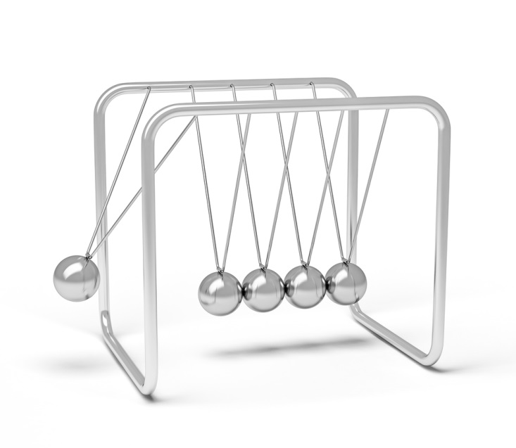Which of the following are the units for pressure? **[1 mark]**

|  |  |  |  |
| --- | --- | --- | --- |
| **A** | N | |  |
| **B** | Pa | |  |
| **C** | m2/N | |  |
| **D** | kg | |  |
|  |  |  | |

Your answer

1. What is Specific Heat Capacity? **[1 mark]**

|  |  |  |  |
| --- | --- | --- | --- |
| **A** | The temperature rise of 1kg of a substance when 1 J of energy is supplied. | |  |
| **B** | The amount of energy needed to cause 1 kg of a substance to melt. | |  |
| **C** | The amount of energy needed to change the temperature of 1 kg of a substance by 1°C | |  |
| **D** | The temperature rise needed for 1 kg of a substance to melt. | |  |
|  |  |  | |

Your answer

|  |  |  |  |  |  |
| --- | --- | --- | --- | --- | --- |
| **6** | **(a)** |  | Using ideas about energy, what happens to particles when heating a block of ice from -2°C to 2°C? **[3 marks]** | |  |
|  | **(b)** |  | While the ice is at 0°C, 500 kJ of energy are supplied to it. Given the Specific Latent Heat of ice is 334kJ/kg, what is the mass of the block?  **[2 marks]** | |  |
|  |  |  |  |  | |

1. Solid brass has a density of 8.5 g/cm3, and liquid brass has a density of 7.5 g/cm3.

|  |  |  |  |  |
| --- | --- | --- | --- | --- |
| **(a)** |  | Why is solid brass denser than liquid brass?  When answering make sure you discuss the arrangement of atoms, and the movement of atoms in the brass. **[5 marks]** | |  |
| **(b)** | **(i)** | What is the volume of 20 g of solid brass? **[2 marks]** | |  |
|  | **(ii)** | What is the volume of 20 g of liquid brass? **[1 mark]** | |  |
|  |  |  |  | |

1. Jay takes a fully inflated balloon and puts it in a freezer. Two hours later the balloon appears deflated.

|  |  |  |  |  |
| --- | --- | --- | --- | --- |
| **(a)** |  | Why is this? **[4 marks]** | |  |
| **(b)** |  | The balloon is then heated up until it explodes. Why, in terms of particle behaviour, does it explode? **[2 marks]** | |  |
|  |  |  |  | |

1. 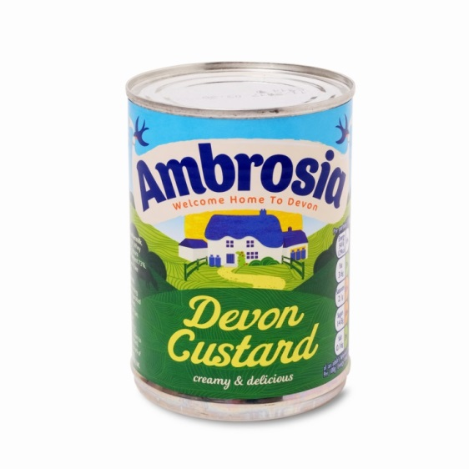Sarah is heating up a tin of custard. It takes 2 kJ to heat the 400 g tin 60°C

|  |  |  |  |
| --- | --- | --- | --- |
| **(a)** |  | What is the Specific Heat Capacity of custard? Include the unit. **[4 marks]** |  |
| **(b)** | **(i)** | Sarah then stirs in 100 g of cream. The temperature of the custard drops by half, as the energy is transferred to the cream. How much energy is transferred? **[2 marks]** |  |
|  | **(ii)** | The temperature of the cream rises by 20°C, what is the Specific Heat Capacity of the cream? **[2 marks]** |  |

1. The current model of the atom is the Bohr model, in which electrons orbit a central nucleus. Before this there were a number of other models.

|  |  |  |  |  |
| --- | --- | --- | --- | --- |
| **(a)** |  | What are the main features of the plum pudding model? **[2 marks]** | |  |
| **(b)** |  | Write down the experimental results that led to the Rutherford model of the atom, and how the observations are linked to the model. **[6 marks]** | |  |
|  |  |  |  | |