# End of topic quiz

# Topic P2: Forces

## Learner Activity

### Topic: P1 of J250

**Total marks: 40**

1. A car travels 10 km in 1 hour, what is his average speed? **[1 mark]**

|  |  |  |  |
| --- | --- | --- | --- |
| **A** | 0.002 m/s | |  |
| **B** | 0.17 m/s | |  |
| **C** | 2.8 m/s | |  |
| **D** | 166.7 m/s | |  |
|  |  |  | |

Your answer

1. Which of the following are scalar quantities? **[1 mark]**

A: Distance

B: Displacement

C: Speed

D: Velocity

|  |  |  |  |
| --- | --- | --- | --- |
| **A** | A and B | |  |
| **B** | B and C | |  |
| **C** | C and D | |  |
| **D** | A and C | |  |
|  |  |  | |

Your answer

1. What is the work done in pushing a 5 kg bag half a metre across a desk? **[1 mark]**

|  |  |  |  |
| --- | --- | --- | --- |
| **A** | 2.5 J | |  |
| **B** | 5.0 J | |  |
| **C** | 25 J | |  |
| **D** | 49.1 J | |  |
|  |  |  | |

Your answer

1. Which of the following planets has the greatest gravitational field strength? **[1 mark]**

|  |  |  |  |
| --- | --- | --- | --- |
| **A** | Earth | |  |
| **B** | Jupiter | |  |
| **C** | Mercury | |  |
| **D** | Pluto | |  |
|  |  |  | |

Your answer

1. A 500 g ball is lifted 20 m up from the surface of Earth. What is its gravitational potential energy? **[1 mark]**

|  |  |  |  |
| --- | --- | --- | --- |
| **A** | 10 J | |  |
| **B** | 100 J | |  |
| **C** | 10000 J | |  |
| **D** | 98000 J | |  |
|  |  |  | |

Your answer

1. A car of mass 1000 kg accelerates from 5 m/s to 30 m/s over a distance of 20 m.

|  |  |  |  |  |
| --- | --- | --- | --- | --- |
| **(a)** |  | What is its acceleration? Give the correct unit. **[4 marks]** | |  |
| **(b)** | **(i)** | What is its kinetic energy at the start? **[2 marks]** | |  |
|  | **(ii)** | What is its kinetic energy at the end? **[1 mark]** | |  |
|  |  |  |  | |

1. Ronny wants to find out how fast Trish can run across the school field.

|  |  |  |  |  |
| --- | --- | --- | --- | --- |
| **(a)** |  | Write down what measurements Ronny should take, including what instruments they should use, and what calculations they should make in order to find an accurate value for Trish’s speed. **[6 marks]** | |  |
| **(b)** |  | Trish runs 400 m at a speed of 9 m/s. How long does she take? **[1 mark]** | |  |
|  |  |  |  | |

1. A skydiver jumps out of a plane and falls for 20 seconds. They then open their parachute and fall for another 20 seconds.

|  |  |  |  |  |
| --- | --- | --- | --- | --- |
| **(a)** |  | Write down, using Newton’s Laws of Motion, how the motion of the skydiver changes during these two periods due to the forces acting on them. **[6 marks]** | |  |
| **(b)** |  | To begin with their weight is 900N and there is negligible air resistance acting on them. What is their acceleration? Include a unit. **[2 marks]** | |  |
|  |  |  |  | |

1. 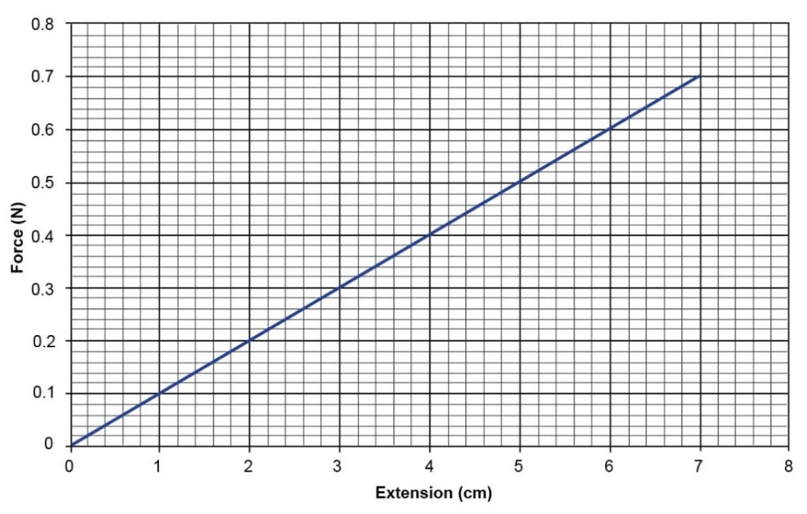

|  |  |  |  |
| --- | --- | --- | --- |
| **(a)** | **(i)** | What does the term spring constant mean? **[2 marks]** |  |
|  | **(ii)** | Using the graph above work out the spring constant for this spring. Include a unit. **[3 marks]** |  |
| **(b)** |  | What is the energy stored in the spring when extended by 7cm? **[2 marks]** |  |

1. Jay carries a 5 kg mass up a flight of stairs, the stairs were 5 m in height.

|  |  |  |  |  |
| --- | --- | --- | --- | --- |
| **(a)** | **(i)** | How much gravitational potential energy does the mass now have?  **[2 marks]** | |  |
|  | **(ii)** | Jay drops the mass. Assuming all gravitational energy is converted to kinetic energy, what is its velocity just before impact? **[2 marks]** | |  |
| **(b)** |  | Jay takes 30 seconds to climb the stairs. What power was Jay using to lift the mass? **[2 marks]** | |  |
|  |  |  |  | |