End of topic quiz

Topic P3: Electricity and magnetism

Learner Activity

Topic: P3 of J250
Total marks: 40

1 | 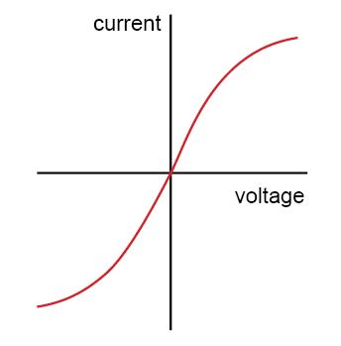  Which circuit component has the IV graph shown above? [1 mark]
 | A | Filament bulb
 | B | Diode
 | C | Thermistor
 | D | Resistor
 | Your answer

2 | What circuit component is this? [1 mark]
 | A | Light Dependant Resistor
 | B | Resistor
 | C | Thermistor
 | D | Variable Resistor
 | Your answer

3 | Which of the following statements about series circuits is true? [1 mark]  - The current through the battery is the same throughout the circuit.  - The current through the battery is shared between each component in the circuit.  - The potential difference across the battery is shared between the components.  - The potential difference across each component is the same as across the battery.
 | A | 1 and 3
 | B | 1 and 4
 | C | 2 and 3
 | D | 2 and 4
 | Your answer

4 | A wire is placed between the north and south poles of a permanent magnet and at right angles to the magnetic field. The current in switched on (electric current flowing out of the paper).  S  N  Which way will the wire move? [1 mark]
 | A | Up
 | B | Down
 | C | Left
 | D | Right
 | Your answer

5 | 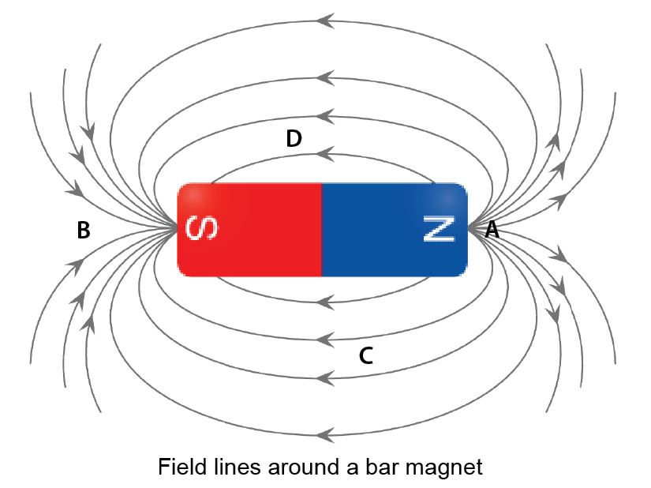  At which of these points is the magnetic field the strongest? [1 mark]
 | A | A
 | B | B
 | C | C
 | D | D
 | Your answer

6 | The graph below shows an I-V graph for a common circuit component.  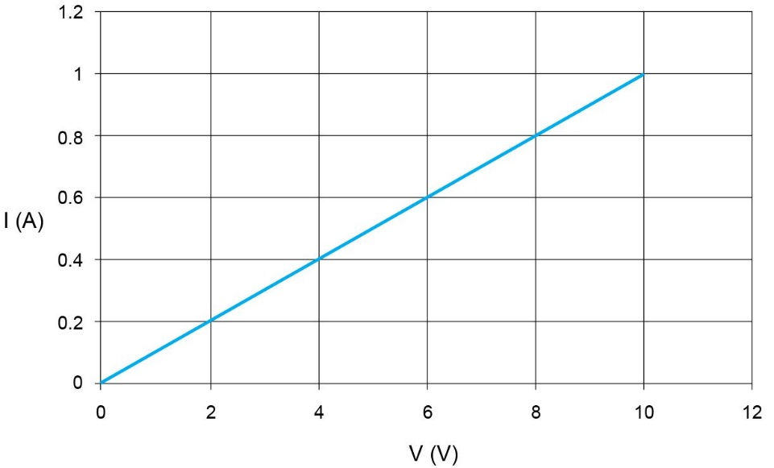
 | (a) | (i) | What circuit component does this graph represent? [1 mark]
 |  | (ii) | What is the resistance of the component at 5 V? [2 marks]
 | (b) | (i) | How would you connect a voltmeter to measure the voltage across the component? [1 mark]
 |  | (ii) | How would you connect an ammeter to measure the current through the component?[1 mark]

7 |   Planes need to be earthed before they are refuelled; otherwise there is a risk of a spark being created which could ignite the fuel vapour.
 | (a) | (i) | Write down how planes gain charge during flight. [2 marks]
 |  | (ii) | Write down how a charged plane coming near a refuelling nozzle could cause a spark. [3 marks]
 | (b) | (i) | Why does Earthing a plane after landing stop this happening? [2 marks]

8 | Robin wants to carry out an investigation of the resistance of an LDR at different light levels.  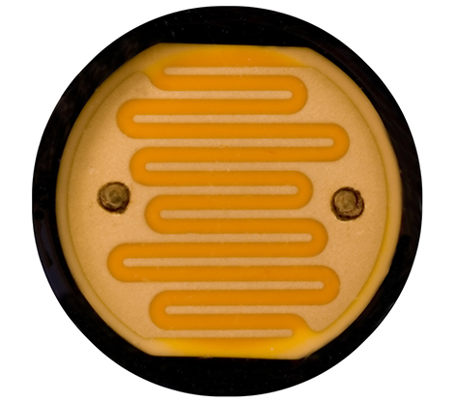
 | (a) | (i) | How could Robin do this? [5 marks]
 |  | (ii) | How could Robin best shows these results? [1 mark]
 | (b) | (i) | What sort of application might an LDR be used in? [1 mark]

9 | The image below shows three resistors in series.  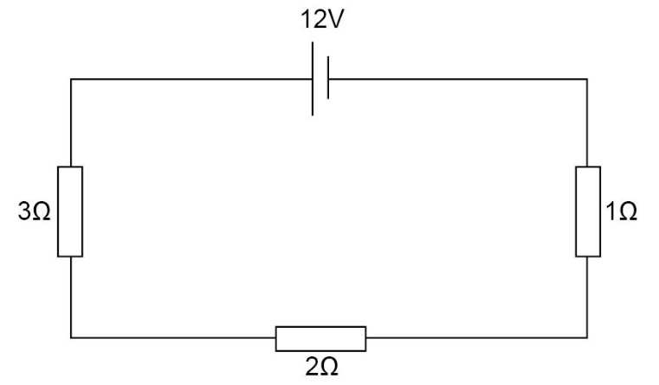
 | (a) | (i) | What is the total resistance of the circuit? [1 mark]
 |  | (ii) | What is the current flowing through the resistors? [2 marks]
 | (b) | (i) | Which of the resistors has the biggest potential difference across it?  [1 mark]
 |  | (ii) | What value is this voltage? [1 mark]
 |  | (iii) | What is the combined voltage across the other two resistors? [1 mark]

10 | This toaster has a power rating of 1500 W.  
 | (a) | (i) | What is the definition of power? [2 marks]
 |  | (ii) | If the toaster is switched on for 10 minutes, how much energy is transferred to the bread?[3 marks]
 | (b) | (i) | The toaster is using mains electricity at 230 V. What is the current running through the appliance? [3 marks]
 |  | (ii) | What is the resistance of the heating element in the toaster? [2 marks]

