End of topic quiz

Topic P4: Waves and radioactivity

Learner Activity

Topic: P4 of J250
Total marks: 40

1. | Which of the following definitions are true? [1 mark]  - Wavelength is the length a wave travels in one second.  - Wavelength is the length of one wave.  - Frequency is the number of waves that occur in one second.  - Frequency is time it takes for one wave to occur.
 | A | 1 and 3
 | B | 1 and 4
 | C | 2 and 3
 | D | 2 and 4
 | Your answer

2. | Which type of radiation is missing from the following list? [1 mark]  X Rays  ---------------  Visible Light
 | A | Radio waves
 | B | Infra-Red
 | C | Ultraviolet
 | D | Microwaves
 | Your answer

3. | Which of the following is the least penetrating? [1 mark]
 | A | Alpha
 | B | Beta
 | C | Gamma
 | D | X-Rays
 | Your answer

4. | What is the speed of a wave of wavelength 4 mm and a frequency of 10 Hz? [1 mark]
 | A | 0.04 m/s
 | B | 0.4 m/s
 | C | 4 m/s
 | D | 40 m/s
 | Your answer

5. | The diagram below shows light being passed through a glass block.  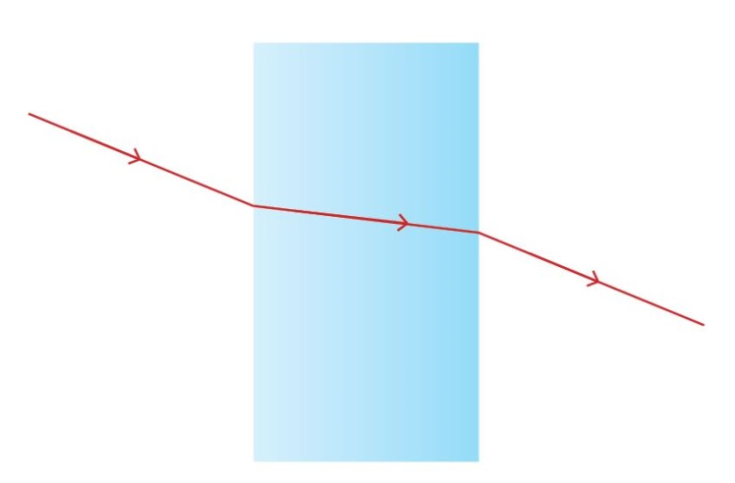  What property of waves is shown above? [1 mark]
 | A | Reflection
 | B | Refraction
 | C | Diffraction
 | D | Dispersion
 | Your answer

[
[1]
6. | Plutonium undergoes radioactive decay to become Uranium. The incomplete decay equation for this is shown below.  $${}_{94}^{239}{Pu} → {}_{…..}^{235}U + {}_{2}^{……}{….}$$
 | (a) | (i) | Complete the above decay equation. [3 marks]
 |  | (ii) | What is the other type of particle radiation? [1 mark]
 | (b) | (i) | Plutonium- 239 is an isotope. What is an isotope? [2 marks]

7. | Light travels at a speed of 300,000,000 m/s.
 | (a) | (i) | What sort of wave is light? [1 mark]
 |  | (ii) | What are the main differences between transverse and longitudinal waves in terms of energy and particle movement? [3 marks]
 | (b) | (i) | Radio waves have a frequency which ranges from 3 kHz to 300 GHz. What is the smallest possible wavelength they could have? [2 marks]

8. | Microwave ovens use microwaves to heat food.  
 | (a) | (i) | How does this happen? [4 marks]
 |  | (ii) | Microwaves have a frequency of 2,450 MHz. What is their wavelength? [2 marks]
 | (b) | (i) | Name another use of microwaves. [1 mark]

9.  Activity | The graph below shows the decay curve of a radioactive substance.  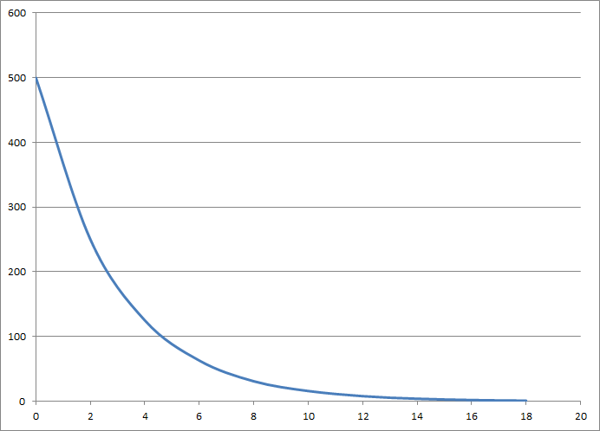  Time / days
 | (a) | (i) | Use the above graph to work out the half-life of this isotope. [2 marks]
 |  | (ii) | What is meant by half life? [2 marks]
 | (b) | (i) | The above isotope is a gamma emitter. Why would it be suitable for use as a tracking isotope in a human? [3 marks]
 |  | (ii) | When an isotope emits gamma radiation it does not change to a different atom or isotope. Why not? [2 marks]
10. | X Rays and Gamma Rays are both ionising Electromagnetic Waves.
 | (a) | (i) | Why is ionisation dangerous to humans? [2 marks]
 |  | (ii) | What safety precautions can be taken by medical staff to minimise their exposure to this radiation? [4 marks]
 | (b) | (i) | A chest CT scan exposes the patient to a large amount of ionising radiation. Why are chest CT scans used, even though they are risky? [2 marks]

