# End of topic quiz

# Topic P5: Energy

## Learner Activity

### Topic: P5 of J250

**Total marks: 40**

1. A light bulb outputs 20 J of energy for every 1 kJ inputted. What is the efficiency of the light bulb? **[1 mark]**

|  |  |  |
| --- | --- | --- |
| **A** | 0.2 % |  |
| **B** | 2 % |  |
| **C** | 20 % |  |
| **D** | 50 % |  |

Your answer

1. A toy car is at the top of a ramp, it has 20 J of gravitational potential energy. When it runs down the ramp and reaches the bottom it has zero gravitational potential energy.

Assuming friction and air resistance have no effect, how much kinetic energy does it have at the bottom of the ramp? **[1 mark]**

|  |  |  |
| --- | --- | --- |
| **A** | 0 J |  |
| **B** | 10 J |  |
| **C** | 20 J |  |
| **D** | 30 J |  |

Your answer

1. Which of the following statements is true? **[1 mark]**

|  |  |  |
| --- | --- | --- |
| **A** | Energy can be created, but not destroyed. |  |
| **B** | Energy can be destroyed, but not created. |  |
| **C** | Energy can be both created and destroyed. |  |
| **D** | Energy can be neither created nor destroyed. |  |

Your answer

1. Which of the following devices would you use to measure energy in an electrical circuit?   
   **[1 mark]**

|  |  |  |
| --- | --- | --- |
| **A** | Ammeter |  |
| **B** | Joulemeter |  |
| **C** | Ohmeter |  |
| **D** | Voltmeter |  |

Your answer

1. During energy transfer processes, friction can occur. When this happens some of the energy being transferred can be changed into a ‘wasted’ store of energy. Which store is this? **[1 mark]**

|  |  |  |
| --- | --- | --- |
| **A** | Elastic potential |  |
| **B** | Kinetic |  |
| **C** | Gravitational potential |  |
| **D** | Thermal |  |

Your answer

1. Beth has a mass of 35 kg, her father pulls her back until she is 1.4 m off the ground.

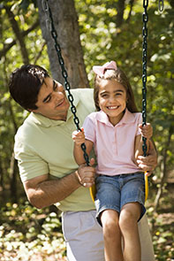

|  |  |  |  |
| --- | --- | --- | --- |
| **(a)** | **(i)** | As Beth is pulled back she gains stored energy. What store of energy is this?  **[1 mark]** | |
|  |  |  | |
|  |  |  |  |
|  | **(ii)** | Write down the amount of this energy she has? **[2 marks]** | |
|  |  |  | |
|  |  |  |  |
| **(b)** | **(i)** | When her father lets go of her Beth swings forward.  There **is** air resistance and friction.  How much would the amount of kinetic energy she has compare to the amount of energy she had to start with? **[1 mark]** | |
|  |  |  | |
|  |  |  |  |
|  | **(ii)** | Write down the energy transfers which take place as Beth swings from the top position to the middle position. **[4 marks]** | |
|  |  |  | |
|  |  |  |  |
|  | **(iii)** | How could the energy loss through friction be reduced? **[1 mark]** | |
|  |  |  | |

1. A games console with a power rating of 130 W is played with for 4 hours a day.

|  |  |  |  |
| --- | --- | --- | --- |
| **(a)** |  | Over a week, how much energy does it use? **[4 marks]** | |
|  |  |  | |
|  |  |  |  |
| **(b)** | **(i)** | The games console uses mains voltage. How much current is going through it? **[2 marks]** | |
|  |  |  | |
|  |  |  |  |
|  | **(ii)** | The cables connecting the games console to the plug heat up when it is on.  Why is this? **[3 marks]** | |
|  |  |  | |

1. Marcy takes a spring of spring constant 20 N/m. The spring extends by 30 cm. A toy car is placed in front of the spring so that when the spring is released it will hit the car and transfer all the stored energy into the car. The car has a mass of 10 g.

|  |  |  |  |
| --- | --- | --- | --- |
| **(a)** |  | How much energy is stored in the spring? **[3 marks]** | |
|  |  |  | |
|  |  |  |  |
| **(b)** | **(i)** | How much kinetic energy does the car have once the spring is fully compressed again? **[1 mark]** | |
|  |  |  | |
|  |  |  |  |
|  | **(ii)** | How fast is the car travelling at this point? Give a unit. **[3 marks]** | |
|  |  |  | |



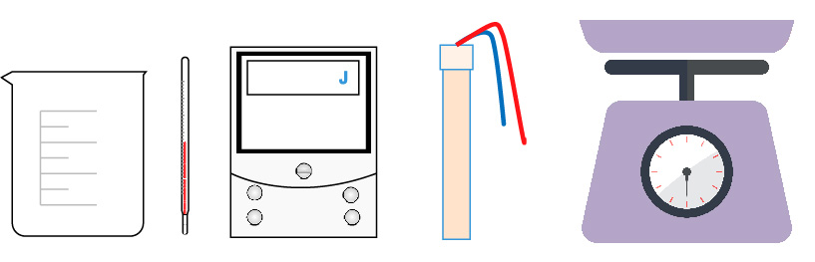

beaker thermometer joulemeter immersion heater scales

|  |  |  |  |
| --- | --- | --- | --- |
| **(a)** | **(i)** | How could you investigate to find the specific heat capacity of water using the above equipment? **[6 marks]** | |
|  |  |  | |
|  |  |  |  |
|  | **(ii)** | During this experiment the water is also transferring energy to the air and surroundings.  Write down two ways to prevent this. **[2 marks]** | |
|  |  |  | |
|  |  |  |  |
| **(b)** |  | Copper has a specific heat capacity of 390 J/kg°C.  How much energy is needed to raise the temperature of 100 g of it by 50°C?  **[2 marks]** | |
|  |  |  | |