# End of topic quiz

# Topic P6: Global challenges

## Learner Activity

### Topic: P6 of J250

**Total marks: 40**

1. Which of the following is a renewable source of energy? **[1 mark]**

|  |  |  |
| --- | --- | --- |
| **A** | Natural gas |  |
| **B** | Solar |  |
| **C** | Nuclear |  |
| **D** | Coal |  |

Your answer

1. What is the average walking speed of a human? **[1 mark]**

|  |  |  |
| --- | --- | --- |
| **A** | 0.5 m/s |  |
| **B** | 1.0 m/s |  |
| **C** | 1.5 m/s |  |
| **D** | 2 m/s |  |

Your answer

1. Which of the following affect braking distance? **[1 mark]**

|  |  |  |
| --- | --- | --- |
| **A** | Alcohol |  |
| **B** | Loud music |  |
| **C** | Worn tyres |  |
| **D** | Tiredness |  |

Your answer

1. A transformer has a p.d. of 20 V across the primary coil, and a current of 0.2 A.

The secondary coil has a p.d. of 50 V across it.

What current flows through the secondary coil? **[1 mark]**

|  |  |  |
| --- | --- | --- |
| **A** | 0.08 A |  |
| **B** | 0.5 A |  |
| **C** | 0.8 A |  |
| **D** | 5 A |  |

Your answer

1. Which of the following melts when too high a current passes through an electrical device?   
   **[1 mark]**

|  |  |  |
| --- | --- | --- |
| **A** | Earth wire |  |
| **B** | Fuse wire |  |
| **C** | Live wire |  |
| **D** | Neutral wire |  |

Your answer



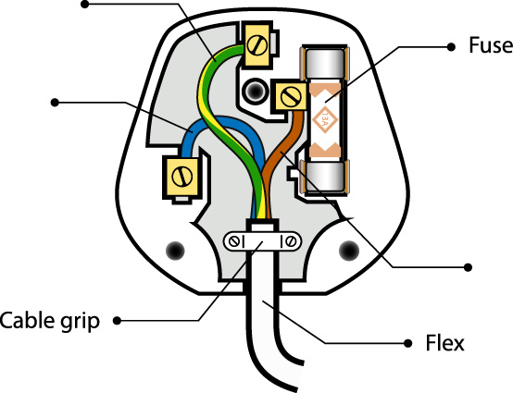

|  |  |  |  |
| --- | --- | --- | --- |
| **(a)** |  | Label the wires. **[3 marks]** | |
|  |  |  |  |
| **(b)** |  | What does each wire do? **[3 marks]** | |
|  |  |  | |



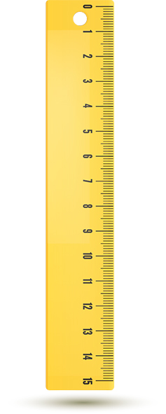

|  |  |  |  |
| --- | --- | --- | --- |
| **(a)** | **(i)** | Write down how you could investigate the differences in reaction time with three classmates using a ruler **[5 marks]** | |
|  |  |  | |
|  |  |  |  |
|  | **(ii)** | It is possible to use a stopwatch to test reaction time, by having one partner start the watch and the other stop it as fast as possible. Write down one difficulty associated with this method. **[1 mark]** | |
|  |  |  | |

1. During a car crash the car and people in it feel a large deceleration.

|  |  |  |  |
| --- | --- | --- | --- |
| **(a)** |  | Write down, using Newton’s Laws, why this is dangerous to the people in the car. **[4 marks]** | |
|  |  |  | |
|  |  |  |  |
| **(b)** |  | Write down two different safety features inside the car, and give examples of how they increase safety. **[4 marks]** | |
|  |  |  | |

1. In the UK electricity is supplied to the country using the National Grid.

|  |  |  |  |
| --- | --- | --- | --- |
| **(a)** |  | What frequency is this energy supplied at? **[1 mark]** | |
|  |  |  | |
|  |  |  |  |
| **(b)** |  | What is the process by which electricity is transported to our homes by the National Grid? **[5 marks]** | |
|  |  |  | |
|  |  |  |  |
| **(c)** |  | Why do we transmit electricity at high voltages? **[2 marks]** | |
|  |  |  | |

1. Currently the UK uses a number of different methods to generate electricity.

|  |  |  |  |
| --- | --- | --- | --- |
| **(a)** |  | Name two renewable methods the UK currently uses. **[2 marks]** | |
|  |  |  | |
|  |  |  |  |
| **(b)** |  | Write down the pros and cons of using coal and wind to generate electricity.  In your opinion, which is better and why? **[5 marks]** | |
|  |  |  | |