End of topic quiz

Topic P1: Matter

Instructions and answers for teachers
These instructions cover the learner activity section which can be found on page 9. This end of topic quiz supports OCR GCSE (9–1) Combined Science A (J250), Topic P1.
When distributing the activity section to the learners either as a printed copy or as a Word file you will need to remove the teacher instructions section.

The Activity
This end of topic quiz is a teaching and learning resource comprised of 40 marks covering a range of question types. The quiz starts with some multiple choice questions (MCQs) and then moves on to some short answer questions and then finally on to some longer answer questions.
This resource can be used to test and consolidate understanding at the end of teaching the topic or to revisit and refresh knowledge at a later point in the course.

Learning Outcomes
This end of topic quiz relates to the specification learning outcomes in Topic P1: Matter. The questions in this quiz cover a range of the following topics:
P1.1 The particle model
P1.2 Changes of state

Topic: P1 of J250 - Answers
Total marks: 40

- Robin has a block of material, which measures 10 cm on each side.
The block has a mass of 100 g. What is the density of the block? [1 mark]
A | 0.0001 kg/m³
B | 0.01 kg/m³
C | 100 kg/m³
D | 10000 kg/m³
Your answer
C

- Which of the following shows the correct order of development for models of the atom? [1 mark]
A | Thomson, Rutherford, Bohr.
B | Rutherford, Thomson, Bohr.
C | Thomson, Bohr, Rutherford.
D | Bohr, Rutherford, Thompson.
Your answer
A

- 10 kJ of energy are supplied to a 100 g block of material. This is enough to cause it to melt, without any rise in temperature. What is the Specific Latent Heat of the material? [1 mark]
A | 0.1 J/kg
B | 10 J/kg
C | 100 J/kg
D | 100 000 J/kg
Your answer
D

- Which of the following are the units for pressure? [1 mark]
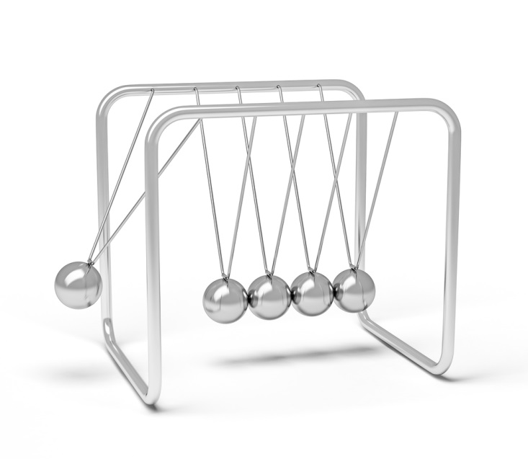
A | N
B | Pa
C | m²/N
D | kg
Your answer
A

- What is Specific Heat Capacity? [1 mark]
A | The temperature rise of 1 kg of a substance when 1J of energy is supplied.
B | The amount of energy needed to cause 1 kg of a substance to melt.
C | The amount of energy needed to change the temperature of 1 kg of a substance by 1°C
D | The temperature rise needed for 1 kg of a substance to melt.
Your answer
C
6. | (a) |  | Using ideas about energy, what happens to particles when heating a block of ice from -2°C to 2°C? [3 marks]
-2 → 0: Energy supplied raises the temperature of the ice by increasing the KE of the particles. ✓
0: Energy supplied weakens the bonds between particles.✓
From 0 °C: Energy supplied raises the temperature of the ice by increasing the KE of the particles.✓
 | (b) |  | While the ice is at 0°C, 500 kJ of energy are supplied to it. Given the Specific Latent Heat of ice is 334 kJ/kg, what is the mass of the block?  [2 marks]
500 ÷ 334✓
= 1.50 kg ✓

- Solid brass has a density of 8.5 g/cm³, and liquid brass has a density of 7.5 g/cm³.
(a) |  | Why is solid brass denser than liquid brass?  When answering make sure you discuss the arrangement of atoms, and the movement of atoms in the brass. [5 marks]
Solid
Particles are in a fixed lattice ✓
Particles vibrate around a fixed point ✓
So take up less volume for a given mass.✓
Liquid
Particles move loosely around each other ✓
Particles move around more ✓
(b) | (i) | What is the volume of 20 g of solid brass? [2 marks]
20 ÷ 8.5 ✓
= 2.35 cm³ ✓
 | (ii) | What is the volume of 20 g of liquid brass? [1 mark]
 |  | 2.66 cm³ ✓

- Jay takes a fully inflated balloon and puts it in a freezer. Two hours later the balloon appears deflated.
(a) |  | Why is this? [4 marks]
The gas particles inside the balloon have less energy✓
Therefore they move more slowly✓
This means fewer collisions with the balloon✓
So the pressure is lower.✓
(b) |  | The balloon is then heated up until it explodes. Why, in terms of particle behaviour, does it explode? [2 marks]
Particles have more energy and collide more✓
The pressure due to this is big enough to break the bonds in the balloon.✓


- Sarah is heating up a tin of custard. It takes 2 kJ to heat the 400 g tin 60°C

(a) |  | What is the Specific Heat Capacity of custard? Include the unit. [4 marks]
energy ÷ (mass x temp rise) ✓
2000 ÷ (0.4 x 60) ✓
= 83.3 ✓
J/kg°C ✓
(b) | (i) | Sarah then stirs in 100 g of cream. The temperature of the custard drops by half, as the energy is transferred to the cream. How much energy is transferred? [2 marks]
0.4 x 30 x 83.3 ✓
= 999.6 or 1 kJ✓
 | (ii) | The temperature of the cream rises by 20°C, what is the Specific Heat Capacity of the cream? [2 marks]
1000 ÷ (0.1 x 20)✓
= 500✓

- The current model of the atom is the Bohr model, in which electrons orbit a central nucleus. Before this there were a number of other models.
(a) |  | What are the main features of the plum pudding model? [2 marks]
Large positive mass✓
Studded with negative particles.✓
(b) |  | Write down the experimental results that led to the Rutherford model of the atom, and how the observations are linked to the model. [6 marks]
Alpha particles fired at gold foil✓
Most passed through✓
therefore mostly empty space✓
Some changed course✓
as repelled by positive mass✓
A tiny amount rebounded straight back therefore positive mass is tiny.✓
OCR Resources: the small print
OCR’s resources are provided to support the teaching of OCR specifications, but in no way constitute an endorsed teaching method that is required by the Board, and the decision to use them lies with the individual teacher. Whilst every effort is made to ensure the accuracy of the content, OCR cannot be held responsible for any errors or omissions within these resources.
© OCR 2016 - This resource may be freely copied and distributed, as long as the OCR logo and this message remain intact and OCR is acknowledged as the originator of this work.
OCR acknowledges the use of the following content: Page 4 and 11 Newtons Cradle f9photos/Shutterstock.com: Pages 8 and 15 Ambrosia Custard tin abimages/Shutterstock.com
Please get in touch if you want to discuss the accessibility of resources we offer to support delivery of our qualifications: resources.feedback@ocr.org.uk
We’d like to know your view on the resources we produce. By clicking on ‘Like’ or ‘Dislike’ you can help us to ensure that our resources work for you. When the email template pops up please add additional comments if you wish and then just click ‘Send’. Thank you.
Whether you already offer OCR qualifications, are new to OCR, or are considering switching from your current provider/awarding organisation, you can request more information by completing the Expression of Interest form which can be found here: www.ocr.org.uk/expression-of-interest
Looking for a resource? There is now a quick and easy search tool to help find free resources for your qualification:
www.ocr.org.uk/i-want-to/find-resources/

This formative assessment resource has been produced as part of our free GCSE teaching and learning support package. All the GCSE teaching and learning resources, including delivery guides, topic exploration packs, lesson elements and more are available on the qualification webpages.
If you are looking for examination practice materials, you can find the Sample Assessment Materials (SAMs) on the qualification webpage: Combined Science A (9-1).

End of topic quiz

Topic P1: Matter

Learner Activity

Topic: P1 of J250
Total marks: 40
- Robin has a block of material, which measures 10 cm on each side.
The block has a mass of 100 g. What is the density of the block? [1 mark]
A | 0.0001 kg/m³
B | 0.01 kg/m³
C | 100 kg/m³
D | 10000 kg/m³
Your answer

- Which of the following shows the correct order of development for models of the atom?
[1 mark]
A | Thomson, Rutherford, Bohr.
B | Rutherford, Thomson, Bohr.
C | Thomson, Bohr, Rutherford.
D | Bohr, Rutherford, Thompson.
Your answer

- 10 kJ of energy are supplied to a 100 g block of material. This is enough to cause it to melt, without any rise in temperature. What is the Specific Latent Heat of the material? [1 mark]
A | 0.1 J/kg
B | 10 J/kg
C | 100 J/kg
D | 100 000 J/kg
Your answer

- Which of the following are the units for pressure? [1 mark]
A | N
B | Pa
C | m²/N
D | kg
Your answer

- What is Specific Heat Capacity? [1 mark]
A | The temperature rise of 1kg of a substance when 1 J of energy is supplied.
B | The amount of energy needed to cause 1 kg of a substance to melt.
C | The amount of energy needed to change the temperature of 1 kg of a substance by 1°C
D | The temperature rise needed for 1 kg of a substance to melt.
Your answer

6 | (a) |  | Using ideas about energy, what happens to particles when heating a block of ice from -2°C to 2°C? [3 marks]
 | (b) |  | While the ice is at 0°C, 500 kJ of energy are supplied to it. Given the Specific Latent Heat of ice is 334kJ/kg, what is the mass of the block?  [2 marks]

- Solid brass has a density of 8.5 g/cm3, and liquid brass has a density of 7.5 g/cm³.
(a) |  | Why is solid brass denser than liquid brass?  When answering make sure you discuss the arrangement of atoms, and the movement of atoms in the brass. [5 marks]
(b) | (i) | What is the volume of 20 g of solid brass? [2 marks]
 | (ii) | What is the volume of 20 g of liquid brass? [1 mark]

- Jay takes a fully inflated balloon and puts it in a freezer. Two hours later the balloon appears deflated.
(a) |  | Why is this? [4 marks]
(b) |  | The balloon is then heated up until it explodes. Why, in terms of particle behaviour, does it explode? [2 marks]


- Sarah is heating up a tin of custard. It takes 2 kJ to heat the 400 g tin 60°C

(a) |  | What is the Specific Heat Capacity of custard? Include the unit. [4 marks]
(b) | (i) | Sarah then stirs in 100 g of cream. The temperature of the custard drops by half, as the energy is transferred to the cream. How much energy is transferred? [2 marks]
 | (ii) | The temperature of the cream rises by 20°C, what is the Specific Heat Capacity of the cream? [2 marks]
- The current model of the atom is the Bohr model, in which electrons orbit a central nucleus. Before this there were a number of other models.
(a) |  | What are the main features of the plum pudding model? [2 marks]
(b) |  | Write down the experimental results that led to the Rutherford model of the atom, and how the observations are linked to the model. [6 marks]

