End of topic quiz

Topic P3: Electricity and magnetism

Instructions and answers for teachers
These instructions cover the learner activity section which can be found on page 12. This end of topic quiz supports OCR GCSE (9–1) Combined Science A (J250), Topic P3.
When distributing the activity section to the learners either as a printed copy or as a Word file you will need to remove the teacher instructions section.

The Activity
This end of topic quiz is a teaching and learning resource comprised of 40 marks covering a range of question types. The quiz starts with some multiple choice questions (MCQs) and then moves on to some short answer questions and then finally on to some longer answer questions.
This resource can be used to test and consolidate understanding at the end of teaching the topic or to revisit and refresh knowledge at a later point in the course.

Learning Outcomes
This end of topic quiz relates to the specification learning outcomes in Topic P3: Electricity and magnetism. The questions in this quiz cover a range of the following topics:
P3.1 Static and Charge
P3.2 Simple circuits
P3.3 Magnets and magnetic fields

Topic: P2 of J250 - Answers
Total marks: 40

1 | 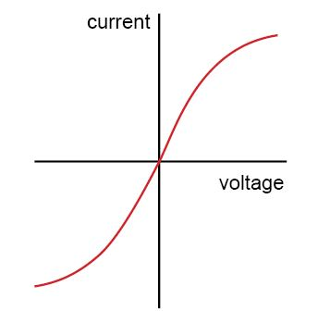  Which circuit component has the IV graph shown above? [1 mark]
 | A | Filament bulb
 | B | Diode
 | C | Thermistor
 | D | Resistor
A | Your answer

2 | What circuit component is this? [1 mark]
 | A | Light Dependant Resistor
 | B | Resistor
 | C | Thermistor
 | D | Variable Resistor
D | Your answer

3 | Which of the following statements about series circuits is true? [1 mark]  - The current through the battery is the same throughout the circuit.  - The current through the battery is shared between each component in the circuit.  - The potential difference across the battery is shared between the components.  - The potential difference across each component is the same as across the battery.
 | A | 1 and 3
 | B | 1 and 4
 | C | 2 and 3
 | D | 2 and 4
A | Your answer

4 | A wire is placed between the north and south poles of a permanent magnet and at right angles to the magnetic field. The current in switched on (electric current flowing out of the paper).  N  S  Which way will the wire move? [1 mark]
 | A | Up
 | B | Down
 | C | Left
 | D | Right
A | Your answer

5 | 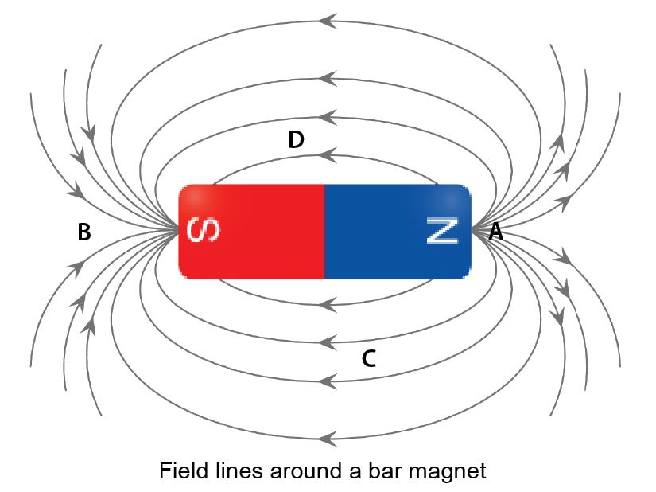  At which of these points is the magnetic field the strongest? [1 mark]
 | A | A
 | B | B
 | C | C
 | D | D
A | Your answer

6 | The graph below shows an I-V graph for a common circuit component.  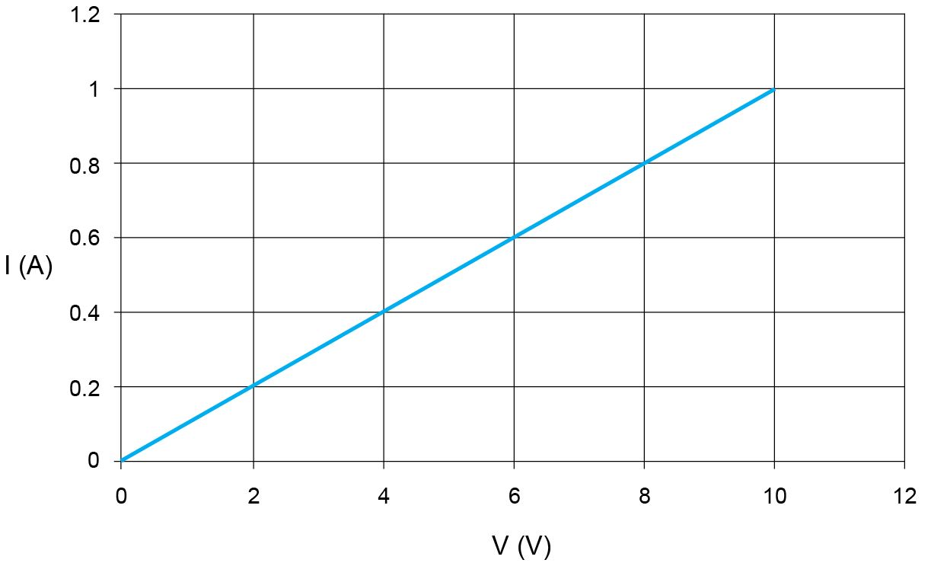
 | (a) | (i) | What circuit component does this graph represent? [1 mark]
 |  |  | Resistor/Ohmic conductor✓
 |  | (ii) | What is the resistance of the component at 5 V? [2 marks]
5 ÷ 0.5 ✓
= 10 Ω✓
 | (b) | (i) | How would you connect a voltmeter to measure the voltage across the component? [1 mark]
 |  |  | In parallel✓
 |  | (ii) | How would you connect an ammeter to measure the current through the component?[1 mark]
 |  |  | In series✓

7 |   Planes need to be earthed before they are refuelled; otherwise there is a risk of a spark being created which could ignite the fuel vapour.
 | (a) | (i) | Write down how planes gain charge during flight. [2 marks]
Plane undergoes friction with air/vapour particles✓
Electrons are gained or lost✓
 |  | (ii) | Write down how a charged plane coming near a refuelling nozzle could cause a spark. [3 marks]
Charged plane causes nozzle to become oppositely charged by electron movement✓
Difference in charges causes air particles to become ionised✓
Ions move towards relevant charged objects, this is a spark.✓
 | (b) | (i) | Why does Earthing a plane after landing stop this happening? [2 marks]
This provides an easy path for electrons to flow to/from the plane✓
So it is no longer charged✓

8 | Robin wants to carry out an investigation of the resistance of an LDR at different light levels.  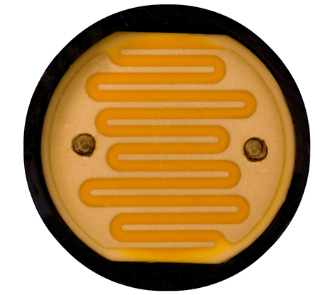
 | (a) | (i) | How could Robin do this? [5 marks]
Set up a circuit with the LDR in it✓
Ammeter in series/voltmeter in parallel OR Ohmmeter✓
Alter how much light falls on the LDR (change distance from lamp/cover LDR partially/any sensible suggestion.)✓
Take readings of V and I✓
Calculate R✓
 |  | (ii) | How could Robin best shows these results? [1 mark]
 |  |  | Line graph (of light level versus R)✓
 | (b) | (i) | What sort of application might an LDR be used in? [1 mark]
 |  |  | Automatic lighting/other sensible suggestion✓

9 | The image below shows three resistors in series.  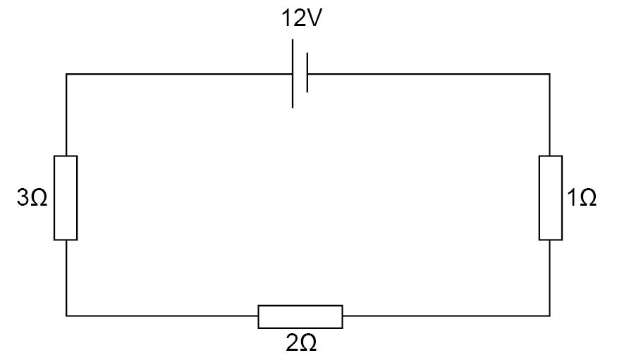
 | (a) | (i) | What is the total resistance of the circuit? [1 mark]
 |  |  | 6 Ohm✓
 |  | (ii) | What is the current flowing through the resistors? [2 marks]
I = V ÷ R✓
12 ÷ 6 = 2✓
 | (b) | (i) | Which of the resistors has the biggest potential difference across it?  [1 mark]
 |  |  | 3 Ohm✓
 |  | (ii) | What value is this voltage? [1 mark]
 |  |  | 6 V✓
 |  | (iii) | What is the combined voltage across the other two resistors? [1 mark]
 |  |  | 6 V✓

10 | This toaster has a power rating of 1500 W.  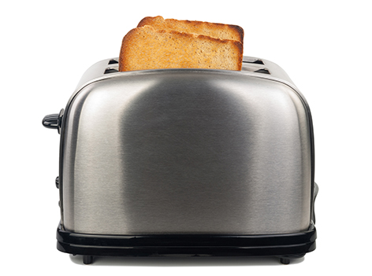
 | (a) | (i) | What is the definition of power? [2 marks]
Energy transferred✓
per unit time.✓
 |  | (ii) | If the toaster is switched on for 10 minutes, how much energy is transferred to the bread?[3 marks]
Time is 10 x 60 = 600 s✓
Energy = 1500 x 600✓
= 900 kJ✓
 | (b) | (i) | The toaster is using mains electricity at 230 V. What is the current running through the appliance? [3 marks]
Power = IV✓
Current = 1500 ÷ 230✓
= 6.5 A✓
 |  | (ii) | What is the resistance of the heating element in the toaster? [2 marks]
R = 230 ÷ 6.5✓
35 Ω✓

We’d like to know your view on the resources we produce. By clicking on ‘Like’ or ‘Dislike’ you can help us to ensure that our resources work for you. When the email template pops up please add additional comments if you wish and then just click ‘Send’. Thank you.
Whether you already offer OCR qualifications, are new to OCR, or are considering switching from your current provider/awarding organisation, you can request more information by completing the Expression of Interest form which can be found here: www.ocr.org.uk/expression-of-interest
Looking for a resource? There is now a quick and easy search tool to help find free resources for your qualification:
www.ocr.org.uk/i-want-to/find-resources/
OCR Resources: the small print
OCR’s resources are provided to support the teaching of OCR specifications, but in no way constitute an endorsed teaching method that is required by the Board, and the decision to use them lies with the individual teacher. Whilst every effort is made to ensure the accuracy of the content, OCR cannot be held responsible for any errors or omissions within these resources.
© OCR 2016 - This resource may be freely copied and distributed, as long as the OCR logo and this message remain intact and OCR is acknowledged as the originator of this work.
OCR acknowledges the use of the following content: Question 5: Bar magnet – attaphong/Shutterstock.com, Question 7: Refuelling – Nadagirl/Shutterstock.com, Question 8: LDR – Awe Inspiring Images/Shutterstock.com, Question 10: Toaster – SeDmi/Shutterstock.com
Please get in touch if you want to discuss the accessibility of resources we offer to support delivery of our qualifications: resources.feedback@ocr.org.uk
This formative assessment resource has been produced as part of our free GCSE teaching and learning support package. All the GCSE teaching and learning resources, including delivery guides, topic exploration packs, lesson elements and more are available on the qualification webpages.
If you are looking for examination practice materials, you can find the Sample Assessment Materials (SAMs) on the qualification webpage: Combined Science A (9–1).

End of topic quiz

Topic P3: Electricity and magnetism

Learner Activity

Topic: P3 of J250
Total marks: 40

1 | Which circuit component has the IV graph shown above? [1 mark]
 | A | Filament bulb
 | B | Diode
 | C | Thermistor
 | D | Resistor
 | Your answer

2 | What circuit component is this? [1 mark]
 | A | Light Dependant Resistor
 | B | Resistor
 | C | Thermistor
 | D | Variable Resistor
 | Your answer

3 | Which of the following statements about series circuits is true? [1 mark]  - The current through the battery is the same throughout the circuit.  - The current through the battery is shared between each component in the circuit.  - The potential difference across the battery is shared between the components.  - The potential difference across each component is the same as across the battery.
 | A | 1 and 3
 | B | 1 and 4
 | C | 2 and 3
 | D | 2 and 4
 | Your answer

4 | A wire is placed between the north and south poles of a permanent magnet and at right angles to the magnetic field. The current in switched on (electric current flowing out of the paper).  N  S  Which way will the wire move? [1 mark]
 | A | Up
 | B | Down
 | C | Left
 | D | Right
 | Your answer

5 | At which of these points is the magnetic field the strongest? [1 mark]
 | A | A
 | B | B
 | C | C
 | D | D
 | Your answer

6 | The graph below shows an I-V graph for a common circuit component.
 | (a) | (i) | What circuit component does this graph represent? [1 mark]
 |  | (ii) | What is the resistance of the component at 5 V? [2 marks]
 | (b) | (i) | How would you connect a voltmeter to measure the voltage across the component? [1 mark]
 |  | (ii) | How would you connect an ammeter to measure the current through the component?[1 mark]

7 | Planes need to be earthed before they are refuelled; otherwise there is a risk of a spark being created which could ignite the fuel vapour.
 | (a) | (i) | Write down how planes gain charge during flight. [2 marks]
 |  | (ii) | Write down how a charged plane coming near a refuelling nozzle could cause a spark. [3 marks]
 | (b) | (i) | Why does Earthing a plane after landing stop this happening? [2 marks]

8 | Robin wants to carry out an investigation of the resistance of an LDR at different light levels.
 | (a) | (i) | How could Robin do this? [5 marks]
 |  | (ii) | How could Robin best shows these results? [1 mark]
 | (b) | (i) | What sort of application might an LDR be used in? [1 mark]

9 | The image below shows three resistors in series.
 | (a) | (i) | What is the total resistance of the circuit? [1 mark]
 |  | (ii) | What is the current flowing through the resistors? [2 marks]
 | (b) | (i) | Which of the resistors has the biggest potential difference across it?  [1 mark]
 |  | (ii) | What value is this voltage? [1 mark]
 |  | (iii) | What is the combined voltage across the other two resistors? [1 mark]

10 | This toaster has a power rating of 1500 W.
 | (a) | (i) | What is the definition of power? [2 marks]
 |  | (ii) | If the toaster is switched on for 10 minutes, how much energy is transferred to the bread?[3 marks]
 | (b) | (i) | The toaster is using mains electricity at 230 V. What is the current running through the appliance? [3 marks]
 |  | (ii) | What is the resistance of the heating element in the toaster? [2 marks]

